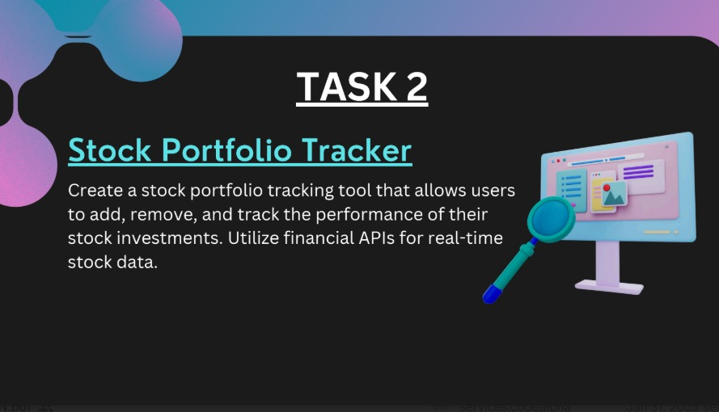

**Concept Overview:**

* The Stock Portfolio Tracker is a Python program that helps users manage and monitor their stock investments by:
* Adding, removing, or viewing stocks in their portfolio.
* Tracking the real-time value of each stock.
* Calculating the total portfolio value.
* Optionally, using a financial API (like Yahoo Finance, Alpha Vantage, or yfinance) to fetch live stock prices.

**Key Components:**

1. User Portfolio:

A dictionary or list storing stock symbols (like AAPL, GOOGL) and the number of shares owned.

**2. Real-Time Data:**

Fetch current stock prices using an API.

Example: yfinance library in Python.

**3. Core Features:**

* Add stock: User enters a stock symbol and quantity.
* Remove stock: Delete a stock from the portfolio.
* View portfolio: Display current stock values and total worth

**4. Optional Features:**

* Show daily change or % change in stock prices.
* Save/load the portfolio from a file.

**Learning Goals:**

* Working with external APIs
* Managing data structures (like dictionaries)
* Basic financial calculations
* Enhancing user experience via CLI

**CODE**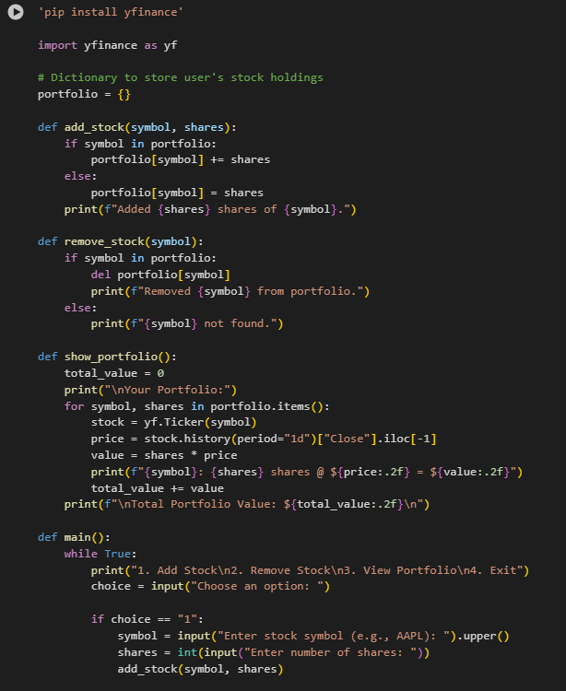

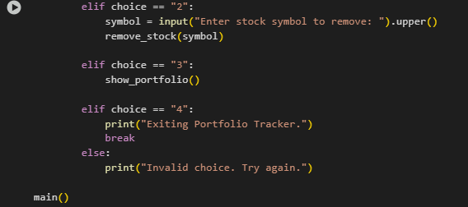

**OUTPUT**

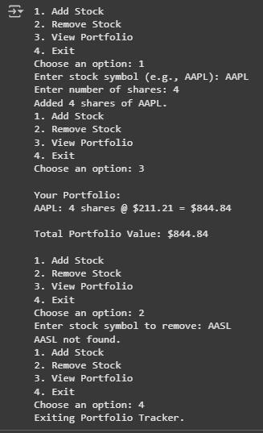

**SUBMITTED BY :**

ANISHA GARG