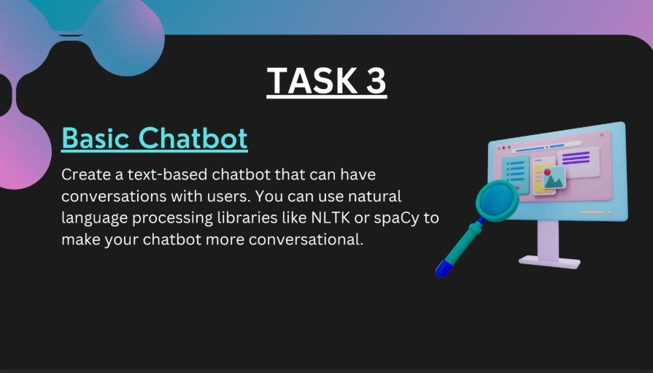

**Concept Overview:**

This task involves building a text-based chatbot using Python. The chatbot can have simple conversations with users and optionally use Natural Language Processing (NLP) libraries like NLTK or spaCy to improve its responses.

**Main Goals:**

* Build a chatbot that takes user input and returns relevant responses.
* Handle greetings, questions, or predefined keywords.
* Make the bot more intelligent by using NLP for understanding user intent.

**Key Components:**

**1. Basic Chatbot (Rule-Based):**

* Uses if-else or keyword matching.

Example:

User: “Hello”

Bot: “Hi there! How can I help you?”

**2. NLP-Powered Chatbot (Using NLTK/spaCy):**

* Tokenizes and processes user input.
* Identifies key intents or sentiments.
* Responds more naturally based on patterns or similarity.

**3. Features You Can Add:**

* Greeting recognition
* FAQ responses (e.g., “What is your name?”)
* Exit phrases (like “bye” or “quit”)
* Memory (store previous user inputs)
* Learning Outcomes:
* Understanding of basic NLP techniques.
* Writing interactive command-line applications.
* Implementing logic-based and language-aware systems.

**CODE**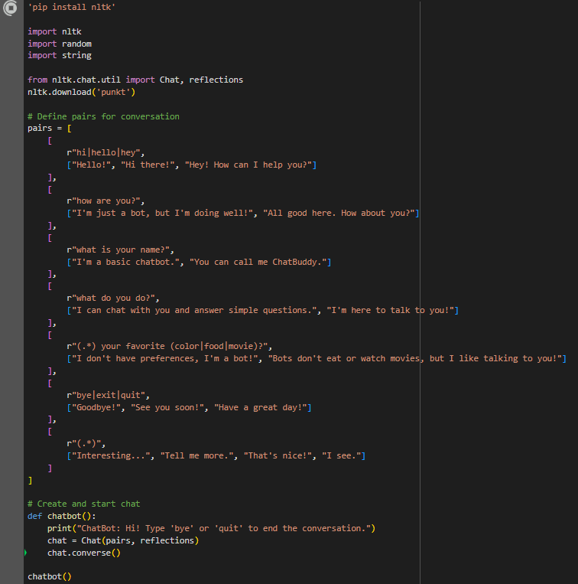

**OUTPUT**

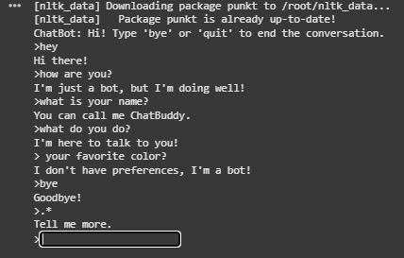

**SUBMITTED BY :**

ANISHA GARG