#include <stdio.h>

int main() {

char str1[100], str2[100];

int count1[256] = {0}, count2[256] = {0};

int i;

printf("Enter first string: ");

gets(str1);

printf("Enter second string: ");

gets(str2);

for (i = 0; str1[i] != '\0'; i++) {

count1[(int)str1[i]]++;

}

for (i = 0; str2[i] != '\0'; i++) {

count2[(int)str2[i]]++;

}

for (i = 0; i < 256; i++) {

if (count1[i] != count2[i]) {

printf("Strings are not anagrams.\n");

return 0;

}

}

printf("Strings are anagrams.\n");

return 0;

}

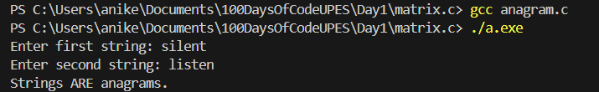

#include <stdio.h>

int second_Largest(int a[], int n) {

int i, largest, second;

largest = second = a[0];

for (i = 1; i < n; i++) {

if (a[i] > largest) {

second = largest;

largest = a[i];

}

else if (a[i] > second && a[i] != largest) {

second = a[i];

}

}

return second;

}

int main() {

int a[50], n, i;

printf("Enter size of array: ");

scanf("%d", &n);

printf("Enter %d elements: ", n);

for (i = 0; i < n; i++) {

scanf("%d", &a[i]);

}

printf("Second largest = %d\n", second_Largest(a, n));

return 0;

}

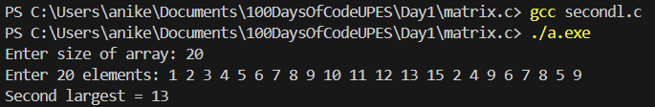

#include <stdio.h>

int sumDigits(int n) {

if (n == 0)

return 0;

return (n % 10) + sumDigits(n / 10);

}

int main() {

int num;

printf("Enter a number: ");

scanf("%d", &num);

printf("Sum of digits = %d\n", sumDigits(num));

return 0;

}

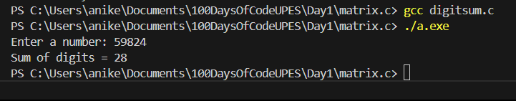

#include <stdio.h>

struct Student {

int rollNumber;

char name[50];

float marks;

};

void inputStudent(struct Student *s) {

printf("Enter roll number: ");

scanf("%d", &s->rollNumber);

printf("Enter name: ");

scanf(" %s[^\n]s", &s->name);

printf("Enter marks: ");

scanf("%f", &s->marks);

}

void displayStudent(struct Student s) {

printf("\nStudent Details:\n");

printf("Roll Number: %d\n", s.rollNumber);

printf("Name: %s\n", s.name);

printf("Marks: %.2f\n", s.marks);

}

int main() {

struct Student s;

inputStudent(&s);

displayStudent(s);

return 0;

}

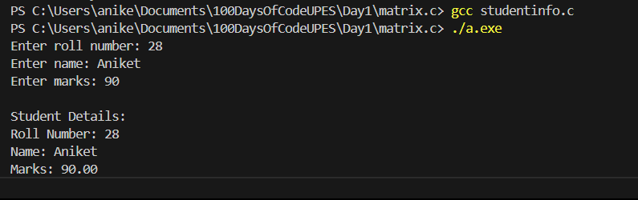

#include <stdio.h>

void sortArray(int arr[], int n) {

int i, j, temp;

for (i = 0; i < n ; i++) {

for (j = i+1; j < n ; j++) {

if (arr[i] > arr[j]) {

temp = arr[i];

arr[i] = arr[j];

arr[j] = temp;}

}

}

}

void printArray(int arr[], int n) {

for (int i = 0; i < n; i++) {

printf("%d ", arr[i]);

}

printf("\n");

}

int main() {

int arr[100], n;

printf("Enter number of elements: ");

scanf("%d", &n);

printf("Enter %d elements:\n", n);

for (int i = 0; i < n; i++) {

scanf("%d", &arr[i]);

}

printf("\nOriginal array: ");

printArray(arr, n);

sortArray(arr, n);

printf("Sorted array: ");

printArray(arr, n);

return 0;

}

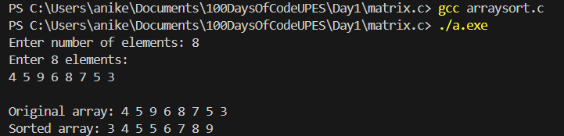

#include <stdio.h>

void swap(int *a, int *b) {

int temp;

temp = *a;

*a = *b;

*b = temp;

}

int main() {

int x, y;

printf("Enter two numbers: ");

scanf("%d %d", &x, &y);

printf("Before swapping: x = %d, y = %d\n", x, y);

swap(&x, &y);

printf("After swapping: x = %d, y = %d\n", x, y);

return 0;

}

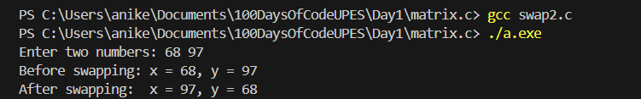

#include <stdio.h>

struct Employee {

int ID;

char name[50];

float basicPay;

float DA;

float HRA;

float grossSalary;

};

void calculateSalary(struct Employee *e) {

e->DA = 0.1 * e->basicPay;

e->HRA = 0.05 * e->basicPay;

e->grossSalary = e->basicPay + e->DA + e->HRA;

}

void inputEmployee(struct Employee *e) {

printf("Enter Employee ID: ");

scanf("%d", &e->ID);

printf("Enter Employee Name: ");

scanf(" %s[^\n]s", e->name);

printf("Enter Basic Pay: ");

scanf("%f", &e->basicPay);

calculateSalary(e);

}

void displayEmployee(struct Employee e) {

printf("\nEmployee Details:\n");

printf("ID: %d\n", e.ID);

printf("Name: %s\n", e.name);

printf("Basic Pay: %.2f\n", e.basicPay);

printf("DA: %.2f\n", e.DA);

printf("HRA: %.2f\n", e.HRA);

printf("Gross Salary: %.2f\n", e.grossSalary);

}

int main() {

struct Employee e;

inputEmployee(&e);

displayEmployee(e);

return 0;

}

