#Dict To List

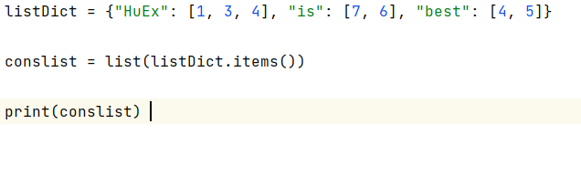

C:\Python310\python.exe C:/Users/andethe/PycharmProjects/pythonProject1/Seleniumscripts/Huex.py

[('HuEx', [1, 3, 4]), ('is', [7, 6]), ('best', [4, 5])]

Process finished with exit code 0

#Rename

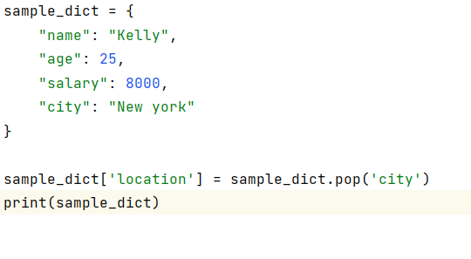

C:\Python310\python.exe C:/Users/andethe/PycharmProjects/pythonProject1/Seleniumscripts/sampledict.py

{'name': 'Kelly', 'age': 25, 'salary': 8000, 'location': 'New york'}

Process finished with exit code 0