TOPIC: SCHOOL MANAGEMENT SYSTEM

Project report to be submitted to Department of Computer Science



For the AISSC Practical Examination
Conducted by Central Board of Secondary Education
New Delhi

Submitted to
DEPARTMENT OF COMPUTER SCIENCE International Indian School – Jeddah November-2021-2022
DECLARATION

Myself, Anirudh Sooriyamoorthy do hereby declare that the project entitled SCHOOL MANAGEMENT SYSTEM is a bona-fide record of the work done by me under the supervision of Mr. Qurban Ahmed and submitted to the Department Of Computer Science, International Indian School – Jeddah, for the AISSCE Practical Examination 2021-22

Place: Jeddah, Saudi Arabia
Date:

Signature of the Candidates:

Anirudh Sooriyamoorthy
-------------

CERTIFICATE

This is to certify that the title of the Project entitled
“SCHOOL MANAGEMENT SYSTEM” is an activity
done by Master Anirudh Sooriyamoorthy under my
supervision and submitted to the Department of
Computer Science, International Indian School
Jeddah for the AISSCE Practical Examination
2021-22

Place: Jeddah
Date:

Signature Of The Guide:

----------------------

ACKNOWLEDGEMENT

Back in the day, I saw people guiding us through their enthusiasm and encouragement which helped me get through in creating this project. I am happy to use this moment to express my sincere gratitude to all who have contributed to the fulfilment of the project work.

I express my sincerest gratitude to myself, without whose help and valuable suggestions, I would not have completed this project within the given deadline

Finally I thank the Almighty who has led me through my life and helped me through his blessings to complete the project!

ABSTRACT

The project entitled SCHOOL MANAGEMENT SYSTEM is a simple Python program which is capable of storing, updating, removing and viewing data used in a Office information system. It is used for daily Office activities like managing Office records etc. By adding more GUI features, it can be used as an administration tool for many institutions. A menu driven system is used to execute different activities like inserting, deleting and updating Office data. The user is asked to enter his/her choice and the associated activity is executed in the program according to the input. It is developed in aims of accommodating daily routines for nearly every type of institution. We have tried our level best in providing all the information and the facility to any Office employees so that maximum satisfaction is achieved by the user with least effort.

OBJECTIVE
The first objective of this system is to maintain the data of all the School Student’s and Teacher’s in the database. It maintains the personal record as well as the follow up record of the Student’s. Teacher’s employee’s personal record and salary record are also stored in the software.

GENERAL OBJECTIVES
The SCHOOL MANAGEMENT SYSTEM facilitates the user in following respects:-

* Data entry of student’s
* Data entry of Teacher’s
* Updating student’s Records
*Inserting New Records
* Deleting unwanted Records
*Data Retrieval of student’s and Teacher’s Records
OVERVIEW OF THE PROJECT
*A complete School Management integrated software application spans across all functional requirements of institutes like students admission, system Employees, Teacher’s ,bills , and Complains etc.
*This system also keeps the records of hardware assets besides software of this organization. The proposed system will keep a track of teacher’s, students and generation of report regarding the present status.

*This software package is very easy to operate with very simple instructions and can even be used by any staff member lacking in computer skills.

*This software administrates the complete profile of a employee in a very systematic way and it will be very easy for an administrator or HOD of the School department to have an overview of a particular student's profile and generating reports dynamically.

*This software makes your working smooth while saving about 90% of manual, work, resulting into a hassle free and paper less Management. Saving a lot of working hours directly means saving a lot of money
HARDWARE SPECIFICATION

The SCHOOL MANAGEMENT SYSTEM was developed on Intel 10 GB RAM with Windows environment. The configuration of the machine is as follows.
Main Processor: Intel Core i7
Main Memory: 16 GB RAM
Hard disk drive: 1TB

SOFTWARE SPECIFICATION
Operating System: Windows 11
Programming Language: Python 3.9 or above
Back End Tool : MySQL
Documentation: Microsoft Word 2019

1)Python code
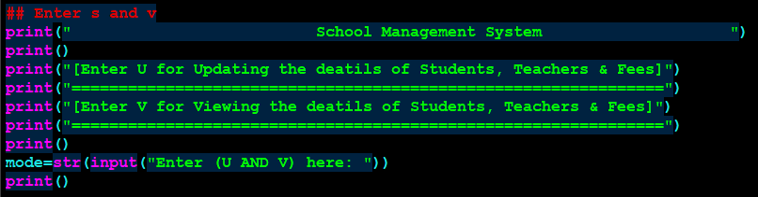
# This code have 2 modes- Updating and Viewing the details.
Output-
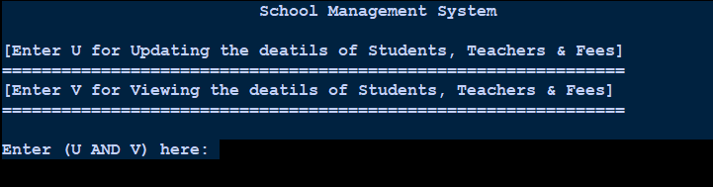
2) Python code
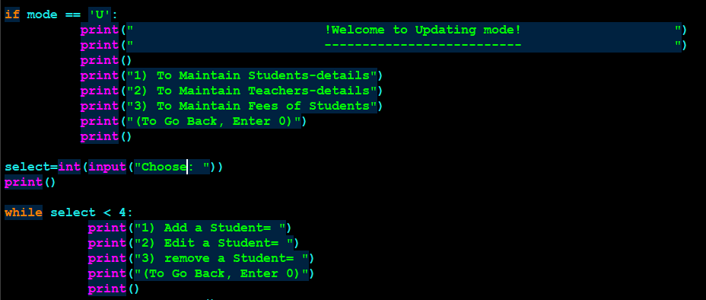
# This Updating mode is used by admin of the school.
Output-
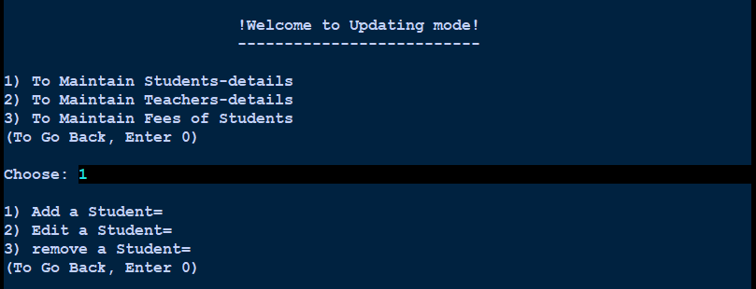
3) Python code
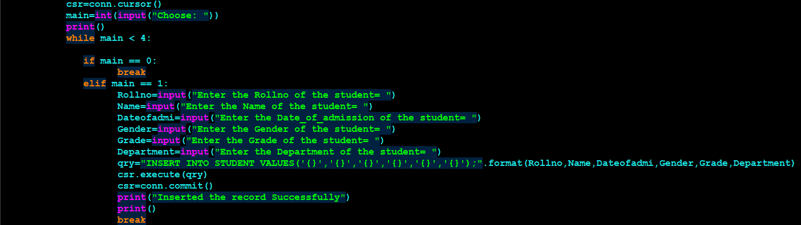
# Enter the student details here.
Output-
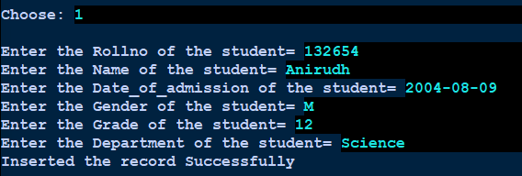
4) Python code
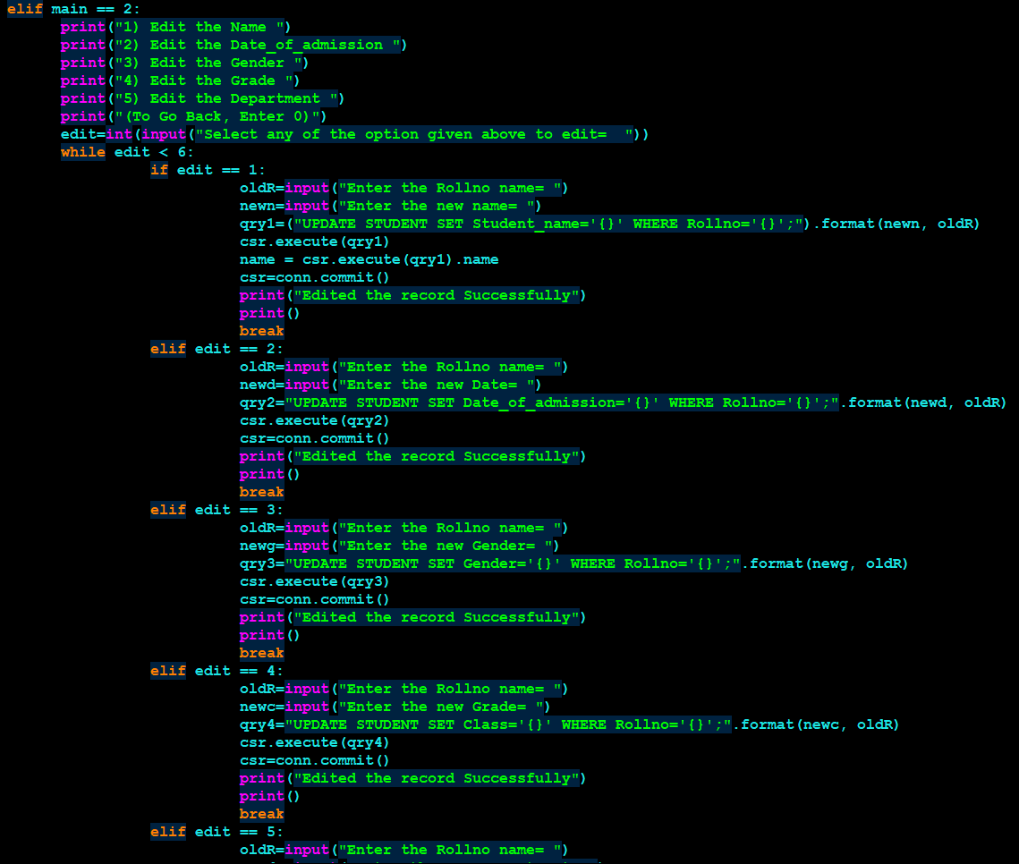
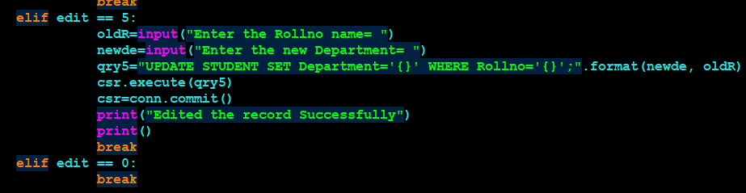
# Editing an student record here
Output-
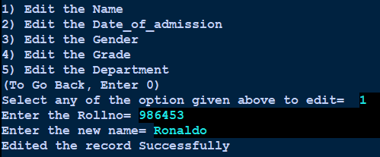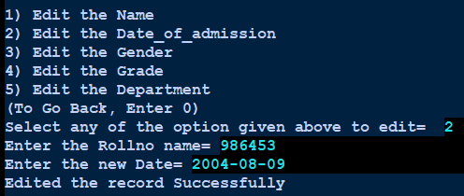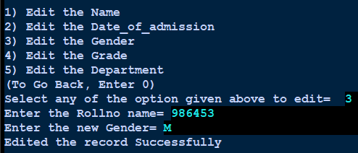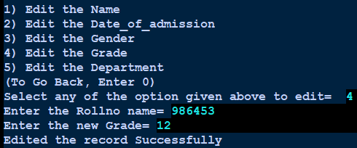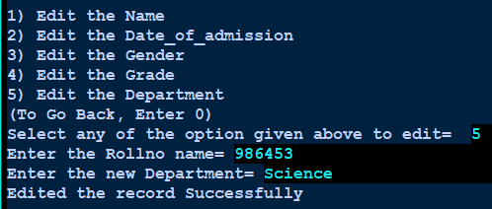
5) Python code
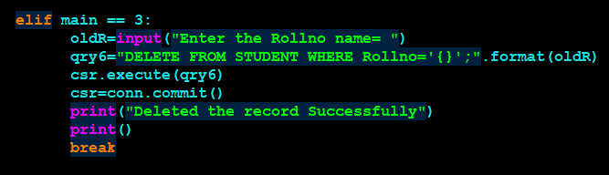
# Deleting an student record here.
Output-
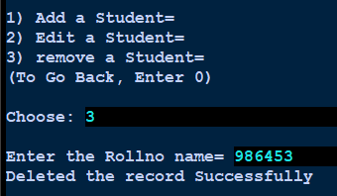
6) Python code
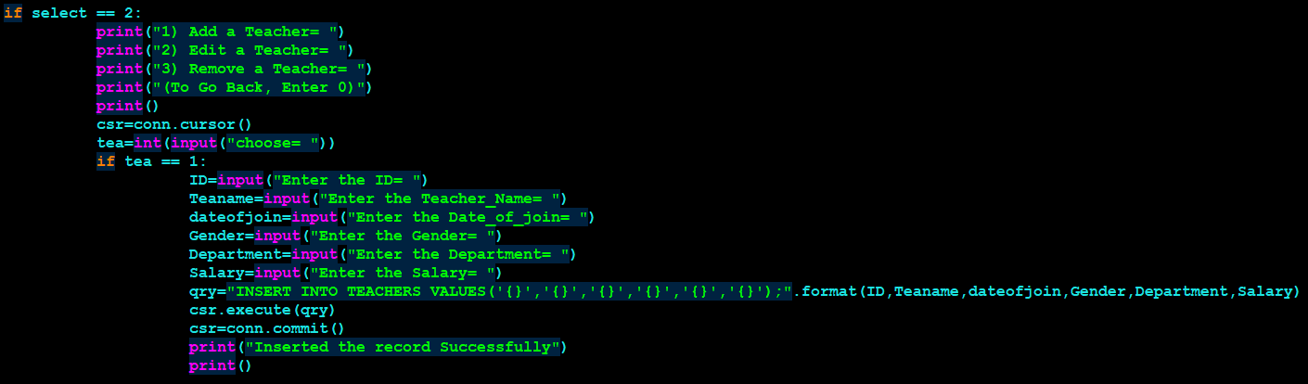
# Enter the Teacher’s details here.
Output-
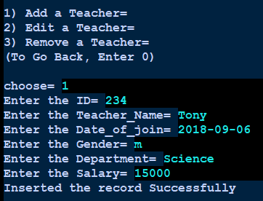
7) Python code
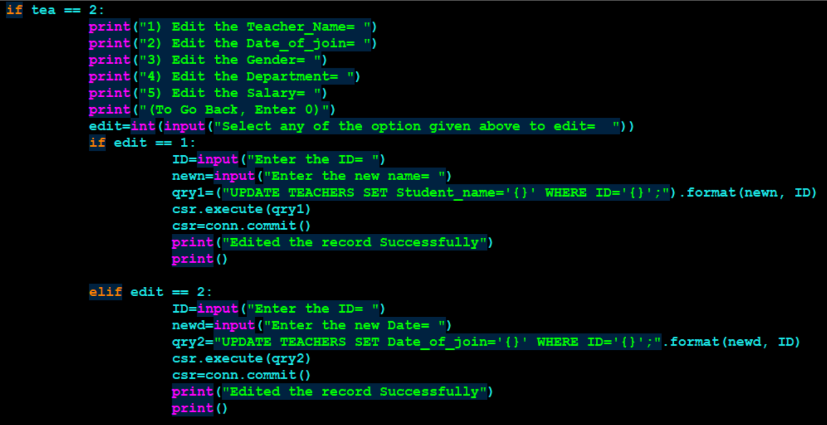
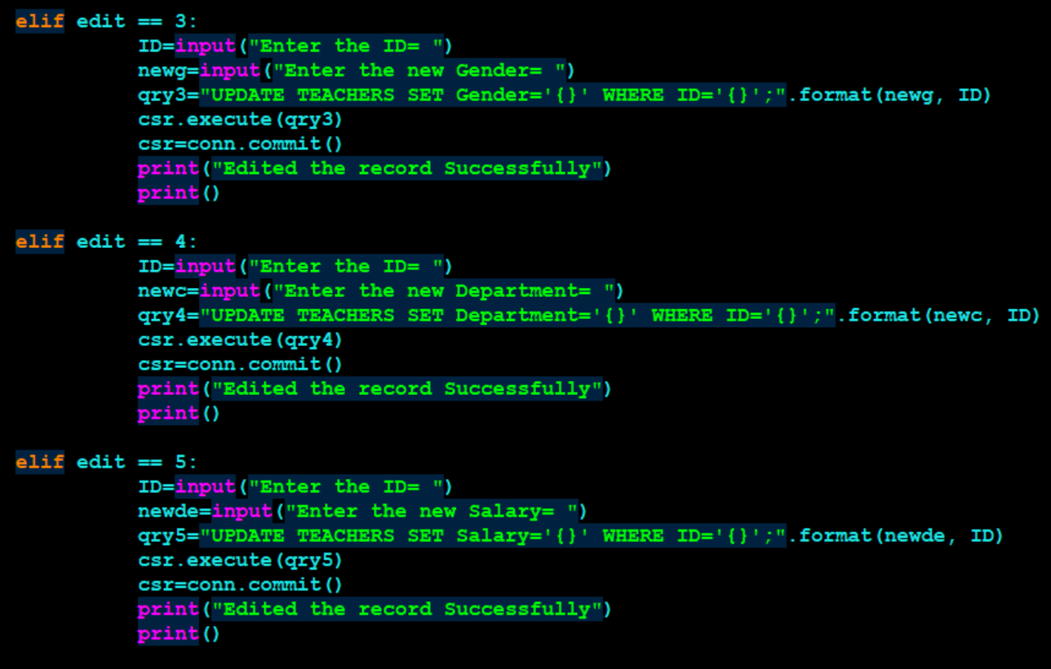
# Editing an Teacher record here
Output-
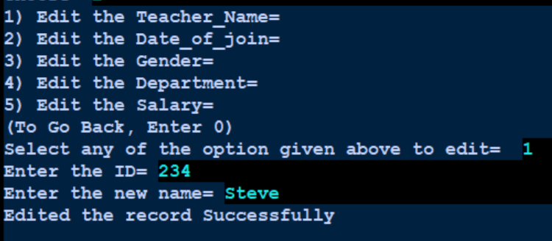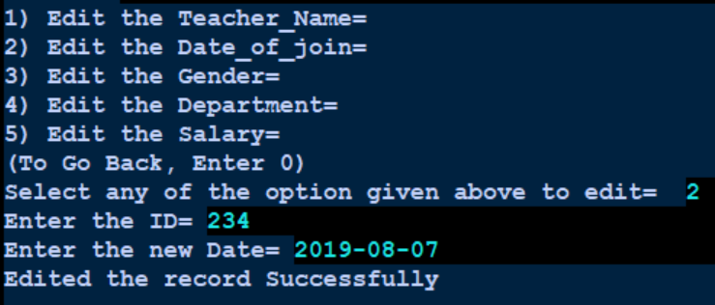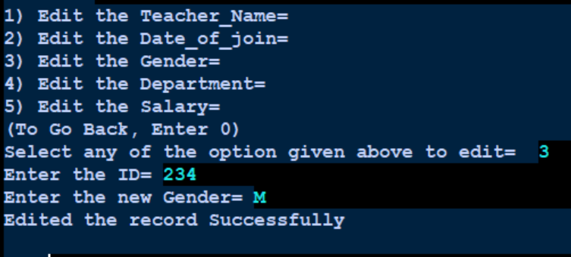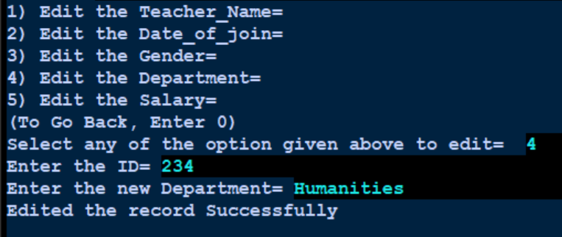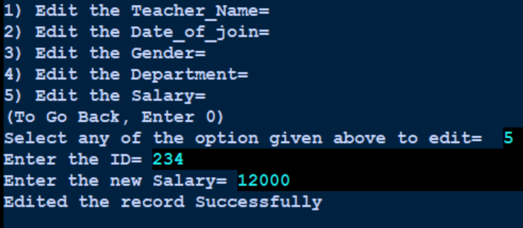
8) Python code
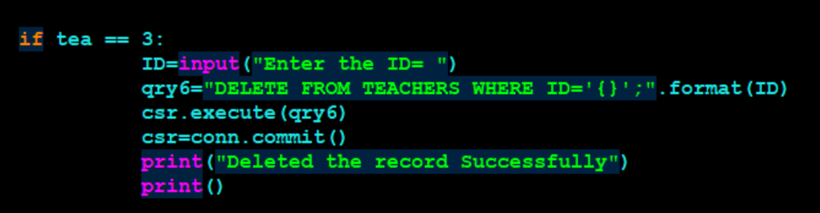
# Deleting an Teacher’s record here.

Output-
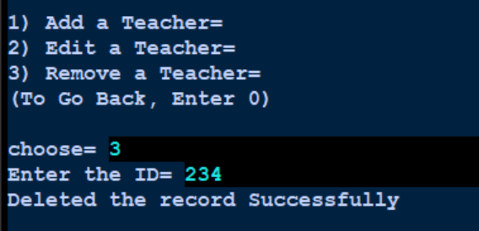
9) Python code
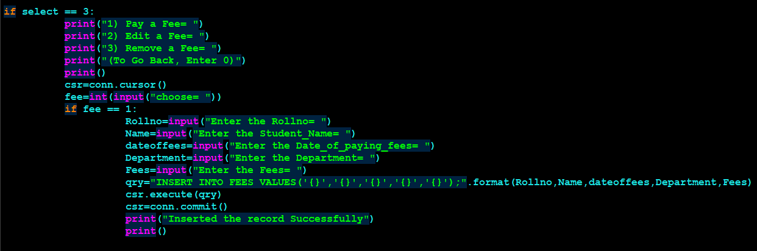
# Enter the fee’s details here.
Output-
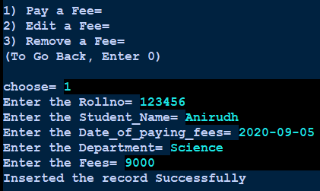

10) Python code
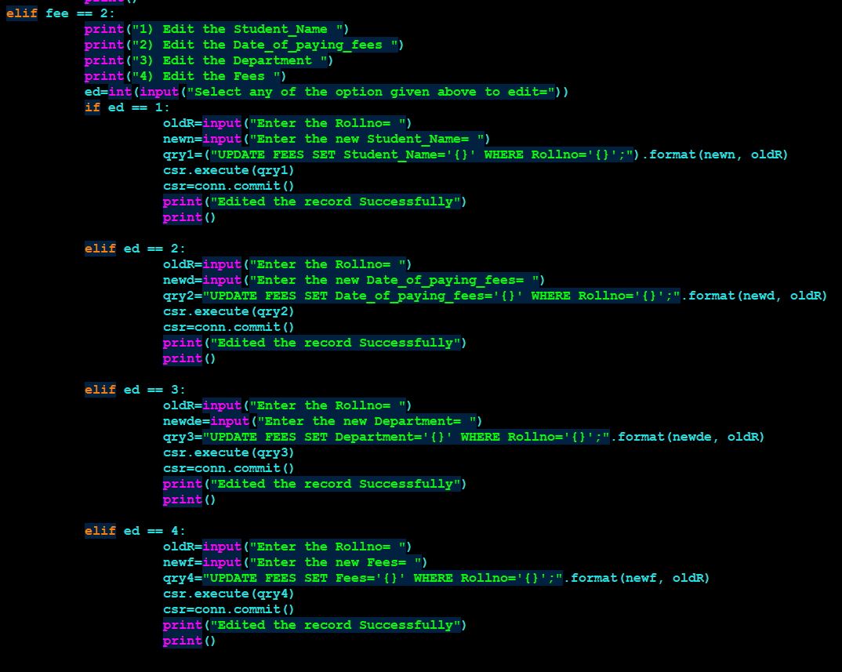
# Editing an Fee records here
Output-
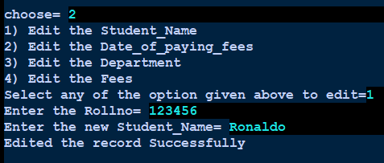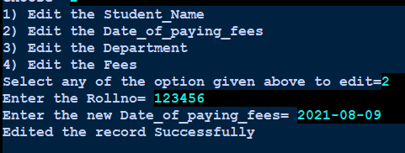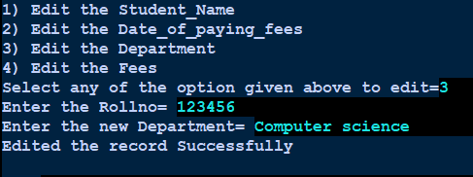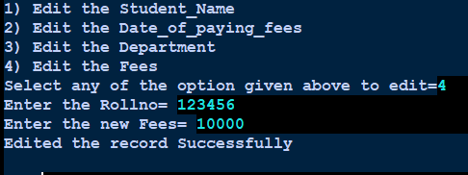
11) Python code
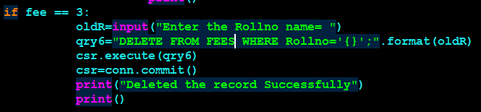
# Deleting an Fee records here.
Output-
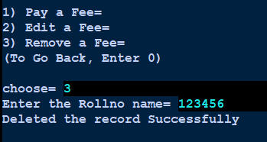
12)Python code
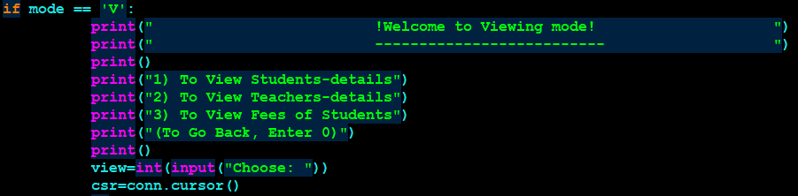
# This Viewing mode is used by admin of the school
Output-
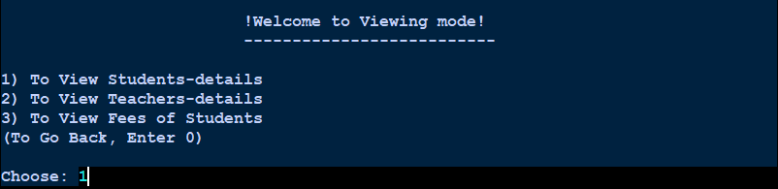
13)Python code
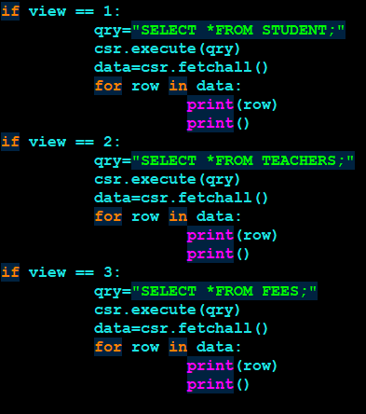
# Viewing the table of student, teachers and fees.
Output-
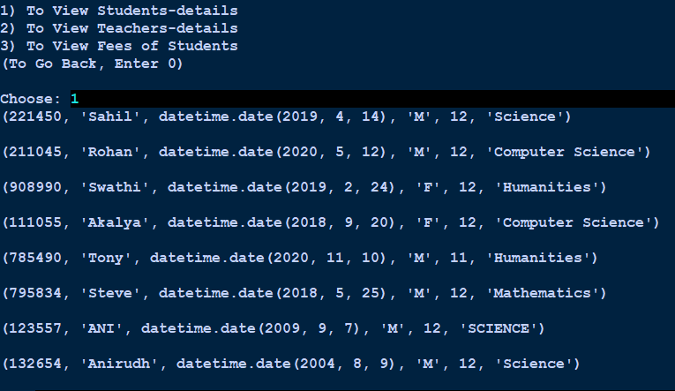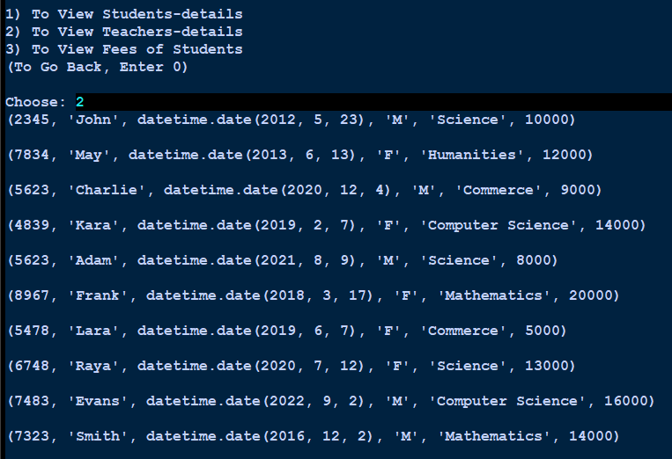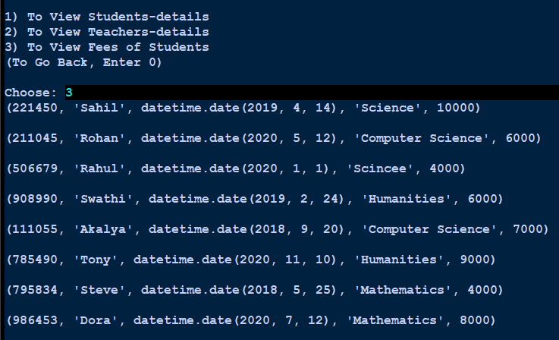

These are the tables used in this project-

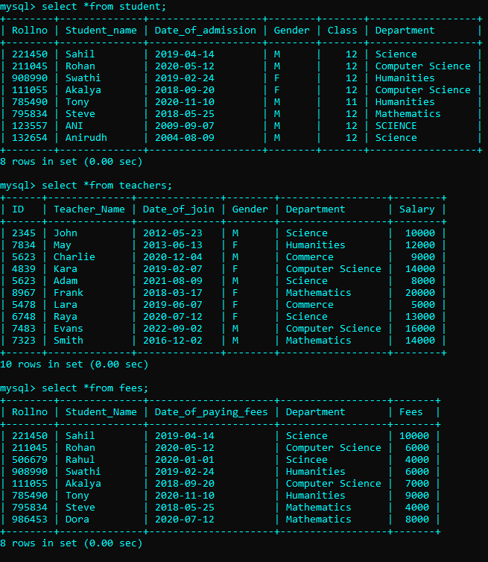

CONCLUSION

The coding, testing and installation do not mean the end in the case of any software project. Maintenance is one of the important phases of the software life cycle. The SCHOOL MANAGEMENT SYSTEM is not an exhaustive work. Using the time and resources we have tried our best to make the system functional. Though the system has benefits compared to a manual system, We accept its limitations and can be enhanced in many ways. One of the ways by which we can enhance the system is to provide a GUI interface for data entry. Since a modular approach has been maintained in the project, any change can be made without affecting the entire program.

