**Topics: Normal distribution, Functions of Random Variables**

1. The time required for servicing transmissions is normally distributed with *μ* = 45 minutes and *σ* = 8 minutes. The service manager plans to have work begin on the transmission of a customer’s car 10 minutes after the car is dropped off and the customer is told that the car will be ready within 1 hour from drop-off. What is the probability that the service manager cannot meet his commitment?
2. 0.3875
3. 0.2676
4. 0.5
5. 0.6987

Ans: Normal distribution with *μ* = 45 & *σ* = 8

Let us consider, X be the amount of time it takes to complete the repairing of car in one hour.

We have to calculate Pr(X > 50)

Pr(X > 50) = 1 – Pr(X ≤ 50)

Now,

Z = (X - *μ) / σ*

= (X – 45) / 8

Pr(X ≤ 50) = Pr (Z ≤ (50-45)/8)

= Pr (Z ≤ 0.625)

Now by using normal distribution table we can say,

Pr (Z ≤ 0.625) = 0.7324

= 73.24%

The probability that the service manager cannot meet his commitment will be,

= 100 – 73.24

= 26.76 %

= 0.2676.

1. The current age (in years) of 400 clerical employees at an insurance claims processing center is normally distributed with mean *μ* = 38 and Standard deviation *σ* =6. For each statement below, please specify True/False. If false, briefly explain why.
2. More employees at the processing center are older than 44 than between 38 and 44.

Ans: If more employees are older than 44, it means *μ* is tending towards 44 but it was 38.

If considering standard deviation, it is not possible as *μ*  is given 38 with

*σ* =6.

Hence More employees at the processing center are older than 44 than between 38 and 44. is False.

1. A training program for employees under the age of 30 at the center would be expected to attract about 36 employees.

Ans: Z = (X - *μ) / σ*

Pr(X ≤ 30) = Pr(Z ≤ (30-38)/6)

= Pr(Z ≤ -1.33)

= 0.09176 ………………..(From Z table)

Required or expected count = 0.09176 * 400

= 36.704

≈ 37.

Therefore it is True.

1. If *X1* ~ *N*(μ, σ2) and *X*2 ~ *N*(μ, σ2) are *iid* normal random variables, then what is the difference between 2 *X*1 and *X*1 + *X*2? Discuss both their distributions and parameters.

Ans: 1. 2X1 will just larger scale version of X1, so as X1 normally distributed 2X1 also normally distributed.

2.X1 & X2 both variables are independent normal random variables and hence

X1 + X2 are exactly normal with associate parameters.

1. Let X ~ N(100, 202). Find two values, *a* and *b*, symmetric about the mean, such that the probability of the random variable taking a value between them is 0.99.
2. 90.5, 105.9
3. 80.2, 119.8
4. 22, 78
5. 48.5, 151.5
6. 90.1, 109.9

Ans: We have to find the value of a & b which are symmetric about the mean

The probability of getting value between a & b,

= 1 – 0.99

= 0.01

The probability towards left from a,

= ( - ) 0.01/2

= - 0.005

And probability towards right from b,

= ( + ) 0.001/2

= 0.005

Now we got the probabilities if a & b, we have to calculate random variable at a & b ,

We know,

Z = (X - *μ) / σ .*

We are interested to calculate X,

( Z * *σ* ) + *μ* = X .

For probability 0.005 the Z value is -2.575829 ………. (from Z table )

X = ( Z * *σ* ) + *μ*

For (-0.005)

X = - ( - 2.575829 ) *20 + 100

= 151.51658

1. Consider a company that has two different divisions. The annual profits from the two divisions are independent and have distributions Profit1 ~ N(5, 32) and Profit2 ~ N(7, 42) respectively. Both the profits are in $ Million. Answer the following questions about the total profit of the company in Rupees. Assume that $1 = Rs. 45
2. Specify a Rupee range (centered on the mean) such that it contains 95% probability for the annual profit of the company.

Ans: 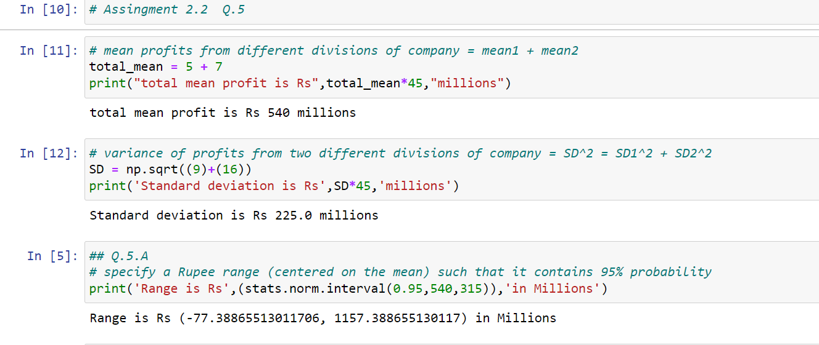

The Rupee range is - 77.388 to 1157.388 in millions.

1. Specify the 5th percentile of profit (in Rupees) for the company.

Ans: 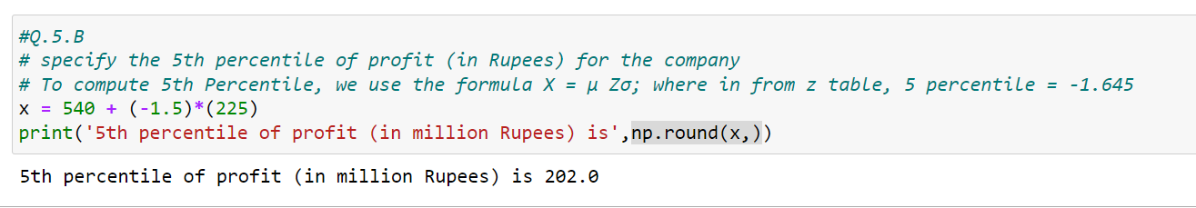

1. Which of the two divisions has a larger probability of making a loss in a given year?

Ans: 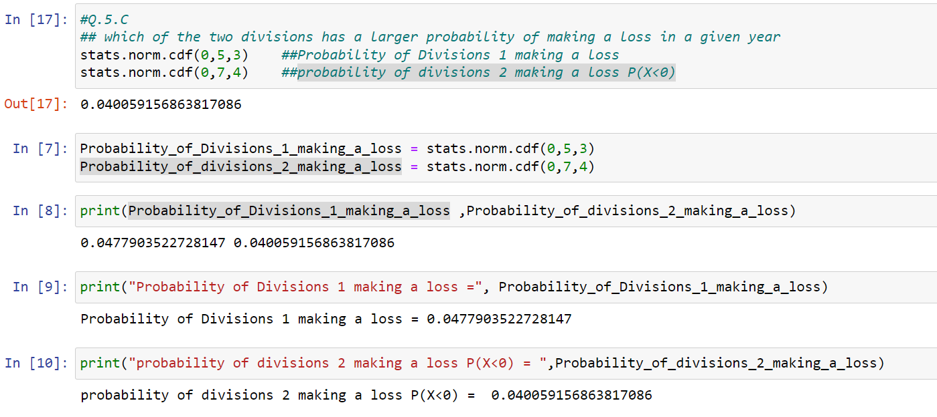

1.Probability of Division 1 making a loss = 0.0477903522728147.

2.Probability of Division 2 making a loss = P(X<0) = 0.04005915.