PFD200 – Professional Development
Portfolio
Student Name | Anita Moneva
Student ID Number | 2324039
Module Code & Name | PFD200 – Professional Development
Module Leader | Anjuna Deva Raj
Module Lecturer | Dr. Kinjal Chaudhari
Date of Submission | 15.06.2026

Declarations

By submitting this assignment, I declare that this work is fully my own. I confirm that work done by others (including internet sources), is acknowledged by quotations and appropriate citing and referencing. | 
I declare that this work has not used the work of any other student(s), past or present, at this or any other institution or source. | 
I declare that I have not commissioned another person to complete this work. This could include the use of professional essay-writing services, essay banks or ghost-writing services. | 
I declare that I have not asked another person to complete this work for me. This could include the help of friends, classmates, other students, or family members. | 
I acknowledge that I have read all the texts listed in the bibliography/reference list. I confirm all sources cited in the work appear in the bibliography or reference list at the end. | 
Name/Signed: Anita Moneva

Date: 15.06.2026

Declaration of AI Use in Current Academic Work

It is important to acknowledge the use of AI tools in your work and to be clear about how you have used them. It is generally considered poor academic practice to include any content generated by GenAI tools in your work, unless you are explicitly reflecting on, analysing, and evaluating the output of the software.
You should put an ‘x’ against any statement in the list below that you know is TRUE to honestly declare how you have used AI in your work:

[ ] I can confirm that I have not used any AI tools within this piece of work.
[ x ] I have used AI tools to help me with developing ideas.
[ x ] I have used AI tools to help formulate a plan or structure for my assessment.
[ x ] I have used AI tools to assist me with my research/gathering information.
[ x ] I have used AI tools to help me understand key theories and concepts.
[ x ] I have used AI tools to identify themes as part of my data analysis for my work.
[ x ] I have used AI tools to give me feedback on a draft piece of work.
[ ] I have used AI tools to proofread my work for correct spelling and grammar.
[ ] I have used AI tools to generate tables, figures or diagrams.

Contents

1. Introduction (Approx. 150 words) …………………………………………………………….5
2. Task 1 (Part 1): Self-Assessment (500 words) …………………………………………….5
3. Task 1 (Part 2): Project Proposal (300-500 words) ………………………………………6
4. Task 2: Project Development ………………………………………………………………….7
5. Task 3: Digital Portfolio ………………………………………………………………………….8
6. Conclusion (Approx. 150 words) ……………………………………………………………..9
7. References ………………………………………………………………………………………….9
Professional Development Portfolio
Basic Expense Tracker – Professional Development Portfolio

Introduction
Professional development is a journey that continuously enables persistent self-growth, strengthening of technical knowledge and refining employability skills and career readiness. In the computing sector, employers are increasingly looking for graduates with both technical ability and soft skills, including communication, teamwork, problem-solving and self-management (Cottrell 2010). This portfolio showcases the planning, development and assessment of a self-directed mini-project called Building a Simple Expense Tracker.
This project was chosen after conducting a competitive self-assessment of my software development, database integration and application testing skills. The portfolio includes a self-assessment, project proposal, as well as report and digital portfolio activities that match the structure laid out in the assessment brief. What is more, the portfolio assesses self-knowledge, academic readiness and potential career path in software development. This project has been completed, and technical and professional skills have been improved, which will help to enhance the career aspirations in information technology (Morgan 2024).

Self-Assessment
1. Current Skills and Knowledge
Before starting this project, I took a 360-degree assessment of my technical skills and established an improvement plan to get up-to-date with all the new frameworks. It is essential for professional development as this act requires people to reflect on their strengths and weaknesses, furthermore establishing realistic developmental goals (Cottrell 2013).
My technical side consists of working on Python programming, along with SQL database management and basic software development principles. During my foundation degree studies to date, I have done numerous practical assignments that entail programming as well as database design and systems analysis. I know generally how variables, loops, functions and basic object-oriented programming works also roughly have an idea about relational database structures. I have also used GitHub for version control and collaborative project management.

2. Strengths
My best attribute is that I am a problem solver. With programming challenges, I am able to carefully break down the problem and come up with possible solutions. It is a skill that was earned through various coursework and self-directed learning.
Another strength is adaptability. As the technology sector advances rapidly, professionals need to regularly update their knowledge and skills (Morgan 2024). I have a practice of researching unknown ideas and working with new technologies if needed.
3. Areas for Development
In spite of these strengths, the presentation has a number of areas for improvement. Firstly, I have very little experience developing entire desktop applications that combine UI with DB. I have built small programs, but this is the first time that I will be working through all stages of an application: plan, implement code and run tests (and evaluate).
Second, I need to improve my understanding of software testing. Test management plays a vital role (Myers, Sandler and Badgett 2011) as it validates the quality of the software product. Previous work mostly targeted functionality, with little going towards systematic testing strategies.
Time management is another area to improve. Although deadlines are generally met, preparing for academia and other transferable skills can be very difficult to balance. This will not only increase my productivity, but it will also improve my effectiveness on a professional level.
4. Career Goals
Long-Term Career Goals: Software Developer, who focuses on business applications and data management systems. Software developers must design, develop, test and maintain software solutions to meet the needs of an organisation (Pressman & Maxim 2020).
In order to do so, I must develop a stronger foundation for practical programming skills as well as solidify more knowledge in database integration and software testing. Hence, the Expense Tracker project was chosen as it directly combats these developmental requirements while aligning with my career objectives.

Project Proposal
1. Project Title
Basic Expense Tracker
2. Project Overview
The suggested project is to create and develop a desktop-based Expense Tracker application using Python and SQLite. It helps users to keep track of their income and expenditure through transaction categorisation and spending behaviour monitoring.
Key Takeaway: Effective management of personal finances is becoming an important phenomenon in everyday life. This leads to lots of people not being able to track their spending correctly, which results in poor budgeting choices. Expense tracking applications offer users tools to evaluate their spending and increase financial literacy.
3. Identified Skills Gap
It was chosen due to the project addressing some of the gaps identified through self-assessment.
These include:
- Database integration
- User interface development
- Software testing
- Project documentation
- Independent software development
Creating an entire application will give you hands-on experience in every phase of the software development lifecycle.
4. Justification
This is considered an important milestone because it allows for a practical application of theoretical components. Experiential learning enables students to deepen their understanding via the application of concepts in real life (Kolb, 2015).
In addition, software developers should be proficient in developing applications with practical uses. This is going to be an expense tracker which allows me to practice my knowledge in requirements analysis, database management and how a user interface works, as well as software testing.
The project also supports employability through the strengthening of technical and transferable skills such as planning, organisation and problem-solving.
5. Project Plan
WEEK | ACTIVITY
1 | Research expense tracking systems
2 | Define requirements and design the database
3 | Create interface mock-ups
4 | Develop database functionality
5 | Implement application features
6 | Conduct testing and debugging
7 | Complete documentation
8 | Create a digital portfolio

Project Development
1. Project Description
The last project I will be working on is a desktop application that aids users in managing their personal finances. Users can log both income and expenses, classify individual transactions and create a financial overview.
The project was guided by a software development process with phases of planning, design, implementation and testing & evaluation (Sommerville 2016).
2. Tools and Technologies
Phyton | Application Development
SQLite | Database Management
Visual Studio Code | Programming Environment
GitHub | Version Control
Microsoft Excel | Testing Records

Python was chosen for its readability and good support of rapid application development (Pressman and Maxim, 2020).
3. Development Process
Planning Phase
The first stage of the planning included looking for other expense tracking systems and user needs. Functional requirements were to record transactions, categorise expenses and create summaries.
Design Phase
The system had a user-centred design. The interface includes:
- Transaction entry form
- Category selection menu
- Transaction history table
- Summary section
For the Database design, I created a Transactions table that contained:
- Transaction ID
- Date
- Category
- Amount
- Type
- Description

Implementation Phase
Implementation was done by building each feature in small steps.
Key functions included:
- Add transaction
- Edit transaction
- Delete transaction
- View transaction history
- Calculate totals
- Generate balance summaries
SQLite was integrated by using the sqlite3 library of Python.

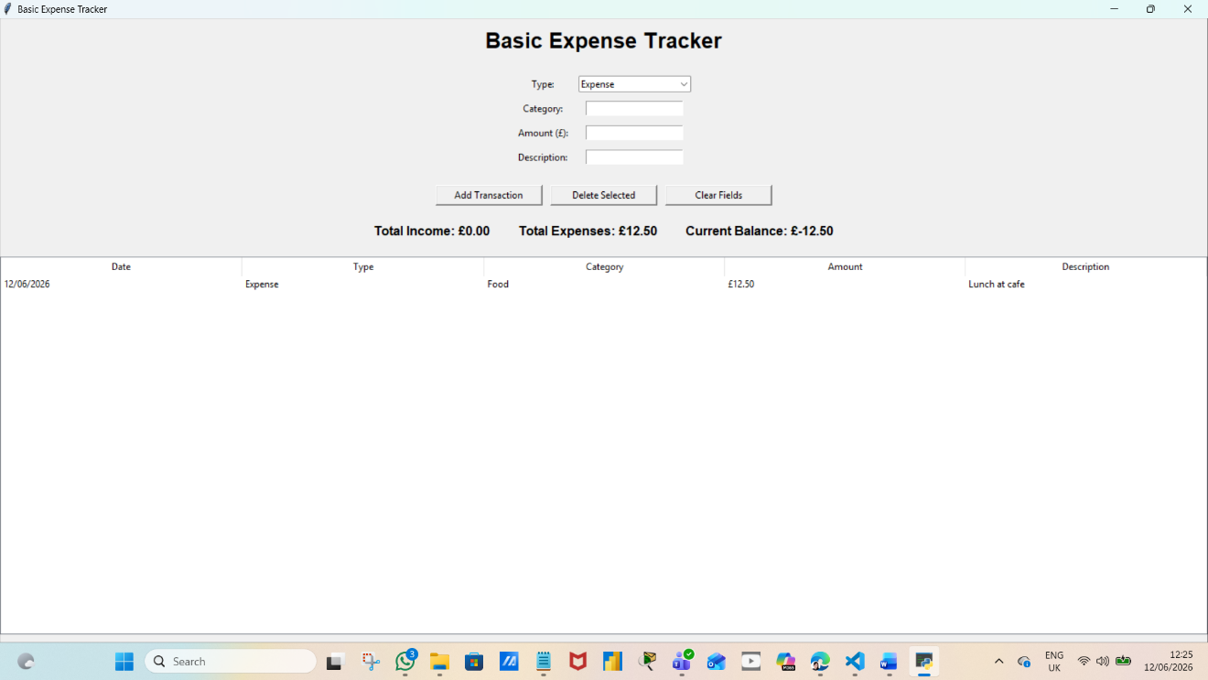

Testing Phase
If you didn't get the memo: tests were written throughout development to keep things sane.
Testing Evidence
Test Case | Expected Result | Actual Result | Status
Add transaction | Saved successfully | Successful | Pass
Delete transaction | Removed from database | Successful | Pass
Invalid amount | Error message shown | Successful | Pass
Calculate balance | Correct total displayed | Successful | Pass
Update record | Record modified | Successful | Pass

Software defects may reduce user experience and harm system reliability (Myers et al., 2011), so testing is a critical activity.
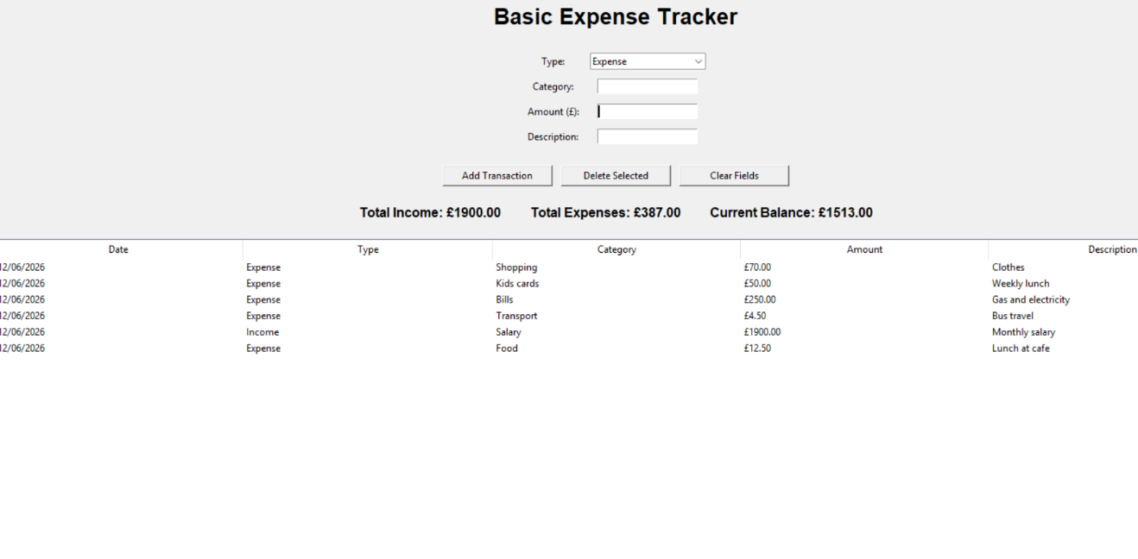
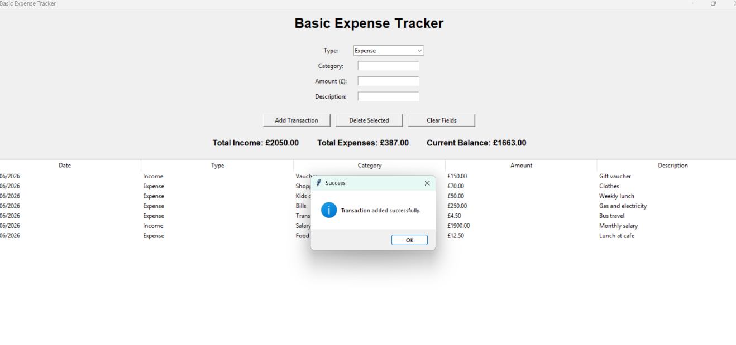
4. Key Features
The application includes:
- Income tracking
- Expense tracking
- Categorisation
- Transaction management
- Balance calculations
- Database storage
These features covered the project requirements as defined when it was proposed.
5. Challenges and Solution
A huge hurdle was connecting the GUI with the SQLite database. Testing at first was a complete failure–SQL syntax errors were aborting transactions before data could be saved at all.
In the worst case, this entailed digging into technical documentation and applying debugging techniques to remedy it. This stringed work helped me have better insights into database operations and error handling.
An additional challenge was to keep track of the project while also being a student. We started to better manage our time & productivity by implementing a weekly project schedule.

6. Evaluation
The project met all key objectives and successfully filled the documented skills gaps.
Technical improvements include:
- Stronger Python programming skills
- Improved database integration knowledge
- Enhanced testing and debugging abilities
- Increased understanding of software development methodologies
However, in terms of its usefulness for my career, the project taught planning, organisation and independent learning skills.
Yet a few upgrades can be made that might support later designs like:
- Data visualisation charts
- PDF export functionality
- User authentication
- Cloud synchronisation
- Mobile application support
This project is a perfect demonstration of the application of theoretical knowledge into practice, which has also enhanced my confidence in delivering software development solutions.
Digital Portfolio
1. Portfolio Overview
GitHub was used to build a digital portfolio that would ultimately house the Expense Tracker project and other professional development activities.
The portfolio contains:
- Source code
- Documentation
- Screenshots
- Testing evidence
GitHub has been identified as a useful mechanism for showcasing technical competence and readiness to practice professionally (Chacon and Straub, 2014).
2. GitHub Repository
GitHub Repository
https://github.com/Ani84449/Basic-Expense-Tracker.git
Repository Structure:
- README.md
- Source Code
- Documentation
- Screenshots
- Testing Evidence
The README file explains installation instructions, project objectives and system features.

Conclusion
Portfolio This portfolio showcases successful project planning, development and evaluation of the Building a Basic Expense Tracker. Through the project, theoretical knowledge was put into practice and benefited personal development within a software development environment.
The project closed the skills gaps connected to application development, database integration and software testing. In addition, you developed transferable skills in communication, problem-solving and organisation/time management.
A mixture of successes and lessons for the future emerged through critical reflection at all stages. Although you hit your goals with the app, it can be enhanced much easier through visual reportings and cloud support & more security as well.
In general, the project has enhanced my confidence in software development while strengthening that desire to follow a career either at or near technology jobs. It provides knowledge and experience for further studies in academia, as well as working life.

References
Chacon, S. and Straub, B. (2014) Pro Git. 2nd end. New York: Apress.
Cottrell, S. (2010). Skills for Success: Personal Development and Employability. 2nd end. Basingstoke: Palgrave Macmillan.
Cottrell, S. (2013). The Study Skills Handbook. 4th end. Basingstoke: Palgrave Macmillan.
Kolb, D. (2015). Experiential Learning. 2nd end. Upper Saddle River: Pearson.
Morgan, J. (2024). The Future of Work. Hoboken: Wiley.
Myers, G., Sandler, C. and Badgett, T. (2011). The Art of Software Testing. 3rd end. Hoboken: Wiley.
National Cyber Security Centre (2024) Cyber Security Guidance for Individuals and Organisations. London: NCSC.
Pressman, R. and Maxim, B. (2020). Software Engineering: A Practitioner's Approach. 9th edn. New York: McGraw-Hill.
Sommerville, I. (2016). Software Engineering. 10th edn. Harlow: Pearson.

