**Lab 2 - Working with Directory Structures**

1.) Write a C program to emulate the ls -l UNIX command that prints all files in a current directory and lists access privileges, etc. DO NOT simply exec ls -l from the program.

#include <unistd.h>

#include <stdio.h>

#include <sys/stat.h>

#include <sys/types.h>

#include<dirent.h>

int main()

{

DIR * dp;

struct dirent * entry;

struct stat statbuf;

if((dp = opendir(".")) == NULL)

{

printf("Cannot open directory \n");

return 0;

}

chdir(".");

while((entry = readdir(dp)) != NULL)

{

lstat(entry->d_name,&statbuf);

if(!S_ISDIR(statbuf.st_mode))

{

printf("%s \t \t",entry->d_name);

printf((S_ISDIR(statbuf.st_mode)) ? "d" : "-");

printf((statbuf.st_mode & S_IRUSR) ? "r" : "-");

printf((statbuf.st_mode & S_IWUSR) ? "w" : "-");

printf((statbuf.st_mode & S_IXUSR) ? "x" : "-");

printf((statbuf.st_mode & S_IRGRP) ? "r" : "-");

printf((statbuf.st_mode & S_IWGRP) ? "w" : "-");

printf((statbuf.st_mode & S_IXGRP) ? "x" : "-");

printf((statbuf.st_mode & S_IROTH) ? "r" : "-");

printf((statbuf.st_mode & S_IWOTH) ? "w" : "-");

printf((statbuf.st_mode & S_IXOTH) ? "x" : "-");

printf("\n\n");

}

}

}

**Output**

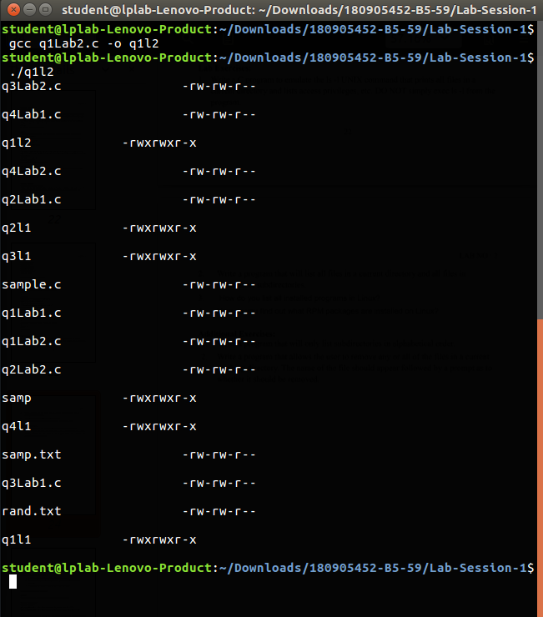

2.) Write a program that will list all files in a current directory and all files in subsequent subdirectories.

#include <unistd.h>

#include <stdio.h>

#include <dirent.h>

#include <string.h>

#include <sys/stat.h>

#include <stdlib.h>

void printdir(char *dir, int depth)

{

DIR *dp;

struct dirent *entry;

struct stat statbuf;

if((dp = opendir(dir)) == NULL)

{

fprintf(stderr,"cannot open directory: %s\n",dir);

return;

}

chdir(dir);

while((entry = readdir(dp)) != NULL)

{

lstat(entry->d_name,&statbuf);

if(S_ISDIR(statbuf.st_mode))

{

/* Found a directory,

but ignore . and .. */

if(strcmp(".",entry->d_name) == 0 ||strcmp("..",entry->d_name) == 0)

{

continue;

}

printf("%*s%s/\n",depth,"",entry->d_name);

/* Recurse at a new

indent level */

printdir(entry->d_name, depth+4);

}

else { printf("%*s%s\n",depth,"",entry->d_name); }

}

chdir("..");

closedir(dp);

}

int main()

{

printf("Directory scanof current one:\n");

printdir(".",0);

printf("Done.\n");

exit(0);

}

**Output**

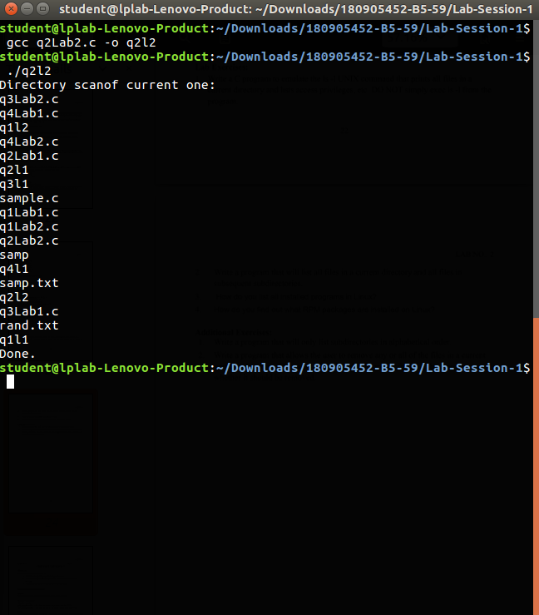

3.) How do you list all installed programs in Linux?

dpkg –l OR apt list

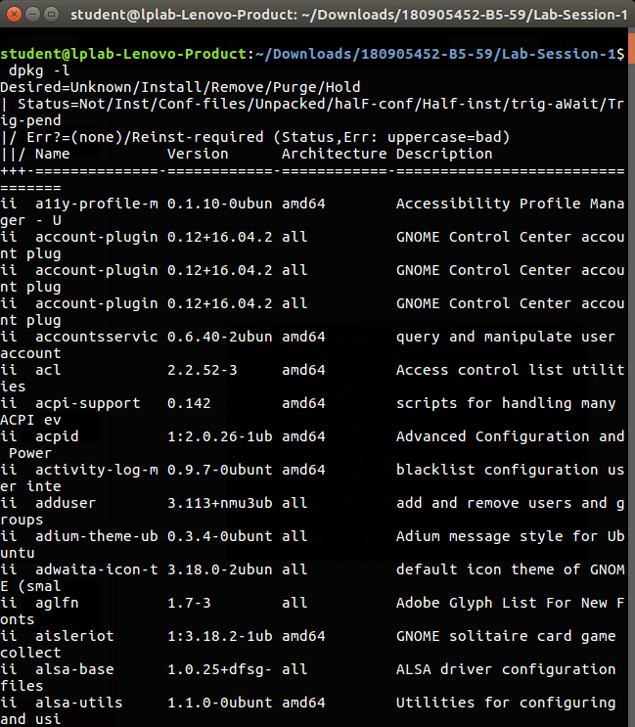

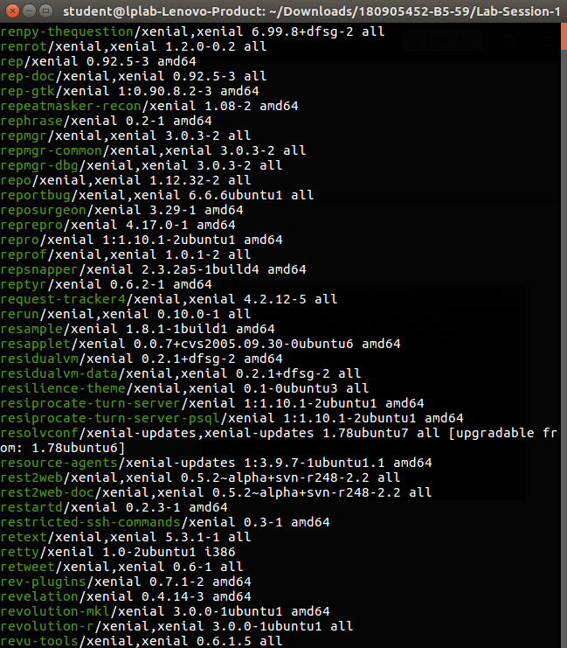

4.) How do you find out what RPM packages are installed on Linux?

