**Lab 1. jQuery**

1. Write a web page which contains table with 3 X 3 dimensions (fill some data) and one image. Style the rows with alternate color. Move the table and image together from right to left when button is clicked.

<html>

<head>

<title>Question 1</title>

<script src="https://ajax.googleapis.com/ajax/libs/jquery/3.5.1/jquery.min.js"></script>

<script type = "text/javascript" language = "javascript">

$(document).ready(function()

{

$(".btn").click(function()

{

$("div").animate({left: '0px'});

} );

});

</script>

<style type="text/css">

table

{

font-family: arial, sans-serif;

border-collapse: collapse;

}

td, th

{

border: 1px solid #dddddd;

text-align: left;

padding: 8px;

}

tr:nth-child(even)

{

background-color: #dddddd;

}

.main-container

{

display: flex;

flex-direction: column;

}

.sub-container

{

position: relative;

left: 250px;

}

</style>

</head>

<body>

<div class="main-container">

<div class="sub-container">

<table>

<tr style="background-color:#F0FFFF">

<th>Firstname</th>

<th>Lastname</th>

<th>Age</th>

</tr>

<tr style="background-color:#5F9EA0">

<td>David</td>

<td>Warner</td>

<td>34</td>

</tr>

<tr style="background-color:#7FFFD4">

<td>Kane</td>

<td>Williamson</td>

<td>30</td>

</tr>

<tr style="background-color:#00FFFF">

<td>Rashid</td>

<td>Khan</td>

<td>24</td>

</tr>

</table>

<br>

<div class="image">

<img src="cricketbat.jpg" alt="cricketbat" width="300" height="150">

</div>

</div>

<div class="btn">

<button type="button">Click Me!</button>

</div>

</div>

</body>

</html>

Output:

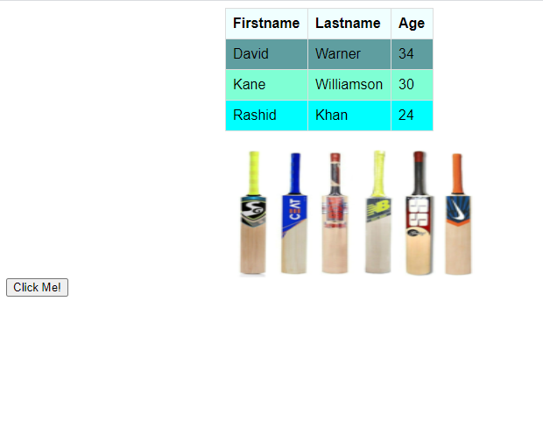

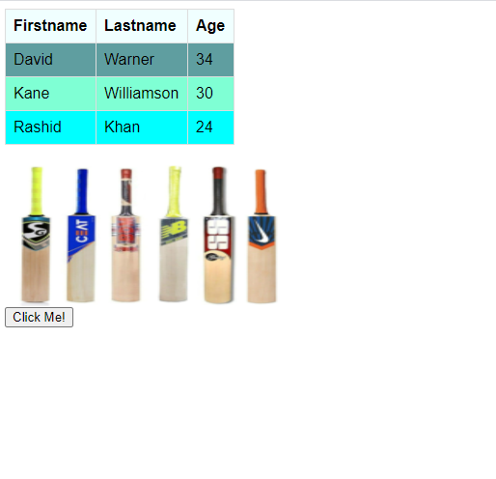

2. Design a calculator to perform basic arithmetic operations. Use textboxes and buttons to design web page.

<html>

<head>

<title>Question 2 - Simple Calculator</title>

<script src="https://ajax.googleapis.com/ajax/libs/jquery/3.4.0/jquery.min.js"></script>

<script>

$(document).ready(function()

{

$("#btnAdd").on('click',function()

{

Add();

});

$("#btnSubstract").on('click',function()

{

Substract();

})

$("#btnMultiply").on('click',function()

{

Multiply();

})

$("#btnDivide").on('click',function()

{

Divide();

})

});

function Add()

{

var no1=parseInt($("#txtNo1").val());

var no2=parseInt($("#txtNo2").val());

var result =no1+no2;

alert("The result is "+result);

}

function Substract()

{

var no1=parseInt($("#txtNo1").val());

var no2=parseInt($("#txtNo2").val());

var result =no1-no2;

alert("The result is "+result);

}

function Multiply()

{

var no1=parseInt($("#txtNo1").val());

var no2=parseInt($("#txtNo2").val());

var result =no1*no2;

alert("The result is "+result);

}

function Divide()

{

var no1=parseInt($("#txtNo1").val());

var no2=parseInt($("#txtNo2").val());

var result =no1/no2;

alert("The result is "+result);

}

</script>

</head>

<body>

First Number <input type="text" id="txtNo1" placeholder="Enter first number"><br>

Second Number<input type="text" id="txtNo2" placeholder="Enter second number"><br>

<input type="button" id="btnAdd" value="Add">

<input type="button" id="btnSubstract" value="Substract">

<input type="button" id="btnMultiply" value="Multiply">

<input type="button" id="btnDivide" value="Divide">

</body>

</html>

Output:

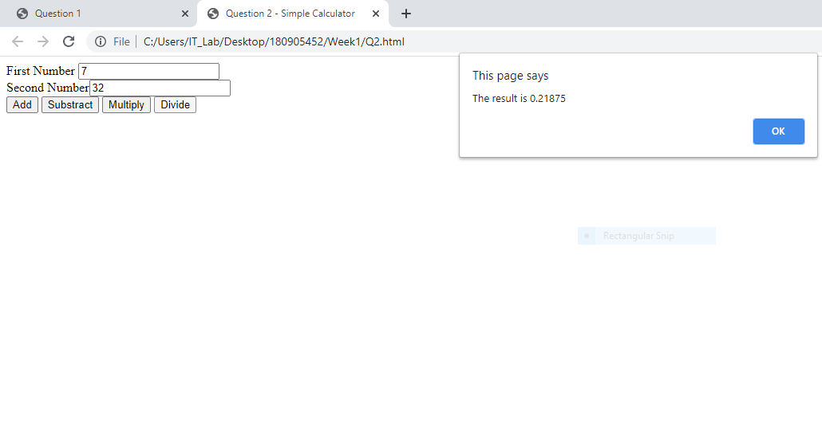

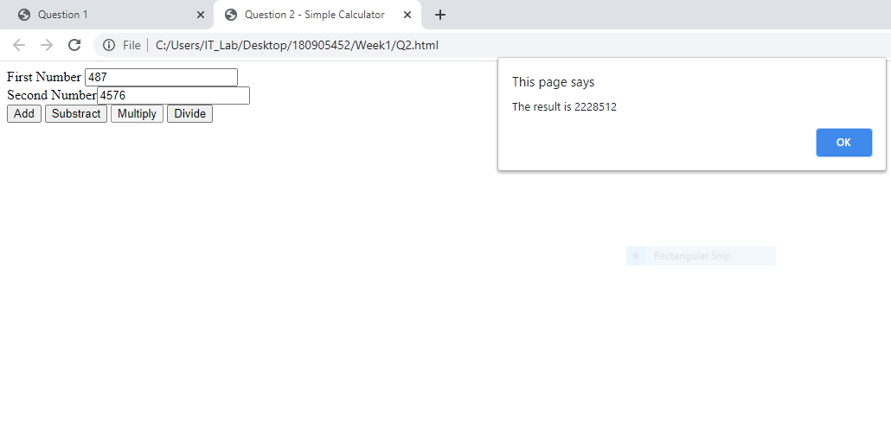

3. Create a web page to design a birthday card shown below.

<!DOCTYPE html>

<html>

<head>

<title>Birthday Card</title>

<script src="https://code.jquery.com/jquery-3.5.1.js">

</script>

<script type="text/javascript" language="javascript">

$(document).ready(function () {

$('#btn').click(function () {

var bg = $('#colors option:selected').text();

$('#div2').css("background-color",bg);

var ft = $('#fonts option:selected').text();

$('#div2').css("font-family",ft);

var fs = parseFloat($('#fsize').val());

$('#p2').css("font-size",fs);

var bd = $('input[type="radio"]:checked').val();

$('#div2').css("border",bd);

var txt = $('#txtarea').val();

$('#p2').html(txt);

var x = $('input[type="checkbox"]:checked').length>0;

if(x){

$('#p3').replaceWith("<img id=\"myimg\" src='bday.jpg' style='justify-content: center;' height='200px' width='200px'>");

}

else{

$('#p3').replaceWith('<p id="p3"></p>');

$('#myimg').replaceWith('<p id="p3"></p>');

}

});

});

</script>

</head>

<body>

<div style="width: 100%; overflow: hidden;background-color: gray;">

<div style="width: 600px; float: left;">

<label for="colors">Choose a background color:</label><br>

<select name="colors" id="colors">

<option value="orange">orange</option>

<option value="white">white</option>

<option value="pink">pink</option>

<option value="aqua">aqua</option>

</select>

<br><br>

<label for="fonts">Choose a font:</label><br>

<select name="fonts" id="fonts">

<option value="serif">serif</option>

<option value="sans-serif">sans-serif</option>

<option value="monospace">monospace</option>

<option value="cursive">cursive</option>

<option value="fantasy">fantasy</option>

</select>

<br><br>

<p>Enter a font size :</p>

<input type="text" id="fsize" placeholder="font size"/>

<br><br>

<label for="borders">Select a border:</label><br>

<input type="radio" name="borders" value="none" />None<br>

<input type="radio" name="borders" value="double" />Double<br>

<input type="radio" name="borders" value="solid" />Solid<br>

<br>

<input type="checkbox" name="check" id="check">Add default image<br><br>

<p>Enter text here: </p>

<textarea id="txtarea" name="txtarea" rows="4" cols="50"></textarea>

<br><br>

<button type="submit" id="btn">Update</button>

</div>

<div id="div2" style="margin-left: 620px;text-align: center;height: 600px;width: 500px;">

<br><br>

<p id="p2"></p>

<br><br>

<p id="p3"></p>

</div>

</div>

</body>

</html>

Output:

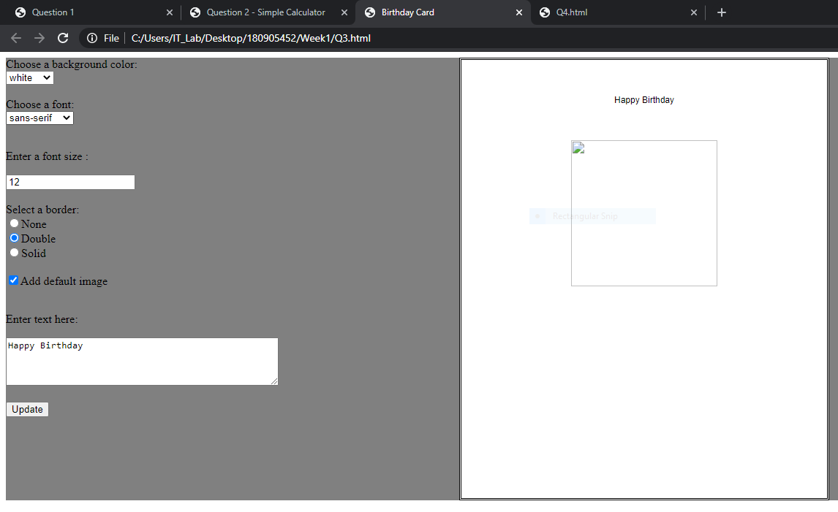

4. Design a webpage. The page contains:

Dropdown list with HP, Nokia, Samsung, Motorola, Apple as items.

Checkbox with Mobile and Laptop as items.

Textbox where you enter quantity.

There is a button with text as ‘Produce Bill’.

On Clicking Produce Bill button, alert should be displayed with total amount.

<!DOCTYPE html>

<html lang="en">

<head>

<meta charset="UTF-8">

<meta http-equiv="X-UA-Compatible" content="IE=edge">

<meta name="viewport" content="width=device-width, initial-scale=1.0">

<script src="https://ajax.googleapis.com/ajax/libs/jquery/3.5.1/jquery.min.js"></script>

<script type = "text/javascript" language = "javascript">

$(document).ready(function(){

$('#bill').click(function(){

let brand_name = $('#brand-choice').val();

let quan = $('#quantity').val();

console.log({quan});

let amt = 0;

let price = 0;

if(brand_name == 'HP'){

if($('#laptop').prop("checked") == true){

price = 80000;

}

else{

price = 14000;

}

}

else if(brand_name == 'Nokia'){

if($('#laptop').prop("checked") == true){

price = 60500;

}

else{

price = 8000;

}

}

else if(brand_name == 'Samsung'){

if($('#laptop').prop("checked") == true){

price = 70000;

}

else{

price = 21500;

}

}

else if(brand_name == 'Motorola'){

if($('#laptop').prop("checked") == true){

price = 50000;

}

else{

price = 32000;

}

}

else{

if($('#laptop').prop("checked") == true){

price = 140000;

}

else{

price = 21000;

}

}

let n = parseInt(quan);

amt = n*price;

alert(amt);

});

});

</script>

</head>

<body>

<p>

<table>

<tr>

<td>Brand</td>

<td>Laptop</td>

<td>Mobile</td>

</tr>

<tr>

<td>HP</td>

<td>80000</td>

<td>14000</td>

</tr>

<tr>

<td>Nokia</td>

<td>60500</td>

<td>8000</td>

</tr>

<tr>

<td>Samsung</td>

<td>70000</td>

<td>21500</td>

</tr>

<tr>

<td>Motorola</td>

<td>50000</td>

<td>32000</td>

</tr>

<tr>

<td>Apple</td>

<td>140000</td>

<td>21000</td>

</tr>

</table>

</p>

<label for="brand-choice">Choose a Brand:</label>

<input list="brands" id="brand-choice" name="brand-choice" />

<datalist id="brands">

<option value="HP"></option>

<option value="Nokia"></option>

<option value="Samsung"></option>

<option value="Motorola"></option>

<option value="Apple"></option>

</datalist>

<p>Choose:</p>

<div>

<input type="checkbox" id="laptop" name="laptop" checked>

<label for="laptop">Laptop</label>

</div>

<div>

<input type="checkbox" id="mobile" name="mobile">

<label for="mobile">Mobile</label>

</div>

<div>

<label for="quantity">Quantity</label>

<input type="text" id="quantity" name="quantity" required>

</div>

<button id="bill">Bill Amount</button>

<p id="write-bill"></p>

</body>

</html>

Output:

