**IT Lab 2 : Bootstrap**

1.)

<html>

<head>

<body>

<form>

<table>

<tr>

<td>

<label for="sname">Employee Name</label>

</td>

<td>

<input type="text" id="sname" name="Student_name">

</td>

</tr>

<tr>

<td>

<label for="semail">Employee Email</label>

</td>

<td>

<input type="text" id="semail" name="Student_mail">

<button type="button">Check</button>

</td>

</tr>

<tr>

<td>

<label for="age">Age</label>

</td>

<td>

<input type="text" name="s-age" id="age" size="2" maxlength="2">

</td>

</tr>

<tr>

<td>

<label>Country</label>

</td>

<td>

<input type="text" value="India" name="country" disabled>

</td>

</tr>

<tr>

<td>

<label for="pass">Employee_No</label>

</td>

<td>

<input type="registeration_no" id="rno">

</td>

</tr>

<tr>

<td>

<label>Salary structure</label>

</td>

<td>

<label>

<input type="checkbox" checked> Fixed pay

</label>

<label>

<input type="checkbox"> Variable pay

</label>

</td>

</tr>

<tr>

<td>

<label>Gender</label>

</td>

<td>

<label>

<input type="radio" value="f" name="gender"> Female</label>

<label>

<input value="m" type="radio" name="gender"> Male</label>

</td>

</tr>

<tr>

<td>

<label for="city">Base location</label>

</td>

<td>

<select id="city" name="city">

<option disabled selected>--Choose City--</option>

<optgroup label="SELECT">

<option>New Delhi</option>

<option>Mumbai</option>

<option>Channai</option>

<option>Hydrabad</option>

<option>Gurgaon</option>

</option>Bangaluru</option>

</optgroup>

</select>

</td>

</tr>

<tr>

<td>

<label>Address</label>

</td>

<td>

<textarea rows="4" cols="40"></textarea>

</td>

</tr>

<tr>

<td></td>

<td>

<input type="submit" value="Submit">

<input type="reset">

</td>

</tr>

<tr>

<td>

<button type = "button">Search</button>

<button type = "button">Update</button>

<button type = "button">Read</button>

<button type = "button">Create</button>

<button type = "button">Delete</button>

</td>

</tr>

</table>

</form>

</body>

</head>

</html>

Output:

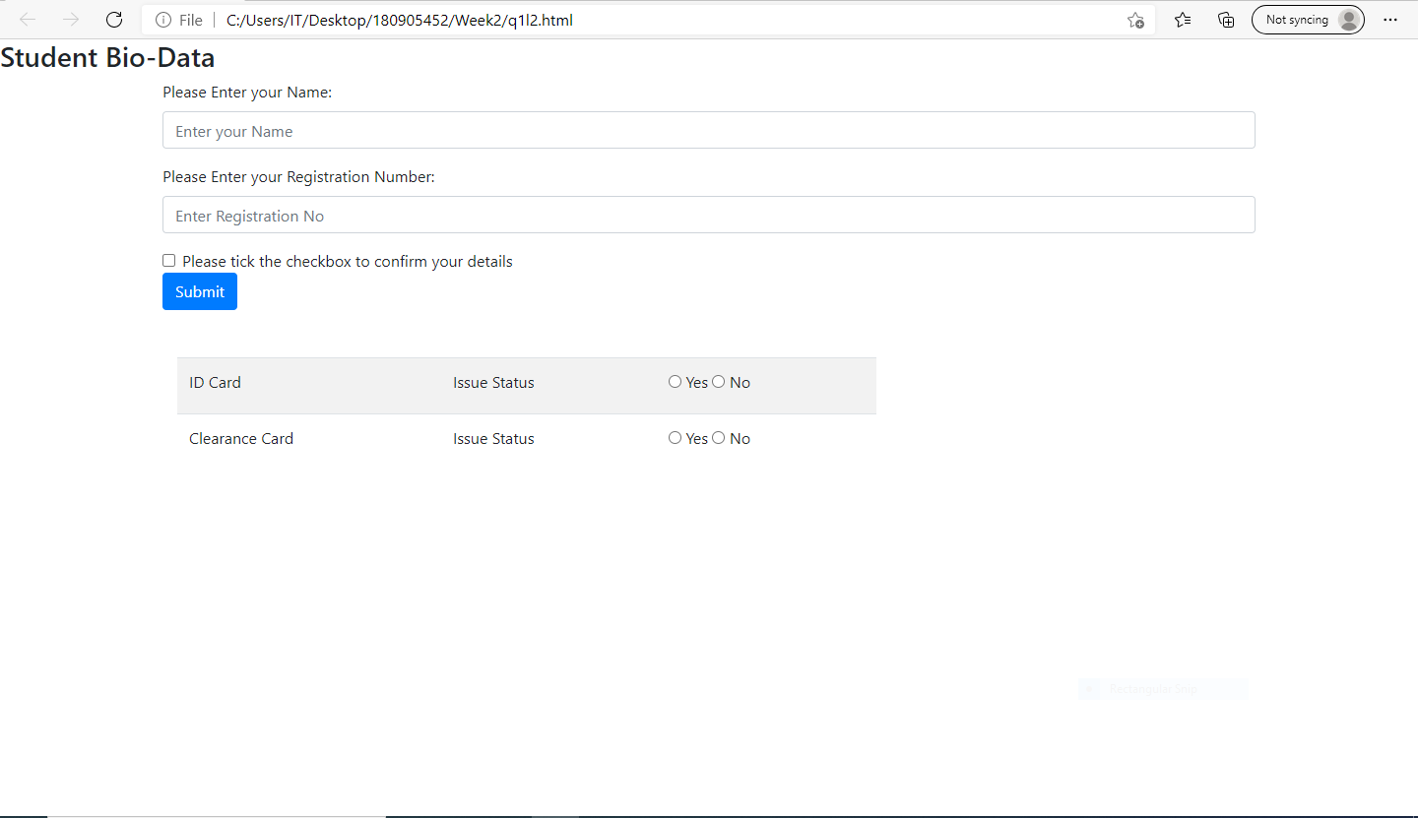

2.)

<!DOCTYPE html>

<html lang="en">

<head>

<meta charset="UTF-8" />

<meta http-equiv="X-UA-Compatible" content="IE=edge" />

<meta name="viewport" content="width=device-width, initial-scale=1.0" />

<link

rel="stylesheet"

href="https://maxcdn.bootstrapcdn.com/bootstrap/3.3.7/css/bootstrap.min.css"

integrity="sha384-BVYiiSIFeK1dGmJRAkycuHAHRg32OmUcww7on3RYdg4Va+PmSTsz/K68vbdEjh4u"

crossorigin="anonymous"

/>

<title>Lab 2 - Question 2</title>

</head>

<body>

<div class="container">

<h3>Employee Entries : </h3>

<table class="table table-bordered">

<thead>

<tr>

<th>Employee ID</th>

<th>Employee Name</th>

<th>Employee salary</th>

</tr>

</thead>

<tbody>

<tr>

<td>1</td>

<td>Mr.X</td>

<th>Rs.75000</th>

</tr>

<tr>

<td>2</td>

<td>Mr.Y</td>

<th>Rs.60000</th>

</tr>

<tr>

<td>3</td>

<td>Ms.Z</td>

<th>Rs.80000</th>

</tr>

</tbody>

</table>

<form>

<legend>Create New Employee : </legend>

<div class="form-group">

<label for="name">Employee ID</label>

<input type="number" class="form-control" id="name" placeholder="Enter Employee ID" />

</div>

<div class="form-group">

<label for="name">Employee Name</label>

<input type="text" class="form-control" id="name" placeholder="Enter employee name" />

</div>

<div class="form-group">

<label for="name">Employee Salary</label>

<input type="number" class="form-control" id="name" placeholder="Enter Employee salary" />

</div>

<button type="submit" class="btn btn-success">CREATE</button>

</form>

<hr>

<form>

<legend>Update the details of the Employee : </legend>

<div class="form-group">

<label for="exampleFormControlSelect2">Select the Employee to update : </label>

<select multiple class="form-control" id="exampleFormControlSelect2">

<option>1</option>

<option>2</option>

<option>3</option>

</select>

</div>

<div class="form-group">

<label for="name">Employee New ID</label>

<input type="number" class="form-control" id="name" placeholder="Enter employee ID" />

</div>

<div class="form-group">

<label for="name">Employee New Name</label>

<input type="text" class="form-control" id="name" placeholder="Enter Employee name" />

</div>

<div class="form-group">

<label for="name">Employee New Salary</label>

<input type="number" class="form-control" id="name" placeholder="Enter employee salary" />

</div>

<button type="submit" class="btn btn-info">UPDATE</button>

</form>

<hr>

<form>

<legend>Delete the Employee : </legend>

<div class="form-group">

<label for="exampleFormControlSelect2">Select the Employee to delete : </label>

<select multiple class="form-control" id="exampleFormControlSelect2">

<option>1</option>

<option>2</option>

<option>3</option>

</select>

</div>

<button type="submit" class="btn btn-danger">DELETE</button>

</form>

</div>

<link

rel="stylesheet"

href="https://maxcdn.bootstrapcdn.com/bootstrap/3.3.7/css/bootstrap-theme.min.css"

integrity="sha384-rHyoN1iRsVXV4nD0JutlnGaslCJuC7uwjduW9SVrLvRYooPp2bWYgmgJQIXwl/Sp"

crossorigin="anonymous"

/>

<script

src="https://maxcdn.bootstrapcdn.com/bootstrap/3.3.7/js/bootstrap.min.js"

integrity="sha384-Tc5IQib027qvyjSMfHjOMaLkfuWVxZxUPnCJA7l2mCWNIpG9mGCD8wGNIcPD7Txa"

crossorigin="anonymous"

></script>

</body>

</html>

Output:

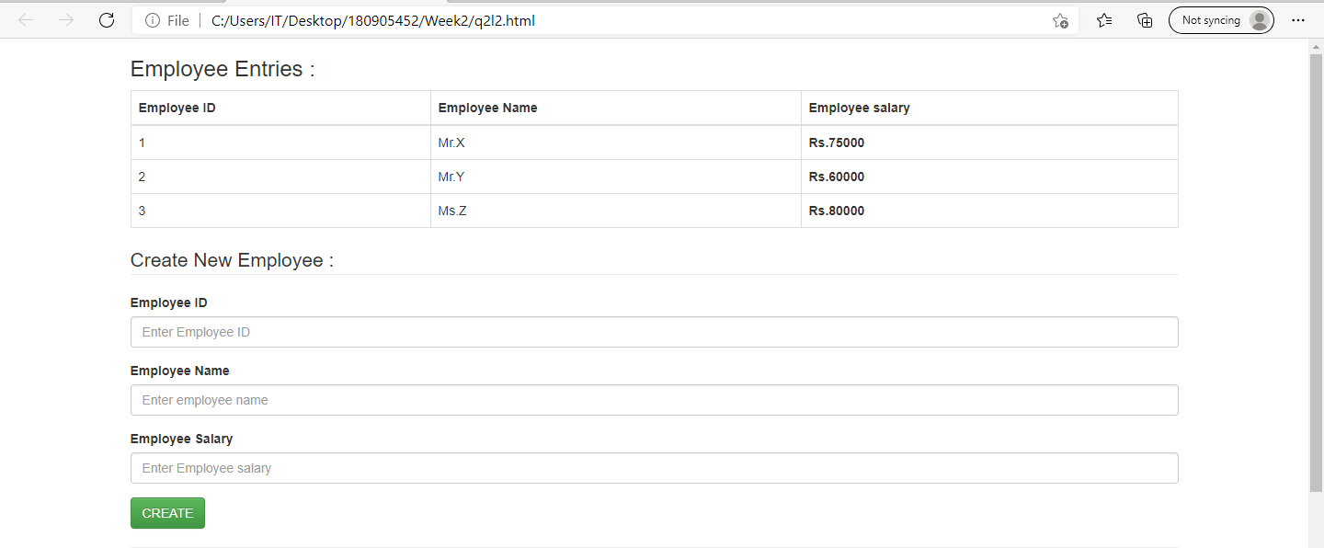

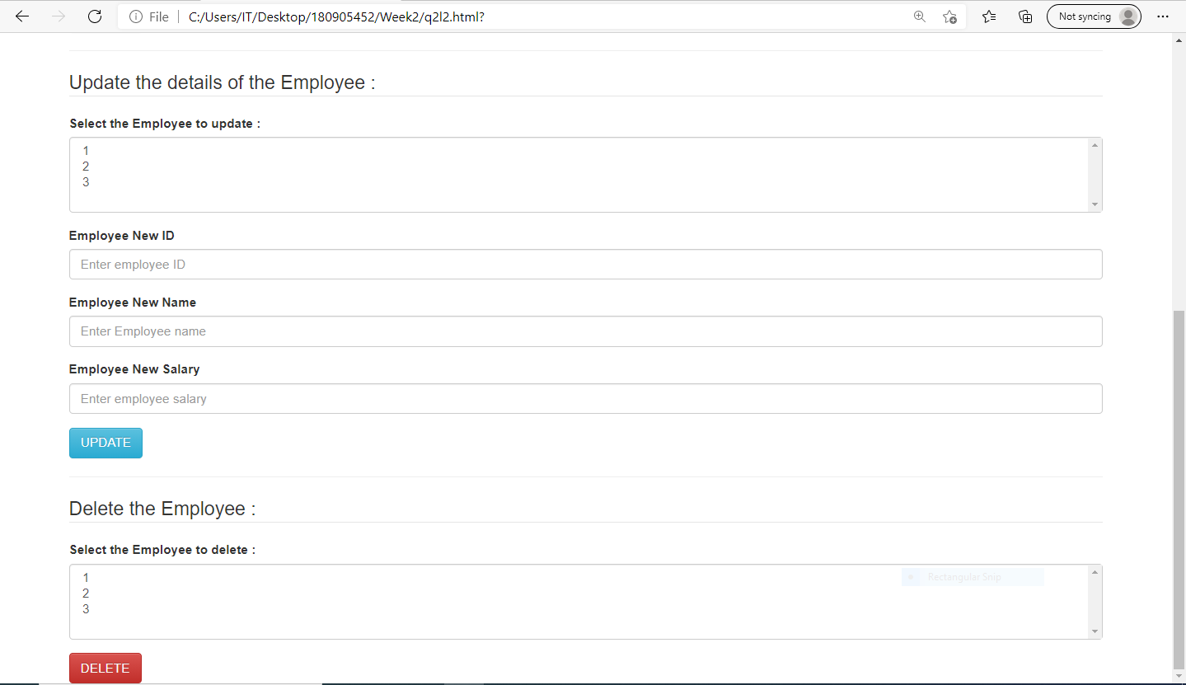

3.)

<!DOCTYPE html>

<html lang="en">

<head>

<meta charset="utf-8">

<meta name="viewport" content="width=device-width, initial-scale=1">

<link rel="stylesheet" href="https://maxcdn.bootstrapcdn.com/bootstrap/3.4.1/css/bootstrap.min.css">

<script src="https://ajax.googleapis.com/ajax/libs/jquery/3.5.1/jquery.min.js"></script>

<script src="https://maxcdn.bootstrapcdn.com/bootstrap/3.4.1/js/bootstrap.min.js"></script>

</head>

<body>

<div class="container-fluid" >

<div class="row" style="min-height: 400px" >

<h1>TOP</h1>

<button type="button" class="btn btn-default">CSE</button>

<button type="button" class="btn btn-primary">CCE</button>

<button type="button" class="btn btn-success">IT</button>

<button type="button" class="btn btn-info">ECE</button>

<button type="button" class="btn btn-warning">EEE</button>

<button type="button" class="btn btn-danger">E&I</button>

<button type="button" class="btn btn-link">More Branches</button>

</div>

<div class = 'row' style="min-height: 400px" >

<h1>BOTTOM</h1>

<div class="col-sm-4">

CSE Lab

<div class="btn-group-vertical">

<button type="button" class="btn btn-primary">DS Lab</button>

<button type="button" class="btn btn-primary">IT Lab</button>

<button type="button" class="btn btn-primary">PP Lab</button>

</div>

</div>

<div class="col-sm-4">

<h2> Please Enter your Credentials : </h2>

<form>

<div class="input-group">

<span class="input-group-addon"><i class="glyphicon glyphicon-user"></i></span>

<input id="text" type="text" class="form-control" name="User" placeholder="Please Enter your Username">

</div>

<div class="input-group">

<span class="input-group-addon"><i class="glyphicon glyphicon-lock"></i></span>

<input id="password" type="password" class="form-control" name="password" placeholder="Please Enter your Password">

</div>

<div class="input-group">

<span class="input-group-addon">Text</span>

<input id="msg" type="text" class="form-control" name="msg" placeholder="Please Enter your Additional Info">

</div>

</form>

</div>

<div class="col-sm-4">

<table class="table table-condensed">

<thead>

<tr>

<th>First Name</th>

<th>Last Name</th>

<th>E-Mail</th>

</tr>

</thead>

<tbody>

<tr>

<td>GP</td>

<td>Anirudh</td>

<td>anirudh.cse5452@gmail.com</td>

</tr>

</tbody>

</table>

</div>

</div>

</div>

</body>

</html>

Output:

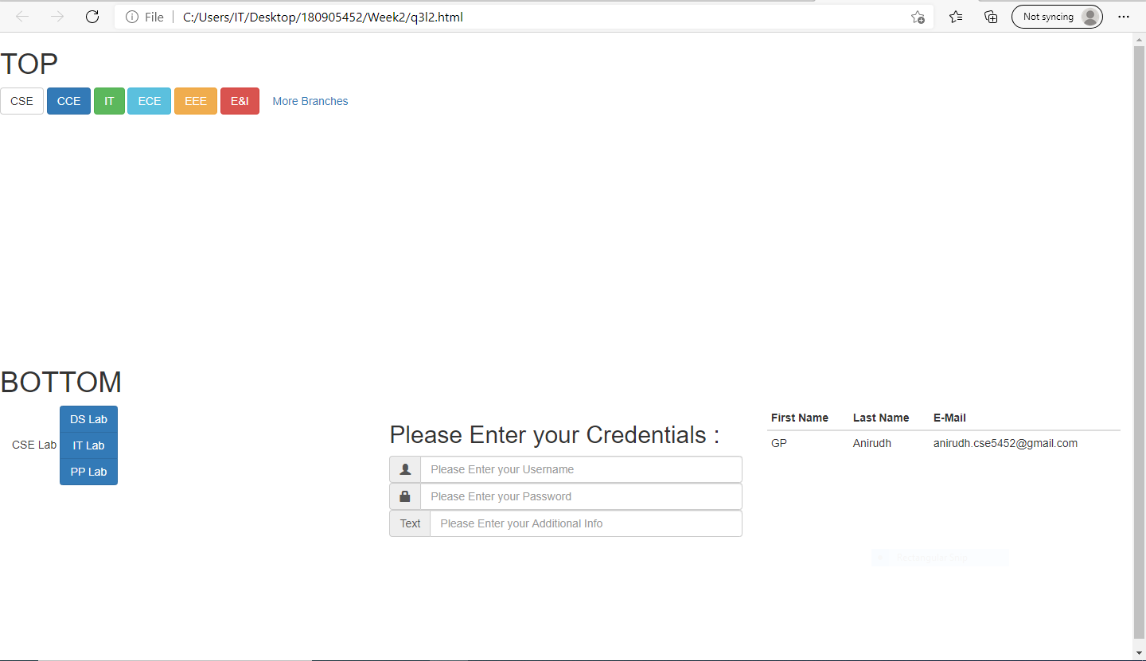

4.)

<!DOCTYPE html>

<html lang="en">

<head>

<meta charset="UTF-8" />

<meta http-equiv="X-UA-Compatible" content="IE=edge" />

<meta name="viewport" content="width=device-width, initial-scale=1.0" />

<link rel="stylesheet" href="https://maxcdn.bootstrapcdn.com/bootstrap/4.5.2/css/bootstrap.min.css">

<script src="https://ajax.googleapis.com/ajax/libs/jquery/3.5.1/jquery.min.js"></script>

<script src="https://cdnjs.cloudflare.com/ajax/libs/popper.js/1.16.0/umd/popper.min.js"></script>

<script src="https://maxcdn.bootstrapcdn.com/bootstrap/4.5.2/js/bootstrap.min.js"></script>

<title>Lab 2</title>

</head>

<body>

<div class="container">

<h1>Time Table of VIth Semester CSE Section B</h1>

<div id="carouselExampleIndicators" class="carousel slide" data-ride="carousel">

<ol class="carousel-indicators">

<li data-target="#carouselExampleIndicators" data-slide-to="0" class="active"></li>

<li data-target="#carouselExampleIndicators" data-slide-to="1"></li>

<li data-target="#carouselExampleIndicators" data-slide-to="2"></li>

</ol>

<div class="carousel-inner" style="background-color: white;">

<div class="carousel-item active">

<h3>Online Class Timetable for 2021 Batch</h3>

<table class="table table-responsive table-bordered" style="border: 1ch;">

<thead>

<tr>

<th>

Days

</th>

<th>

8-9:30 AM

</th>

<th>

10-11:30 AM

</th>

<th class="bg-info">

</th>

<th>

2-3:30 PM

</th>

<th>

4-4:30 PM

</th>

</tr>

</thead>

<tbody>

<tr>

<th>

Monday

</td>

<td>

----

</td>

<td>

----

</td>

<td class="bg-info">

</td>

<td>

EEFM

</td>

<td>

DS

</td>

</tr>

<tr>

<th>

Tuesday

</td>

<td>

PCAP

</td>

<td>

PE-1

</td>

<td class="bg-info">

</td>

<td>

----

</td>

<td>

----

</td>

</tr>

<tr>

<th>

Wednesday

</td>

<td>

----

</td>

<td>

----

</td>

<td class="bg-info">

</td>

<td>

PE-II

</td>

<td>

OE-III

</td>

</tr>

<tr>

<th>

Thursday

</td>

<td>

EEFM

</td>

<td>

DS

</td>

<td class="bg-info">

</td>

<td>

----

</td>

<td>

----

</td>

</tr>

<tr>

<th>

Friday

</td>

<td>

----

</td>

<td>

----

</td>

<td class="bg-info">

</td>

<td>

PCAP

</td>

<td>

PE-I

</td>

</tr>

<tr>

<th>

Saturday

</td>

<td>

PE-II

</td>

<td>

OE-III

</td>

<td class="bg-info">

</td>

<td>

----

</td>

<td>

----

</td>

</tr>

</tbody>

</table>

</div>

<div class="carousel-item">

<h1>LAB Timetable </h1>

<table class="table table-responsive table-bordered" style="border: 0ch;">

<thead>

<tr>

<th>

Days

</th>

<th>

8-10 AM

</th>

<th>

10-11 AM

</th>

<th>

11-1 AM

</th>

<th class="bg-info">

</th>

<th>

1-3 PM

</th>

<th>

3-5 PM

</th>

</tr>

</thead>

<tbody>

<tr>

<th>Monday</th>

<td>----</td>

<td>----</td>

<td>ITL(B1)</td>

<td class="bg-info"></td>

<td>----</td>

<td>----</td>

</tr>

<tr>

<th>Tuesday</th>

<td>----</td>

<td>----</td>

<td>----</td>

<td class="bg-info"></td>

<td>PPL(B2) / DSL(B1)</td>

<td>----</td>

</tr>

<tr>

<th>Wednesday</th>

<td>ITL(B2)</td>

<td>----</td>

<td>----</td>

<td class="bg-info"></td>

<td>----</td>

<td>----</td>

</tr>

<tr>

<th>Thursday</th>

<td>----</td>

<td>----</td>

<td>----</td>

<td class="bg-info"></td>

<td>----</td>

<td>----</td>

</tr>

<tr>

<th>Friday</th>

<td>PPL(B1)</td>

<td>----</td>

<td>DSL(B2)</td>

<td class="bg-info"></td>

<td>----</td>

<td>----</td>

</tr>

<tr>

<th>Saturday</th>

<td>----</td>

<td>----</td>

<td>----</td>

<td class="bg-info"></td>

<td>----</td>

<td>----</td>

<td>----</td>

</tr>

</tbody>

</table>

</div>

<div class="carousel-item">

<h1>Faculty list</h1>

<table class="table table-responsive table-bordered" style="border: 0ch;">

<thead>

<tr>

<th>

Subject Name

</th>

<th>

Subject Code

</th>

<th>

Name of Faculty

</th>

</tr>

</thead>

<tbody>

<tr>

<th>

Engineering Economics and Financial Management(EEFM)

</td>

<td>

HUM 3051

</td>

<td>

Lt. Cdr .(Retd) Geethalakshmi(GL)

</td>

</tr>

<tr>

<th>

Distributed Systems(DS)

</td>

<td>

CSE 3251

</td>

<td>

Mr. Manamohana Krishna(MM)

</td>

</tr>

<tr>

<th>

Parallel Computer Architecture and Programming(PCAP)

</td>

<td>

CSE 3252

</td>

<td>

Dr. Bhargav B J(BBJ)

</td>

</tr>

<tr>

<th>

PE-I

</td>

<td>

----

</td>

<td>

----

</td>

</tr>

<tr>

<th>

PE-II

</td>

<td>

----

</td>

<td>

----

</td>

</tr>

<tr>

<th>

OE-III

</td>

<td>

----

</td>

<td>

----

</td>

</tr>

<tr>

<th>

Distributed Systems Lab(DSL)

</td>

<td>

CSE 3261

</td>

<td>

B1 -- Mr. Manamohana Krishna(MM), Ms. Archana Praveen Kumar(ARC) Lab-05

<br>

B2 -- Mr. Manamohana Krishna(MM), Ms. Archana Praveen Kumar(ARC) Lab-05

</td>

</tr>

<tr>

<th>

Internet Technologies Lab(DSL)

</td>

<td>

CSE 3262

</td>

<td>

B1 -- Ms. Ancilla(ANC), Ms. Suma D(SD) Lab-05

<br>

B2 -- Ms. Ancilla(ANC), Ms. Suma D(SD) Lab-05

</td>

</tr>

<tr>

<th>

Parallel Programming Lab(DSL)

</td>

<td>

CSE 3263

</td>

<td>

B1 -- Dr. Bhargav B J(BBJ), Dr. Manjunath K N(MKN) Lab-03

<br>

B2 -- Dr. Bhargav B J(BBJ), Dr. Manjunath K N(MKN) Lab-03

</td>

</tr>

</tbody>

</table>

</div>

</div>

<a class="carousel-control-prev" href="#carouselExampleIndicators" role="button" data-slide="prev">

<span class="carousel-control-prev-icon" aria-hidden="true"></span>

<span class="sr-only">Previous</span>

</a>

<a class="carousel-control-next" href="#carouselExampleIndicators" role="button" data-slide="next">

<span class="carousel-control-next-icon" aria-hidden="true"></span>

<span class="sr-only">Next</span>

</a>

</div>

</div>

</body>

</html>

Output:

