**Lab 3: Python Basics**

1.)

num1 = int(input("Enter the num1: "))

num2 = int(input("Enter the num2: "))

op = input("Enter the operation that needs to be performed: ")

if(op=="+"):

print(num1+num2)

elif(op=="-"):

print(num1-num2)

elif(op=="*"):

print(num1*num2)

elif(op=="/"):

print(num1/num2)

else:

print("Invalid operation")

Output:

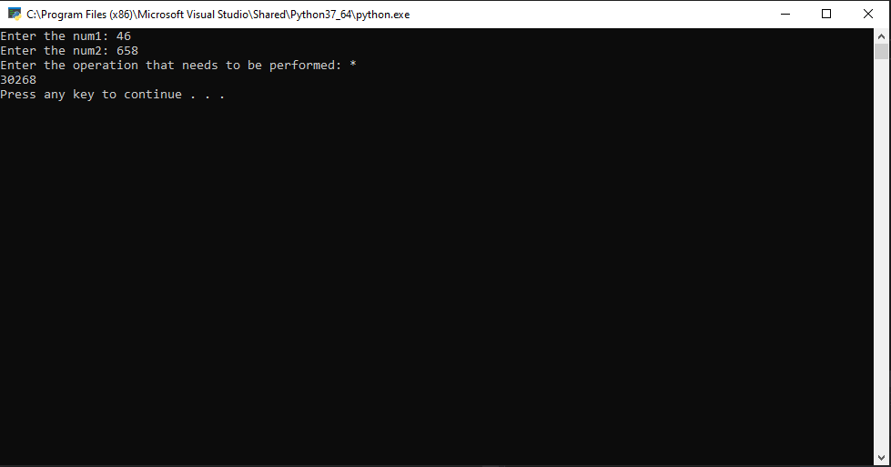

2.)

# Open the file in write mode

f1 = open("output.txt", "w")

# Open the input file and get

# the content into a variable data

with open("input.txt", "r") as myfile:

data = myfile.read()

# For Full Reversing we will store the

# value of data into new variable data_1

# in a reverse order using [start: end: step],

# where step when passed -1 will reverse

# the string

data_1 = data[::-1]

# Now we will write the fully reverse

# data in the output1 file using

# following command

f1.write(data_1)

f1.close()

Input:

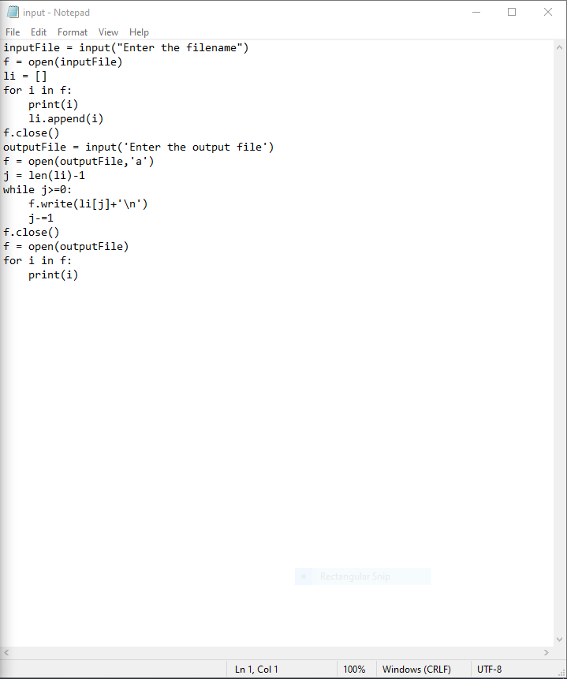

Output:

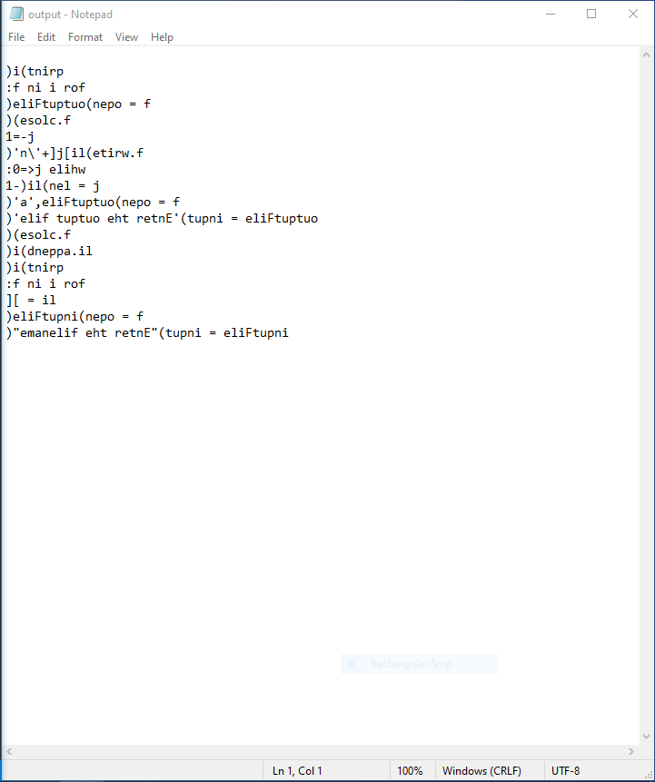

3.)

def binarySearch(a,x,si,ei):

if(si>ei):

print("Element not found")

else:

mid = si+(ei-1)//2

if(a[mid]>x):

binarySearch(a, x, mid+1, ei)

elif(a[mid]<x):

binarySearch(a,x,si,mid-1)

elif(a[mid]==x):

print("Element found at "+str(mid))

li = [int(i) for i in input("Enter the list").split()]

x = int(input("Enter the element to be searched"))

binarySearch(li,x,0,len(li)-1)

Output:

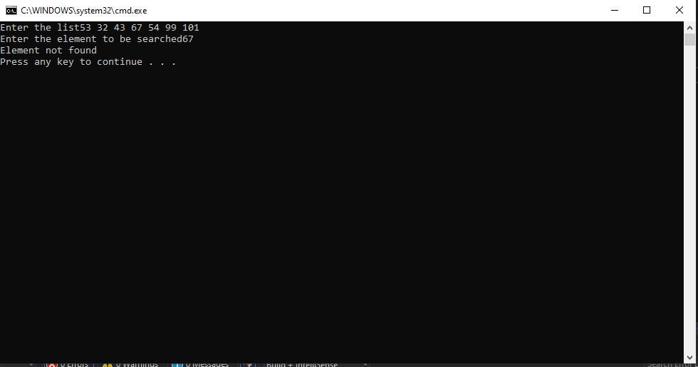

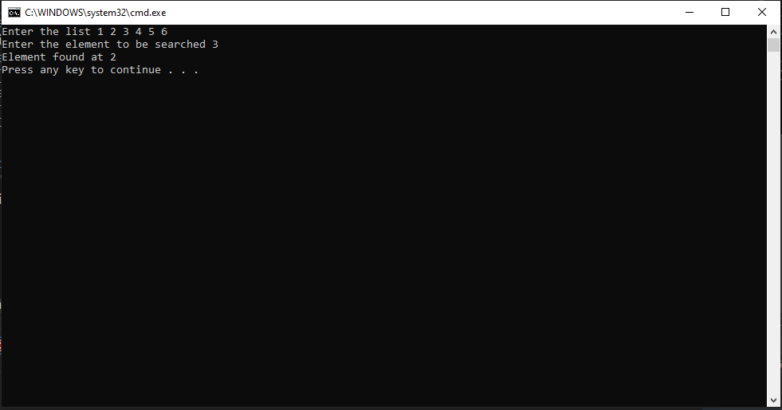

4.)

li = [i for i in input("enter the words space seperated: ").split()]

li.sort()

for i in li:

print(i,end = " ")

print()

Output:

