**IT Lab 4: Python Objects and Classes**

**Name:** GP Anirudh

**Roll Number:** 59

**Section:** B

**Batch:** B2

**Registration Number:** 180905452

**Date:** 17-3-2021

1.) Write a Python class to get all possible unique subsets from a set of distinct integers

**Code:**

class powerSetClass:

'''This class is to find uniwue possible subsets'''

def __init__(self, arr):

self.arr = arr

def powerSetGenerator(self):

powerSet=[]

for i in range(2**(len(self.arr))):

subset = []

for j in range(len(self.arr)):

if((i & (1<<j))):

subset.append((self.arr[j]))

if subset not in powerSet:

powerSet.append(subset)

return powerSet

pass

if __name__ == '__main__':

print("Enter the numbers in the array with space seperation")

arr = [i for i in input().split()]

psc = powerSetClass(arr)

powerSet = psc.powerSetGenerator()

print(powerSet)

**Output: (P.T.O)**

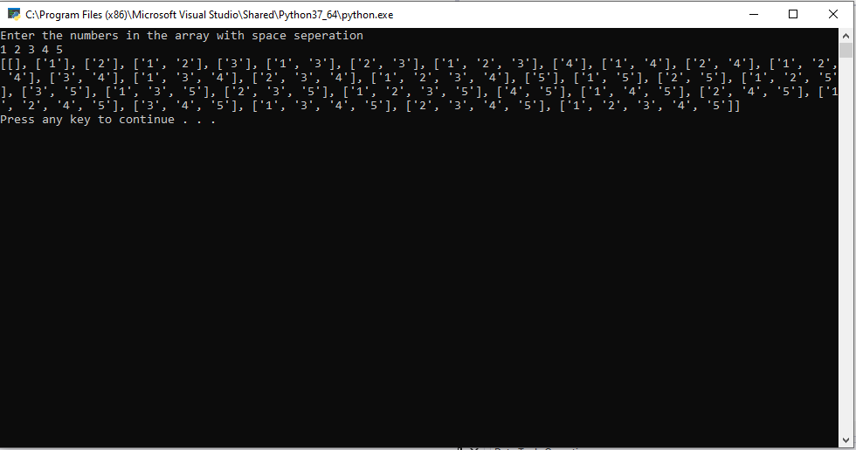

2.) Write a Python class to find a pair of elements (indices of the two numbers) from a given array whose sum equals a specific target number.

**Code:**

class pairtargetsum:

def __init__(self, arr, target):

self.arr = arr

self.target = target

def pairFinder(self):

for i in range(0,len(self.arr)-1):

if self.arr[i]+self.arr[i+1]==self.target:

print(str(i+1)+" ,"+str(i+2))

return

print("pair not found")

pass

if __name__ == '__main__':

print("Enter the numbers in the array with space seperation")

arr = [int(i) for i in input().split()]

print("Enter the target sum")

t = int(input())

pts = pairtargetsum(arr,t)

pts.pairFinder()

**Output:**

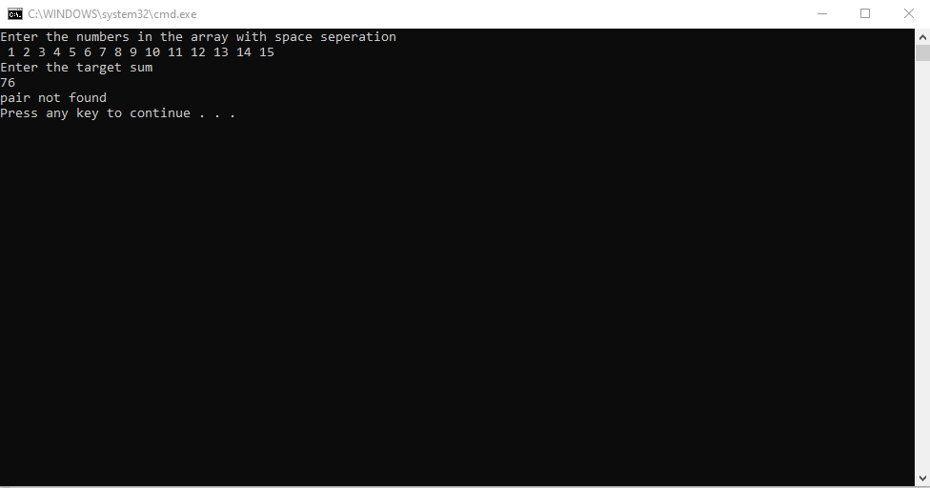

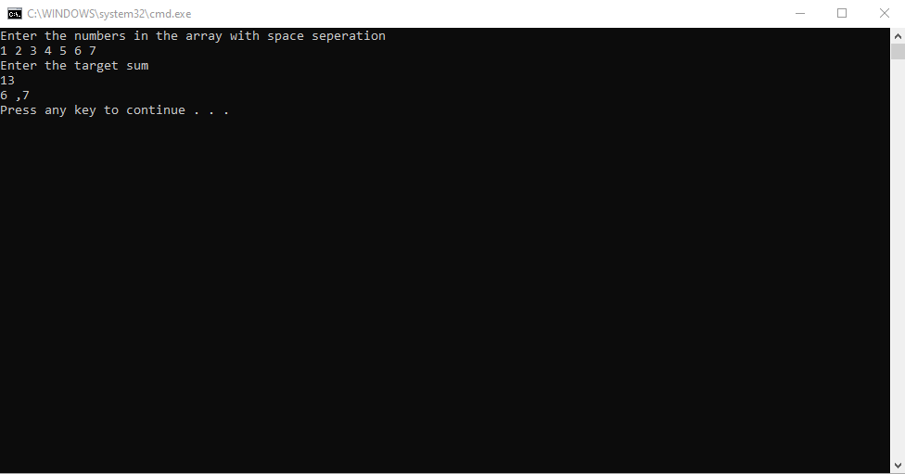

3.) Write a Python class to implement pow(x, n).

**Code:**

class Maths:

def pow(x,n):

if n==1:

return x

return x*pow(x,n-1)

pass

if __name__ == '__main__':

x = int(input("Enter the Base"))

n = int(input("Enter the power"))

print("The value is "+str(Maths.pow(x,n)))

**Output:**

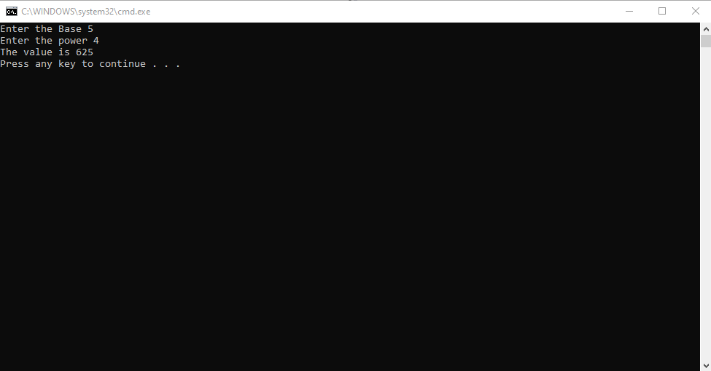

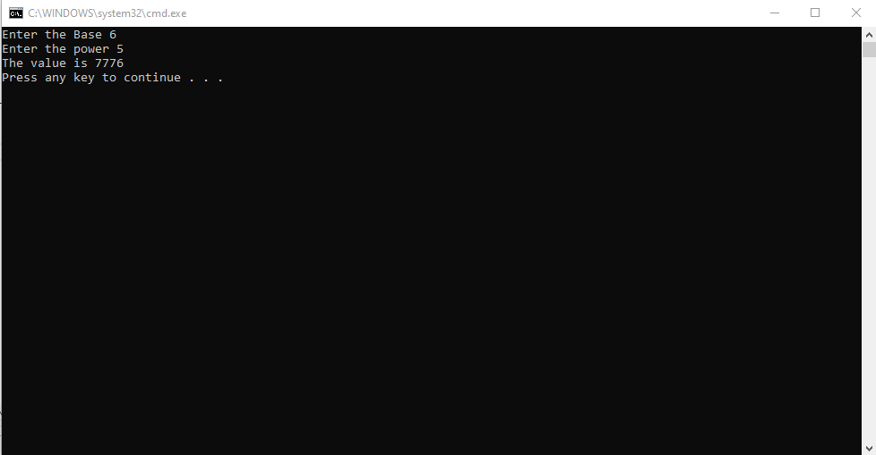

4.) Write a Python class which has two methods get_String and print_String. get_String accept a string from the user and print_String print the string in upper case.

**Code:**

class Strings:

def get_String(self):

self.string = input("Enter the string")

def print_String(self):

for i in self.string:

if (ord(i)>=97):

print(chr(ord(i)-32),end="")

else:

print(i,end="")

print()

pass

if __name__=='__main__':

string = Strings()

string.get_String()

string.print_String()

**Output:**

