**Lab 1: Introduction to execution environment of MPI**

1.)

#include <mpi.h>

#include <stdio.h>

#include <math.h>

int main(int argc, char** argv)

{

int x = 2;

// Initialize the MPI environment

MPI_Init(NULL, NULL);

int size;

MPI_Comm_size(MPI_COMM_WORLD, &size);

int rank;

MPI_Comm_rank(MPI_COMM_WORLD, &rank);

double P = pow(x , rank);

printf("%d to the power of %d is %f \n" , x , rank , P);

// Finalize the MPI environment.

MPI_Finalize();

}

Output:

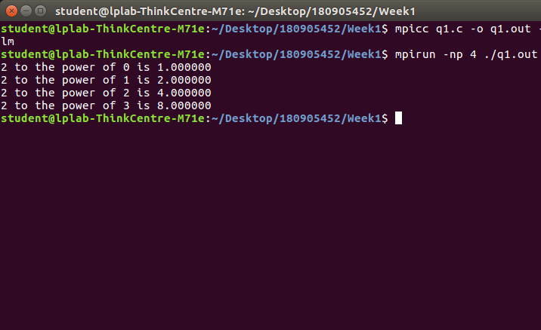

2.)

#include<stdio.h>

#include <mpi.h>

int main(int argc, char *argv[])

{

int rank, size;

MPI_Init(&argc, &argv);

MPI_Comm_rank(MPI_COMM_WORLD, &rank);

MPI_Comm_size(MPI_COMM_WORLD, &size);

if(rank%2==0)

printf("Process %d : Hello\n",rank);

else

printf("Process %d : World\n",rank);

MPI_Finalize();

return 0;

}

Output:

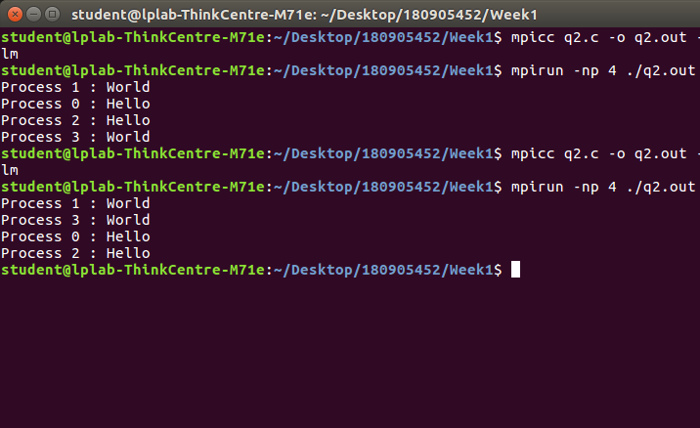

3.)

#include <mpi.h>

#include <stdio.h>

#include <math.h>

int main(int argc, char* argv[])

{

int rank, size,a=10,b=4;

MPI_Init(&argc,&argv);

MPI_Comm_rank(MPI_COMM_WORLD, &rank);

MPI_Comm_size(MPI_COMM_WORLD, &size);

if (rank == 0)

printf("Process %d says, Sum of %d and %d is %d\n",rank,a,b,a + b);

if (rank == 1)

printf("Process %d says, Difference of %d and %d is %d\n", rank, a, b, a - b);

if (rank == 2)

printf("Process %d says, Product of %d and %d is %d\n", rank, a, b, a * b);

if (rank == 3)

printf("Process %d says, Quotient of %d and %d is %f\n", rank, a, b, (double)a / b);

MPI_Finalize();

return 0;

}

Output:

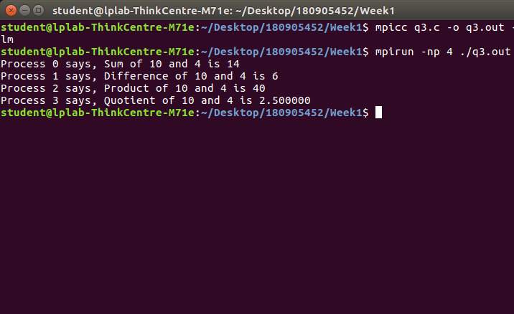

4.)

#include <mpi.h>

#include <stdio.h>

#include <math.h>

int main(int argc, char* argv[])

{

int rank, size;

char str[6] = "HeLLo";

MPI_Init(&argc,&argv);

MPI_Comm_rank(MPI_COMM_WORLD, &rank);

MPI_Comm_size(MPI_COMM_WORLD, &size);

if (str[rank] >= 'a' && str[rank] <= 'z')

str[rank] = str[rank] - 32;

else

str[rank] = str[rank] + 32;

printf("Process % d says, Modified string is %s\n",rank,str);

MPI_Finalize();

return 0;

}

Output:

