**PP Lab 5**

**Name:** GP Anirudh

**Registration Number:** 180905452

**Section:** B

**Batch:** B2

**Roll Number:** 59

1.) Write and execute a program in CUDA to add two vectors of length N to meet the following requirements using 3 different kernels.

a) block size as N

b) N threads within a block

c) Keep the number of threads per block as 256 (constant) and vary the number of blocks to handle N elements.

%%cu

#include <cuda.h>

#include <stdlib.h>

#include <stdio.h>

// 1a, 1b, 1c

__global__ void vecAddKernel_1a(float* A, float* B, float* C)

{

int idx = threadIdx.x + blockIdx.x * blockDim.x;

C[idx] = A[idx] + B[idx];

}

__global__ void vecAddKernel_1b(float* A, float* B, float* C)

{

int idx = threadIdx.x + blockIdx.x * blockDim.x;

C[idx] = A[idx] + B[idx];

}

__global__ void vecAddKernel_1c(float* A, float* B, float* C, int n)

{

int idx = threadIdx.x + blockIdx.x * blockDim.x;

if (idx < n)

{

C[idx] = A[idx] + B[idx];

}

}

void vecAdd(float* A, float* B, float* C, int n)

{

int size = n * sizeof(float);

float* d_A;

float* d_B;

float* d_C;

cudaMalloc((void**) &d_A, size);

cudaMalloc((void**) &d_B, size);

cudaMalloc((void**) &d_C, size);

cudaMemcpy(d_A, A, size, cudaMemcpyHostToDevice);

cudaMemcpy(d_B, B, size, cudaMemcpyHostToDevice);

printf("A: ");

for (int i = 0; i < n; i++)

{

printf("%f, ", A[i]);

}

printf("\n");

printf("B: ");

for (int i = 0; i < n; i++)

{

printf("%f, ", B[i]);

}

printf("\n\n");

vecAddKernel_1a<<<n, 1>>>(d_A, d_B, d_C);

cudaMemcpy(C, d_C, size, cudaMemcpyDeviceToHost);

printf("A+B (from 1a kernel): ");

for (int i = 0; i < n ; i++)

{

printf("%f, ", C[i]);

}

printf("\n");

vecAddKernel_1b<<<1, n>>>(d_A, d_B, d_C);

cudaMemcpy(C, d_C, size, cudaMemcpyDeviceToHost);

printf("A+B (from 1b kernel): ");

for (int i = 0; i < n ; i++)

{

printf("%f, ", C[i]);

}

printf("\n");

vecAddKernel_1c<<<ceil(n/256.0), n>>>(d_A, d_B, d_C, n);

cudaMemcpy(C, d_C, size, cudaMemcpyDeviceToHost);

printf("A+B (from 1c kernel): ");

for (int i = 0; i < n ; i++)

{

printf("%f, ", C[i]);

}

printf("\n");

cudaFree(d_A);

cudaFree(d_B);

cudaFree(d_C);

}

int main()

{

float *h_A, *h_B, *h_C;

int n = 5;

int size = n * sizeof(float);

h_A = (float*) malloc(size);

h_B = (float*) malloc(size);

h_C = (float*) malloc(size);

for (int i = 0; i < n; i++)

{

h_A[i] = (i+1) * 10;

h_B[i] = i+1;

}

vecAdd(h_A, h_B, h_C, n);

return 0;

}

**Output:**

**
**

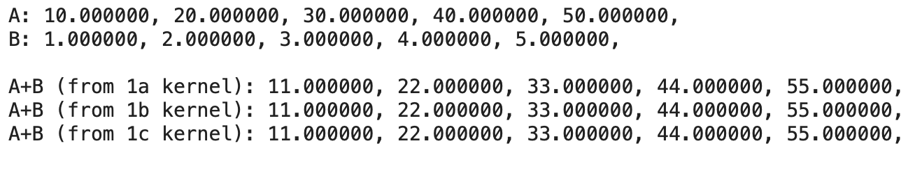

2.) Write and execute a CUDA program to read an array of N integer values. Sort the array in parallel using parallel selection sort and store the result in another array.

%%cu

#include <cuda.h>

#include <stdlib.h>

#include <stdio.h>

__global__ void selectionSortKernel(float* unsorted_arr, float* sorted_arr, int n)

{

int idx = threadIdx.x + blockIdx.x * blockDim.x;

float key = unsorted_arr[idx];

int pos = 0;

for (int i = 0; i < n; i++)

{

if (unsorted_arr[i] < key || (unsorted_arr[i] == key && i < idx))

{

pos++;

}

}

sorted_arr[pos] = key;

}

void selectionSort(float* unsorted_arr, float* sorted_arr, int n)

{

int size = n * sizeof(float);

float* d_unsorted_arr;

float* d_sorted_arr;

cudaMalloc((void**) &d_unsorted_arr, size);

cudaMalloc((void**) &d_sorted_arr, size);

cudaMemcpy(d_unsorted_arr, unsorted_arr, size, cudaMemcpyHostToDevice);

selectionSortKernel<<<1, n>>>(d_unsorted_arr, d_sorted_arr, n);

cudaMemcpy(sorted_arr, d_sorted_arr, size, cudaMemcpyDeviceToHost);

cudaFree(d_unsorted_arr);

cudaFree(d_sorted_arr);

}

int main()

{

float *h_unsorted_arr, *h_sorted_arr;

int n = 5;

int size = n * sizeof(float);

h_unsorted_arr = (float*) malloc(size);

h_sorted_arr = (float*) malloc(size);

for (int i = 0; i < 5; i++)

{

h_unsorted_arr[i] = rand() % 50;

}

selectionSort(h_unsorted_arr, h_sorted_arr, n);

printf("unsorted_arr: ");

for (int i = 0; i < n; i++)

{

printf("%f, ", h_unsorted_arr[i]);

}

printf("\n\n");

printf("sorted_arr: ");

for (int i = 0; i < n; i++)

{

printf("%f, ", h_sorted_arr[i]);

}

printf("\n");

return 0;

}

**Output:**

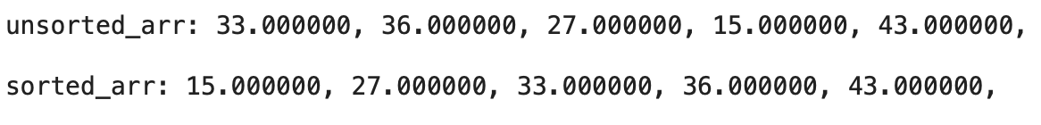

3.) Write a execute a CUDA program to read an integer array of size N. Sort this array using odd-even transposition sorting. Use 2 kernels.

%%cu

#include <cuda.h>

#include <stdlib.h>

#include <stdio.h>

__global__ void oddEven(float* arr, int n)

{

int idx = threadIdx.x + blockIdx.x * blockDim.x;

if (idx % 2 == 1 && idx + 1 < n)

{

if (arr[idx] > arr[idx+1])

{

float temp = arr[idx];

arr[idx] = arr[idx+1];

arr[idx+1] = temp;

}

}

}

__global__ void evenOdd(float* arr, int n)

{

int idx = threadIdx.x + blockIdx.x * blockDim.x;

if (idx%2 == 0 && idx+1 < n)

{

if (arr[idx] > arr[idx+1])

{

float temp = arr[idx];

arr[idx] = arr[idx+1];

arr[idx+1] = temp;

}

}

}

void oddEvenTranspositionSort(float* arr, int n)

{

int size = n * sizeof(float);

float* d_arr;

cudaMalloc((void**) &d_arr, size);

cudaMemcpy(d_arr, arr, size, cudaMemcpyHostToDevice);

for (int i = 0; i <= n/2; i++)

{

oddEven<<<1, n>>>(d_arr, n);

evenOdd<<<1, n>>>(d_arr, n);

}

cudaMemcpy(arr, d_arr, size, cudaMemcpyDeviceToHost);

cudaFree(d_arr);

}

int main()

{

float *h_arr;

int n = 5;

int size = n * sizeof(float);

h_arr = (float*) malloc(size);

for (int i = 0; i < 5; i++)

{

h_arr[i] = rand() % 50;

}

printf("unsorted_arr: ");

for (int i = 0; i < n; i++)

{

printf("%f, ", h_arr[i]);

}

printf("\n\n");

oddEvenTranspositionSort(h_arr, n);

printf("sorted_arr: ");

for (int i = 0; i < n; i++)

{

printf("%f, ", h_arr[i]);

}

printf("\n");

return 0;

}

**Output:**

