1. **Target Audience & Decisions of The Analyses**

Our analyses are mainly targeted to the Capital Bikeshare. Based on our analyses, we were able to make recommendations regarding station/bike arrangements and necessary schedules (e.g. maintenance).

1. **Source Data & Data Processing**

**Capital Bikeshare**

These datasets were provided by Capital Bikeshare, which contain bike-ride details for the period of October 2010 to June 2016 (about 15,000,000 rows). The data were cleaned by SQL Server mainly in regards to data formats, and were stored in phpMyAdmin. Unnecessary columns were dropped.

**Weather History**

These datasets were provided by Weather Underground, which contains the detailed weather conditions in Washington D.C. Metro Area from October 2010 to June 2016. The data were cleaned by Microsoft Excel and converted to .csv files from .txt files. Unnecessary columns were dropped.

**Station Details**

These datasets were provided by Capital Bikeshare, which contains the detailed information for 408 bike stations. The data were cleaned by Microsoft Excel and converted to .csv files from .xml files.

**Holiday Schedule**

This dataset was collected by us, from the information provided by DC.gov. It contains the details of date and event/holiday name for the period of October 2010 to June 2016.

1. **Plot & Analyses & Interpretation**

**How do the weather conditions effect bike trips?**

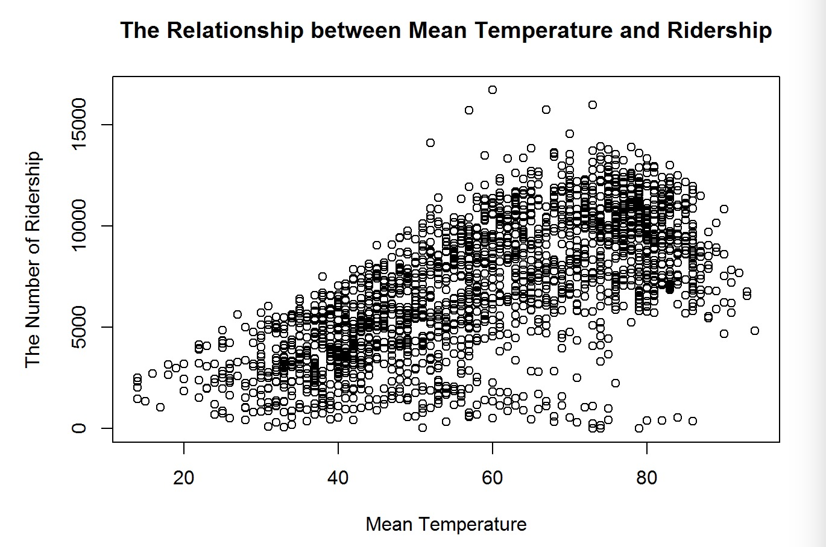

This graph shows the relationship between mean temperature in a day and number of ridership. According to the graph, there is a moderate positive relationship between mean temperature in a day and number of ridership, even though there are some outliers.

**What are the peak hours on bike trips in a day?**

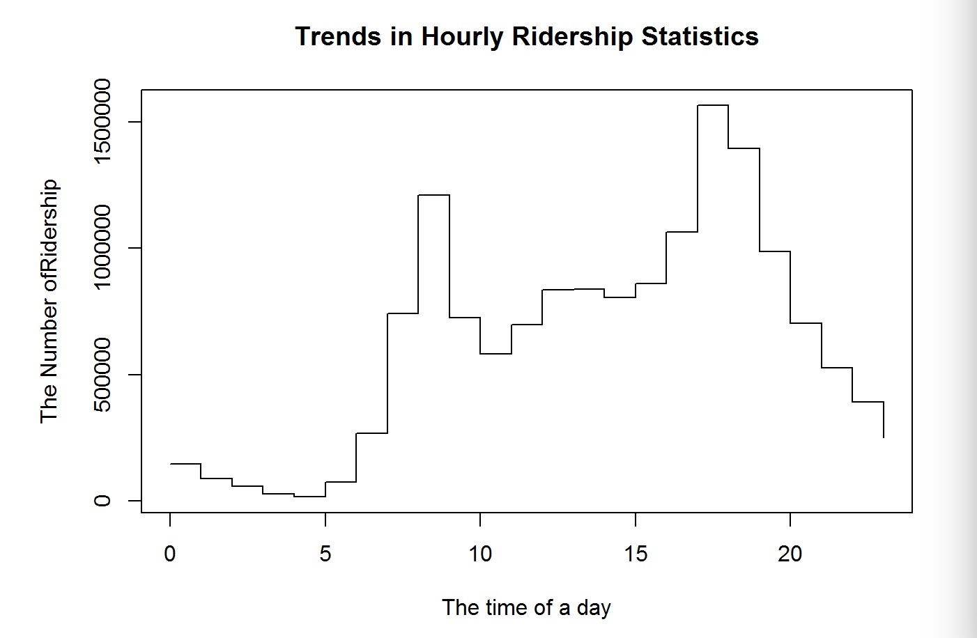

This graph shows the time distribution of picking up bikes in a day. From this plot we observed that there are two peaks in a day (8 a.m. and 5 p.m.), which are typically on-duty and off-duty times.

**How strongly/feebly the station location play a role on bike trips?**

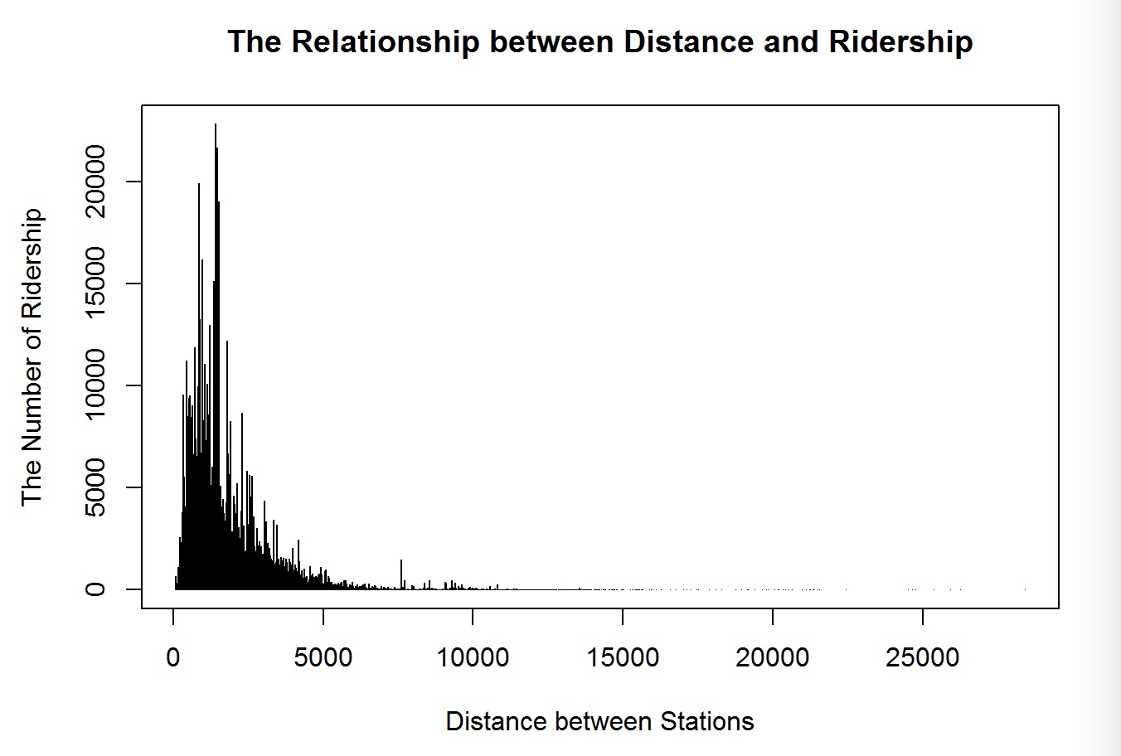

This graph shows the relationship between distance and number of ridership. Since the graph has a distribution of large positive skew, there is a negative relationship between distance and ridership.

**How do the national holidays impact the bike-trip counts?**

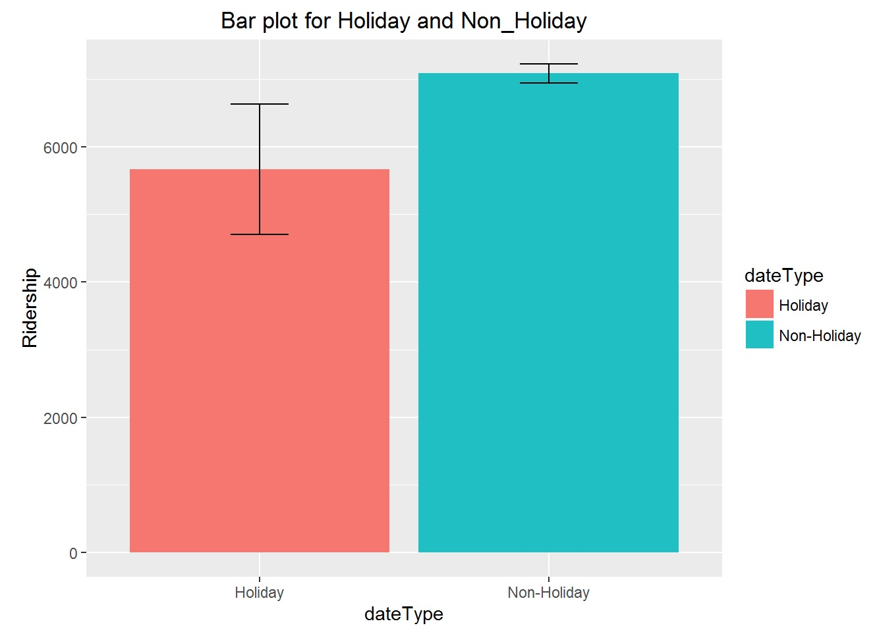

According to the comparison of the mean ridership between national holidays and non-holiday, the mean ridership on national holidays is less than the mean ridership of non-holiday. Moreover, the mean ridership in national holidays contain an extremely large confidence interval due to the relatively small data size (64 national holiday dates V.S. 2047 non-holiday dates).

1. **Recommendation Based on The Analyses**

Based on the ridership analyses of peak-hour, distance, and the national holidays V.S. non-holiday, we found that the major potential users may be the people who commute between home and office. Therefore, we would recommend Capital Bikeshare to set up more bike stations or arrange more bikes in existing stations around office area. Also, based on ridership analyses of peak-hour and the mean temperature in a day, we would recommend Capital Bikeshare to schedule maintenance during non-peak hours and non-popular seasons (e.g. winter), if necessary.