**Summary of Project**

The main objective of our project is to bring to bear evidence about the ramifications of hazardous waste emitted into our country’s atmosphere. We have examined numerous companies in a variety of industries, and identified several ways each has individually disposed of waste in their respective states and counties. Using data from the year 2014, we have identified certain egregious industries based on their waste release; some emitted substantially higher amounts of chemicals than other industries. Also we looked at the six most prominent chemicals in industrial effluents. Since carcinogenesis is a major component and unfortunate byproduct of industrial waste emissions, we decided that taking a closer look into particular industry sectors that contributed the most to carcinogenic compound releases would be judicious. Another important area of examination is how the waste from certain industries is readily emitted, whether through more traditional ways of stack emissions, or through unintentional or uncontrolled means known as fugitive emissions.

As our topic is a prime example of information geared toward a particular subset of the population, our audience would consist primarily of individuals within the federal government and environment-related climate action nonprofits, who are entrusted with the task of beholding industries to certain ethical standards of business and industry practices. The decisions industries make in regards to the way they dispose of hazardous waste would be the difference between fiscally responsible, yet environmentally sound judgments that protect the environment, and heavy economic sanctions levied by the government on those businesses. In addition, healthcare decisions can be made based on the evidence shown here. It would be vital for the implementation of public health initiatives to see what states more health resources should be allocated to, based on carcinogenesis rates and emissions from industries located there.

The data source we worked from in this project is the Toxic Release Inventory Basic Data Files prepared by the Environmental Analysis Division and Toxics Release Information Branch of the Environmental Protection Agency (EPA). This data includes the quantities of toxic chemicals released into the environment on site at facilities, the quantities transferred off site to other facilities, as well as summary data pertaining to the release of, recycling, energy recovery, and treatment of chemicals. Here, we used the National Data File which contains all the TRI data for the United States for a specific calendar year for all 50 states and six U.S. Districts and territories (2014). TRI basic data files: Calendar years 1987 - 2015. Retrieved November 2, 2016, from Environmental Protection Agency, <https://www.epa.gov/toxics-release-inventory-tri-program/tri-basic-data-files-calendar-years-1987-2015>.

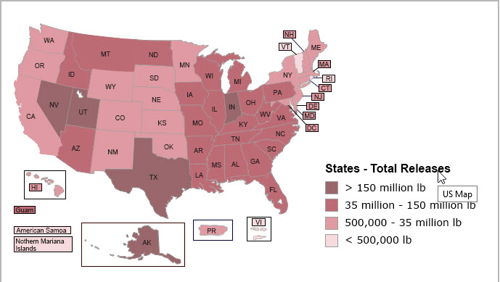

Figure 1

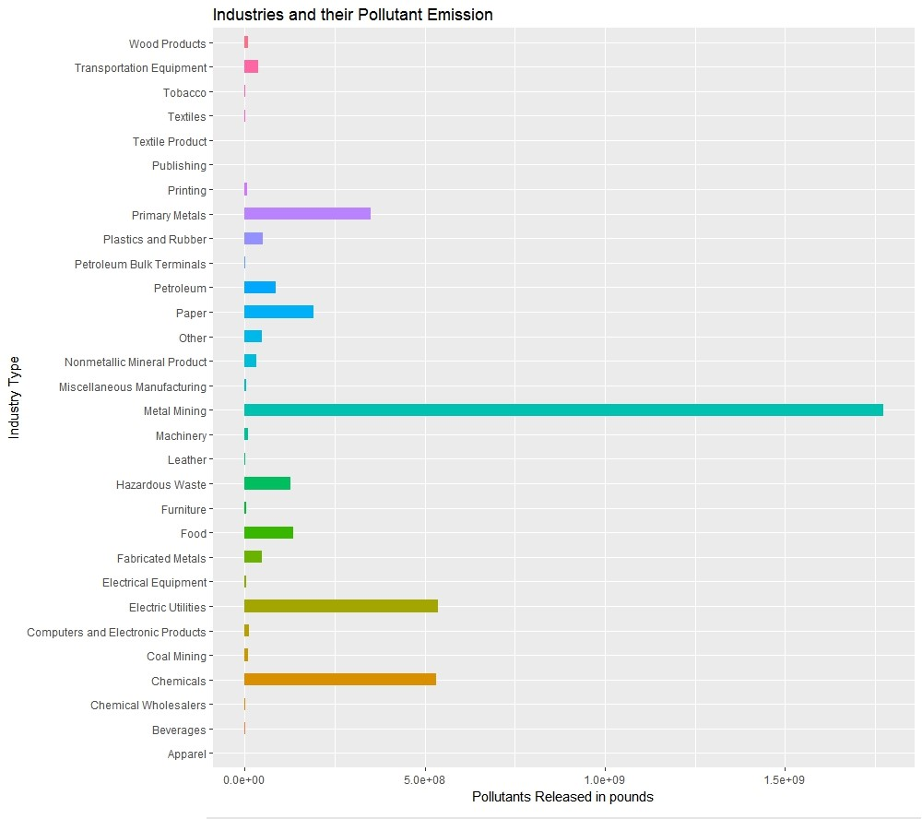

Figure 2

Figure 1 show states of US with high Toxic releases and Figure 2 shows which industries release higher industrial effluents. This can help in building better understanding how certain industries in a given region contribute towards high toxic releases.

Based on the evidence at hand, our audience should derive some thought-provoking information as to why certain industries must be taken to task about their emissions-supporting procedures. As watchdogs of industry behavior, the government has the important job of regulating known carcinogenic chemicals that are emitted into the atmosphere and should hold certain industries, accountable for putting the health of the American public in jeopardy. The results of this report show that certain chemicals should be examined more rigorously, as well as their mode of waste disposal. EPA regulators and community climate change activists should use this information as added confirmation that the fight for more responsible industry disposal standards is a critical one for the safety and well-being of all Americans. Companies should be financially incentivized to dispose in more environmentally healthy ways.

[591 words]