Analysis_Rscript

#-************************* Impressive Impalas *************************-#  
  
#-************************* Question-1 *************************-#  
#-How has the tornado occurrence varied over the last 10 years?  
#Variable under consideration: Count of the tornadoes each year  
  
#Importing the ggplot2 library  
library(ggplot2)

## Warning: package 'ggplot2' was built under R version 3.3.2

#-Read the csv file by manually browsing through the file structure  
#-Read he state-wise data for tornadoes and exports in d  
#-Read he region-wise data for tornadoes and exports in x  
d=read.csv("C:\\Users\\kavas\\Desktop\\Documents\\Courses\\600_AW\\Project\\Rplot\\Tor_Exp_StateWise_RPlot.csv")  
x=read.csv("C:\\Users\\kavas\\Desktop\\Documents\\Courses\\600_AW\\Project\\Rplot\\Tor_Exp_RegionWise_RPlot.csv")  
  
#-We divide the data set using the subset command to analyze   
#--different geographic regions in the United States  
#--namely Midwest, Northeast, Southeast and West  
dMW=subset(d,d$Region=="Mid-West")  
dNE=subset(d,d$Region=="North-East")  
dSE=subset(d,d$Region=="South-East")  
dW=subset(d,d$Region=="Western")  
  
xMW=subset(x,x$Region=="Mid-West")  
xNE=subset(x,x$Region=="North-East")  
xSE=subset(x,x$Region=="South-East")  
xW=subset(x,x$Region=="Western")  
  
#Plot for the number of tornadoes in United-States  
ggplot(d,aes(x=d$Year,y=d$Count))+  
 geom_bar(stat="identity", fill="indianred")+  
 xlab("Year")+ylab("Number of Tornadoes")+  
 ggtitle("United States of America: Number of Tornadoes")

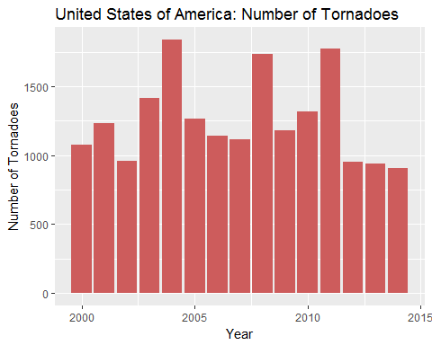

#Plot for the number of tornadoes in North-East  
ggplot(dNE,aes(x=dNE$Year,y=dNE$Count))+  
 geom_bar(stat="identity", fill="darkcyan")+  
 xlab("Year")+ylab("Number of Tornadoes")+  
 ggtitle("Northeast: Number of Tornadoes")

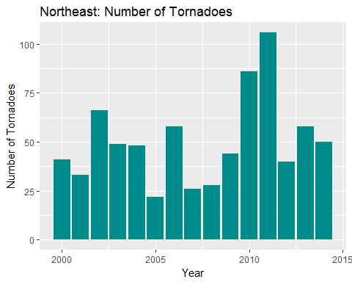

#Plot for the number of tornadoes in South-East  
ggplot(dSE,aes(x=dSE$Year,y=dSE$Count))+  
 geom_bar(stat="identity", fill="goldenrod1")+  
 xlab("Year")+ylab("Number of Tornadoes")+  
 ggtitle("Southeast: Number of Tornadoes")

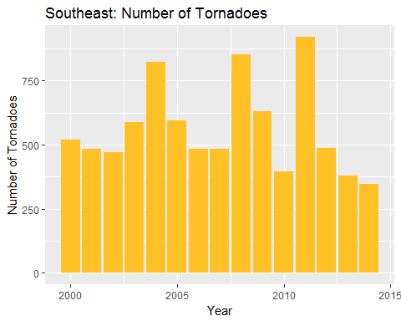

#Plot for the number of tornadoes in Mid-West  
ggplot(dMW,aes(x=dMW$Year,y=dMW$Count))+  
 geom_bar(stat="identity", fill="hotpink3")+  
 xlab("Year")+ylab("Number of Tornadoes")+  
 ggtitle("Midwest: Number of Tornadoes")

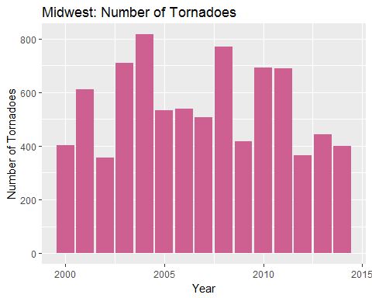

#Plot for the number of tornadoes in West  
ggplot(dW,aes(x=dW$Year,y=dW$Count))+  
 geom_bar(stat="identity", fill="forestgreen")+  
 xlab("Year")+ylab("Number of Tornadoes")+  
 ggtitle("West: Number of Tornadoes")

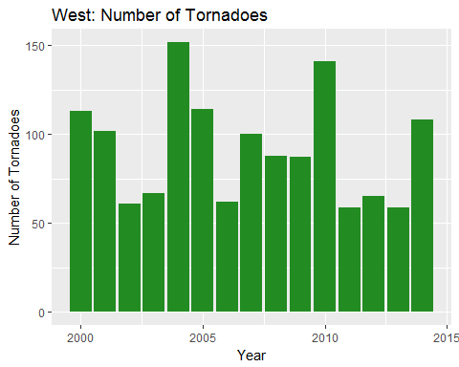

#-************************* Question-2 *************************-#  
#-What is the relationship between tornado occurrences and Exports  
#-Variable under consideration:  
#-Dependent Variable: Total exports from a state/region  
#-Independent Variable: Average F-scale value, Count of tornadoes  
  
#Analyzing the data using linear regression model for each region

#Region: Mid-West, Dependent Variable: Agricultural Exports, Independent Variable: Count of Tornadoes  
summary(lm(xMW$Sum.of.Agricultural.Exports~xMW$Sum.of.Count))

##   
## Call:  
## lm(formula = xMW$Sum.of.Agricultural.Exports ~ xMW$Sum.of.Count)  
##   
## Residuals:  
## Min 1Q Median 3Q Max   
## -22321 -15235 -1634 17697 23515   
##   
## Coefficients:  
## Estimate Std. Error t value Pr(>|t|)   
## (Intercept) 48153.77 18163.14 2.651 0.020 *  
## xMW$Sum.of.Count -11.97 31.86 -0.376 0.713   
## ---  
## Signif. codes: 0 '***' 0.001 '**' 0.01 '*' 0.05 '.' 0.1 ' ' 1  
##   
## Residual standard error: 18460 on 13 degrees of freedom  
## Multiple R-squared: 0.01074, Adjusted R-squared: -0.06535   
## F-statistic: 0.1412 on 1 and 13 DF, p-value: 0.7131

#Region: Mid-West, Dependent Variable: Animal Product Exports, Independent Variable: Count of Tornadoes

summary(lm(xMW$Sum.of.Animal.Products~xNE$Sum.of.Count))

##   
## Call:  
## lm(formula = xMW$Sum.of.Animal.Products ~ xNE$Sum.of.Count)  
##   
## Residuals:  
## Min 1Q Median 3Q Max   
## -4559.0 -2947.0 -259.9 1791.9 6855.4   
##   
## Coefficients:  
## Estimate Std. Error t value Pr(>|t|)   
## (Intercept) 5157.13 2422.28 2.129 0.0529 .  
## xNE$Sum.of.Count 58.77 44.14 1.331 0.2059   
## ---  
## Signif. codes: 0 '***' 0.001 '**' 0.01 '*' 0.05 '.' 0.1 ' ' 1  
##   
## Residual standard error: 3737 on 13 degrees of freedom  
## Multiple R-squared: 0.12, Adjusted R-squared: 0.0523   
## F-statistic: 1.773 on 1 and 13 DF, p-value: 0.2059

#Region: Mid-West, Dependent Variable: Plant Product Exports, Independent Variable: Count of Tornadoes

summary(lm(xMW$Sum.of.Plant.Products~xNE$Sum.of.Count))

##   
## Call:  
## lm(formula = xMW$Sum.of.Plant.Products ~ xNE$Sum.of.Count)  
##   
## Residuals:  
## Min 1Q Median 3Q Max   
## -18213 -12236 3111 9408 20115   
##   
## Coefficients:  
## Estimate Std. Error t value Pr(>|t|)   
## (Intercept) 23126.6 9013.3 2.566 0.0235 *  
## xNE$Sum.of.Count 205.2 164.2 1.249 0.2337   
## ---  
## Signif. codes: 0 '***' 0.001 '**' 0.01 '*' 0.05 '.' 0.1 ' ' 1  
##   
## Residual standard error: 13910 on 13 degrees of freedom  
## Multiple R-squared: 0.1071, Adjusted R-squared: 0.03847   
## F-statistic: 1.56 on 1 and 13 DF, p-value: 0.2337

#Region: Northeast, Dependent Variable: Agricultural Exports, Independent Variable: Count of Tornadoes

summary(lm(xNE$Sum.of.Agricultural.Exports~xNE$Sum.of.Count))

##   
## Call:  
## lm(formula = xNE$Sum.of.Agricultural.Exports ~ xNE$Sum.of.Count)  
##   
## Residuals:  
## Min 1Q Median 3Q Max   
## -3268.9 -2074.4 347.3 1408.4 4099.5   
##   
## Coefficients:  
## Estimate Std. Error t value Pr(>|t|)   
## (Intercept) 4328.29 1662.70 2.603 0.0219 *  
## xNE$Sum.of.Count 34.69 30.30 1.145 0.2729   
## ---  
## Signif. codes: 0 '***' 0.001 '**' 0.01 '*' 0.05 '.' 0.1 ' ' 1  
##   
## Residual standard error: 2565 on 13 degrees of freedom  
## Multiple R-squared: 0.0916, Adjusted R-squared: 0.02173   
## F-statistic: 1.311 on 1 and 13 DF, p-value: 0.2729

#Region: Northeast, Dependent Variable: Animal Product Exports, Independent Variable: Count of Tornadoes

summary(lm(xNE$Sum.of.Animal.Products~xNE$Sum.of.Count))

##   
## Call:  
## lm(formula = xNE$Sum.of.Animal.Products ~ xNE$Sum.of.Count)  
##   
## Residuals:  
## Min 1Q Median 3Q Max   
## -804.6 -529.1 -118.9 278.8 1262.8   
##   
## Coefficients:  
## Estimate Std. Error t value Pr(>|t|)   
## (Intercept) 902.925 439.483 2.055 0.0606 .  
## xNE$Sum.of.Count 9.909 8.009 1.237 0.2379   
## ---  
## Signif. codes: 0 '***' 0.001 '**' 0.01 '*' 0.05 '.' 0.1 ' ' 1  
##   
## Residual standard error: 678.1 on 13 degrees of freedom  
## Multiple R-squared: 0.1054, Adjusted R-squared: 0.03653   
## F-statistic: 1.531 on 1 and 13 DF, p-value: 0.2379

#Region: Northeast, Dependent Variable: Plant Product Exports, Independent Variable: Count of Tornadoes

summary(lm(xNE$Sum.of.Plant.Products~xNE$Sum.of.Count))

##   
## Call:  
## lm(formula = xNE$Sum.of.Plant.Products ~ xNE$Sum.of.Count)  
##   
## Residuals:  
## Min 1Q Median 3Q Max   
## -2697.0 -1620.9 179.3 1273.2 3221.0   
##   
## Coefficients:  
## Estimate Std. Error t value Pr(>|t|)   
## (Intercept) 3659.59 1320.72 2.771 0.0159 *  
## xNE$Sum.of.Count 27.19 24.07 1.130 0.2790   
## ---  
## Signif. codes: 0 '***' 0.001 '**' 0.01 '*' 0.05 '.' 0.1 ' ' 1  
##   
## Residual standard error: 2038 on 13 degrees of freedom  
## Multiple R-squared: 0.08939, Adjusted R-squared: 0.01934   
## F-statistic: 1.276 on 1 and 13 DF, p-value: 0.279

#Region: Southeast, Dependent Variable: Agricultural Exports, Independent Variable: Count of Tornadoes

summary(lm(xSE$Sum.of.Agricultural.Exports~xSE$Sum.of.Count))

##   
## Call:  
## lm(formula = xSE$Sum.of.Agricultural.Exports ~ xSE$Sum.of.Count)  
##   
## Residuals:  
## Min 1Q Median 3Q Max   
## -11492 -8023 -1180 9209 13335   
##   
## Coefficients:  
## Estimate Std. Error t value Pr(>|t|)   
## (Intercept) 28723.193 8847.565 3.246 0.00637 **  
## xSE$Sum.of.Count -3.268 15.017 -0.218 0.83110   
## ---  
## Signif. codes: 0 '***' 0.001 '**' 0.01 '*' 0.05 '.' 0.1 ' ' 1  
##   
## Residual standard error: 9855 on 13 degrees of freedom  
## Multiple R-squared: 0.00363, Adjusted R-squared: -0.07301   
## F-statistic: 0.04736 on 1 and 13 DF, p-value: 0.8311

#Region: Southeast, Dependent Variable: Animal Product Exports, Independent Variable: Count of Tornadoes

summary(lm(xSE$Sum.of.Animal.Products~xSE$Sum.of.Count))

##   
## Call:  
## lm(formula = xSE$Sum.of.Animal.Products ~ xSE$Sum.of.Count)  
##   
## Residuals:  
## Min 1Q Median 3Q Max   
## -2520 -1866 -348 2030 3072   
##   
## Coefficients:  
## Estimate Std. Error t value Pr(>|t|)   
## (Intercept) 7477.503 1982.422 3.772 0.00233 **  
## xSE$Sum.of.Count -1.733 3.365 -0.515 0.61509   
## ---  
## Signif. codes: 0 '***' 0.001 '**' 0.01 '*' 0.05 '.' 0.1 ' ' 1  
##   
## Residual standard error: 2208 on 13 degrees of freedom  
## Multiple R-squared: 0.02001, Adjusted R-squared: -0.05538   
## F-statistic: 0.2654 on 1 and 13 DF, p-value: 0.6151

#Region: Southeast, Dependent Variable: Plant Product Exports, Independent Variable: Count of Tornadoes

summary(lm(xSE$Sum.of.Plant.Products~xSE$Sum.of.Count))

##   
## Call:  
## lm(formula = xSE$Sum.of.Plant.Products ~ xSE$Sum.of.Count)  
##   
## Residuals:  
## Min 1Q Median 3Q Max   
## -7460.2 -4685.0 -571.6 5535.0 7995.8   
##   
## Coefficients:  
## Estimate Std. Error t value Pr(>|t|)   
## (Intercept) 17947.960 5412.662 3.316 0.00557 **  
## xSE$Sum.of.Count -1.369 9.187 -0.149 0.88383   
## ---  
## Signif. codes: 0 '***' 0.001 '**' 0.01 '*' 0.05 '.' 0.1 ' ' 1  
##   
## Residual standard error: 6029 on 13 degrees of freedom  
## Multiple R-squared: 0.001705, Adjusted R-squared: -0.07509   
## F-statistic: 0.02221 on 1 and 13 DF, p-value: 0.8838

#Region: West, Dependent Variable: Agricultural Exports, Independent Variable: Count of Tornadoes

summary(lm(xW$Sum.of.Agricultural.Exports~xW$Sum.of.Count))

##   
## Call:  
## lm(formula = xW$Sum.of.Agricultural.Exports ~ xW$Sum.of.Count)  
##   
## Residuals:  
## Min 1Q Median 3Q Max   
## -11774.4 -7578.6 -964.2 7120.5 17369.1   
##   
## Coefficients:  
## Estimate Std. Error t value Pr(>|t|)   
## (Intercept) 29294.93 7933.40 3.693 0.00271 **  
## xW$Sum.of.Count -76.02 82.30 -0.924 0.37251   
## ---  
## Signif. codes: 0 '***' 0.001 '**' 0.01 '*' 0.05 '.' 0.1 ' ' 1  
##   
## Residual standard error: 9304 on 13 degrees of freedom  
## Multiple R-squared: 0.06158, Adjusted R-squared: -0.01061   
## F-statistic: 0.8531 on 1 and 13 DF, p-value: 0.3725

#Region: West, Dependent Variable: Animal Product Exports, Independent Variable: Count of Tornadoes

summary(lm(xW$Sum.of.Animal.Products~xW$Sum.of.Count))

##   
## Call:  
## lm(formula = xW$Sum.of.Animal.Products ~ xW$Sum.of.Count)  
##   
## Residuals:  
## Min 1Q Median 3Q Max   
## -1794.1 -1070.7 -574.9 1236.2 3216.2   
##   
## Coefficients:  
## Estimate Std. Error t value Pr(>|t|)   
## (Intercept) 4753.57 1365.93 3.480 0.00407 **  
## xW$Sum.of.Count -15.50 14.17 -1.094 0.29401   
## ---  
## Signif. codes: 0 '***' 0.001 '**' 0.01 '*' 0.05 '.' 0.1 ' ' 1  
##   
## Residual standard error: 1602 on 13 degrees of freedom  
## Multiple R-squared: 0.08424, Adjusted R-squared: 0.0138   
## F-statistic: 1.196 on 1 and 13 DF, p-value: 0.294

#Region: West, Dependent Variable: Plant Product Exports, Independent Variable: Count of Tornadoes

summary(lm(xW$Sum.of.Plant.Products~xW$Sum.of.Count))

##   
## Call:  
## lm(formula = xW$Sum.of.Plant.Products ~ xW$Sum.of.Count)  
##   
## Residuals:  
## Min 1Q Median 3Q Max   
## -9980.3 -6266.7 -517.7 5884.3 14152.9   
##   
## Coefficients:  
## Estimate Std. Error t value Pr(>|t|)   
## (Intercept) 24541.36 6597.63 3.720 0.00257 **  
## xW$Sum.of.Count -60.52 68.45 -0.884 0.39264   
## ---  
## Signif. codes: 0 '***' 0.001 '**' 0.01 '*' 0.05 '.' 0.1 ' ' 1  
##   
## Residual standard error: 7738 on 13 degrees of freedom  
## Multiple R-squared: 0.05673, Adjusted R-squared: -0.01583   
## F-statistic: 0.7818 on 1 and 13 DF, p-value: 0.3926

#-We divide the data set using the subset command to analyze   
#--different states in the United States  
  
dTexas=subset(d,d$State=="TX")  
dNEMex=subset(d,d$State=="NM")  
dOk=subset(d,d$State=="OK")  
dAr=subset(d,d$State=="AR")  
dLa=subset(d,d$State=="LA")  
dAz=subset(d,d$State=="AZ")  
dKs=subset(d,d$State=="KS")  
  
#Analyzing the data using multiple regression model for states   
#--with high occurrence of tornadoes

#Two independent variables are used in this analysis – ‘Count of Tornadoes’ and ‘Average of F-scale’

#State: Texas, Dependent Variable: Agricultural Exports  
summary(lm(dTexas$Agricultural.Exports~dTexas$Count+dTexas$Average.of.F.Scale))

##   
## Call:  
## lm(formula = dTexas$Agricultural.Exports ~ dTexas$Count + dTexas$Average.of.F.Scale)  
##   
## Residuals:  
## Min 1Q Median 3Q Max   
## -1741.8 -912.2 -187.2 939.7 1987.3   
##   
## Coefficients:  
## Estimate Std. Error t value Pr(>|t|)   
## (Intercept) 8429.654 1758.734 4.793 0.000439 ***  
## dTexas$Count -22.567 8.728 -2.586 0.023852 *   
## dTexas$Average.of.F.Scale -2327.622 4699.187 -0.495 0.629317   
## ---  
## Signif. codes: 0 '***' 0.001 '**' 0.01 '*' 0.05 '.' 0.1 ' ' 1  
##   
## Residual standard error: 1251 on 12 degrees of freedom  
## Multiple R-squared: 0.402, Adjusted R-squared: 0.3023   
## F-statistic: 4.033 on 2 and 12 DF, p-value: 0.04573

#State: Texas, Dependent Variable: Animal Product Exports

summary(lm(dTexas$Animal.Products~dTexas$Count+dTexas$Average.of.F.Scale))

##   
## Call:  
## lm(formula = dTexas$Animal.Products ~ dTexas$Count + dTexas$Average.of.F.Scale)  
##   
## Residuals:  
## Min 1Q Median 3Q Max   
## -771.06 -187.11 27.68 243.24 570.26   
##   
## Coefficients:  
## Estimate Std. Error t value Pr(>|t|)   
## (Intercept) 2401.994 592.573 4.053 0.00160 **  
## dTexas$Count -9.935 2.941 -3.378 0.00548 **  
## dTexas$Average.of.F.Scale 818.766 1583.305 0.517 0.61447   
## ---  
## Signif. codes: 0 '***' 0.001 '**' 0.01 '*' 0.05 '.' 0.1 ' ' 1  
##   
## Residual standard error: 421.6 on 12 degrees of freedom  
## Multiple R-squared: 0.4899, Adjusted R-squared: 0.4049   
## F-statistic: 5.763 on 2 and 12 DF, p-value: 0.01762

#State: Texas, Dependent Variable: Plant Product Exports

summary(lm(dTexas$Plant.Products~dTexas$Count+dTexas$Average.of.F.Scale))

##   
## Call:  
## lm(formula = dTexas$Plant.Products ~ dTexas$Count + dTexas$Average.of.F.Scale)  
##   
## Residuals:  
## Min 1Q Median 3Q Max   
## -1142.55 -836.13 -32.46 640.71 1555.36   
##   
## Coefficients:  
## Estimate Std. Error t value Pr(>|t|)   
## (Intercept) 6027.666 1364.876 4.416 0.000841 ***  
## dTexas$Count -12.632 6.773 -1.865 0.086829 .   
## dTexas$Average.of.F.Scale -3146.421 3646.832 -0.863 0.405171   
## ---  
## Signif. codes: 0 '***' 0.001 '**' 0.01 '*' 0.05 '.' 0.1 ' ' 1  
##   
## Residual standard error: 971 on 12 degrees of freedom  
## Multiple R-squared: 0.3085, Adjusted R-squared: 0.1933   
## F-statistic: 2.677 on 2 and 12 DF, p-value: 0.1093

#State: New Mexico, Dependent Variable: Agricultural Exports

summary(lm(dNEMex$Agricultural.Exports~dNEMex$Count+dNEMex$Average.of.F.Scale))

##   
## Call:  
## lm(formula = dNEMex$Agricultural.Exports ~ dNEMex$Count + dNEMex$Average.of.F.Scale)  
##   
## Residuals:  
## Min 1Q Median 3Q Max   
## -193.45 -148.24 -53.13 119.48 309.90   
##   
## Coefficients:  
## Estimate Std. Error t value Pr(>|t|)   
## (Intercept) 494.400 87.381 5.658 0.000106 ***  
## dNEMex$Count -4.171 10.306 -0.405 0.692809   
## dNEMex$Average.of.F.Scale 400.619 271.959 1.473 0.166468   
## ---  
## Signif. codes: 0 '***' 0.001 '**' 0.01 '*' 0.05 '.' 0.1 ' ' 1  
##   
## Residual standard error: 189.6 on 12 degrees of freedom  
## Multiple R-squared: 0.1564, Adjusted R-squared: 0.01583   
## F-statistic: 1.113 on 2 and 12 DF, p-value: 0.3604

#State: Oklahoma, Dependent Variable: Agricultural Exports

summary(lm(dOk$Agricultural.Exports~dOk$Count+dOk$Average.of.F.Scale))

##   
## Call:  
## lm(formula = dOk$Agricultural.Exports ~ dOk$Count + dOk$Average.of.F.Scale)  
##   
## Residuals:  
## Min 1Q Median 3Q Max   
## -482.29 -240.23 -11.78 179.17 677.74   
##   
## Coefficients:  
## Estimate Std. Error t value Pr(>|t|)   
## (Intercept) 861.469 308.726 2.790 0.0163 *  
## dOk$Count 6.458 3.798 1.700 0.1148   
## dOk$Average.of.F.Scale 19.430 591.229 0.033 0.9743   
## ---  
## Signif. codes: 0 '***' 0.001 '**' 0.01 '*' 0.05 '.' 0.1 ' ' 1  
##   
## Residual standard error: 376.3 on 12 degrees of freedom  
## Multiple R-squared: 0.2599, Adjusted R-squared: 0.1365   
## F-statistic: 2.107 on 2 and 12 DF, p-value: 0.1644

#State: Arkansas, Dependent Variable: Agricultural Exports

summary(lm(dAr$Agricultural.Exports~dAr$Count+dAr$Average.of.F.Scale))

##   
## Call:  
## lm(formula = dAr$Agricultural.Exports ~ dAr$Count + dAr$Average.of.F.Scale)  
##   
## Residuals:  
## Min 1Q Median 3Q Max   
## -1531.37 -759.12 80.32 851.64 1295.43   
##   
## Coefficients:  
## Estimate Std. Error t value Pr(>|t|)  
## (Intercept) 1153.4944 1172.2499 0.984 0.345  
## dAr$Count 0.9216 12.3591 0.075 0.942  
## dAr$Average.of.F.Scale 1551.5482 1039.1923 1.493 0.161  
##   
## Residual standard error: 1000 on 12 degrees of freedom  
## Multiple R-squared: 0.1573, Adjusted R-squared: 0.01684   
## F-statistic: 1.12 on 2 and 12 DF, p-value: 0.3581

#State: Louisiana, Dependent Variable: Agricultural Exports

summary(lm(dLa$Agricultural.Exports~dLa$Count+dLa$Average.of.F.Scale))

##   
## Call:  
## lm(formula = dLa$Agricultural.Exports ~ dLa$Count + dLa$Average.of.F.Scale)  
##   
## Residuals:  
## Min 1Q Median 3Q Max   
## -609.2 -365.4 -89.0 462.1 835.5   
##   
## Coefficients:  
## Estimate Std. Error t value Pr(>|t|)  
## (Intercept) 980.705 996.972 0.984 0.345  
## dLa$Count 4.568 9.735 0.469 0.647  
## dLa$Average.of.F.Scale 48.757 1079.636 0.045 0.965  
##   
## Residual standard error: 558.4 on 12 degrees of freedom  
## Multiple R-squared: 0.02527, Adjusted R-squared: -0.1372   
## F-statistic: 0.1556 on 2 and 12 DF, p-value: 0.8576

#State: Arizona, Dependent Variable: Agricultural Exports

summary(lm(dAz$Agricultural.Exports~dAz$Count+dAz$Average.of.F.Scale))

##   
## Call:  
## lm(formula = dAz$Agricultural.Exports ~ dAz$Count + dAz$Average.of.F.Scale)  
##   
## Residuals:  
## Min 1Q Median 3Q Max   
## -486.60 -164.89 -43.33 235.55 484.96   
##   
## Coefficients:  
## Estimate Std. Error t value Pr(>|t|)   
## (Intercept) 962.47 137.06 7.022 1.39e-05 ***  
## dAz$Count -40.92 31.91 -1.283 0.224   
## dAz$Average.of.F.Scale 608.83 361.12 1.686 0.118   
## ---  
## Signif. codes: 0 '***' 0.001 '**' 0.01 '*' 0.05 '.' 0.1 ' ' 1  
##   
## Residual standard error: 354.6 on 12 degrees of freedom  
## Multiple R-squared: 0.2009, Adjusted R-squared: 0.0677   
## F-statistic: 1.508 on 2 and 12 DF, p-value: 0.2604

#State: Kansas, Dependent Variable: Agricultural Exports

summary(lm(dKs$Agricultural.Exports~dKs$Count+dKs$Average.of.F.Scale))

##   
## Call:  
## lm(formula = dKs$Agricultural.Exports ~ dKs$Count + dKs$Average.of.F.Scale)  
##   
## Residuals:  
## Min 1Q Median 3Q Max   
## -1619.6 -1119.5 359.7 1046.4 1693.1   
##   
## Coefficients:  
## Estimate Std. Error t value Pr(>|t|)   
## (Intercept) 3199.433 1268.287 2.523 0.0268 *  
## dKs$Count -8.752 8.898 -0.984 0.3447   
## dKs$Average.of.F.Scale 2312.203 2529.977 0.914 0.3788   
## ---  
## Signif. codes: 0 '***' 0.001 '**' 0.01 '*' 0.05 '.' 0.1 ' ' 1  
##   
## Residual standard error: 1243 on 12 degrees of freedom  
## Multiple R-squared: 0.1143, Adjusted R-squared: -0.03328   
## F-statistic: 0.7745 on 2 and 12 DF, p-value: 0.4826

#-We plotted the count of tornadoes vs the year for the state of Texas  
ggplot(dTexas,aes(dTexas$Year,dTexas$Count))+  
 geom_point() + geom_line(colour="blue")+  
 xlab("Year") + ylab("Count of Tornadoes") + ggtitle("Number of Tornadoes: Texas")

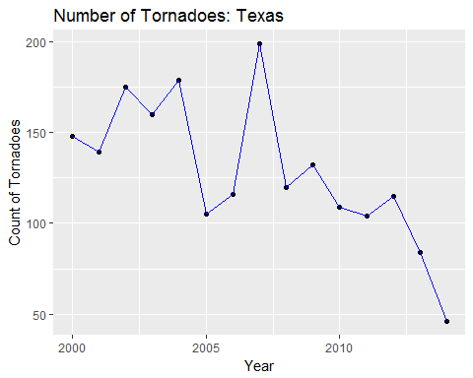

#-We plotted the exports vs the year for the state of Texas  
ggplot(dTexas, aes(dTexas$Year)) +  
 geom_line(aes(y = dTexas$Agricultural.Exports, colour = "Agricultural Products")) +  
 geom_point(aes(y = dTexas$Agricultural.Exports, colour = "Agricultural Products")) +  
 geom_line(aes(y = dTexas$Plant.Products, colour = "Plant Products")) +  
 geom_point(aes(y = dTexas$Plant.Products, colour = "Plant Products")) +  
 geom_line(aes(y = dTexas$Animal.Products, colour = "Animal Products")) +  
 geom_point(aes(y = dTexas$Animal.Products, colour = "Animal Products")) +  
 xlab("Year") + ylab("State-wise Exports") + ggtitle("Exports: Texas") + labs(color='EXPORTS')

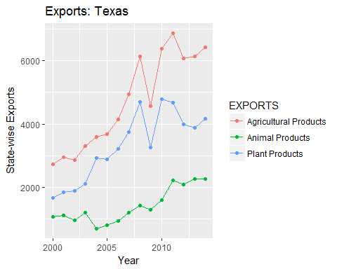

#--We plot the agricultural products and the   
#--magnified version of number of tornadoes   
#--to observe a pattern and deduce a conclusion for the state of Texas  
ggplot(dTexas, aes(dTexas$Year)) +   
 geom_line(aes(y = dTexas$Count*30, colour = "Count")) +  
 geom_point(aes(y = dTexas$Count*30, colour = "Count")) +  
 geom_line(aes(y = dTexas$Agricultural.Exports, colour = "Agricultural Products")) +  
 geom_point(aes(y = dTexas$Agricultural.Exports, colour = "Agricultural Products")) +  
 xlab("Year") + ylab("Agricultural Products") + ggtitle("Exports vs #Tornadoes: Texas") + labs(color='EXPORTS');

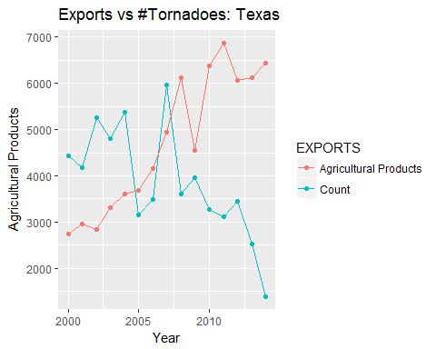

#--We plot the Plant products and the   
#--magnified version of number of tornadoes   
#--to observe a pattern and deduce a conclusion for the state of Texas  
ggplot(dTexas, aes(dTexas$Year)) +   
 geom_line(aes(y = dTexas$Count*30, colour = "Count")) +  
 geom_point(aes(y = dTexas$Count*30, colour = "Count")) +  
 geom_line(aes(y = dTexas$Plant.Products, colour = "Plant Products")) +  
 geom_point(aes(y = dTexas$Plant.Products, colour = "Plant Products")) +  
 xlab("Year") + ylab("Plant Products") + ggtitle("Exports vs #Tornadoes: Texas") + labs(color='EXPORTS');

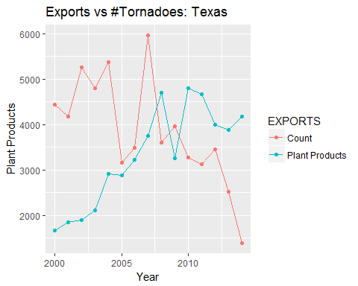

#--We plot the Animal products and the   
#--magnified version of number of tornadoes   
#--to observe a pattern and deduce a conclusion for the state of Texas  
ggplot(dTexas, aes(dTexas$Year)) +   
 geom_line(aes(y = dTexas$Count*10, colour = "Count")) +  
 geom_point(aes(y = dTexas$Count*10, colour = "Count")) +  
 geom_line(aes(y = dTexas$Animal.Products, colour = "Animal Products")) +  
 geom_point(aes(y = dTexas$Animal.Products, colour = "Animal Products")) +  
 xlab("Year") + ylab("Animal Products") + ggtitle("Exports: Texas") + labs(color='EXPORTS')

