Relationship between tornado occurences and the agricultural product exports for the state of Texas.

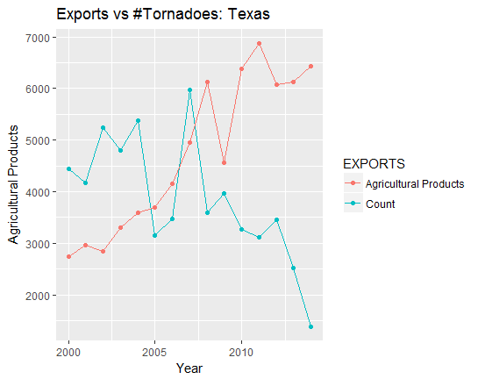

We now examine how the tornado occurrences impact exports from the United States. We chose the state of Texas to check whether there is correlation between the tornado occurrences and exports, as it has the most number of tornado occurrences. We execute the multiple regression statistical test with the dependent variable as agricultural product exports and the independent variable as the number of tornadoes and the average of F-scale. Based on the p-values obtained we conclude that there is a negative correlation between the count of tornadoes and the agricultural product exports. This relation is also seen in the plot shown above where the agricultural product exports decreases with an increase in the number of tornadoes for the state of Texas.