Jeremy Reep

Hemachandra Ghanta

Ruhi Damda

ISQA 8086 Final Summary

Polk County Parks

The clients for this project are two separate entities of the Polk County Park system. Candice Knothe is an environmental specialist/biologist with Parks and Natural Resources in Polk County, Florida. She monitors state or federally listed sensitive species on the federal lands managed by the park system. The species this group has been tasked with is the sand skink, a federally listed threatened fossorial lizard that is found in the central Florida xeric territories. The second client entity is headed by Britt Sutherland, who has been monitoring water quality data in the wetlands of the Circle B Bar Reserve. Both entities have supplied data that this group has analyzed in pursuit of specific research questions.

The sand skink is native to the central Florida peninsula and lives in sandy, shrubby areas where it spends most of its time underground to better avoid predators. This habitat is decreasing due to human interference in the form of commercial, residential, and agricultural development.

A large part of sand skink study is better understanding its natural habitat and how it affects the species. Due to the threatened status of the lizard its habitat, much of the recent research has revolved around how better to understand the relationship between the two. This has been relatively difficult to measure as identified by Britt, et al. in 2010 who confirmed a long-standing hypothesis that the last 60 years of observation was not long enough to discern any notable genetic change in the species. Simply, the lizards live longer than previously thought so measuring generational change is difficult.

This has only emphasized the need to better understand the habitat and how the skinks cope with its change. The lizards are difficult to measure over time, both because of how long they live and also because they are predominantly underground, but the habitat is much easier to study. Interestingly, Exum, Peterman, and Pike found that the sand skinks are quite capable of living in human-altered habitats as long as the soil or sand underneath wasn’t too changed (2007). While the sandy central Florida dunes are preferred, the skinks appear to adapt well enough to the encroachment of man.

The sand skink data supplied by Ms. Knothe is primarily a set of observations split between five sites, where each site is split into a number of points that are divided by quadrant. The observations are recorded at each of these point quadrants over a period of 2003 through 2018 with the majority of the observations recorded in the last few years. Due to the nature of sand skinks to travel under the surface of the sand, a sighting is recorded if the lizard or its tracks are found. Only a complete absence of the lizard or its tracks count as a missed sighting. The supplementary data is a record of the controlled burn schedule in four of the five sites since 2001. sand skink literature has posited that controlled burns in xeric environments have a positive effect on sand skink populations, so this data was supplied to supplement our analysis.

The sand skink data was processed to make it easier to manipulate with R scripting language. Blank columns and rows were removed and notations for each category of observation were made consistent. There were minor spelling and date issues that also required correction for consistency within R.

The specific research questions regarding the sand skinks are as follows:

1. What is sand skink presence or absence at each site for each year? What is the long-term trend in sand skink presence for each site?
2. Has there been a decline in the presence of sand skinks for three years or more at any of the sites?
3. Are there differences in sand skink presence between sites and years?
4. Is there a relationship between sand skink presence/absence and prescribed fire? Is there a decline in sand skink presence due to prescribed fire?

These questions are applied to the 5 different observation sites for the sand skinks: Crooked Lake Sandhill, Crooked Lake West – Stuart, Crooked Lake West – Lewis, Hickory Lake Scrub, and Crooked Lake Prairie. Again, each of these sites were divided into a series of points, of which each point was divided into observation quadrants.

These questions underscore the importance of having a better picture of the present conditions of the sand skink habitat. The population trends are important from a simple perspective of understanding where the skink population is, how it is reacting to changes in the habitat, and the pure absolute quantity of skinks that might be around. Due to the subterranean nature of the sand skink, the prescribed fires in research question four are of significant interest. The periodic controlled burns within the habitat have the goal of increasing the nutrient density within the layers of sand as shrubbery is combusted, which should have a positive impact on the skinks as they move back into the burned areas. These burns are indicated on our plots via the vertical solid black lines.

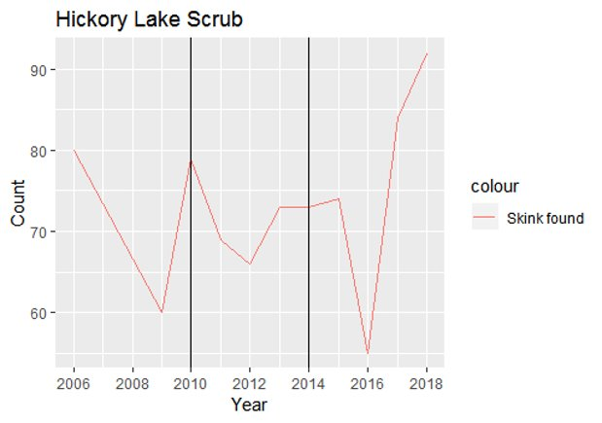

The first observation site is Hickory Lake. Data between 2006 and 2018 show a slight downward trend in observed sand skinks with a population peak in 2018. The results of the 2010 and 2014 burn appear to be inconclusive as the same four-year lag from both had different effects. Both induced a short-term population decrease but 2014 did not see the same population rebound that 2018 has seen.

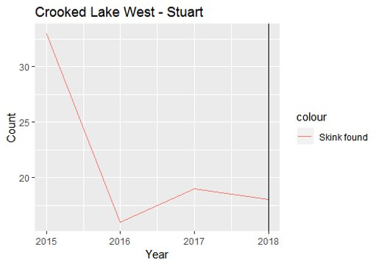

Crooked Lake West – Stuart and Crooked Lake West - Lewis both have nearly identical plots except for the single burn that occurred in Stuart this year. The unfortunate conclusion is that the sand skink population has been decreasing for the last three years. The 2018 burn is also too recent for us to have any insight into its effects on the local population. It is possible that the trends before 2015 were more positive or had different magnitudes that could shed more light on this recent decrease in sand skink observations.

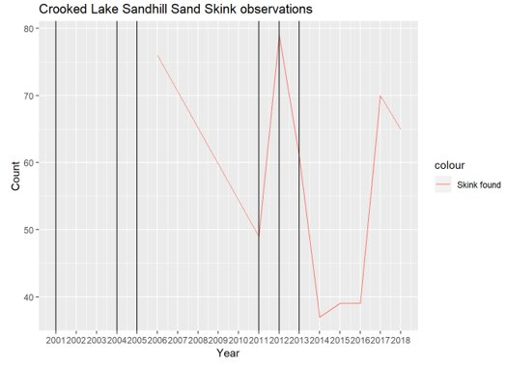

Crooked Lake Sandhill is the largest observation set within this project. Three burns occurred in 2011, 2012, and 2013 which also had interesting results. The immediate effects were not consistent and a positive effect, if any, can be seen after a four-year lag in 2017. Overall, the sand skink presence has not been consistent with a gradual population decrease if a conclusion must be had.

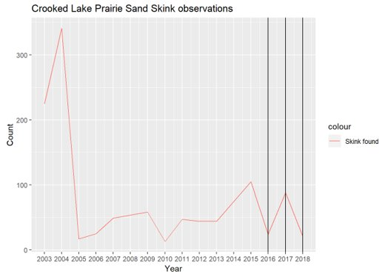

A starker conclusion might be had from the Crooked Lake Prairie data. The sand skink population experienced a severe decline in the 2004-2005 period and has yet to recover. Gains made in the 2010-2015 period appear to have largely been wiped out by 2018. The recency of the burns in this area, 2016, 2017, and 2018, don’t allow for any meaningful analysis of their effects. As seen elsewhere, the inter-burn period has a significant fluctuation of sand skink observations but we lack any real long-term data to show a consistent lag effect from the burns.

The water quality analysis in the Circle B Bar Reserve is largely more straightforward. Mr. Sutherland has been working to quantify the benefits of the wetlands in the reserve. The water flows through two routes on the north and south end of the reserve before depositing into Lake Hancock. The quality of the water is of note due to the number of distinct, protected ecosystems within the reserve. Water quality data was supplied for the period of November 2017 – September 2018. Observations were taken at consistent locations all along the north and south paths of the wetlands.

Processing of the water data was minimal. The supplied data was largely clean and only required slight manipulation. A Boolean variable was added to differentiate between the north and south routes. The sequence of observation points was also codified with a series of integers. Each month’s observations were then collated into a single data file for manipulation with R.

The research questions for the water quality data are isolated to total nitrogen and total phosphorous in the water system.

1. How much of the total nitrogen is removed as water travels through the system?
2. How much of the total phosphorous is removed as water travels through the system?

Both of these questions were applied to the north and south route of the wetland. The southern route has four observation points: Banana Creek, Wading Bird South, Eagle Roost Road, and the Canal Outflow. Nitrogen and phosphorous are both essential nutrients for animal and plant life but can produce negative outcomes in the event of an overabundance. Tracking the levels of these two nutrients can also inform observers on the levels of fertilizers in the ecosystem.

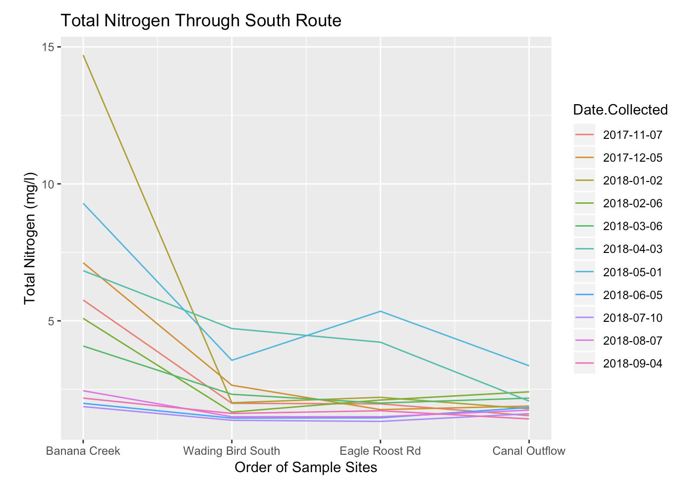

Over all of the observation dates, the total nitrogen levels in the south route decreased in absolute terms. Nitrogen does spike at Eagle Roost Road for two of the observation dates, but the trend is strong even among those two dates in the reduction of nitrogen levels. The initial conclusion is that this path through the waterway is an effective filter for nitrogen. A notable observation is that the levels of nitrogen do slightly ride at the Canal Outflow. This has largely been attributed to backflow from Lake Hancock, which was a suspected issue by Mr. Sutherland.

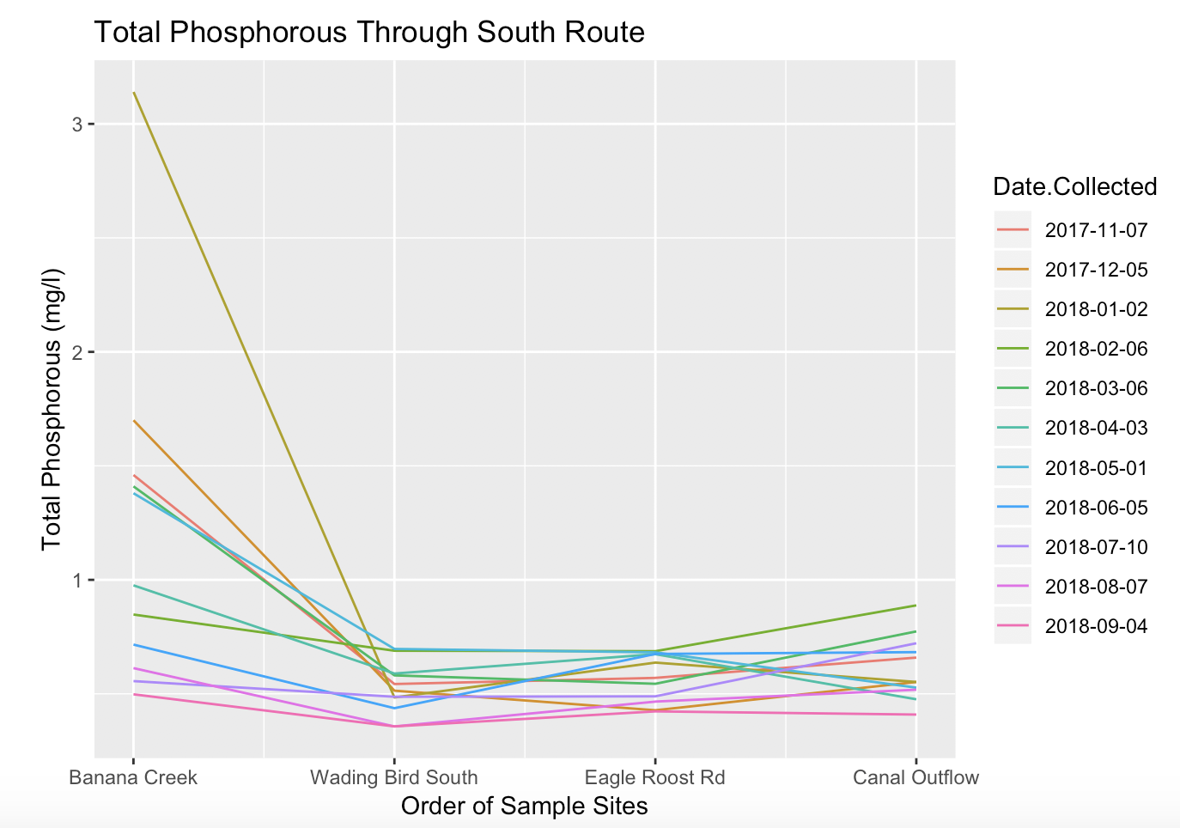

The total phosphorous levels have a similar conclusion compared to nitrogen. Some levels of phosphorous decrease dramatically whereas some remain consistent or even end with a slight increase, however the largest difference is that the amount of phosphorous is overall nearly four times lower than that of nitrogen. This reveals itself in the visualization by magnifying the backflow effect from Lake Hancock while still showing a downward trend in phosphorous levels.

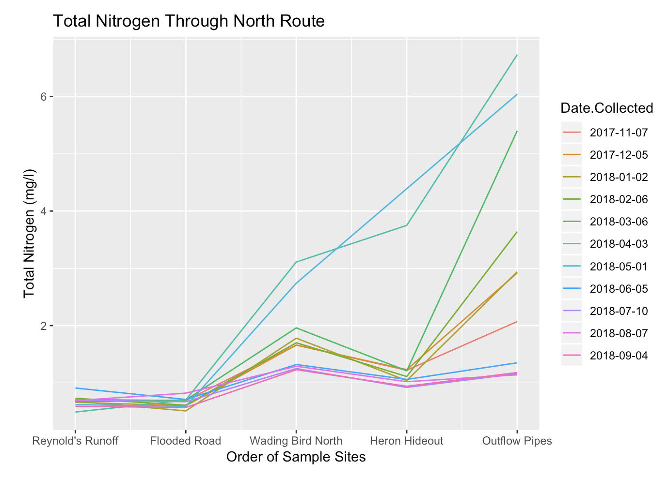

The north route is markedly different than the south route in terms of filtration effectiveness. Even with the addition of a fifth sampling site, nitrogen levels uniformly increase through the water path. The order of sample sites was provided and verified with Mr. Sutherland, who also confirmed that there are elevation differences between the northern and southern routes. This sort of difference also carries through to the phosphorous in the northern route.

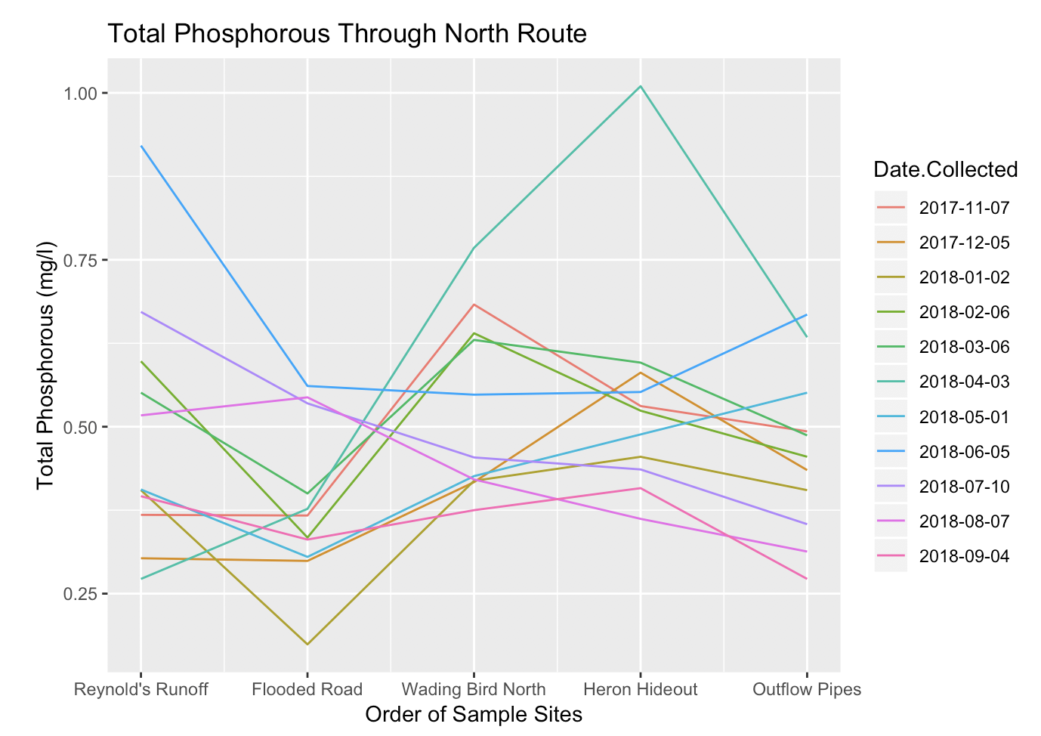

The main difference with the northern route is that the overall trend appears to be downward sloping indicating a removal of phosphorous, however the values fluctuate greatly throughout the system. A point worth noting though is that the real values of this fluctuation are quite small as the total amount of measured phosphorous is less than in the southern route. The smaller amount of phosphorous, and nitrogen, may be amplifying the visualization of the distortion. Regardless, the trends indicate that there is a larger problem in the north route with either poor elevation changes or backflow from Lake Hancock.

The conclusions and recommendations from analysis of the sand skink and water quality projects within Polk County Parks are relatively straightforward then. We did not observe a consistent pater of sand skink presence after the prescribed burns at any of the sites. The overall trend within the sites is also of a decreasing sand skink population, regardless of when a burn occurred. It is our belief that continuing to observe sand skinks will reveal some sort of relationship between their population and the prescribed burns. Currently, the data on the burns is too recent to make an accurate judgement on how the affect the populations as the effects may be lagged over a period greater than four years.

Water quality along the Circle B Bar Reserve appears to change according to assumptions. The southern route maintains a consistent downward trend in both nitrogen and phosphorous particulates that is only countered by a slight backflow from Lake Hancock. Our recommendation is to continue minimal monitoring of this route to ensure that this behavior continues. The northern route is also performing largely as expected, but we are now able to pinpoint specific sample sites where particulate levels seem to be more extremely affected. Elevation changes appear to be more dramatic between sample sites, as well as the backflow from Lake Hancock. Our recommendation is to keep these fluctuations in mind when planning ecological work along the northern route or to use these findings as an initial data finding in order to perform work that may alleviate some of the observed elevation changes.

Works Cited

Britt, Eric J., J. Steve Godley, Earl D. McCoy, Henry R. Mushinsky, and Jonathan Q. Richmond. 2010. "Long Generation Time Delays the Genetic Response to Habitat Fragmentation in the Threatened Florida Sank Skink." *Journal of Herpetology* 44 (4): 641-644.

Exum, J. H., K. S. Peterman, and D. A. Pike. 2007. "Use of Altered Habitats by the Endemic Sand Skink (Plestiodon reynoldsi Steineger)." *Southeastern Naturalist* 6 (4): 715-726.