1. Objective
The main objective of this experiment is to evaluate and compare the inside temperature and relative humidity readings of a room from the HMP155 and AHT10 sensors, and to identify and correct any consistent bias or offset observed between their measurements.
In this setup, both sensors were connected to a Raspberry Pi, which continuously recorded data at an interval of one minute. By collecting simultaneous readings from both sensors under the same environmental conditions, it becomes possible to evaluate how closely the AHT10 follows the performance of the HMP155. By comparing the outputs of the two sensors and identifying the consistent differences (bias) between them, the goal is to apply a correction to the AHT10 readings so that they more closely align with the reliable measurements provided by the HMP155.
2. Experimental Setup
The experimental setup was designed to record temperature and relative humidity data using two sensors, HMP155 and AHT10, connected to a Raspberry Pi for continuous monitoring and data logging. The arrangement ensured that both sensors experienced the same environmental conditions, allowing for a fair comparison of their performance.
Sensors used:
AHT10 – It is a compact, low-cost digital sensor capable of measuring both temperature and relative humidity. It is often used in IoT and hobbyist applications due to its small size, low power consumption, and ease of integration with microcontrollers like the Raspberry Pi.
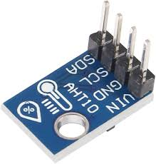
Figure 1: AHT10
HMP155 - It is manufactured by Vaisala, is a high-precision temperature and humidity probe commonly used in research and meteorological applications. It provides accurate and stable readings even in varying environmental conditions. Since it is factory-calibrated and widely regarded as reliable, it was chosen as the reference sensor for this study.
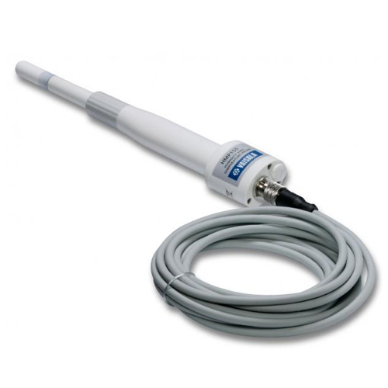
Figure 2: HMP155
The following diagram shows circuit connection of the setup:

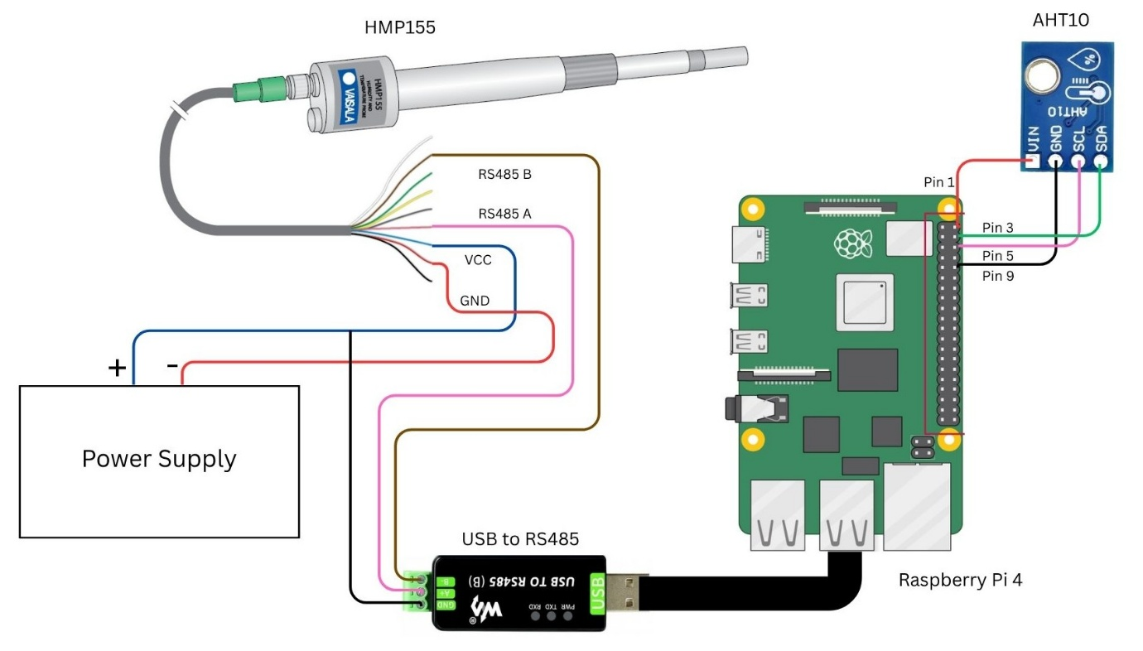
Figure 3: Circuit Diagram

Both the sensors were places side-by-side and the distance between the HMP155 and AHT10 sensors was approximately 14cm, ensuring close spatial proximity. The following image shows the experimental setup:

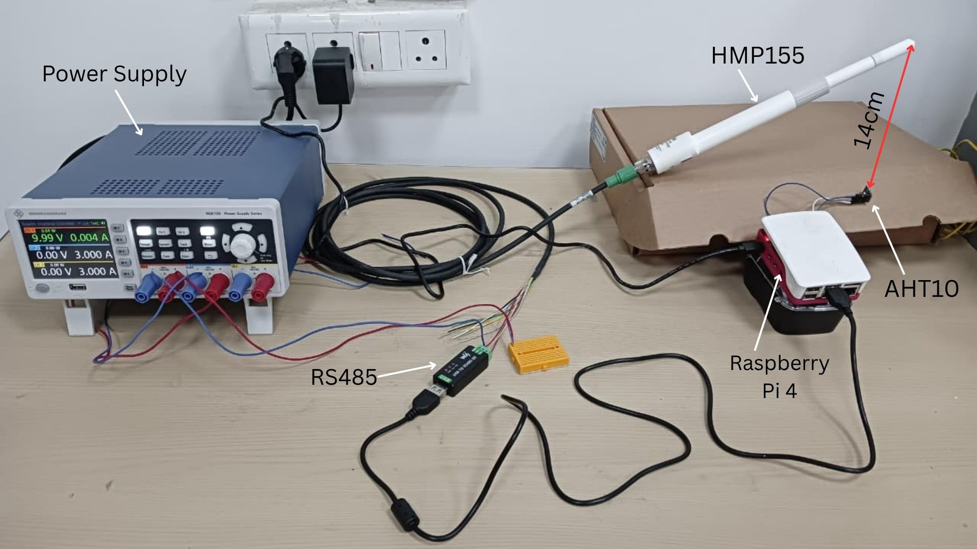
Figure 4: Setup

3. Methodology
3.1 Calculation of Error, Mean, and Standard Deviation
The difference (error) between the two sensors was calculated for both temperature and relative humidity using the following equations:
E_{T} = T_{HMP} – T_{AHT}
E_{RH} = RH_{HMP} – RH_{AHT}
where, T_{HMP} and T_{AHT} are the temperature and RH_{HMP} and RH_{AHT} are the relative humidity from HMP155 and AHT10.
The mean error (average bias) and standard deviation (SD) were then calculated from one full day of data and we calculated using the data from 24th October 2025. The mean represents the systematic bias, while the SD indicates the spread or variability of the errors.
Mathematically, the bias is given by:
B_{T} = $\frac{1}{N}$ $\sum_{k=1}^{N}{\left(T_{HMP_{k}}-T_{AHT_{k}}\right)}$
B_{RH} = $\frac{1}{N}$ $\sum_{k=1}^{N}{\left({RH}_{HMP_{k}}-{RH}_{AHT_{k}}\right)}$
where, B_{T} and B_{RH} are the bias in temperature and humidity
and N is the number of samples taken.
The standard deviations are given by:
σ_{T =} $\sqrt{1/N\sum_{k=1}^{N}{{\left(E_{T_{k}}-B_{T}\right)}^{2}}}$
σ_{RH =} $\sqrt{1/N\sum_{k=1}^{N}{{\left(E_{RH_{k}}-B_{RH}\right)}^{2}}}$

3.2 Bias Correction
The calculated mean errors were then used to correct the AHT10 data for all other days of measurement. The correction was applied as a simple offset to the AHT10 readings:
T_{AHT,corrected} =T_{AHT} + B_{T}
RH_{AHT,corrected} =RH_{AHT} + B_{RH}
This adjustment minimizes the bias and aligns the AHT10 data more closely with the HMP155 reference readings. The corrected values were then plotted along with the HMP155 data to visually confirm the improvement in agreement.

4. Data Visualization
We calculate the mean and standard deviation using the data of 24th October 2025.The following graph shows the temperature and relative humidity data from HMP155 and AHT10 along with a bar graph which shows the error between the two devices’ data.
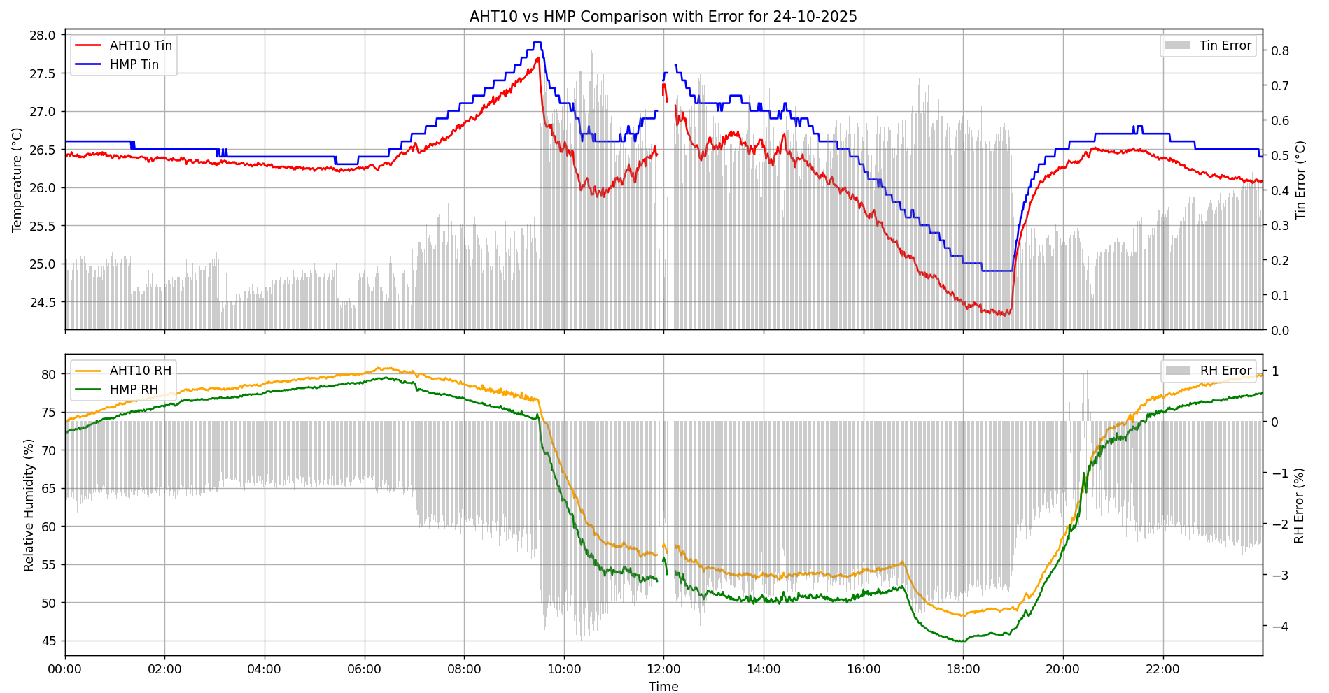
Figure 5: Graph before removing bias
From the above graph, we calculate the average error (bias) and standard deviation. We got the following result:
Average error in temperature (B_{T}) = 0.3407435719249478
Standard deviation in temperature (σ_{T}) = 0.19000604700508397
Average error in relative humidity (B_{RH}) = -2.2783460736622656
Standard deviation in relative humidity (σ_{RH}) = 0.9256705510937738
Now we add these biases to these same data of the same day and again calculate the new mean and standard deviation. After addition of the bias in temperature and relative humidity we get the following graph:
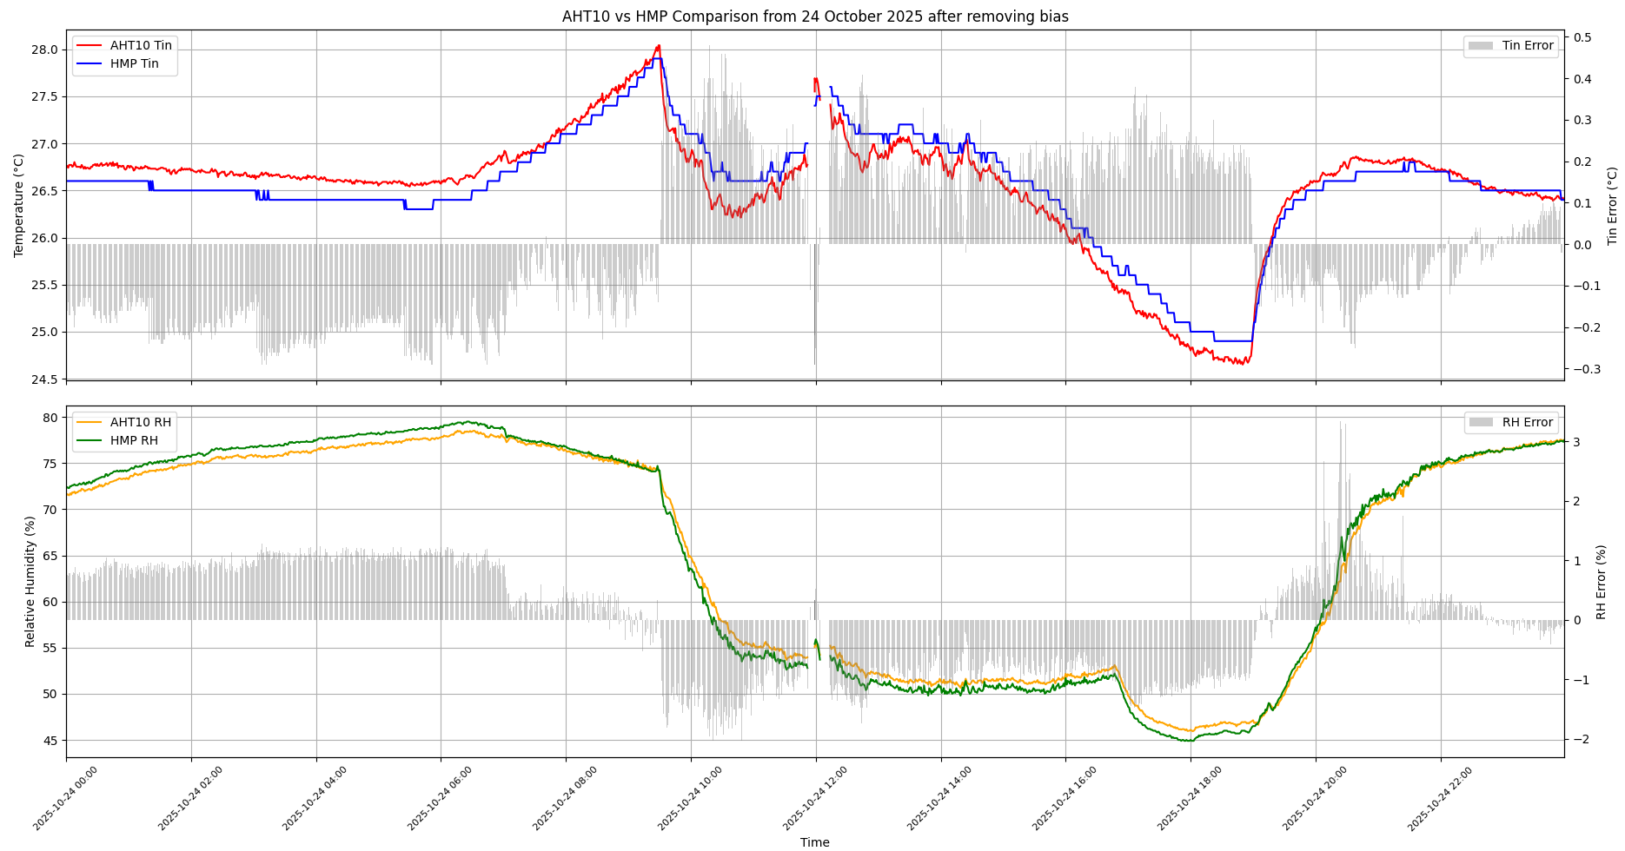
Figure 6: Graph after removing bias of 24 October 2025
After calculation of new average error and standard deviation we get:
Average error in temperature (B_{T}) = 1.5158903396688725 x 10⁻¹⁵
Standard deviation in temperature (σ_{T}) = 0.19000604700508397
Average error in relative humidity (B_{RH}) = -2.5676318456932044 x 10⁻¹⁵
Standard deviation in relative humidity (σ_{RH}) = 0.9256705510937737
The following shows the plot of HMP and AHT data after we remove this bias from all the data for the days from 23rd October to 26th October 2025:
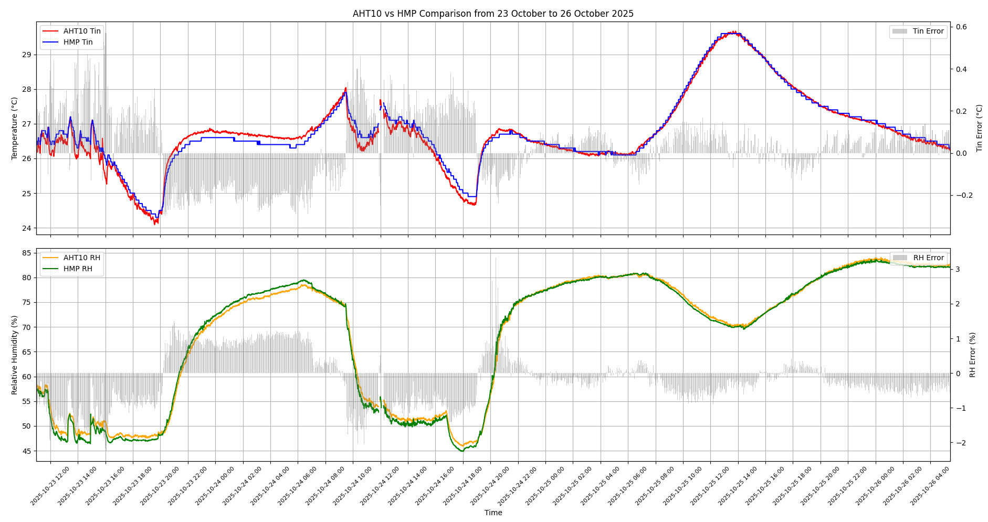
Figure 6: Graph after removing bias from 23 October to 25 October 2025

