**Suggestions**

1. I suggest to change “Change Discount” button into “Add Discount” at the initial stage, when there is no any discount yet.



1. I suggest to add a “Search” button in the “Fundamental” and “Advanced” sections, to save time and find exactly our preferred course.
2. I suggest to color the button which is already pressed, to be clear for the user in which page is he at the moment. In screenshot the chosen field is “MyCourses”.

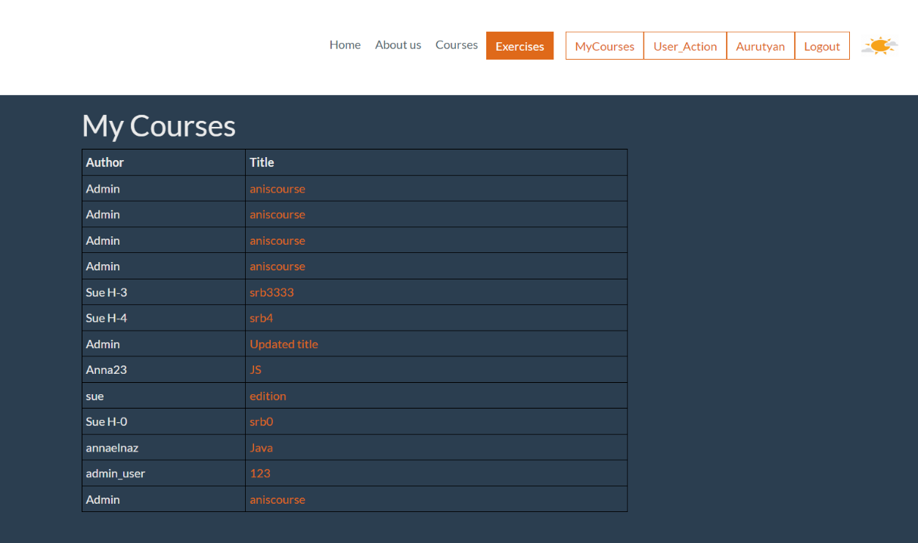

1. I suggest to have a script that the fields “discount” and “course_count” accept only numeric values.



1. I suggest to change the field name “discount” into “Discount” and the field name “course_count” into “Course count”.
2. I suggest to have information about the total count of courses user bought.

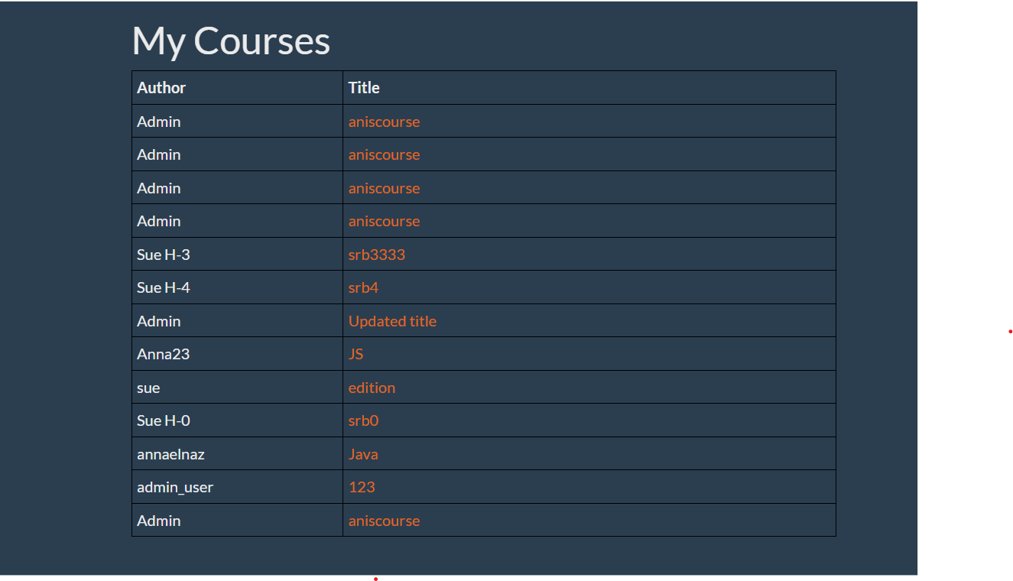

1. I suggest to add an initial information about course acquisition date and duration.
2. I suggest to arrange the courses in alphabetical order.

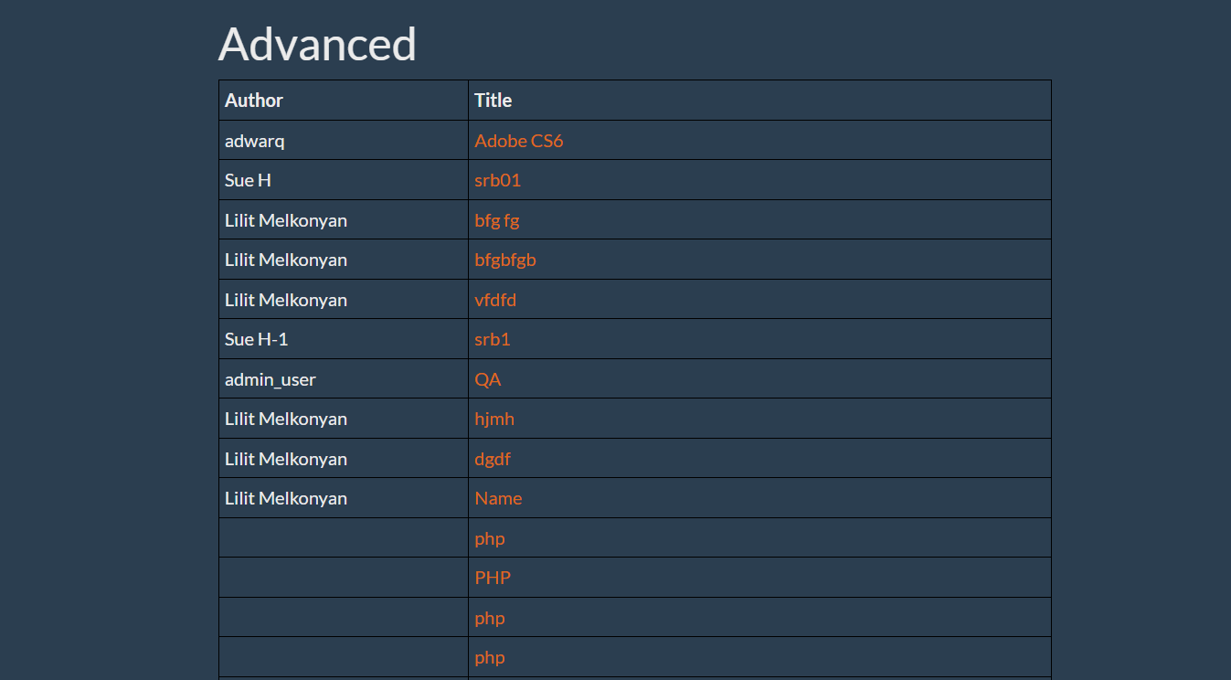

1. I suggest to change “Discount changes” into “Discount is changed” when the admin user is adding a discount.
2. I suggest to have another field, where user can see the prices of courses.



1. I suggest to have a message “The course has been successfully purchased”, when user buys a course.