LibDB

High-Performance Async Library Resource Engine



LibDB is an asynchronous, high-throughput RESTful API designed for university-scale library resource allocation. Bypassing frontend overhead, this engine focuses on raw data throughput, strict schema validation, and fully non-blocking I/O operations using an event-driven ASGI architecture.

Author: Aniket Kundu 23BCE1965
Developed as part of coursework for the MongoDB Database Administrator FACE course.
(Note: Screenshots attached at the end of the report)

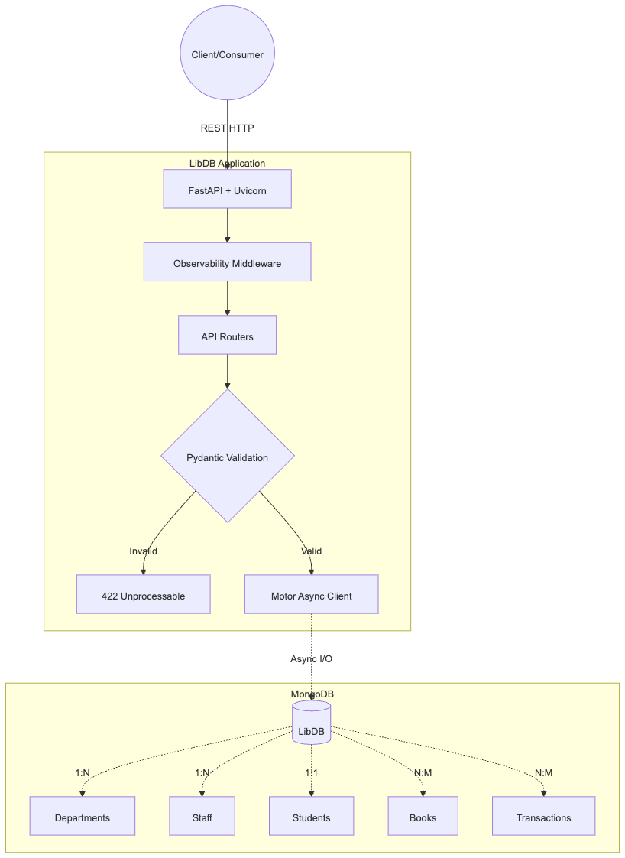
System Architecture

The core of LibDB is built around a non-blocking event loop that handles thousands of concurrent requests without thread-locking, making it highly suitable for distributed environments and peak-load scenarios (like semester end checkouts).
Data Modeling & Relationships
LibDB leverages MongoDB's flexible schema while enforcing strict relational integrity through Pydantic. It utilizes an optimized mix of embedding (for fast reads) and referencing (to prevent array bloat).
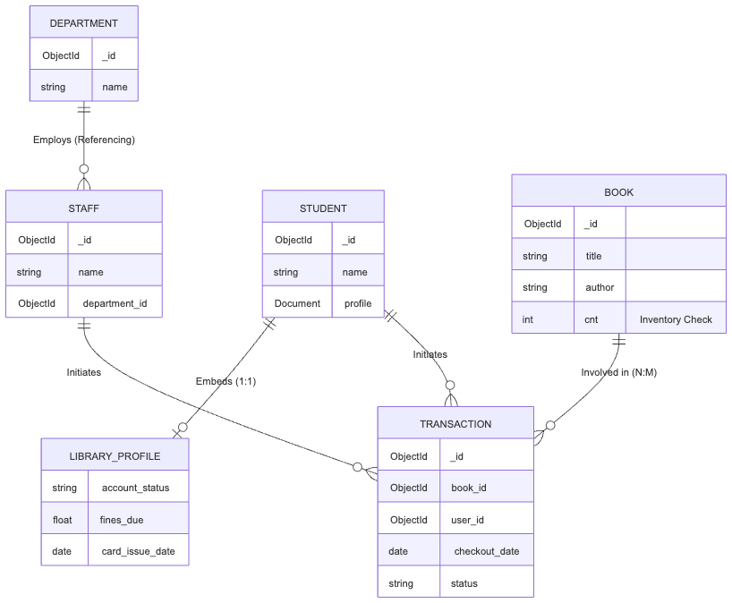

High-Performance Checkout Flow
The transactions router handles the complex N:M mapping. It independently verifies user stock (stk) presence across both Staff and Student domains, and atomically updates the inventory counter (cnt) without race conditions.
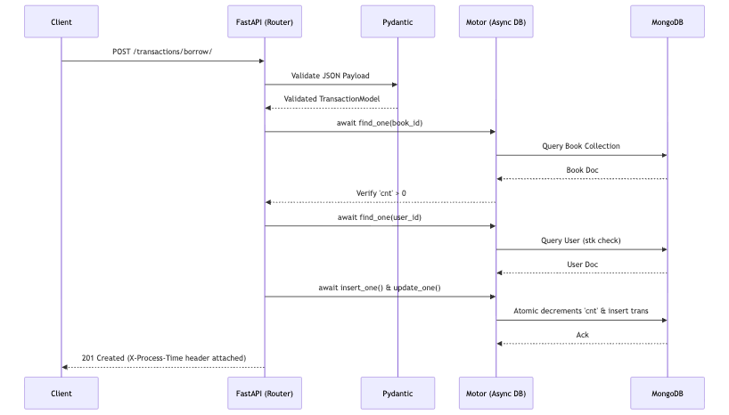

Technology Stack
- Framework: FastAPI (High performance, easy to learn, fast to code, ready for production)
- Server: Uvicorn (Lightning-fast ASGI server implementation)
- Database: MongoDB (NoSQL document database)
- ODM / Driver: Motor (Asynchronous Python driver for MongoDB)
- Data Validation: Pydantic (Data validation using Python type annotations)
- Config Management: pydantic-settings

Project Structure
LibDB/
├── .env # Environment variables
├── config.py # Global settings manager
├── database.py # AsyncIOMotorClient connection logic
├── main.py # Engine entry point & middleware
├── models.py # Strict Pydantic schemas
├── requirements.txt # Python dependencies
└── routers/ # Modular API endpoints
├── __init__.py
├── books.py
├── departments.py
├── staff.py
├── students.py
└── transactions.py

Getting Started

1. Prerequisites
- Python 3.10+
- MongoDB Community Server 7.0+ (Running locally)
- Git

2. Environment Setup
# Clone the repository
git clone [https://github.com/AnicetusVIT/LibDB.git](https://github.com/AnicetusVIT/LibDB.git)
cd LibDB

# Initialize virtual environment
python3 -m venv venv
source venv/bin/activate

# Install dependencies
pip install -r requirements.txt

3. Configuration
Create a .env file in the root directory:
MONGODB_URL=mongodb://localhost:27017
DATABASE_NAME=LibDB
APP_NAME=LibDB Resource Engine

4. Booting the Engine
Start the ASGI server:
uvicorn main:app --reload

Navigate to http://localhost:8000/docs to access the interactive Swagger UI.

API Reference
Domain | Method | Endpoint | Description
Departments | POST | /departments/ | Create a new academic department
 | GET | /departments/ | Fetch all departments
Staff | POST | /staff/ | Register new staff (1:N to Dept)
 | GET | /staff/{id} | Fetch staff details
 | DELETE | /staff/{id} | Remove staff member
Students | POST | /students/ | Register student (1:1 embedded profile)
 | GET | /students/{id} | Fetch student data
Books | POST | /books/ | Add book to catalog (sets initial cnt)
 | PUT | /books/{id} | Update details or inventory
Transactions | POST | /transactions/borrow/ | Checkout book (decrements cnt)
 | POST | /transactions/return/{id} | Return book (increments cnt)

Screenshots:
