Create a single page application. The app has 2 main screens, Intro & Sort.

**Intro screen**

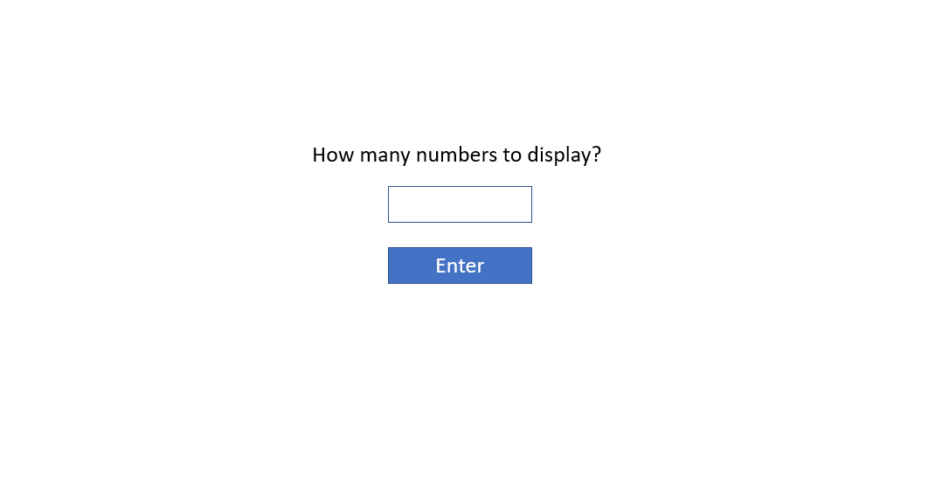

1. Clicking “enter” button takes to next screen, Sort.

**Sortscreen**

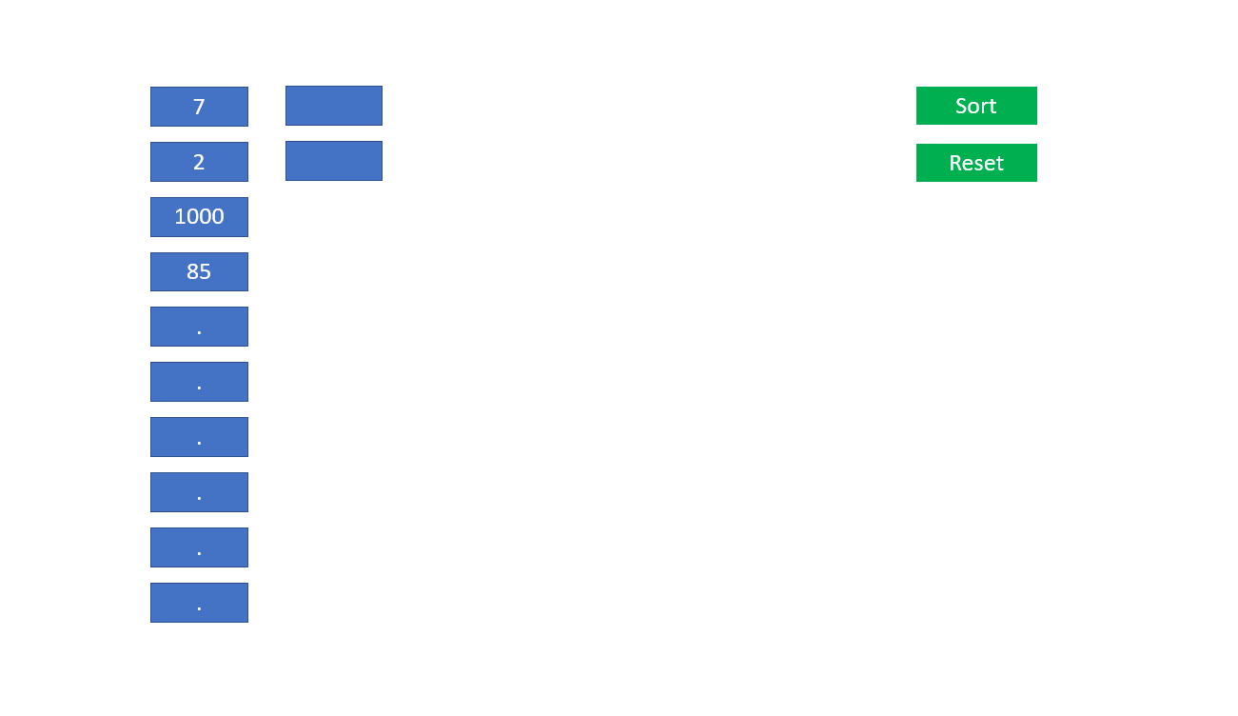

Numbers buttons:

1. Show X random numbers (depends on data entered by user in the previous screen)
2. The max number value is 1000
3. At least one value should be equal or less than 30
4. Present maximum 10 numbers in a column. If there are more numbers, add another column

Sort button:

1. Clicking the sort button will sort the presented numbers in a descending order
2. Clicking the sort button again, will change it to increasing order
3. The screen should be updated after each iteration of quick-sort (i.e. re-implement quick-sort; copy/paste of existing implementation is permitted).

Reset button:

Takes back to intro screen.

Clicking one of the numbers button:

1. If the clicked value is equal or less than 30, present X new random numbers on the screen
2. If the clicked value is more than 30, pop up a message “Please select a value smaller or equal to 30.”

**Implementation requirements**

The app should be created in GWT.

Installation instructions (possibly outdated: this was written about a year ago):

1. Download and install Java SE Development Kit 8u172 (notice, not Java 9 or 10, but 8!) from <http://www.oracle.com/technetwork/java/javase/downloads/jdk8-downloads-2133151.html>

2. Go to [www.eclipse.org/downloads](http://www.eclipse.org/downloads).

3. Download Eclipse.

4. Run the installer.

5. Choose Eclipse IDE for Java Developers.

6. Run the installed Eclipse.

7. Go to Eclipse -> Preferences (or Window -> Preferences).

8. Go to Java -> Installed JREs and make sure Java 8 is selected (add it if not, on Mac, for example, it should be under /Library/Java/JavaVirtualMachines/jdk1.8.0_172.jdk/Contents/Home).

9. Go to Help -> Eclipse Marketplace.

10. Type "gwt" in Find field.

11. Find "GWT Eclipse Plugin 3.0.0".

12. Install with all options.

13. Wait for the installation to complete (progress bar is at the bottom – this takes time).

14. Choose "Install Anyway", when warned about unsigned content.

15. Restart Eclipse when done.

16. Close Welcome screen.

17. Click on File -> New -> Other…

18. Choose GWT Application -> GWT Web Application Project.

19. Type Project name: "gwt", Package: "com.gwt", SDKs – Use GWT and choose GWT 2.8.1. Click Finish.

20. Right click the created project, choose Run As -> GWT Development Mode.

21. In development Mode panel, double click <http://127.0.0.1:8888/Gwt.html> to open it in Chrome.

22. It will take some time to start and compile.

23. You're done: it's running.