1. In the below elements which of them are values or an expression? eg:- values can be integer or string and expressions will be mathematical operators.

*

'hello'

-87.8

-

/

6

2. What is the difference between string and variable?

3. Describe three different data types.

4. What is an expression made up of? What do all expressions do?

5. This assignment statements, like spam = 10. What is the difference between an expression and a statement?

6. After running the following code, what does the variable bacon contain?

bacon = 22

bacon + 1

7. What should the values of the following two terms be?

'spam' + 'spamspam'

'spam' * 3

8. Why is eggs a valid variable name while 100 is invalid?

9. What three functions can be used to get the integer, floating-point number, or string version of a value?

10. Why does this expression cause an error? How can you fix it?

'I have eaten ' + 99 + ' burritos.'

**ANSWER:-**

1. Values: 'hello', -87.8, 6 ; Expressions: *, -, /, +
2. A string is a sequence of characters enclosed within single (' ') or double (" ") quotes, used to represent text. e.g. “Abhishek” ; ‘24101993’

Whereas

A variable is a named storage location that holds a value or reference to a value. It can hold various types of data, including strings, numbers, and other objects.

1. Integers :- Represents whole numbers, like -2, 0, 42.

Floats :- Represents decimal numbers, like -3.14, 2.718.

String :- Represents a sequence of characters, like "abhishek".

1. An expression is made up of values, variables, and operators. It can be a combination of mathematical calculations, logical comparisons, or other operations. Expressions are used to produce a value as an outcome.
2. The main difference between an expression and a statement is that an expression gives a value when evaluated, while a statement performs an action.

An assignment statement like spam = 10 is a statement because it assigns the value 10 to the variable spam.

1. 23 is the result

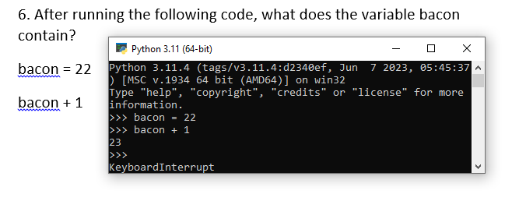

1. Both value will be same

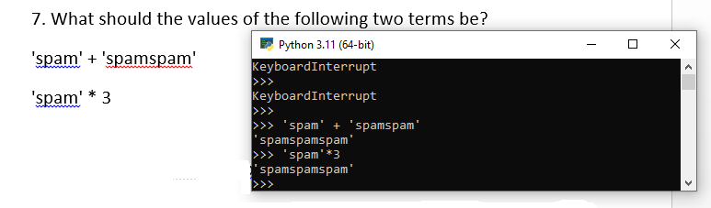

1. Variable name cannot start with number it should be start with any letter so egg is a vaild and 100 is invalid.
2. a. int()

b. float()

c. str()

1. 99 is the integer so we cannot add string to integers so we need to first convert 99 to the string