FEEDBACK MANAGEMENT SYSTEM
By Anisha Sinha, Archit Agarwal, Mayank Chopra
GitHub Link: github.com/AnieSinha/feedback-management-system
Deployed link: feedback-management-ongh.onrender.com

1. Project Overview
The Feedback Management System is an end-to-end training feedback platform that lets an organisation manage faculty, courses, and training programs, collect structured feedback from participants, and turn that feedback into actionable reports. It is built as a Spring Boot REST API backed by MongoDB, secured with JWT authentication and role-based access control across three roles: Admin, Coordinator, and Participant. Admins manage faculty, their skills, and courses; coordinators create and run training programs and enrol participants; participants submit and update feedback on the programs they attend. The system is containerised with Docker and deployed on Render against a managed MongoDB Atlas cluster.

1.1 User Stories
Actor | User Story
Anisha Sinha | As a developer, I want to build the authentication and faculty management layer with features: user login, role-based access control, faculty create, update, and delete operations, and faculty skill management
Archit Agarwal | As a developer, I want to build the course and training program management layer: course create, update, delete, and listing, along with training program creation, modification, deletion, viewing, and participant enrolment.
Mayank Chopra | As a developer, I want to build the feedback and reporting layer: feedback submission and editing, feedback reports, defaulter tracking, training summary reports, and course feedback analytics and connect the system to MongoDB and deploy it on Render.

2. Technical Architecture

2.1 Project Structure
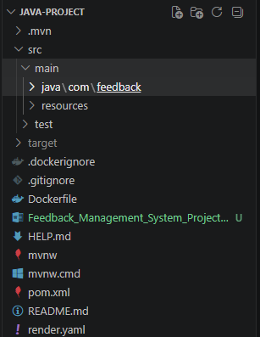

2.2 Core Services
The system is organised into layered Spring components backed by a single MongoDB database.
Component | Description
REST controllers | Spring Boot @RestController layer exposing the auth, faculty, skill, course, training program, feedback, report, and user endpoints.
Service layer | Business logic for each module, including feedback validation, duplicate-submission checks, and report aggregation.
Spring Security + JWT | Stateless authentication. A JWT filter validates the bearer token on each request and populates the security context.
Role-based access control | Method-level @PreAuthorize rules across three roles: ADMIN, COORDINATOR, and PARTICIPANT.
MongoDB (Spring Data) | Document store for users, faculty, skills, courses, training programs, and feedback. Repository interfaces derive the queries.
MongoDB Atlas | Managed cloud cluster used by the deployed application, configured through the MONGODB_URI environment variable.
Static dashboard | HTML, CSS, and JavaScript front-end served by Spring Boot that consumes the REST API and renders charts.
Docker + Render | Docker image deployed as a Render web service, configured by environment variables.

User-1: Anisha Sinha: As a developer, I want to build authentication and faculty management, so that only authorised users can access the system and faculty records and skills are maintained accurately.

1. User Login
Scenario: Training admins, coordinators, and participants log in with their email and password, and receive a JWT that authorises subsequent requests. Valid users reach the application; invalid credentials are rejected.
Output:
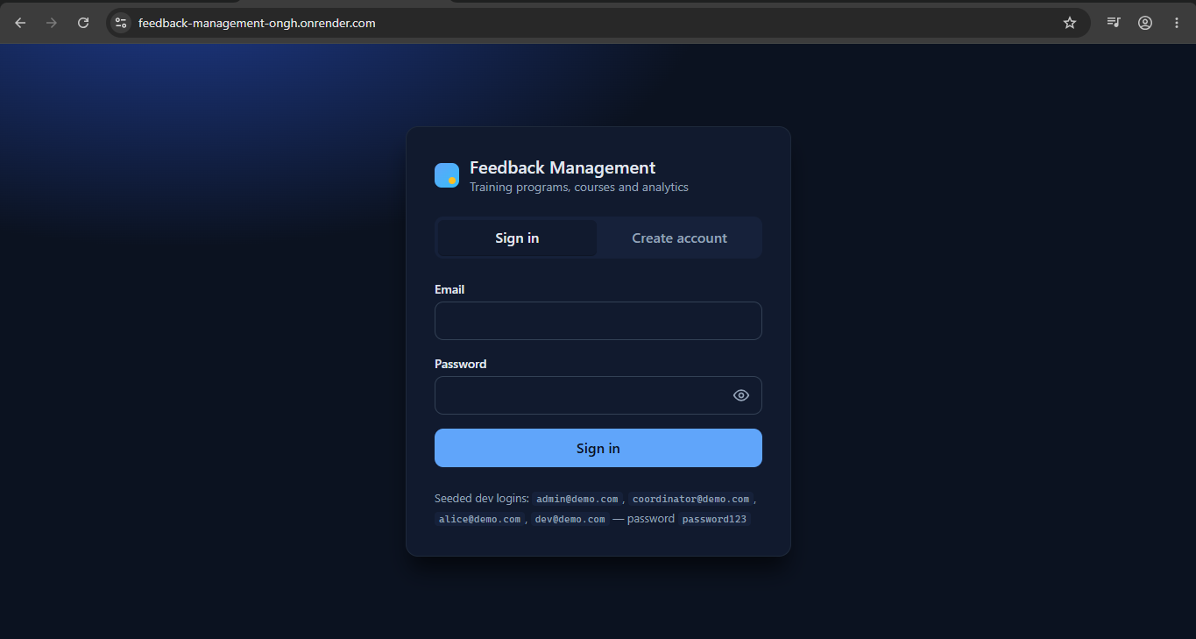

2. Role-Based Access
Scenario: Each user sees and can act on only the features allowed by their role. Method-level authorisation rules enforce the correct permissions for Admin, Coordinator, and Participant.
Output:
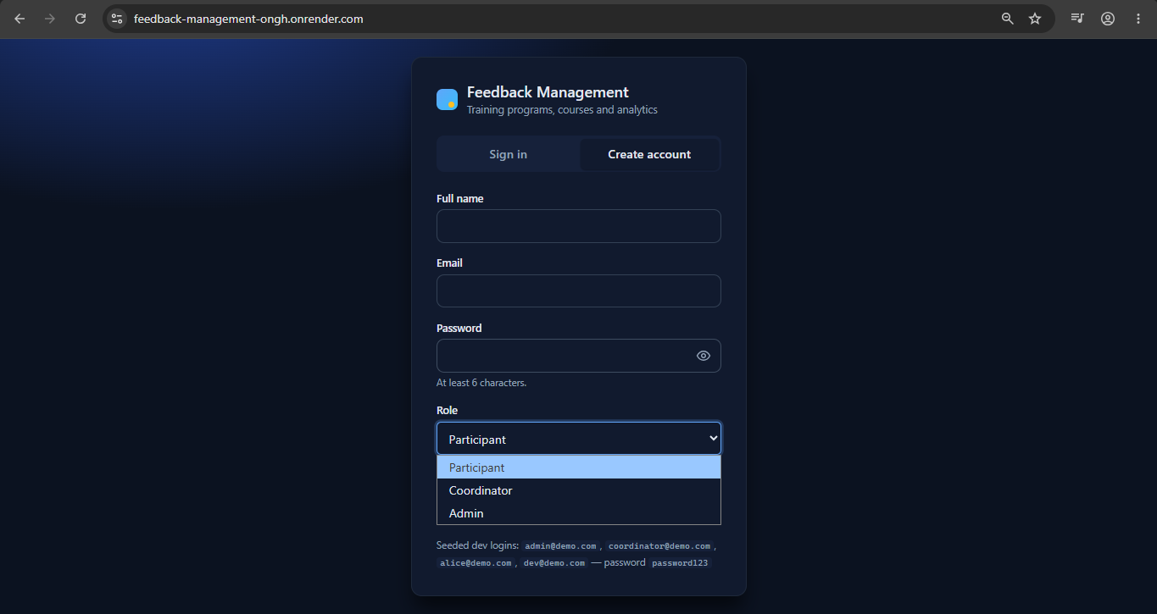

3. Add Faculty
Scenario: An admin adds a faculty member with name, email, department, and years of experience, and the record is saved successfully.
Output:
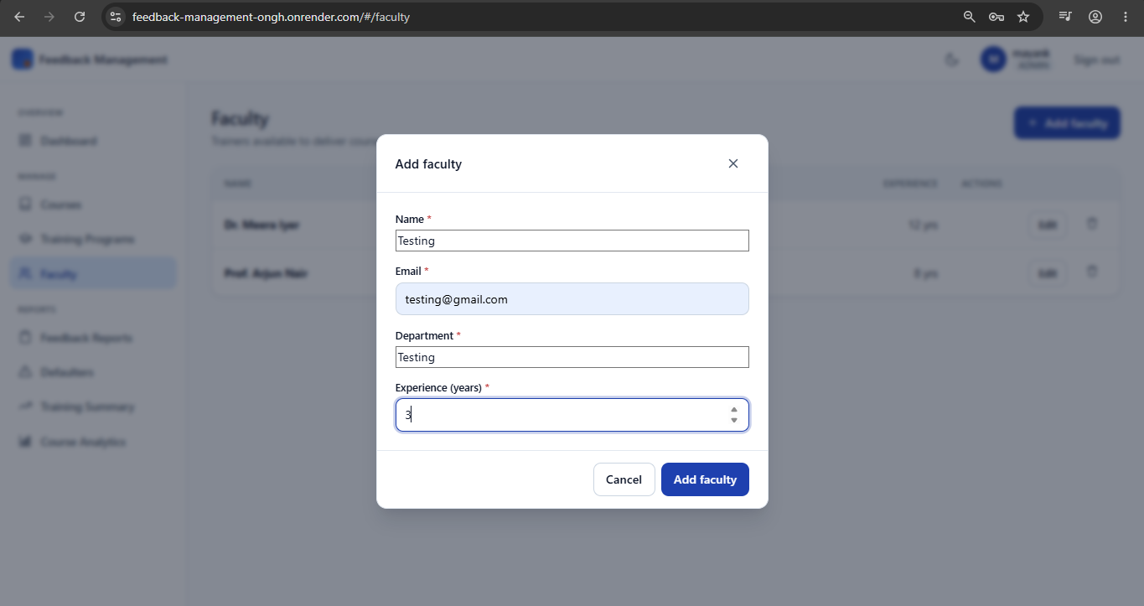
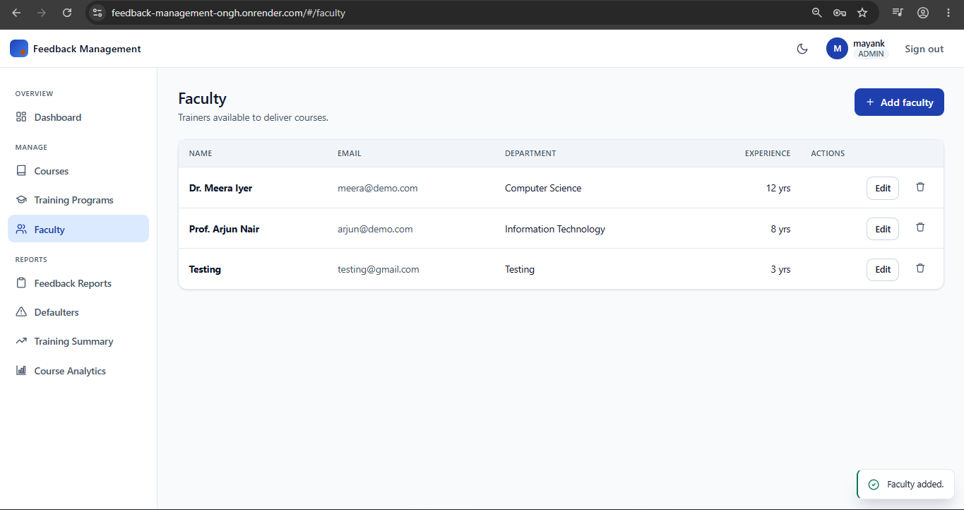

4. Update Faculty
Scenario: An admin edits an existing faculty member's details and the updated information is persisted.
Output:
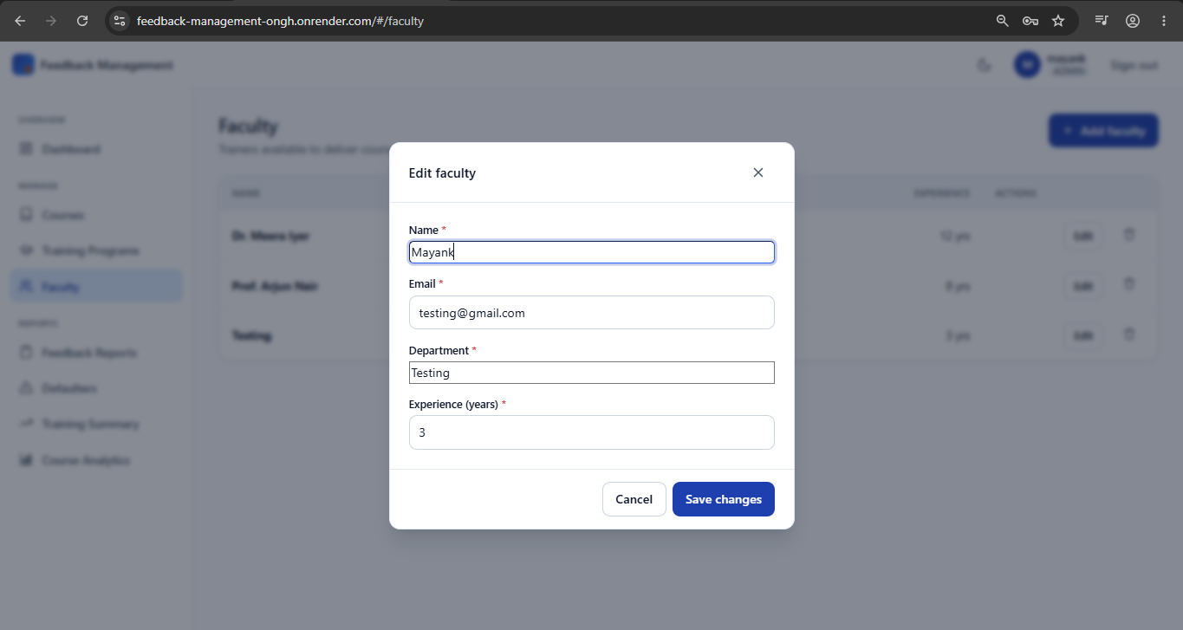

5. Delete Faculty
Scenario: An admin removes a faculty member and the record is deleted successfully.
Output:
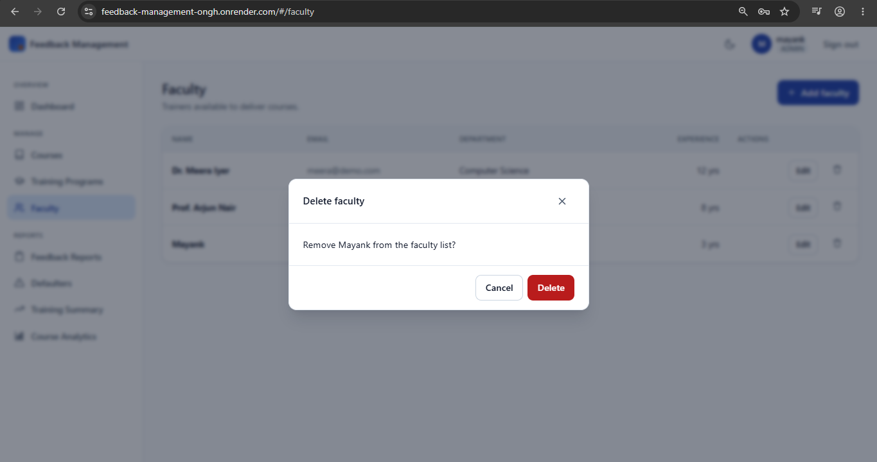
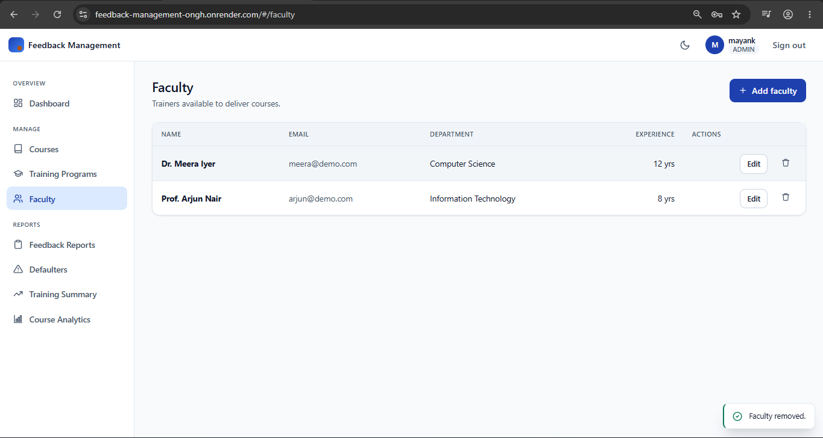

6. Maintain Faculty Skills
Scenario: An admin manages the skill set mapped to each faculty member, adding, updating, and removing skills so that expertise is recorded correctly.
Output:
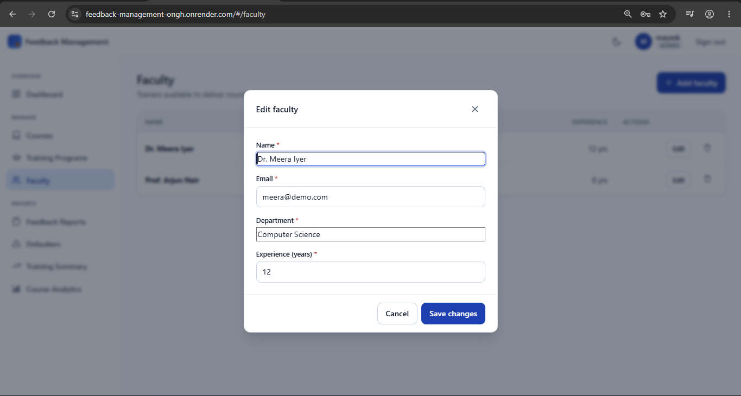

7. Add Course
Scenario: An admin adds a training course with a name, description, and duration, and the course is created successfully.
Output:
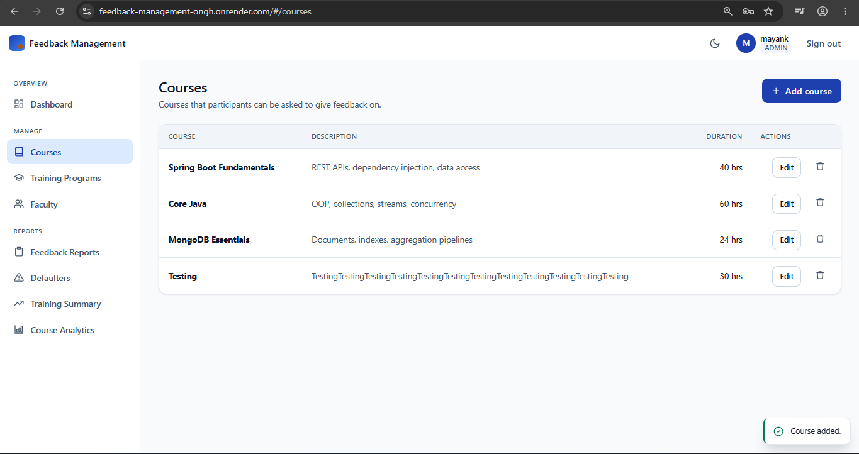

Objective
Deliver secure authentication and authorisation, and a reliable faculty management module that keeps faculty records and their skills accurate.
Key Analysis
- Implement user registration and JWT-based login
- Enforce role-based authorisation for Admin, Coordinator, and Participant
- Build the faculty entity, repository, and REST API
- Add update and delete operations for faculty records
- Create the skill management module mapped to faculty
- Return consistent error responses for invalid credentials and access
Outcomes
- Only authenticated users can reach protected endpoints
- Each role is restricted to the actions it is permitted to perform
- Faculty records can be created, updated, and deleted reliably
- Faculty skills are mapped and maintained accurately
User-2: Archit Agarwal: As a developer, I want to build course and training program management, so that admins and coordinators can manage the training catalogue and enrol participants.

1. Update Course
Scenario: An admin updates an existing course's details and the course information is saved.
Output:
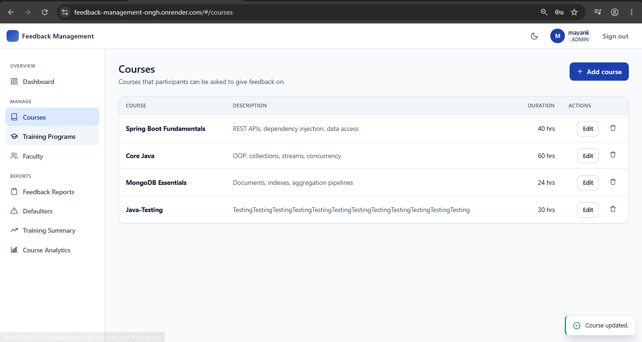

2. Delete Course
Scenario: An admin deletes a course and it is removed from the catalogue successfully.
Output:
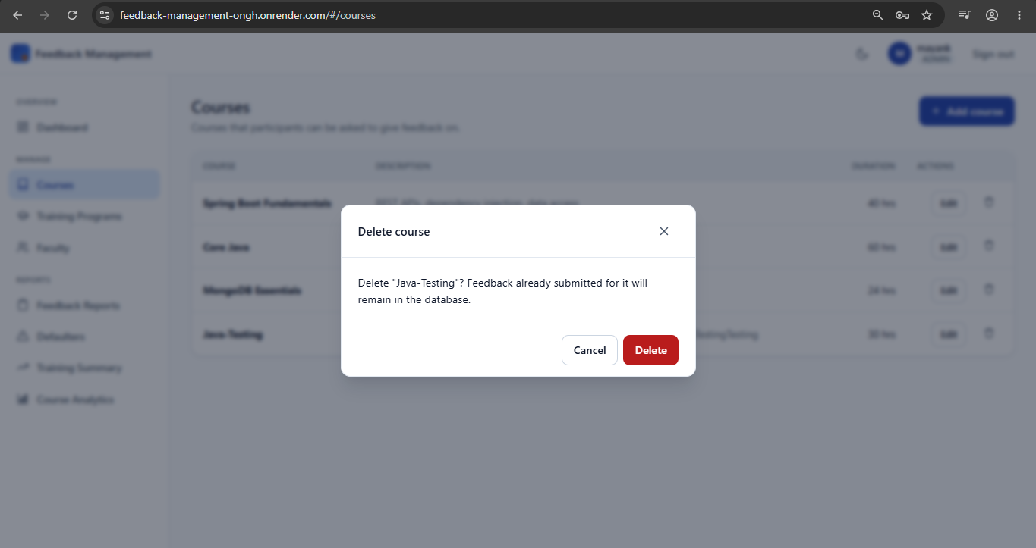
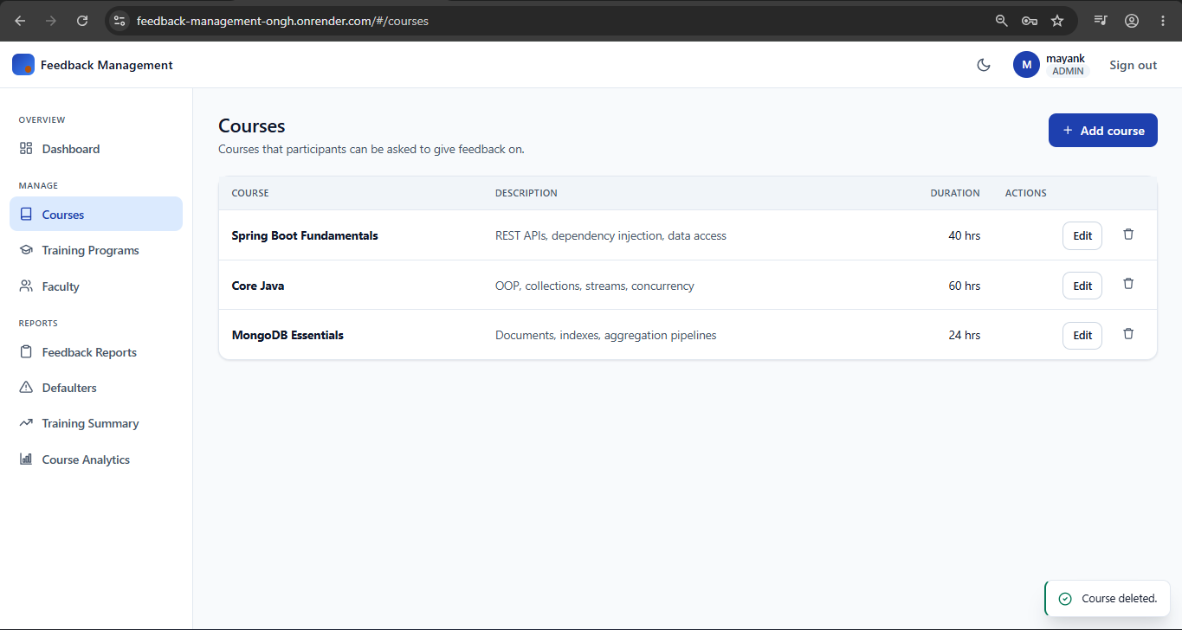

3. View Courses
Scenario: Any authenticated user can view the list of available courses, and the course list is displayed.
Output:
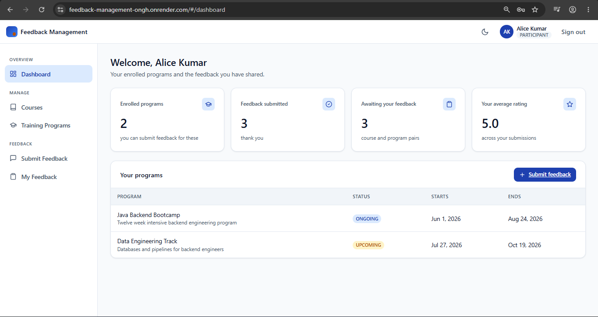
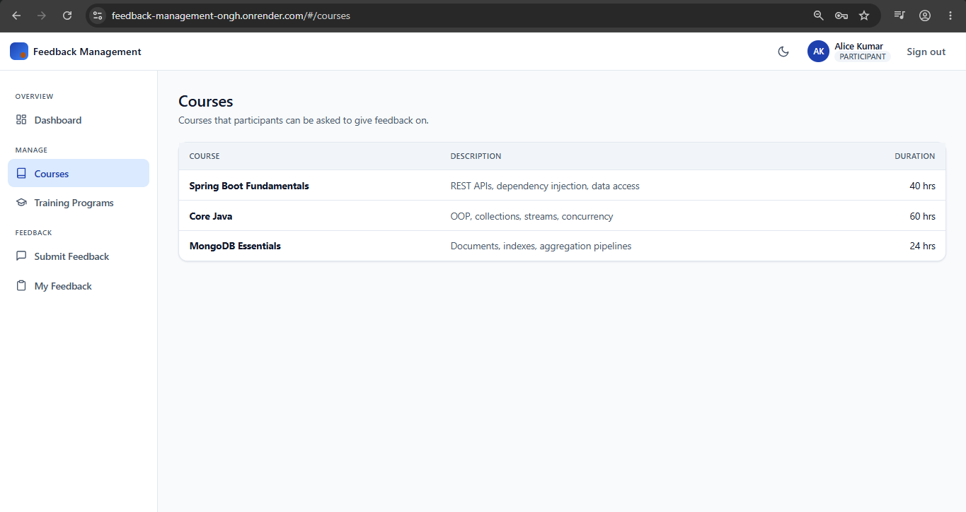

4. Create Training Program
Scenario: A coordinator creates a training program with a name, schedule, participant limit, and the courses it covers, and the program is created successfully.
Output:
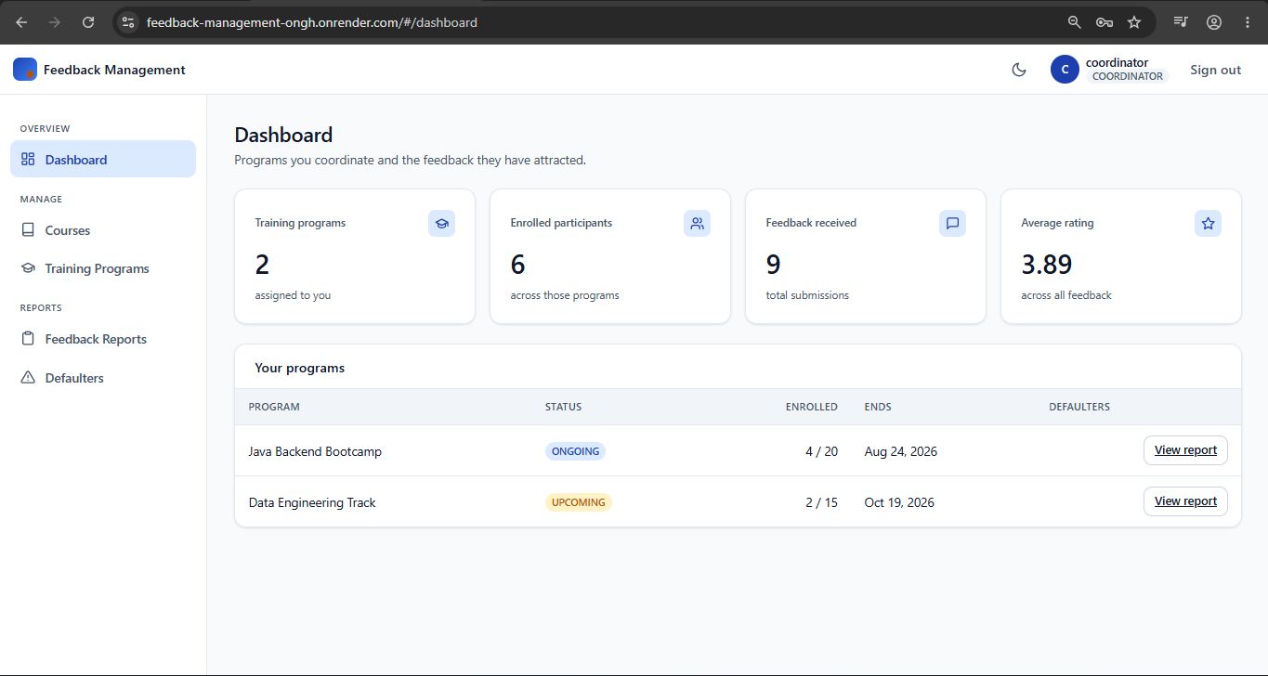
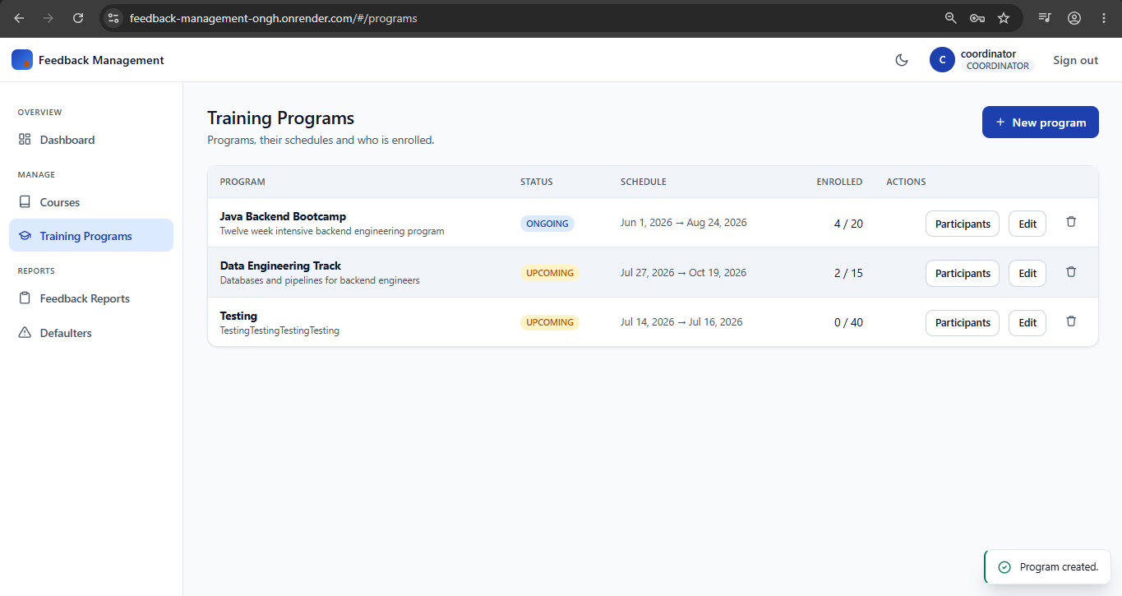

5. Modify Training Program
Scenario: A coordinator modifies an existing training program and the changes are saved successfully.
Output:
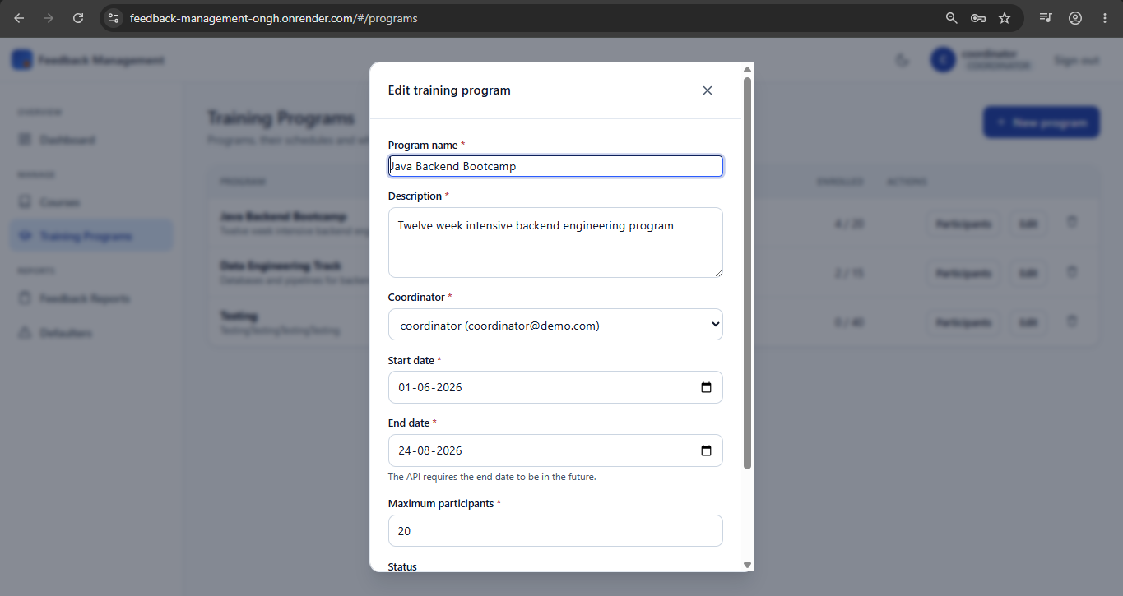

6. Delete Training Program
Scenario: A coordinator deletes a training program and it is removed successfully.
Output:
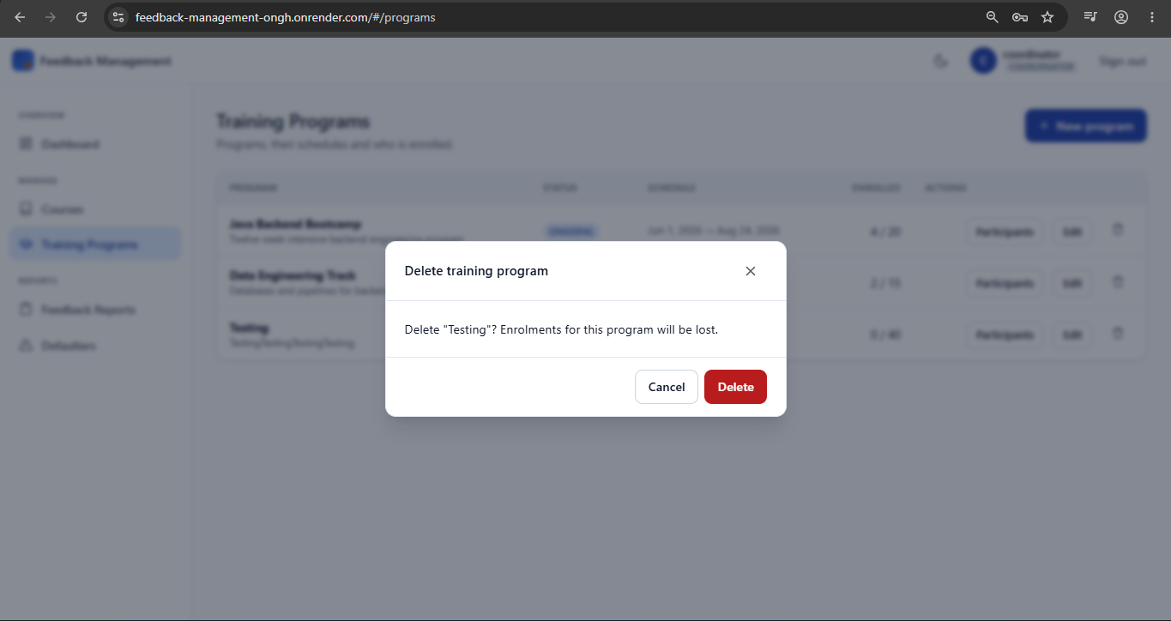
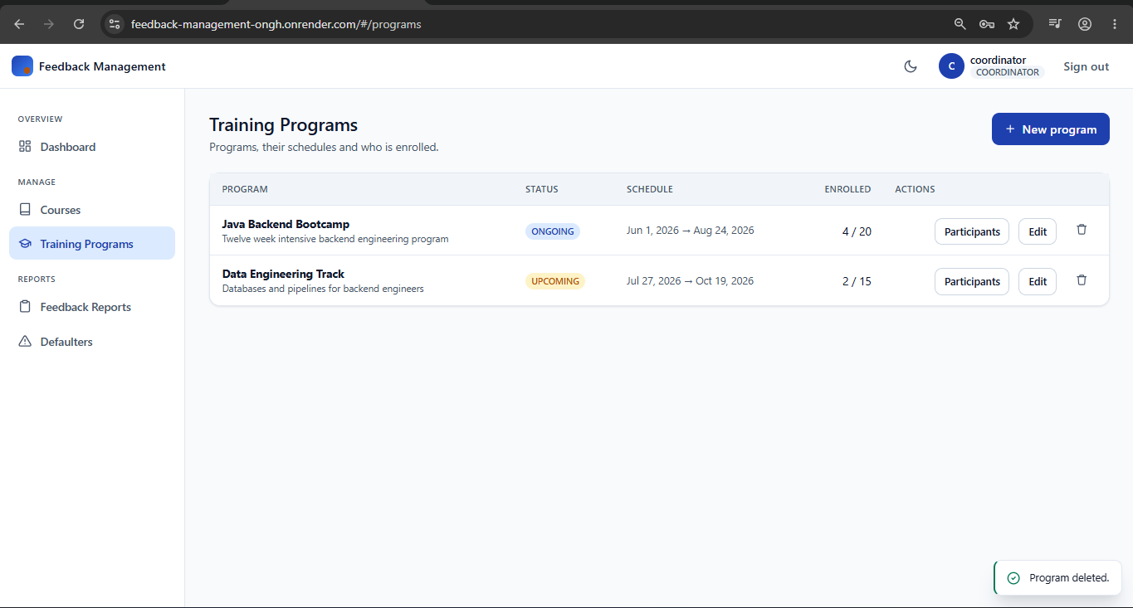

7. View Training Programs
Scenario: Users can view training programs and their details, including enrolled participants.
Output:
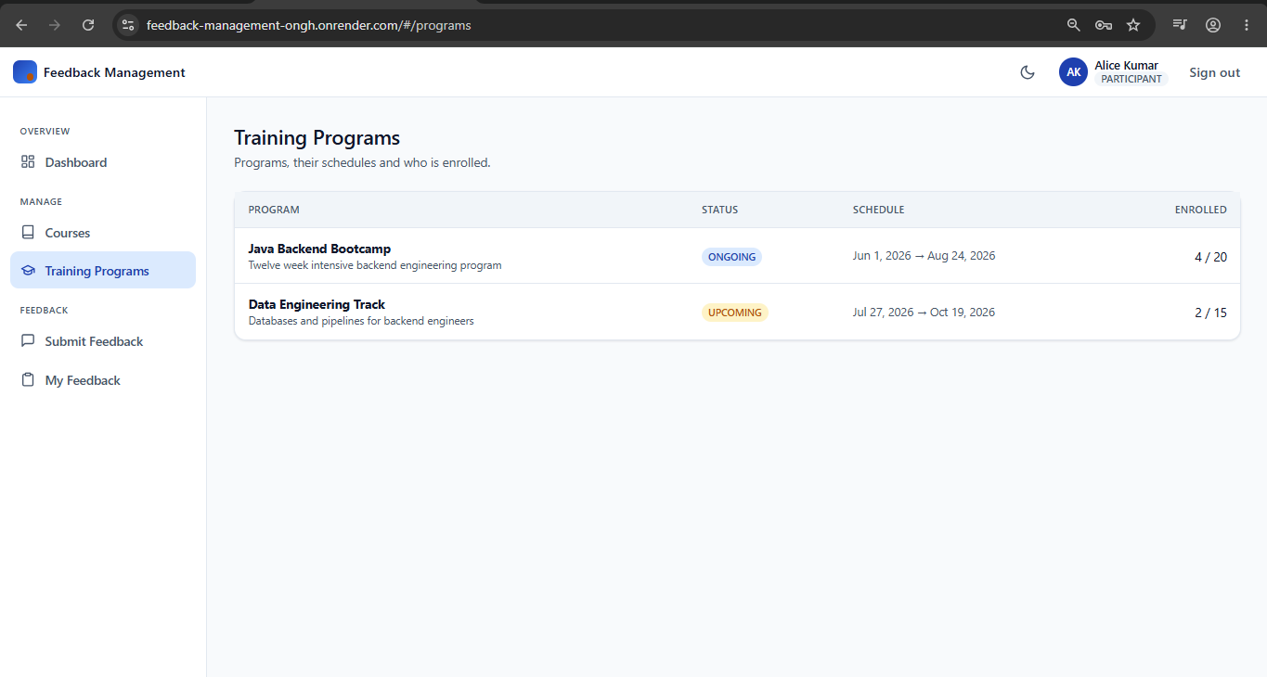
Objective
Deliver a complete, well-authorised catalogue of courses and training programs that the feedback and reporting modules build on.
Key Analysis
- Build the course entity, repository, and CRUD API
- Restrict course creation, updates, and deletion to admins
- Build the training program entity and its CRUD API
- Allow coordinators to enrol and remove participants
- Expose program listings, including lookup by coordinator
- Validate program data such as schedule and participant limits
Outcomes
- Admins can maintain the course catalogue end to end
- Coordinators can create, modify, and delete training programs
- Participants can be enrolled in and removed from programs
- Course and program listings are available to the whole application

User-3: Mayank Chopra: As a developer, I want to build the feedback and reporting layer and take the system to production, so that feedback is captured, analysed, and available on a live URL.

1. Submit Feedback
Scenario: A user submits feedback on a training program they are enrolled in, with a rating and comments, and the feedback is saved successfully. Duplicate submissions for the same program are rejected.
Output:
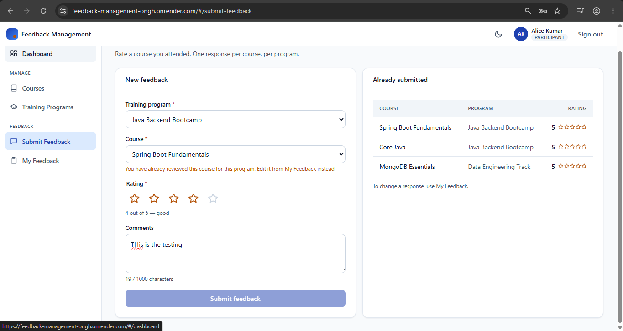
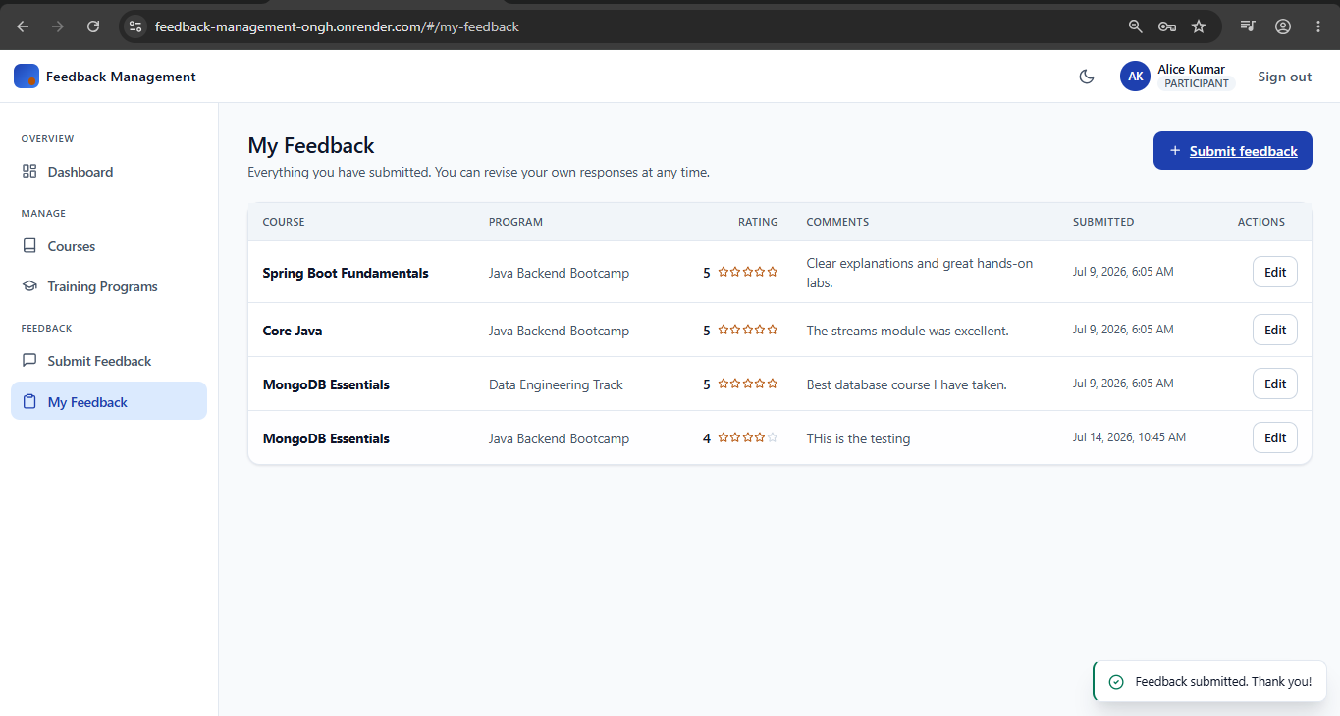

2. View Feedback Reports
Scenario: An admin or coordinator views the feedback submitted for their programs, and the reports are generated successfully.
Output:
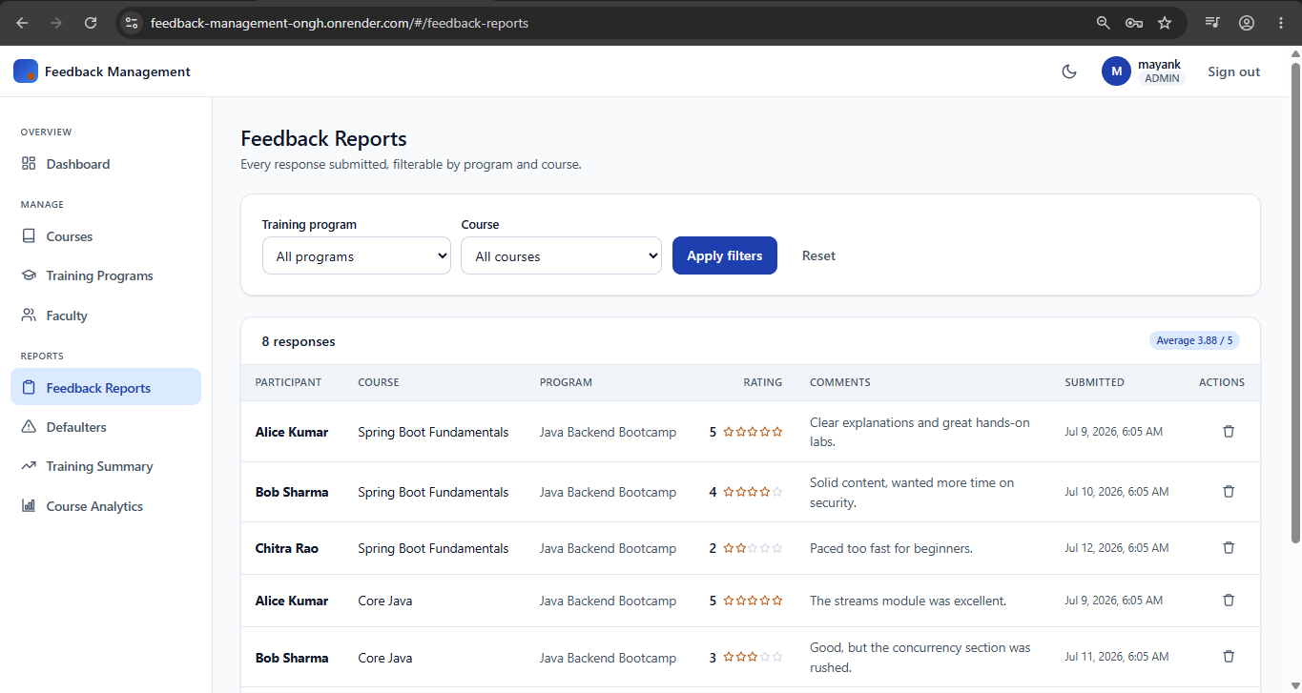

3. View Defaulters Report
Scenario: An admin or coordinator views the participants enrolled in a training program who have not yet submitted feedback, so that follow-up can be targeted.
Output:
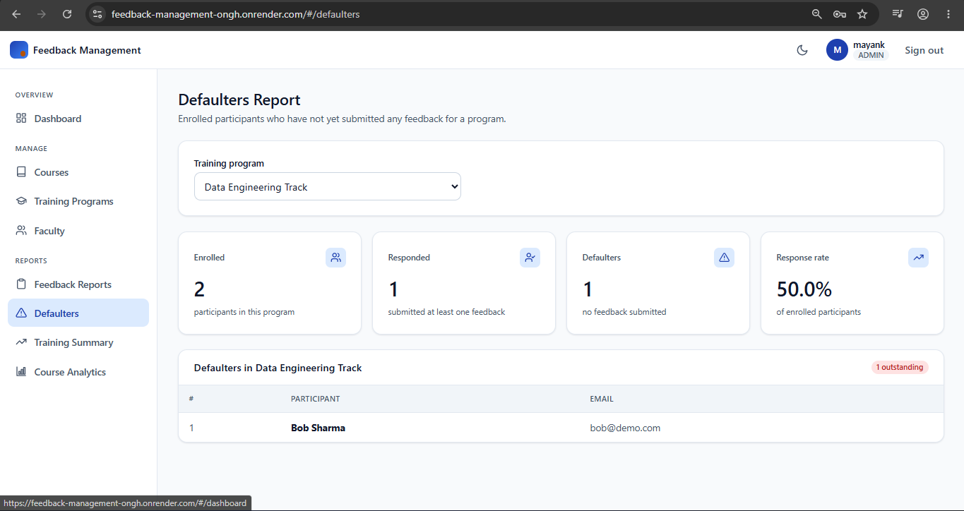

4. Update Feedback
Scenario: A participant updates their own feedback before the submission deadline, and the revised feedback is saved.
Output:

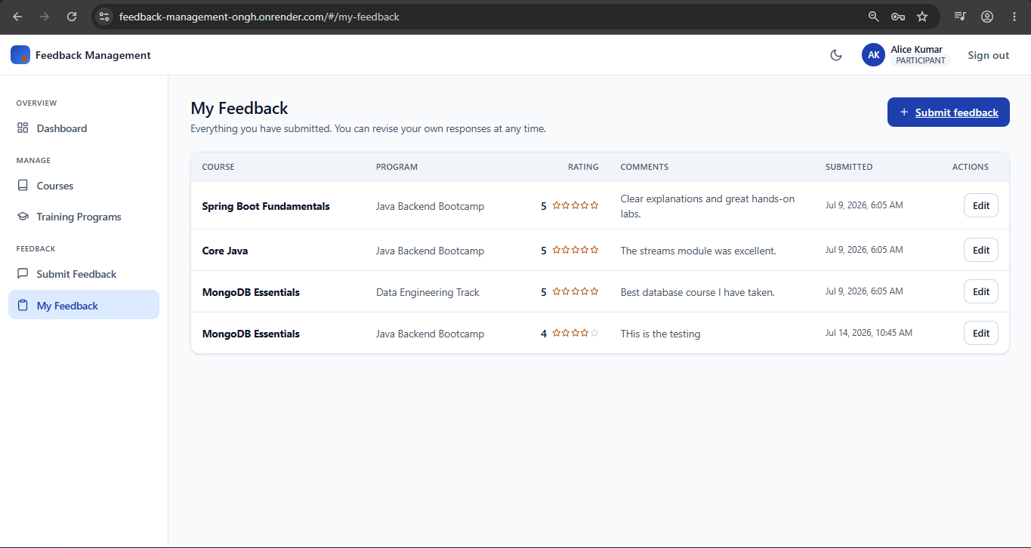
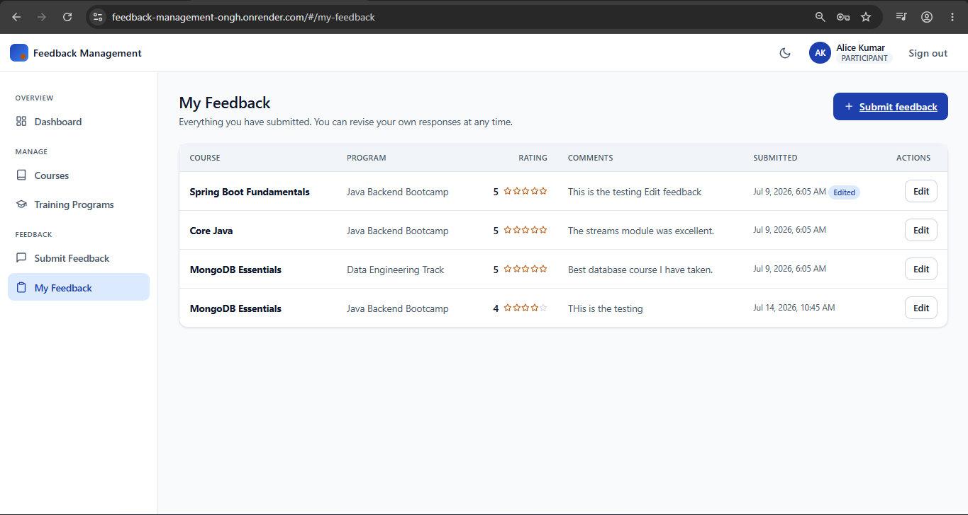

5. Training Summary Report
Scenario: An admin views a summary across training programs showing enrolment, feedback count, response rate, defaulter count, and average rating.
Output:
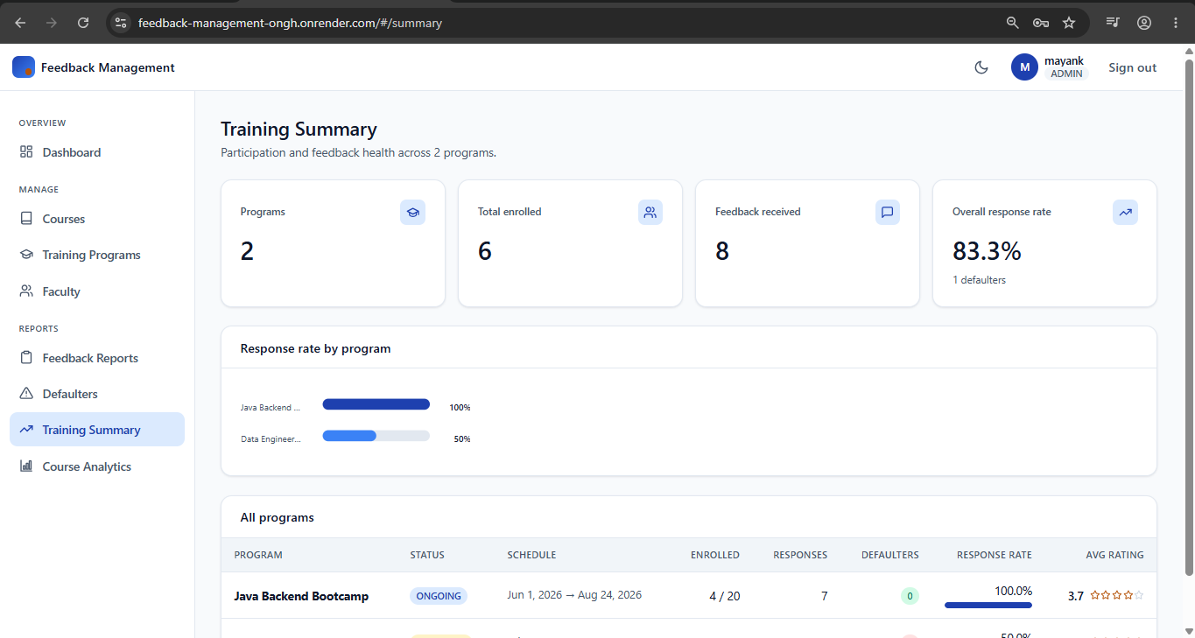

6. Course Feedback Analytics
Scenario: An admin analyses feedback at the course level and the analytics are displayed correctly on the dashboard.
Output:
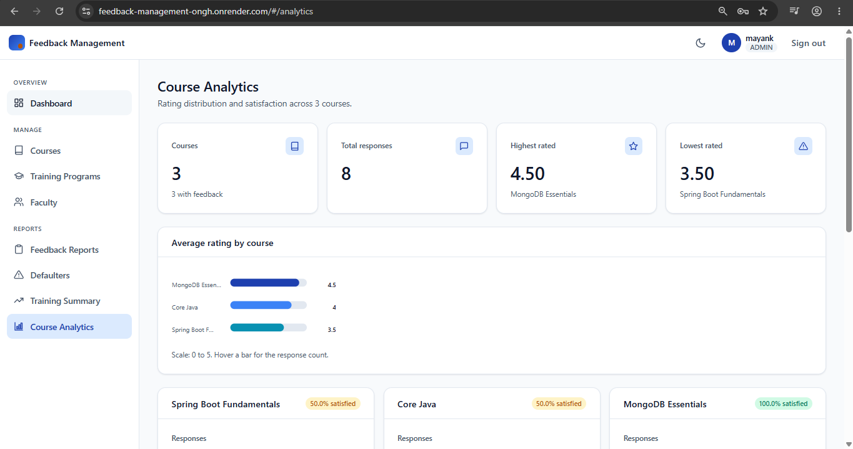
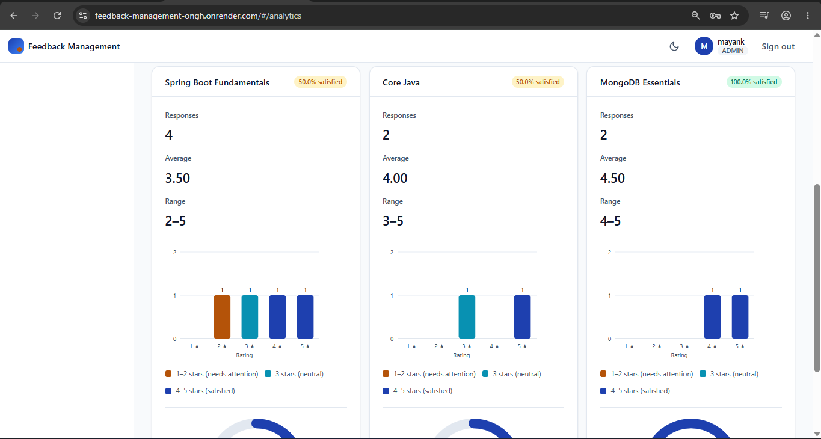

7. MongoDB Integration
Scenario: The application persists every collection: users, faculty, skills, courses, training programs, and feedback to MongoDB, with the connection string supplied by the MONGODB_URI environment variable.
Output:
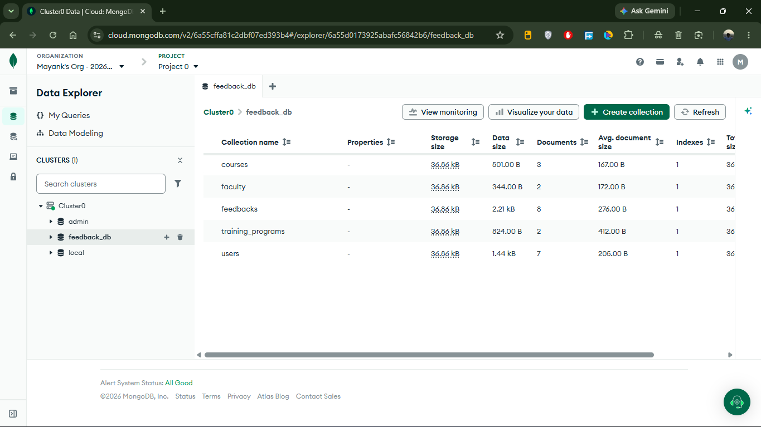

8. Deployment on Render
Scenario: The application is containerized with a Docker image and deployed as a Render web service backed by MongoDB Atlas. Secrets are injected as environment variables and the service is live and reachable on a public URL: feedback-management-ongh.onrender.com
Output:
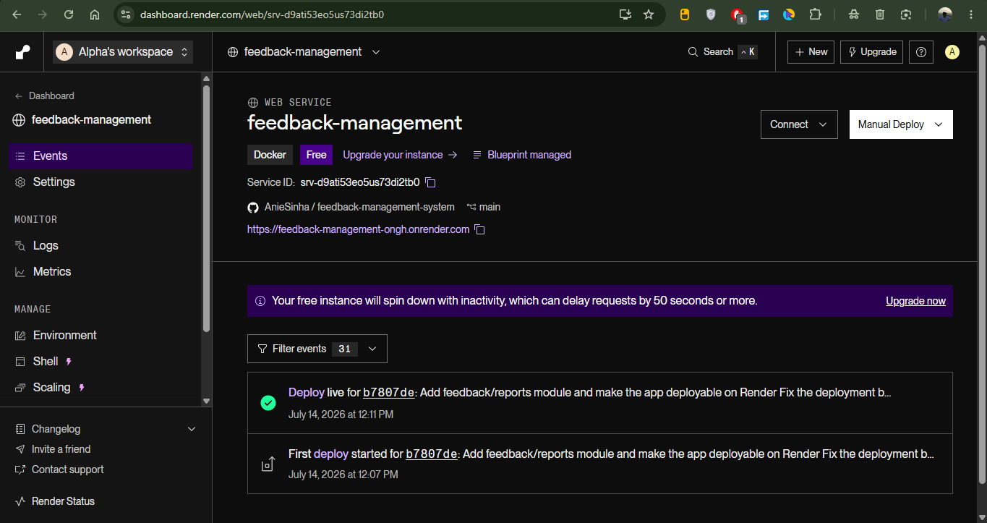
Objective
Capture participant feedback reliably, turn it into reports that show response rates and sentiment, and deploy the whole system to a public URL.
Key Analysis
- Build the feedback entity, repository, and submission API
- Prevent duplicate feedback and allow edits before the deadline
- Generate feedback reports for admins and coordinators
- Build defaulter tracking for participants who have not responded
- Aggregate training summary and course-level analytics
- Connect the application to MongoDB Atlas via environment configuration
- Containerise the application and deploy it on Render
Outcomes
- Participants can submit and revise feedback without duplication
- Admins and coordinators can see response rates and average ratings
- Defaulters are identified so follow-up can be targeted
- All data persists in a managed MongoDB Atlas cluster
- The application runs live on Render with no secrets in the repository

