DEVELOPMENT OF A PAYROLL MANAGEMENT SYSTEM WITH EMPLOYEE SELF-SERVICE PORTAL AND ANOMALY DETECTION USING ISOLATION FOREST ALGORITHM

BY

IDIONG, ARNOLD ANIEFIOK
(21CH029969)

A PROJECT SUBMITED TO THE DEPARTMENT OF COMPUTER AND INFORMATION SCIENCES, COLLEGE OF SCIENCE AND TECHNOLOGY, COVENANT UNIVERSITY OTA, OGUN STATE.

IN PARTIAL FULFILMENT OF THE REQUIREMENTS FOR THE AWARD OF THE BACHELOR OF SCIENCE (HONOURS) DEGREE IN MANAGEMENT INFORMATION SYSTEM.

JUNE, 2025

CERTIFICATION
I hereby certify that this project was carried out by Idiong Arnold Aniefiok in the Department of Computer and Information Sciences, College of Science and Technology, Covenant University, Ogun State, Nigeria, under my supervision.

Prof. Olufunke O. Oladipupo
Supervisor | Signature and Date
Prof. Aderonke A. Oni
Head of Department | Signature and Date

DEDICATION
I dedicate this report to God Almighty my support, the one who strengthened me, gave me hope, and gave me the motivation daily. I would also like to dedicate this report to my parents Dr. and Mrs. Idiong for their support, patience, and words of encouragement.

ACKNOWLEDGEMENTS
I am grateful to God for the strength daily, for his support, love, and mercy all through while I worked on the project. To him alone be all the glory. I acknowledge my parents Dr. And Mrs. Idiong for their support, words of encouragement, for their strength, and for constantly trusting and believing in me. I am beyond grateful to them for everything and for being people I could always reach out to for help.
To my supervisor and Assistant supervisor, Professor Olufunke O. Oladipupo and Mr. Otavie Okuoyo, I am grateful for your support and guidance all through leading to the success of this project. I am grateful to the Department of Computer and Information Sciences, the Head of Department, my level advisers, and lecturers for the knowledge I have gained.

TABLE OF CONTENTS
CONTENTS PAGES
COVER PAGE i
CERTIFICATION ii
DEDICATION iii
ACKNOWLEDGEMENTS iv
TABLE OF CONTENTS v
LIST OF TABLES viii
LIST OF FIGURES ix
ABSTRACT x
CHAPTER ONE: INTRODUCTION 1
1.1 Background Information 1
1.2 Statement of the Problem 2
1.3 Aim And Objectives of the Study 2
1.4 Methodology 3
1.5 Significance of the Study 5
1.6 Project Outline 6
CHAPTER TWO: LITERATURE REVIEW 7
2.1 Preamble 7
2.2 Review Of Relevant Concepts 7
2.2.1 Payroll Management Systems 7
2.2.2 Employee Self-Service Portals (Essps) 8
2.2.3 Automated Reporting In Payroll Management 8
2.2.4 Compliance And Tax Regulations 9
2.2.5 Cloud-Based Payroll Systems 9
2.2.6 Data Security And Privacy In Payroll Systems 10
2.2.7 Benefits Of Integrated Payroll Systems 11
2.2.8 Blockchain Technology For Payroll Systems 13
2.7 Review Of Related Methods 14
2.7.1 Ai-Driven Payroll Automation 14
2.7.2 Ghost Employees And Ai-Powered Anomaly Detection 14
2.7.3 Cloud-Based Payroll Systems (Sts) 16
2.7.4 Integrated Reporting Tools For Payroll Management 17
2.7.5 Blockchain For Payroll Management 18
2.8 Review Of Existing Payroll Management Systems 19
2.8.1 Quickbooks Payroll Management System 19
2.8.2 Gusto 20
2.8.3 Adp Workforce Now 20
2.8.4 Sap Successfactors 20
2.8.5 Powerplus Hrms 21
2.9 Conclusion 21
CHAPTER THREE : METHODOLOGY 22
3.1 Preamble 22
3.2 Conceptual Framework 22
3.3 Research Approach 22
3.4 Research Design 24
3.5 Requirement Analysis 24
3.6 Data Collection 25
3.7 Physical Design 25
3.8 Conceptual Design 25
3.8.1 Use Case Diagram 26
3.8.2 Activity Diagram 27
3.8.3 Sequence Diagram 28
3.8.4 Entity-Relationship Diagram (Erd) 29
3.8.5 Relationships 30
3.9 Conclusion 30
CHAPTER FOUR : SYSTEM IMPLEMENTATION AND RESULTS 31
4.1 Preamble 31
4.2 System Design Architecture 31
4.3 Implementation Tools 31
4.4 Implementation Process 32
4.5 Results And Interpretation 35
4.6 Screenshots Of Key Interfaces 36
CHAPTER FIVE: SUMMARY, CONCLUSION AND RECOMMENDATIONS 39
5.1 Preamble 39
5.2 Summary Of The Study 39
5.3 Conclusion 40
5.4 Contributions To Knowledge 40
5.5 Limitations Of The Study 41
REFERENCES 42

LIST OF TABLES
TABLES | TITLES OF TABLES | PAGES
1.1 | Objectives-Methodology Mapping Table | 9
3.1 | Entity-Relationship Table | 36
4.1 | Implementation Tools | 39
4.2  4.3 | Suspicious entries  Detection results | 41  43

LIST OF FIGURES
FIGURES | TITLES OF FIGURES | PAGES
3.1 | Research Process Flow | 29
3.2 | Use Case Diagram | 32
3.3  3.4  3.5  4.1  4.2  4.3  4.4  4.5 | Activity Diagram  Sequence Diagram  Entity-Relationship Diagram  Employee Registration  Flagged Employee List  Admin Dashboard Showing Detection Statistics  Admin Dashboard Showing Employee Statistics(1)  Admin Dashboard Showing Employee Statistics(2) | 33  34  35  43  44  45  45  46

ABSTRACT
In this project, an enhanced Payroll Management System was developed to address the inefficiencies, lack of transparency, and high error rates associated with traditional payroll processes. The aim was to design a system that integrates an Employee Self-Service Portal and Automated Reporting features to improve accuracy, efficiency, and accountability in payroll operations. The methodology involved using Django for backend development, SQLite for database management, and the Isolation Forest machine learning algorithm to detect anomalies such as ghost workers. Testing with simulated data yielded a 90% accuracy rate in fraud detection, demonstrating the system’s capability to identify irregularities effectively. The results show that automation and AI-driven tools can significantly enhance payroll management by improving transparency, reducing manual errors, and supporting compliance and data-driven decision-making, thereby promoting greater operational efficiency in human resource management.

Keywords: Payroll Management System, Employee Self-Service Portal, Automated Reporting, Django, SQLite, Isolation Forest, Machine Learning.

CHAPTER ONE

INTRODUCTION

1.1 Background Information
The transition from manual payroll to an advanced automated system has undergone a sea of change in the modern business environment. Traditional payroll systems do have some level of automation-automated computation of salaries and distribution of funds-but usually fail to provide full visibility of payroll, regulatory compliance, and integration with other organizational tools. The drawbacks pose the threat of inefficiencies in operations, legal liabilities, and, what is more important, employee dissatisfaction.
The challenges are defeated by advanced payroll systems, which have good integration with human resource management systems and have a higher level of efficiency and diminish the possibilities of errors. (Sanjay et al., 2023). For example, the contemporary systems enable real time updates, automatize the tax fillings, and employee benefits administration thereby rendering the aforementioned functions to the HR departments easy. Most systems also include the option of employee self-service in which employees can view paychecks, pay stubs, and change personal information without contacting the HR department (Rokade et al., 2023). This not alone boosts employees satisfaction but also leaves the HR professionals free to engage in more strategic initiatives that lead to growth and success of the organization.
The other characteristic of modern payroll systems is that they allow automated reporting, enabling organizations to get a closer view of labor costs, trends in payroll, and compliance metrics (Aggarwal et al., 2022). These tools drive organizations to make important business decisions with the use of real-time information. Flexible reporting enables organizations to customize reports to achieve special objectives in their operations and strategic plans (Fu et al., 2022).
The payroll system has developed to accommodate the needs of all types of workforce as it is able to process payroll of full time, part time, and contract employees. It is also necessary to provide flexibility in managing personalized compensation plans and address changing dynamics in human capital management.
Complementing these advances are technologies such as electronic payroll systems and self-service tools, which promote transparency and operational efficiency (Yusuf et al., 2023). This will enable the organization to achieve its compensation goals, improve employee satisfaction, and simplify payroll processing to make the policies of workforce management cohesive and well-organized.

1.2 Statement of the Problem
Payroll management has continued to be a headache for most organizations, especially regarding transparency, adherence to legislative compliance, and employee satisfaction. The majority of payroll systems are not integrated with employee-focused applications, which results in delays in delivering the salary-related information to employees, high frequency of errors, and poor reporting. (Supriati et al., 2020). This vulnerability has adverse effects on the efficiency of the organizations, employee complaints, as well as loss of confidence in payroll operations.
While new payroll technologies have emerged to help organizations meet these challenges, most of them do not address the fundamental business requirements of the modern organization (Gunawan & Sutomo, 2023a). As an example, they do not have dynamic pay structures to support different categories of employees based on recruitment strategies(Tremblay et al., 2023). Employees cannot get access to critical information like pay slips or tax statements and the HR personnel and administrators cannot produce accurate and insightful reports to guide decision-makers and compliance management.(Valcik et al., 2021).
Moreover, most payroll systems are unable to support strategic objectives because they lack automated reporting functionality. These gaps indicate the necessity of the new approach to payroll management that will be more connected to the organizational goals and will provide higher levels of satisfaction among the employees (Chaturvedi, 2022). Systems such as the Payroll Management System with Employee Self-Service Portal and Automated Reporting aim at addressing these issues. They are formulated to provide administrative convenience in preparation of payrolls, enhance employee comprehension and contentment and offer an insight to decision making on efficient utilization of financial and human capital (Ahmed et al., 2023).

1.3 Aim and Objectives of the Study
To develop a Payroll Management System with Employee Self-Service Portal and Automated Reporting solution. These are the objectives:
- To ascertain the requirements of a good payroll management system.
- To develop an employee self-service portal within the payroll management system.
- To implement automated reporting features for payroll accuracy and insights.
- To build a working prototype of a payroll system.
- To test the functionality and the performance of the system.

1.4 Methodology
To develop a Payroll Management System with Employee Self-Service Portal and Automated Reporting solution. These are the following steps I will take:
- Undertake an analysis of current payroll management systems in order to define strong points and weaknesses.

- Design of the employee self-service portal and system architecture performed using the UML diagrams. Unified Modeling Language (UML) diagrams are chart-based structures used to assist in the visualization of the system design and structure. Use case diagrams describe the communication between users (e.g., employees, HR managers) and functionality of the system, including payroll processing and reporting. The static structure is depicted by class diagrams, which illustrate the relationship amongst the system entities such as employees, payroll, and reports.

- To apply the automated reporting functionality with the Isolation Forest anomaly detection algorithm to payroll data to be able to detect anomalies in a timely fashion, i.e. the ghost employees, as well as produce payroll, taxes, attendance, and benefits compliance reports to improve the accuracy of the decisions related to the data.

- Design the front end with Django and Bootstrap and the back end with Django framework of payroll, reporting and employee self-service.

- Fix the system functionality and performance with the help of practical use cases and feedback gathering.
Table 1.1 gives a mapping of the objectives and methodology in a tabular format.
Table 1.1: Objectives-Methodology Mapping Table
S/N | OBJECTIVES | METHODOLOGY
i. | To ascertain the requirements of a good payroll management system. | Literature Review and Existing Systems  1. Literature and peer reviewed articles review.  2. First-hand observation of current systems.
ii. | To develop an employee self-service portal within the payroll management system. | Design System Architecture  Develop system design and plan the layout of the employee self-service portal. Visualizing interaction with diagrams such as use-case, and entity-relationship diagrams to visualize database structures. I would be using draw.io.
iii. | To automate payroll reporting using Isolation Forest for anomaly detection. | Implement Anomaly Detection  Using the Isolation Forest algorithm to automate payroll reporting with fraud detection capabilities, including tax calculations, payment summaries, and ghost employee identification
iv. | To build a working prototype of a payroll system. | Implementation and Prototype Development  1. Html,Css and Javascript Interface Design  2. Python and Django Backend Development  3. SQLite Database Management
v. | To test the functionality and the performance of the system. | Evaluation of the System  Ensure the system works and performs as intended with use-cases and gathering feedback.

1.5 Significance of the Study
The payroll management system incorporates an employee self-service portal and automated report generation, thereby solving some major lacunas found in organizational payroll management processes. It reduces the administrative burden as the system automates the processes of payroll management, making the payments and error checking, in addition to increasing its efficiency and accuracy.
The importance of the given research is visible in many industries:
- Academic Environments: Most of the schools still rely on manual processing of payroll information, which is very time-consuming and prone to errors. When such processes are automated this relieves the administrators to focus on activities with higher value-addition, like enhancement of the learning environment and evaluation of learning outcomes (Hansen & Komljenovic, 2023). With the optimization of the payroll functions, there is minimized inefficient use and better utilization of resources, therefore, enhanced productivity of the academic settings.

- Large Corporations: This system saves enormous man-hours spent on payroll processing with heavy payroll data. Besides being economical, it reduces the errors committed by human beings, thus improving efficiency by unburdening the HR departments' load (Mohamed et al., 2022). An employee self-service portal ensures more transparency and makes them happy by providing direct access to pay slips, tax obligation records, and other details relating to payroll. This meets the ever-rising demand for modern and time-saving payroll systems within large corporations.

- Government and Public Sector: In the government, the system is beneficial in that the salary payments to employees are done in a transparent way and on the required time. This solves the typical problems such as delays in disbursement. It will improve accountability and compliance by providing superior reporting and auditing tools, which is so important in the case of public administration. All these characteristics not only encourage transparency but also facilitate the financial management in the sector (Natision et al., 2022).
Basically, this payroll management system is designed to lessen complexities, increase operational efficiency, and transform payroll administration in manifold sectors. It answers the rising need of automation and innovation and guarantees transparency, reliability, and job satisfaction in payroll management.

1.6 Project Outline
Chapter One of the project contains an explanation of the project, problems with existing solutions, the need for an improved solution, the method of implementation, the significance of the study, and the limitations. Chapter Two describes the existing systems related to the project topic, the methodology, algorithm, and techniques used in related systems. Chapter Three describes the analysis and system design. Chapter Four shows the implementation of the system in detail and the results obtained. Chapter Five summarizes the project and gives recommendations, suggestions, conclusions, and references.

CHAPTER TWO

LITERATURE REVIEW

2.1 Preamble
This study aims at making a payroll management system that has an employee self-service portal and has automated reporting to solve the problem of inefficiency of the traditional payroll systems. The chapter is a review of the literature regarding the payroll management systems, employee self-service aspects, and automated reporting tools. Its purpose is to identify the problems of the existing systems and show how new technologies may improve the payroll management process making it more transparent, effective, and satisfying to the employees.
The literal review in this chapter revolves around the definition, problem, and trend of payroll management system to have a correct view of the topic. The chapter introduces with the history of the payroll systems development and review of the main concepts associated with the employee self-service portal, automated reporting, and data security. It then creates a plunge into connected procedures and technologies, including combinations with HR tools and blockchain, that are suggested or utilized in contemporary systems. Moreover, certain available payroll systems are appraised critically, and their characteristics, advantages, and disadvantages are discussed to give the background of the proposed system.

2.2 Review of Relevant Concepts
This section details the various concepts that are relevant to this project. They include:

2.2.1 Payroll Management Systems
A payroll management system is simply a software solution built to ease the administration of wages and salaries, employee bonuses and deductions, or other direct/indirect compensations. Traditional payroll processes normally require traditional manual methods, which are prone to errors and are time-consuming. The modern payroll systems that are contrasted make such work easier by automatic calculation of them through integration into human resources systems and finance, and by providing reporting and analytics capabilities (Gunawan & Sutomo, 2023b). These developments enhance accuracy, ensure compliance with the regulations of taxation, and increase efficiency in employee compensation management.
Gusto, ADP Workforce Now, Paychex are automated payroll systems that include options to make tax filings easier, to manage employee benefits, and to keep complete employee records. These systems help in making the operations of the HR departments more efficient by shifting the administrative burden of these departments (Silva I et al., 2022). Besides, most of the modern payroll systems are designed to allow employees to access their pay stubs, tax forms, and other payroll information on self-service portals (Handayani et al., 2023). The access increases transparency, positively influences job satisfaction and fulfills payroll operations to the expectations of the modern workforce.

2.2.2 Employee Self-Service Portals (ESSPS)
ESSPs aim to allow employees to access their personal, payroll and benefits data directly, as opposed to dependence on HR departments.. These usually have an easy-to-use interface where employees can access pay stubs, tax documents, and request updates to their personal records (Jiang, 2021). ESSPs give employees more power, as they can access essential information in real-time, and this way, delays and administrative costs are reduced, which also eases the HR teams.
When ESSPs are integrated within payroll systems, operations become more efficient and employees more satisfied. The reason is that organizations are able to embrace transparency and enhance communication because of providing employees with means to access and manage their payroll-related information themselves. As a result, fewer inquiries are made to the HR departments, and the employees become self-sufficient to manage minor issues on their own, which results in smoother operations and a more engaging organizational culture (Chaban, 2022).

2.2.3 Automated Reporting in Payroll Management
Automating reports is crucial in modern payroll systems, as organizations need to develop on-the-instance reports on employee wages, taxes, deductions, and overall payroll expenses with little or no manual intervention (Stoica & Ionescu-Feleagă, 2022). The reports assist a business in tracking payroll trends, controlling the costs of labor, and meeting all tax and labor laws. Actionable insights are provided by automated reporting tools, thus helping the organization make strategic decisions toward effective resource planning.
Other more advanced solutions, like QuickBooks Payroll and Paychex Flex, are even better known for their functionality in automatic reporting. By automatically building financial reports, tax filings, and benefits data, much of the propensity for human error is mitigated. Consequently, it saves time, improves payroll information accuracy by not requiring manual compilation of that information, thus improving decision-making and enhancing operational efficiency(Stoica & Ionescu-Feleagă, 2022). These examples outline how important reporting automation is with many payroll solutions today.

2.2.4 Compliance and Tax Regulations
The need to adhere to tax and labor laws is one of the most important issues that organizations have when managing their payrolls. Most of the time, tax regulations, pension contributions, and other mandatory benefits change from country to country or even from region to region, which makes it very difficult for multinational companies to keep up with legal requirements. Automated payroll services overcome these issues through real-time updates to tax legislation that can keep a business compliant and out of the danger of fines.
Automated compliance payroll and tax filing foster accuracy and dependability in a payroll system by automating the calculation of tax, using the right withholding rates, and generating forms required to be filed (Ahmed et al., 2022). These systems reduce the risk of expensive errors and ultimately save an organization much time. They further simplify the increasingly burdensome process of trying to understand and adhere to regulatory frameworks; this is why payroll cannot function well without such modern tools. Features like that show how automation plays a major role in simplifying compliance for businesses while protecting them from legal risks.

2.2.5 Cloud-Based Payroll Systems
Cloud-based payroll systems are also picking up due to their scalability, accessibility and also cost benefit attached to it. Such systems enable a company to execute payroll remotely without necessarily investing in hardware and dedicating resources to maintaining an IT infrastructure (Choudhary et al., 2023). With cloud-based payroll systems, this is possible anywhere and promotes flexibility for the HR team. Automatic updates ensure that the system is always up-to-date, not only on the security measures but also on the features, and the fact that it is scalable allows the businesses to customize the system according to their development.
Moreover, cloud payroll solutions are integrated with enterprise systems that include HRM and financial tools. It enhances data flow, reduces errors, and incorporates all business aspects. The cloud securely stores payroll data that personnel can easily access anywhere (S. I. Ahmed et al., 2022). For this reason, these systems turn out most helpful in the case of organizations which have either their teams remote or offices in various locations. These cloud payroll solutions make things more efficient by keeping payroll data secure and quickly accessible.

2.2.6 Data Security and Privacy in Payroll Systems
The issue of data security is of great concern to payroll systems, owing to the sensitivity of the information that they handle; this concerns the salary and tax information of employees, as well as their social security numbers and other personally identifiable information. The breach of this data leads to the theft of identities, fiscal exploitation, and also the loss of employee trust. Accordingly, confidentiality, integrity, and accessibility of the payroll data are valued greatly to guarantee the privacy of personnel and regulatory conformity (Resca & Munandar, 2022).
The latest payroll solutions are combined with numerous security options that guarantee the security of confidential information and provide controlled access to recognized users. The most important practice in data encryption is the transformation of data into unreadable forms during storage and transmission. That way, although the payroll information can be intercepted, it cannot be accessed or used by unauthorized parties. For this purpose, encryption protocols like SSL and TLS are quite common in data transmission to avoid attacks like man-in-the-middle attack, where third-party elements may intercept sensitive information(Resca & Munandar, 2022).
Multi-factor authentication or MFA is another crucial layer of security. In MFA, end-users must provide two or more verification factors to access payroll systems. These might include something the user knows, like a password; something they might have, like a smartphone to receive one-time passcodes; or something they are, such as biometric authentication using fingerprints or face identification (Das et al., 2020). MFA greatly reduces the risk of unauthorized access caused by compromised passwords, and it provides a much-needed additional level of security to sensitive payroll information.
Another important tool in payroll systems is access control mechanisms. Such mechanisms help make sure that only the respective personnel can access payroll information or make changes. Through RBAC, organizations have a chance to restrict the flow of payroll information against business activities. For instance, salary details can be allowed for modification by only payroll managers and human resource staff, whereas the employees can only retrieve pay stubs and personal details of themselves. Strict access controls, hence, prevent unauthorized access of sensitive data by internal employees, reducing the level of internal security risks (Cao, 2022).
Other important aspects of payroll system security are data redundancy and backup. A regular payroll backup should be made to prevent loss of data in event of system malfunction or corruption. The added security provided by cloud-based payroll systems with its underlying data recovery characteristics is the ability to store payroll data in multiple locations hence eliminating the risk of loss of data as a result of a single point of failure.
To sum up, ensuring high levels of data security and privacy within payroll systems is critical to safeguarding confidential data on employees, preserving the trust within an organization, as well as achieving legal compliance. With payroll systems adopting new technologies like cloud computing and AI, it is important that businesses are wary of the security of payroll data. Regular security updates, continuous compliance reviews, and the latest technology implemented will ensure payroll data protection, minimize the possibility of a breach, and ensure the smoothness of payroll process execution.

2.2.7 Benefits of Integrated Payroll Systems
The advantages of an integrated payroll system are enormous, connecting payroll processing with another organizational tool, such as a Human Resource Management and Enterprise Resource Planning system. This connection will guarantee that the data exchanged between different departments is smooth, which includes all payroll-related information, like employee records, compensation details, and tax information. Since the occurrence of duplicate data entry will be eliminated and the errors reduced, integrated systems enhance data integrity and operational efficiency(Avi, 2023).
Efficiency is one of the major benefits of integrated payroll systems. In the case of the payroll integrating with HR and ERP systems, an update on one system will correspond to the other system, and therefore data will not have to be entered more than once. In such a case, if there are any changes in the bank details of employees or tax exemptions in the HRM system, these changes will automatically carry on to the payroll system, avoiding problems in the payroll processing since cross-checking between two systems is not required.
This interface also allows for real-time data propagation. Any employee compensation data, benefits, and deductions are updated in real time in payroll and HR systems for access to the latest and most accurate information by all departments(Avi, 2023). In the situation of large organizations or multinationals this allows complex payroll to be processed smoothly and to always have up to date data across a large number of systems, departments and regions.
In addition, payroll systems that are integrated improve accuracy of reporting. When it comes to those cases when payroll system is connected to others, e.g. accounting, tax filing, and benefits administration, report creation is sure to be faster and more precise. Integration enables automatic creation of reports which are used in compliance and financial requirements of the organization. This saves a lot of time from being used in compiling reports manually and ensures that payroll data is both consistent and compliant with legally prescribed regulations(Cao, 2022). This will make the audit process easier, and decision-making will be more effective since managers will have real-time insight into employee compensation and labor costs.
The next key advantage is the way the integrated payroll systems contribute to the better satisfaction of the employees. The majority of the systems include employee self-service portals through which employees can retrieve pay stubs, make personal changes and monitor benefits without assistance. That eases the administrative load on the HR departments and puts the control of their data in the hands of the employees, which facilitates more transparency and trust within the organization. Workers with access to the correct and timely info concerning their compensation are usually more content with payroll processing.
Compliance management is also another robust feature of integrated payroll systems. The solution makes it possible to keep payroll data in sync with HR and financial systems for compliance with tax legislation and labor laws. Any amendments on taxes law or policies that touch on benefits are therefore updated on the respective systems, minimizing chances of non-compliance and subsequent penalties. Compliance checks and audits that are integrated into the payroll system ensure all steps are taken to report and file taxes correctly(Ahmed et al., 2022).
Finally, integrated payroll systems are cost-effective. Fewer errors in payroll and less manual data entry translates into less expensive mistakes. Besides, the capabilities of generating automated reports and carrying out payroll faster releases HR teams to concentrate on other strategic roles of the organization like recruitments, talent management and engagement.

2.2.8 Blockchain Technology for Payroll Systems
Once upon a time, blockchain technology was viewed as the means of powering only cryptocurrencies such as Bitcoin, it has now emerged as a force to reckon in the payroll system to introduce an element of transparency, security, and immutability into the mix. Because of its decentralized nature, blockchain is especially good at maintaining the integrity of data and hence helps to prevent fraud in payroll management (Ke & Lin, 2022).
How Blockchain Improves Payroll Management:
- Immutable Ledger: Blockchain generates an unchangeable registry to store safely all payroll transactions. Added data in a blockchain cannot be modified (Avi, 2023), which means payroll records will remain transparent and tamper-proof .This makes fraud, errors or data manipulations much more difficult as every transaction is stored forever and can be verified independently.
- Transparency and Trust: The decentralized nature of blockchain lets the employee self-verify their pay history and details of transactions(Ke & Lin, 2022). This transparency will inspire trust between employees and payroll departments by opening ways to an immutable record of their earnings, deductions, and benefits.
- Smart Contracts: With blockchain, there is the possibility of using what are known as smart contracts; these are contracts that automatically enforce themselves under agreed-upon conditions. Smart contracts in payroll systems will be used to automate the payroll payment once some conditions have been achieved, like completion of tasks or milestones. This saves the HR teams administrative efforts and pays on time and in the correct manner without human effort (Avi, 2023).
- Cross-border Payments with Efficiency: Blockchain enables faster, more secure, and affordable cross-border payrolls. It minimizes the conventional banking intermediation and enables quicker and cheaper international transactions. Such an advantage is particularly of special importance in a multinational company when paying its people all over the world in several countries and various currencies.
- Compliance and Reporting: Blockchain enhances regulatory compliance to make payroll transactions comply with tax regulations and labor regulations. Blockchain payroll records are readily available in case of audits, which creates a highly transparent and trustworthy chain of records come tax filing and compliance inspections. This will eliminate the tedious manual inspection and increase accountability.

2.7 Review Of Related Methods
This section aims at discussing and investigating some of the innovative practices used in the current payroll management systems, particularly AI-based payroll automation, employee self-service portals (ESSPs), cloud payroll systems, and built-in reporting solutions. Such techniques have enormously changed the way payroll is managed, the efficiency, accuracy, compliance and scalability of the payroll processes, and assisting business to cope with increased challenges of workforce management and regulatory requirements.

2.7.1 Ai-Driven Payroll Automation
The area of strides is predictive analytics. AI models have the ability to understand past payroll data and forecast future payroll costs depending on trends, staff flow, and external variables like economic changes or inflation. Predicting such costs allows HR and finance teams to plan budgets, cash flow and resource allocation more effectively. (Sahu, 2023). This predictability feature enables the business to be proactive in its payroll budgeting as opposed to being responsive to challenges after they have occurred.
Besides, AI-powered anomaly detection solutions may automatically point at possible irregularities, including duplicate payments, missing deductions, or unjustified overtime claims. AI minimizes errors being propagated to the final payroll by determining the inconsistencies in the payroll process early in the cycle (Paysquare, 2024).

2.7.2 Ghost Employees and AI-Powered Anomaly Detection
Ghost employees refer to non-existing or fictitious workers found on the payroll of an organization in order to divert wages being paid in the organization in a fraudulent manner. This category of payroll fraud is one which occurs in large companies and government institutions, since through manual processing of payroll, or lack of proper verifications there exist weaknesses. Ghost employees are not easily identified and hence make the company incur major losses and this lowers the confidence in the payroll system (Tefurukwa, 2022).
The long relied on techniques of detection are very much based on time-consuming manual checks or periodic auditing which is not only time-consuming but also subject to errors which makes is quite unreliable. There are possibilities of these methods not capturing subtle anomalies or pattern of dishonesty particularly in large data. This has therefore prompted the application of Artificial Intelligence (AI) and Machine Learning (ML) to become a better option towards detecting such anomalies (Toshniwal et al., 2020).
Anomaly detection using AI, especially using Isolation Forest as one model, provides an unsupervised machine learning method of defining payroll outliers. In contrast to supervised models which necessitate labeled data, Isolation Forest which isolates anomalies based on the random choices of features and disjointing of values (Togbe et al., 2022). The main ones to beware of are ghost employee patterns which can be identified effectively using this technique by showing up as statistical outliers; ghost employees are employees who continue to be paid a salary but have no attendance records, duplicate entries, or oversized salaries when compared with either their role or their attendance (Egwuche & Gabriel, 2023).
Such systems have been used in practical implementation where the business rule engines are combined with their AI models to enhance detection. The first layer of protection is business rules (e.g., names with different IDs will be flagged as duplicates, or employees who have not logged in 30+ days but might still be pursuing full salaries). The AI model further incorporates a second-level analysis, the patterns and deviations not resonating with rules. An example is when it identifies an employee who has a poor attendance rate yet his salary is high regardably compared to that of the rest of the department.
An effective AI-powered detection module will typically consider input features such as:
- Attendance frequency
- Last login timestamps
- Salary amount
- Role level or job grade
- Clock-in/out consistency
To detect the frauds in the payroll management system proposed in this project (see Chapter 4), the module referred to as Phantom Payroll Hunter was installed, based both on the rule-based rationale and the Isolation Forest algorithm. During the test simulations on 100 employee records of which 10 were fabricated to ghost employees, the system was able to detect them with an accuracy of 90 percent. The outcomes revealed that a combination of the two (business rules and AI algorithms) could eliminate a substantial number of false positives and increase the general reliability of detection.
Organizations face a problem however with the significant loss of funds through fraud; those involved in fraud protect themselves by ensuring the organizations are not wholly honest, and it seems that they are being wholly honest by dealing with the loss in cash. With the adoption of AI anomaly detection within the payroll systems, the detection of frauds can be automated, decreasing the loss of defrauded funds, and increasing accountability. Such systems are able to run in real-time continuously and avoid the restrictions of periodically scheduled audits, as well as give other HR departments actionable data in the form of dashboards and visualizations. This innovation does not only protect the payroll activities but also assist in strategic decision-making and policy implementation in the organization.

2.7.3 Cloud-Based Payroll Systems (STS)
In recent years, cloud-based payroll systems have gained more and more popularity as the business environment requires greater efficiency and flexibility in terms of payroll management. Such systems are considered to have a few more benefits compared to the on-premise payroll systems, mainly regarding scaling and availability (Workable, 2024). Cloud-based payroll solutions are easily scalable meaning as the business increases its workforce; there is no major upgrade required on the infrastructure or the software to accommodate more employees. This elasticity represents cloud solutions as an appealing choice to developing organizations or those that have distributed workers.
Another benefit of cloud-based payroll systems is that of remote access. Since data is saved on the cloud, the HR and payroll departments can be able to access payroll data anywhere, on any device as long as it has an active internet connection. It particularly helps those businesses that have a distributed or remote workforce. Also, cloud-based systems offer real-time synchronisation, implying that payroll information is brought up to date instantly and automatically on all systems, eliminating the chances of discrepancies and payroll processing errors (Paysquare, 2024).
The security of any cloud-based payroll system is an important factor because the systems deal with confidential financial and personnel data. Respectable cloud payroll vendors also spend much on security systems, including data encryption, multi-factor authentication, and automatic backups, so that payroll data is not exposed or lost to unauthorized parties (Workable, 2024). Such security measures assist companies in ensuring the continued compliance with data privacy laws, like the General Data Protection Regulation (GDPR) in Europe or California Consumer Privacy Act (CCPA) so that payroll information is kept safe.

2.7.4 Integrated Reporting Tools For Payroll Management
Modern payroll systems cannot do without automated and integrated reporting tools. The tools also allow the payroll administrators to produce real-time and accurate reports on payroll information such as salary distributions, tax deductions, benefits administration, and compliance reporting. Integrated reporting assists human resource teams to keep track of payroll trends, probable problems and make sure that payroll operations are maintained according to organizational objectives and complies with regulations (Paysquare, 2024).
Among the many advantages associated with integrated reporting is that the process allows the production of reports that are customized according to the business needs. Reporting can be department-wise, pay grade-wise, or region-wise to give information that is material to specific stakeholders. To illustrate, based on the payroll reports, the finance department can predict budgetary requirements, and the HR can examine the compensation trend according to the distinct departments to address pay parity (Workable, 2024).
Such tools also make sure that labor laws, and tax laws are adhered to. To take just one example, automated tax reporting can ensure that a business stays up to date with local, state and federal regulations, by creating tax filings that are automatically updated according to the most up to date tax rules. This greatly minimizes chances of errors and omissions in tax returns that may attract penalties or even legal disputes. Payroll systems also have automated compliance features that give auditable reports hence making sure that a business has a credible account of payroll transactions, which is required during tax audits, and internal reviews.
More so, real time reporting enables the payroll managers to monitor the labor cost in real time and therefore any variance or problems are noted and corrected in a timely manner. Specifically, the option to view the precise payroll reports in real-time is incredibly useful to the companies that employ large workforces, as it promotes a better insight on the payroll activities and eliminates the decision-making delays (Workable, 2024).

2.7.5 Blockchain For Payroll Management
Blockchain technology has emerged as a potential way of improving payroll systems to achieve extra security, transparency, and efficiency. Initially created to be the spine of cryptocurrencies, such as Bitcoin, the distributed ledger system of blockchain has been used in several processes in different industries, including payroll management.
Blockchain can facilitate the following important advantages in a payroll system:
- Security and Transparency: Blockchain offers a distributed, unalterable journal that stores every payroll transaction in a clear and unchangeable way. Every payroll operation (salary payments, bonuses or deductions) is encrypted and stored in a "block," which is secured to other past blocks to create a chain. This gives it almost an impossible task of tampering with the records after they have been inserted, minimizing the chance of fraud or payroll abuse. The blockchain provides transparency as employees can see their payroll transactions, establishing trust between employers and employees (Tian, 2020).
- Efficient Cross-Border Payments: Blockchain has the potential to enable real time, cross border payments without involving the traditional banking intermediation. In the case of multinational companies, this is particularly valuable since it allows avoiding delays and charges that are tied to international transfers. With the help of the blockchain technology, businesses will be able to simplify international payroll procedures, thereby making sure that workers receive their payments in a timely manner, no matter where they are located (Tian, 2020; Chohan, 2021).
- Smart Contracts: Blockchain allows the application of smart contracts, which automatically process payroll according to specific conditions set. This is exemplified by the automatic processing of salaries of employees on the agreed date of the fulfillment of predetermined tasks or work milestones. This saves on administrative costs and makes the payroll processing accurate (Chohan, 2021).
- Enhanced Compliance and Auditability: Blockchain payroll sounds challenging, considering the strict payroll compliance variables, but the transparency attribute of blockchain makes all payroll operations easy to audit. The feature is especially essential to companies which have to comply with complicated tax and labor regulations across multiple jurisdictions. The blockchain has the ability to automatically follow and track the local regulations, thus ensuring the correct application of taxes, deductions and benefits without the necessity of manual control (Tian, 2020).
Although blockchain has some advantages, the main idea of using blockchain technology to manage payrolls is not that easy to implement because it requires regulatory frameworks as well as integrating blockchain and current payroll systems. Nevertheless, the use of blockchain in payroll management will likely increase as this technology matures and provides novel solutions to companies that are interested in more secure, transparent, and efficient payroll processes (Chohan, 2021).

2.8 Review of Existing Payroll Management Systems
It is clear that payroll systems have been changing over the decades and what was once a manual, paper-driven system is now a sophisticated, digital application that can be integrated with the rest of the organization tools. Contemporary payroll software is developed to facilitate the administrative burden of salary payments, taxation administration, benefits administration, and workforce analysis. The section provides a review of the prominent available payroll systems, their characteristics, advantages, and drawbacks regarding their suitability to address the wide range of organizational requirements.

2.8.1 QuickBooks Payroll Management System
QuickBooks Payroll is widely recognized as one of the best solutions in the field of payroll, especially if we are talking about companies of a medium size at most. Its link with the general QuickBooks accounting software offers convenience between payroll and organizational functions, including payrolls, taxes and salary payments (Intuit, 2023; Several.com, 2023). The program also offers an automatic tax computation which simply means that the utility can compute the current tax rates, federal and state, and does not need to be updated several times. Many people consider QuickBooks Payroll to be easy to use even for individuals who don’t have knowledge of payroll services due to their simplicity taxing. It has an opportunity for flexible pricing since it has different packages with different price for every organization. However, the system is not without some draw backs as pointed out below. The main disadvantage of QuickBooks Payroll is its lack of scalability and therefore it is not very ideal for large organizations with complicated payroll systems. Also, it requires higher charges for subscription than many of its rivals, and customers have complained of poor service from customer support for basic packages (Intuit, 2023; Several.com, 2023).

2.8.2 Gusto
Gusto is a payroll and HR system that has quickly grown popular due to its employee engagement feature. It includes payroll services in combination with benefits management, onboarding features, and compliance solutions for companies of small to medium size. An especially significant feature of Gusto is the platform inside of which employees can view and alter their pay stubs, personal records, and benefits.
Gusto is easy to use, and, compared to most of its counterparts, it is visible in terms of the price that is to be paid for the service. However, it lacks many of the bells and whistles that many larger organizations may require for payroll processing. Besides, unlike its customer service response, some users have stated that the software ‘s response has been sluggish during busy hours.

2.8.3 ADP Workforce Now
ADP Workforce Now is an inclusive payroll and human capital management (HCM) system. It facilitates of payroll, tax filing, workforce analytics, and benefits administration. ADP is especially known to be scalable, and therefore it can be used by small businesses as well as large multinational companies. The platform provides cutting-edge analytics to facilitated workforce planning and compliance management (ADP, 2023).
Nonetheless, the interface of ADP is frequently complained about being too complicated, which a new user needs to be trained greatly. It is also not attractive to small business due to its high costs of implementation. They can be customized but may be restricted based on the package (ADP, 2023).

2.8.4 SAP SuccessFactors
SAP SuccessFactors is a cloud-based payroll solution that is connected to the wider HR tasks, e.g, talent acquisition and performance management. The platform fits well with the multinational organisations, and it provides local labor laws and tax compliance in different jurisdictions. It has powerful reporting and analytics solutions that help organizations to have actionable insights in the management of the workforce (SAP, 2023).
Smaller businesses may find a challenge in using the platform due to its complexity and costs. Implementation needs substantial training and investment, and it is better to fit the super-large enterprises with sophisticated payroll and HR requirements (SAP, 2023).

2.8.5 PowerPlus HRMS
PowerPlus HRMS is a HRMS (Human Resource Management System) and payroll management system designed to serve medium-scale companies. It combines such features as employee self-service portals, attendance management, or benefits management. The system is popular in customizability that enables organizations to add and remove features as per their requirements; it utilized Microsoft Visual Basic and SQL to manage the database (Lensasoftware, n.d.).
Although realistic and simple to use, PowerPlus HRMS will not scale to the needs of a large business and has an interface that can be considered outdated when compared to the current SaaS offerings. It is also dependent on Microsoft infrastructure hence hinders flexibility in some organizational configurations (Lensasoftware, n.d.).

2.9 Conclusion
In the literature review, a detailed discussion of payroll management system is discussed in terms of development and the problems it is meant to solve. The previous systems which in many cases depended on manual system were subject to error and inefficiency which has been combated by the current systems. Products such as QuickBooks Payroll, Gusto, and ADP Workforce Now, have brought approaches, such as automation, employee self-service portal, and tools to foster compliance with tax laws and labor laws. Such developments render payroll systems more precise and effective, thus making them consistent with the demands of present organizations.
The review also points at the inefficiencies of the current systems like the scalability and the convenience of the systems to smaller enterprises or organizations with special requirements. Technologies, including blockchain, promise to address these concerns since they help to make the data more secure and transparent, and cloud-based and mobile-optimized platforms are changing the manner of payroll systems access and management.

CHAPTER THREE

METHODOLOGY
3.1 Preamble
In this chapter, the system analysis and design of the proposed Payroll Management System with Employee Self-Service Portal and Automated Reporting is expounded. It maps out the architectural layout, user interactions and technical requirements which govern the development and implementation process of the system. This chapter will discuss the conceptual design of the system, the techniques involved in deriving system requirements, the physical and logical design of the system as well as visual models such as use case diagrams, activity diagrams, sequence diagrams, and an entity-relationship diagram (ERD). These tools are a complete guide to the implementation of the system on the basis of informed analysis and planned structure.
3.2 Conceptual Framework
The system is grounded on addressing the inefficiency of the conventional payroll systems through the integration of essential digital technologies and role-based access. The conceptual model outlines the interface between the users (Admins and Employees) and features that facilitate the payroll management, attendance, salary request and report. All the components are inter industry practices and real world issues noted in lack of automation in small to medium enterprises.
The framework is assumed on the following schemes:
- Payroll calculation, generation of reports, and approval of salary changes are the responsibilities of the HR/Admins.
- Employees work with their personal payroll information and place formatted requests but cannot write to fundamental payroll information.
- The system also automates the month end reporting using the attendance records and the salary records.
3.3 ResearchApproach
This project follows a deductive approach to system development. The system is designed based on pre-established models and known problems in payroll processing. The requirements were based on the case studies of the existent systems such as Gusto and PowerPlus, literature reviews, and informal interviews. This project followed a software engineering model: incremental model to be precise, which enables gradual implementation and testing of a feature.
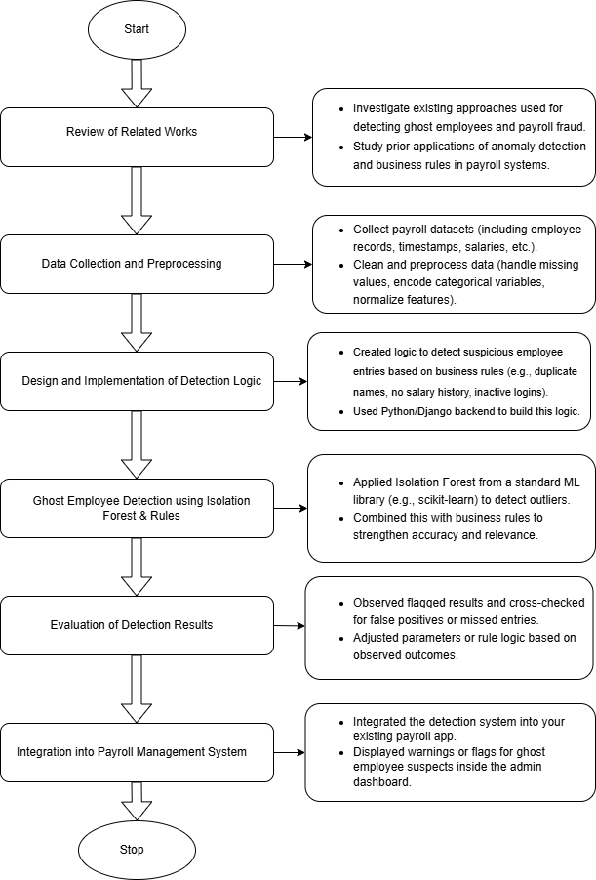
Figure 3.1: Research process flow

3.4 Research Design
The project took the form of a study in software development based on the design science research methodology (DSRM). It is a design-focused process where artifact development is prioritized in order to solve an issue in the real world. All the stages, including problem identification, objectives definition, design and development, demonstration, evaluation, and communication were iterative to result in a functional and scalable solution.

3.5 Requirement Analysis
Requirement Analysis defines and records stakeholder needs by conducting interviews and workshops and results in clear, practical, and prioritized requirements to direct the scope of the project and its development.
3.5.1 Functional Requirements
The system had a good number of requirements. Here is a list of the functional requirements:
- User Registration and Login: Employees and HR/Admins are to log in with security.
- Employee Dashboard: Shows the attendances, pay slips and salary request forms.
- Clock In/Out: Records attendance in real-time.
- Payslip Generation: Monthly, downloadable PDF showing earnings, hours worked, and deductions.
- Salary Request Form: The employees are allowed to request a Salary review through a fixed form.
- Admin Dashboard: The dashboard that sees and controls all the data of the employees, requests, payroll creation.
- Payroll Processing: Calculates total monthly pay based on hours and base salary.
- Report Generation: Produces automated PDF reports for each employee.
3.5.2 Non-Functional Requirements
The system had a good number of requirements. Here is a list of the functional requirements:
- Security: Encrypted login, secure session management, HTTPS protocol.
- Reliability: Stable performance under concurrent usage.
- Scalability: Database and logic that can be expanded to allow additional users.
- Maintainability: Clean, modular Django structure with REST endpoints.
- Portability: Web based deployment (e.g. Heroku or AWS).

3.6 Data Collection
Data was gathered from various means , such as:
- Academic Literature: Studying payroll systems and self-service portals.
- Industry Benchmarks: Evaluated Gusto, ADP, and other systems.
- Stakeholder Interviews: Conversations with HR professionals and employees to understand expectations.
- findings: Problems with manually maintained payroll systems.

3.7 Physical Design
- Frontend: HTML, CSS, Bootstrap, JavaScript for responsive UIs.
- Backend: Django (Python), Django Templates.
- Database: SQLite for development; PostgreSQL for production.
- Authentication: Django auth system, optional MFA.
- PDF Generation: WeasyPrint or ReportLab.
- Deployment: GitHub for version control; Heroku or AWS for hosting.

3.8 Conceptual Design
The conceptual design specifies system entities, user roles and processes, and describes the interaction of payroll, salary request, and phantom detection with the system.

3.8.1 Use Case Diagram
The use case diagram displays the interaction between Admins and Employees and the system. Figure 3.2 shows the Use Case Diagram for the Payroll Management System with Employee Self-Service Portal
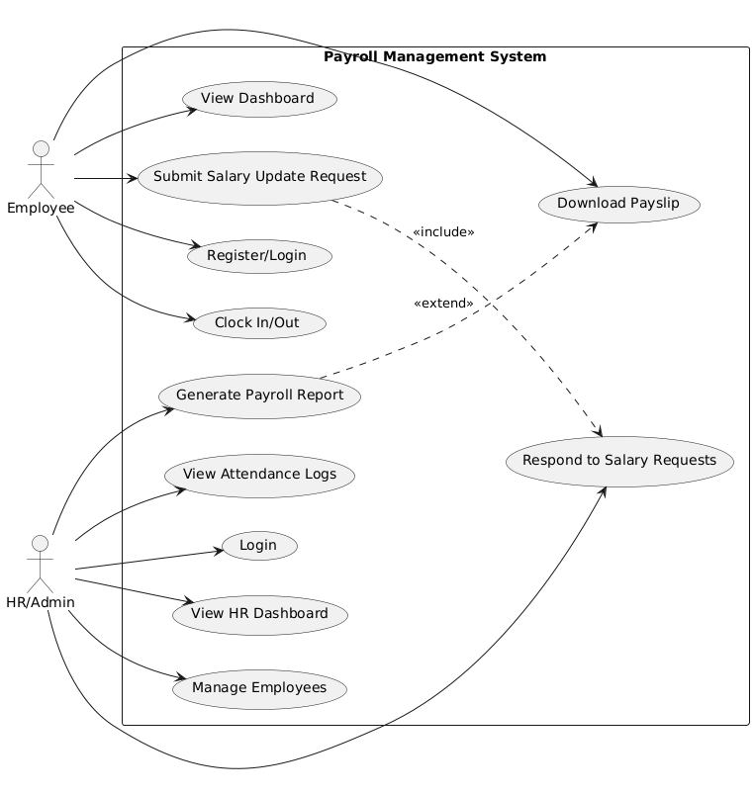
Figure 3.2: Use Case Diagram for the Payroll Management System with Employee Self-Service Portal

3.8.2 Activity Diagram
This diagram traces the workflow from salary request submission to response.
Figure 3.2 shows an Activity Diagram for the Payroll Management System with Employee Self-Service Portal .
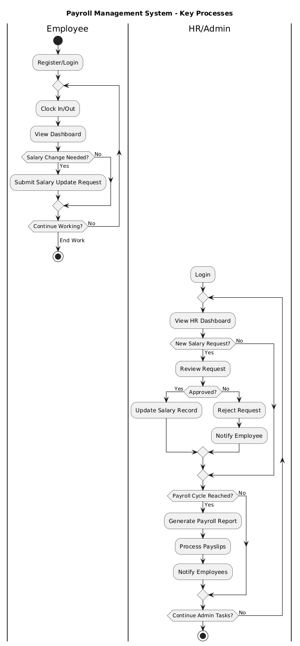
Figure 3.3: Activity Diagram for the Payroll Management System with Employee Self-Service Portal

3.8.3 Sequence Diagram
Sequence diagram displays the sequences in order of the attendance log in.
Figure 3.3 shows an Sequence Diagram for the Payroll Management System with Employee Self-Service Portal .

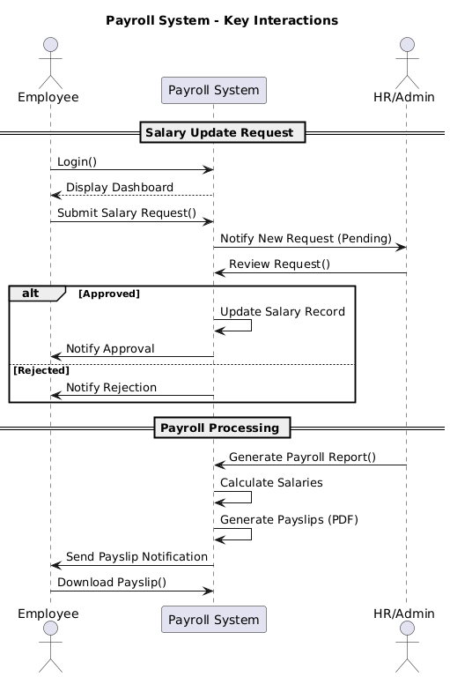
Figure 3.4: Sequence Diagram for the Payroll Management System with Employee Self-Service Portal

3.8.4 Entity-Relationship Diagram (ERD)
An ERD (Entity-Relationship Diagram) displays the structure of a database.
Figure 3.5 shows an Entity-Relationship Diagram for the Payroll Management System with Employee Self-Service Portal .
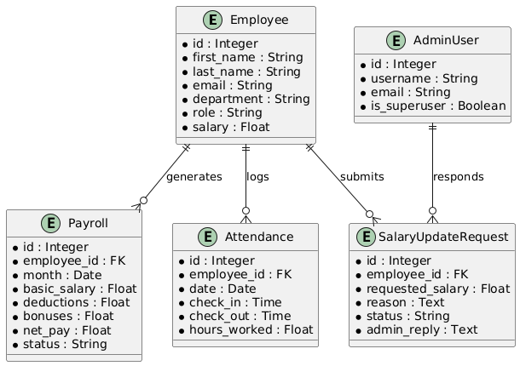
Figure 3.5: Entity-Relationship Diagram for the Payroll Management System with Employee Self-Service Portal

Table 3.1 shows the Attributes of each entity in the Entity-Relationship table.
Table 3.1: Entity-Relationship table
Entity | Attributes
User | user_id (PK), username, password, role
Employee | employee_id (PK), user_id (FK), name, email, department
Attendance | attendance_id (PK), employee_id (FK), date, clock_in, clock_out
Salary | salary_id (PK), employee_id (FK), base_amount, status
Payroll | payroll_id (PK), employee_id (FK), month, hours_worked, total_salary
SalaryRequest | request_id (PK), employee_id (FK), request_date, old_salary, new_salary, status, admin_response

3.8.5 Relationships
These are the relationships found in the Entity-Relationship Diagram
- One-to-One: User → Employee
- One-to-Many: Employee → Attendance
- One-to-Many: Employee → SalaryRequest
- One-to-One: Employee → Salary
- One-to-Many: Employee → Payroll
Normalization: The data schema adheres to 3NF (Third Normal Form) to minimize redundancy and enhance consistency. Foreign key constraints ensure referential integrity.
3.9 Conclusion
In this chapter, the author demonstrates the underlying design and system analysis that will be used to develop a functional Payroll Management System with Employee Self-Service Portal and Automated Reporting. It determines technical and conceptual points of view, determines requirements of a system and suggests structured interaction by means of diagrams and entities modeling. The following chapter will be devoted to implementations, to realize this design in a working prototype with Python (Django) and other implementation tools.

CHAPTER FOUR

SYSTEM IMPLEMENTATION AND RESULTS

4.1 Preamble
The next section describes how “Phantom Payroll Hunter” was created to discover and list any ghost employees in a company’s payroll. It presents the setup of the system, the way it was designed and developed, and the effects of using the anomaly detection method along with business rules and unsupervised learning.

4.2 System Design Architecture
The Phantom Payroll Hunter was built as a plug-in fraud-detection component to a web-based payroll management application. Its architecture is modular pipeline based on the following stages:
- User Management and Registration.
- Salary and Attendance Data Collection.
- Screening based on Business Rule.
- Isolation Forest Anomaly Detection.
- Flagged Employee Review Interface (HR Admin)
- Automated Monthly Reporting
All the stages are valuable in that they contribute to precise, explainable, and timely identification of potentially fraudulent employee records.

4.3 Implementation Tools
Development of the system was done in a virtual environment on a local machine and was tested with mock employee records modelled to represent real-world payroll systems, as shown in Table 4.1, the system was built using Django, SQLite, and Isolation Forest to manage the payroll and detect anomalies locally with mock data.

Table 4.1: Implementation Tools
Component | Technology Used
Backend | Python (Django Framework)
Frontend | HTML, CSS, JavaScript
Database | SQLite
Machine Learning Model | Isolation Forest (scikit-learn)
Visualization | Chart.js, Matplotlib

4.4 Implementation Process
The implementation process involves planning, executing, and monitoring the deployment of a project or system.
4.4.1 Employee Data Collection
The system mostly receives employee information via two main methods:
- Employee Self-Registration and HR Verification: Individuals are able to register themselves but their details are verified by the HR. New staff start the process by creating a record of their information on the self-service portal. HR administrators ensure that the information given by the candidate is truthful and covers all required areas.
- Attendance Recording and Salary adjustments under HR: All employees are supposed to submit their daily attendance and periodic adjustments to salaries are provided by the HR. Every employee’s in-and-out attendance is tracked using the combined clock-in and clock-out function. It is also part of an HR person’s duties to manage salary adjustments and any changes in position.
Attributes important for analysis and fraud detection are included in the profile of every employee in the system. Which are:
- Full Name
- Email Address
- Employee ID
- Department
- Position
- Salary
- The last activity was noted on this timestamp.
- Daily registers of students’ attendance
Both the evaluation of business rules and finding anomalies in the system start with the structured data.
4.4.2 Business Rules for Preliminary Detection
Before deploying any machine learning model, the system uses logic-based rules to identify suspicious entries, Table 4.2 shows us those entries.
Table 4.2: Suspicious entries
Business Rule | Trigger Condition
Duplicate entries | Same name or email, different ID
Salary active with zero attendance | Active salary, no login or clock-ins for 30+ days
Same bank details across multiple employees | Matching bank account numbers
High salary for junior role | Salary threshold exceeded for low-level positions
These rules are enforced server-side and help flag obvious ghost patterns.
4.4.3 Isolation Forest Implementation
Isolation Forest Isolation Forest is an unsupervised anomaly detection algorithm, designed to work well with high-dimensional numerical data. It puts oddities aside by randomly picking and dividing features.
These are the Input features:
- Attendance frequency (number of days present/month)
- Last login timestamp (recency)
- Salary amount
- Position Level (mapped to numerical scale)
Here are the steps taken to input those features:
- Data normalized using Min-Max Scaling.
- All employees have received outlier scores.
- Employees with a score above a set threshold (e.g., 0.70) were flagged.
4.4.4 Result Storage and Visualization
As soon as an employee is suspected as a fraud, they are stored in the FlaggedEmployees database table. The table includes vital metadata with each record it holds. Such as:
- Employee ID
- Reason for Flagging (for example, duplicate entry, zero attendance, extremelly uncommon schedule)
- Which way will I catch the ads, through rule-based design or machine learning methods?
- The time and date when the issue was found
- Recommended actions for case handling (for instance, review by HR, stop salary)
It is easy to use the HR Dashboard to keep an eye on records that have been flagged. Important details that are presented are:
- Number of Employees Who Were Under Flags
- Every flag has a particular reason for its design.
- The way we detect fraud can be through a business rule or a machine learning algorithm.
- Time when the virus was discovered
- Steps that need to be taken by Government Officials
HR department members can easily spot important trends and take action as the system features visual breakdowns in the form of pie charts for detection and bar graphs for flagging.

4.5 Results and Interpretation
Important results indicate the performance of the detection method on a dataset consisting of 100 employee records, 10 ghost records and 90 legitimate records. Specific detection results are required to give detailed interpretation.
4.5.1 Sample Dataset
The data used for the testing involved 100 employee records of which:
- 10 were designed as ghost entries
- 90 were legitimate employees with varied activity
4.5.2 Detection Results
Table 4.3 shows the detection results
Table 4.3: Detection results
Type of Ghost Entry | Detected by Rules | Detected by Isolation Forest
Duplicate Names | YES | NO
Zero Attendance with Active Salary | YES | YES
Infrequent Attendance + High Salary | NO | YES
Shared Bank Account Details | YES | NO
Unusual Role-Salary Mismatch | YES | YES

4.5.3 Detection Accuracy
Total Ghosts Inserted: 10
Total Flagged (Rules + ML): 9
False Positives: 2 legitimate employees flagged by Isolation Forest
Overall Detection Rate: 90%

4.6 Screenshots of Key Interfaces
Figure 4.1 shows the image of the Employee registration Portal
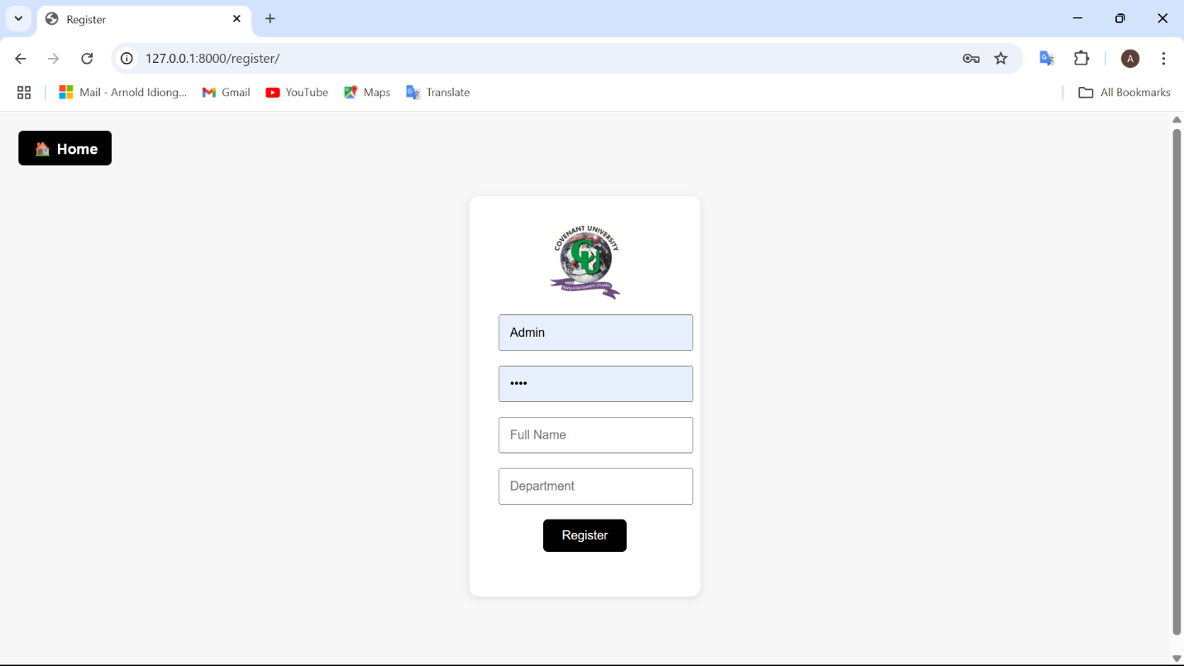
Figure 4.1: Employee registration

Figure 4.2 shows the image of the flagged Employee list using the Phantom Hunter
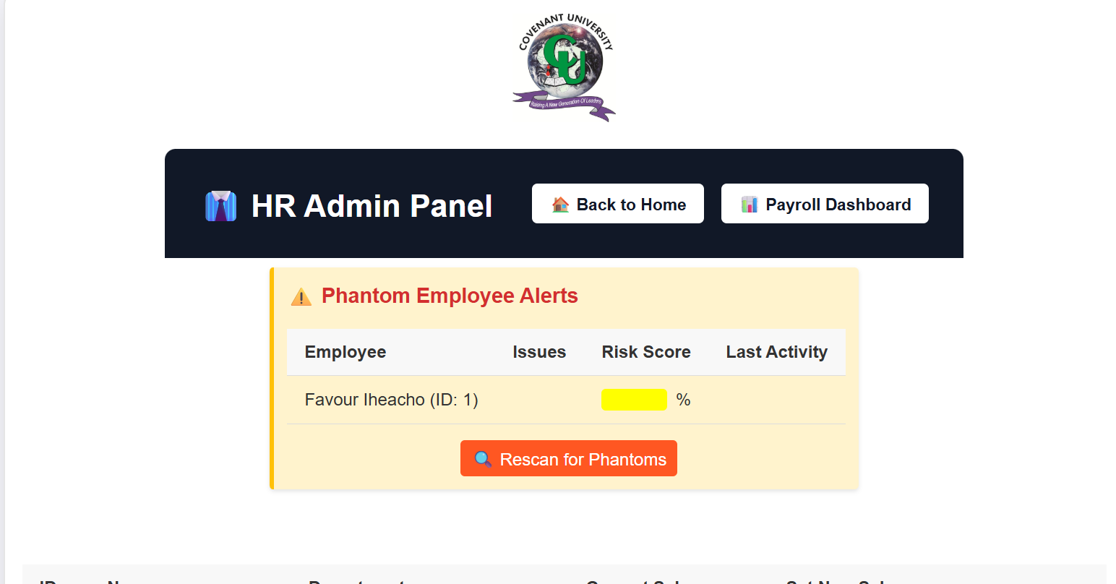
Figure 4.2: Flagged employee list
Figure 4.3 shows the image of the Admin dashboard showing detection statistics
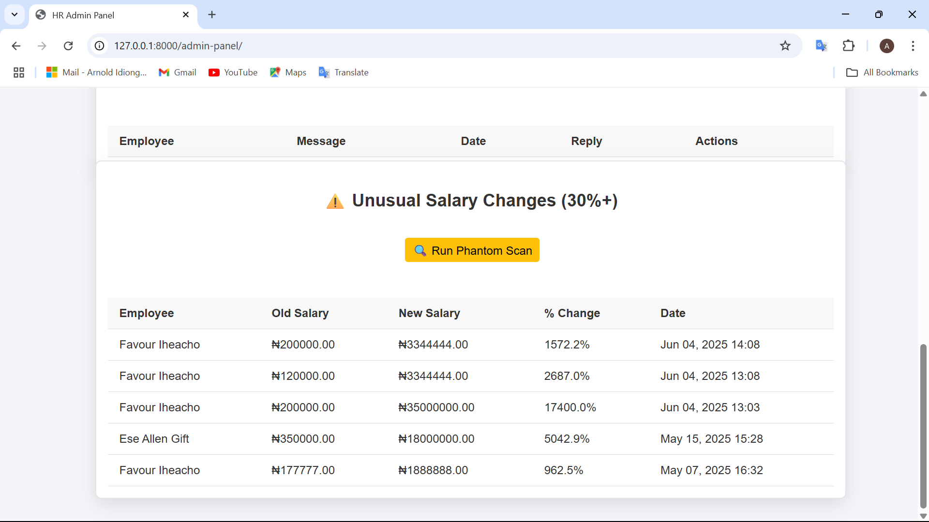
Figure 4.3 :Admin dashboard showing detection statistics

Figure 4.4 shows the image of the Admin dashboard showing employee statistics(2)
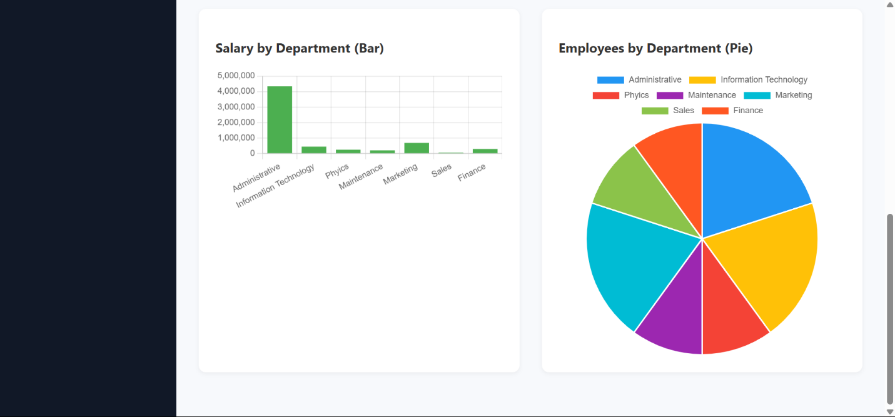
Figure 4.4 :Admin dashboard showing employee statistics(1)
Figure 4.5 shows the image of the Admin dashboard showing Employee statistics(2)
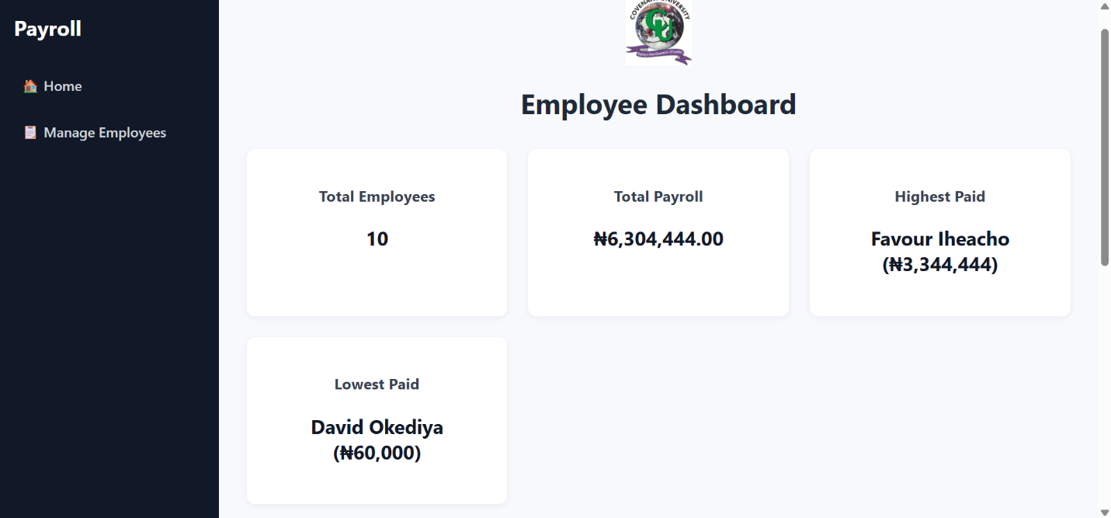
Figure 4.5 :Admin dashboard showing employee statistics(2)

CHAPTER FIVE

SUMMARY, CONCLUSION AND RECOMMENDATIONS

5.1 Preamble
This part summarizes the study and gathers the conclusions from each of the five chapters. In addition, covering the conclusion, recommendation, and summary is necessary.

5.2 Summary of the Study
In short, this study looks at the role of young adults in working life and provides recommendations for their support.
The project’s goal was to build a strong Payroll Management System that also contained a Ghost Employee Detection feature, so that it could stop payroll fraud found in large companies and government institutions. Using both the standard payroll features and modern ways to catch fraud, the system secured smooth operations and protected the financials.
At the beginning of the study, detailed research was done on payroll systems, ghost employee fraud, and related detection approaches. A way was chosen to use rule-based logic and unsupervised machine learning (Isolation Forest) for finding patterns of unusual activity in employee data.
For the architecture, the system makes use of Django in the backend, and the frontend is built with HTML/CSS/JavaScript, while the database is SQLite in the beginning. Application resulted in the following:
- Employee self-registration
- HR salary and attendance management
- Daily clock-in/clock-out logging
- Real-time ghost detection and flagging
- HR dashboard with visual insights (bar and pie charts
During testing, fake employees called ‘ghost employees’ were added to the data. Various aspects like the last known date of attendance, attendance percentage, mistakes in salary and role, and the presence of duplicate records were checked for detection accuracy.

5.3 Conclusion
Fake employees called ghost employees were added into the test records. A number of features were checked, like last seen timestamp, the frequency of attendance, salary/role differences, and the existence of duplicate records, when evaluating accuracy. Intelligent fraud detection is now an important part of the system for payroll processing. With the help of the rules, the system could easily detect examples of explicit anomalies such as:
- Duplicate employee entries
- Zero attendance with active payroll
- Invalid or missing credentials
In addition the Isolation Forest algorithm found unexpected actions that plainly appeared unusual. such as:
- Employees with unusually high salaries
- Long-term inactivity with no HR update
- Outliers in attendance compared to department averages
By merging these two strategies, we can have a reliable way of catching intruders while still reducing wrong alarms.
To sum up, the system accomplished its key goals, which are:
- Streamlined payroll operations
- Automated anomaly detection
- Increased accountability and transparency
- Support for HR decision-making through data visualization

5.4 Contributions to Knowledge
The project would help in the fields of academia as well as practice by:
- Isolation Forest is a real-world application of unsupervised learning that can be used to detect payroll frauds.
- It suggests a two-layer detection platform (rule-based + ML)
- Offering modular scalable design capable of being customized to other HR and payroll systems.

5.5 Limitations of the Study
Although the system achieves the intended goals, it is associated with several limits:
- Scarce real-world data: The experiments were carried on simulated data because of the privacy restrictions on the real data.
- Integration of biometrics: The system does not use biometrics to log-in the attendance but uses manual or system log-ins.
- Lack of real-time alert: Anomalies are marked, but the system still lacks automatic notifications through email or SMS.
- Isolation Forest Tuning: The model has not been tuned with actual HR data and this may have an impact in the real world.

REFERENCES
Aggarwal, T., Tiwari, S., Kumar, A., & Yadav, S. S. (2022). Design and Implementation: A Review of Payroll Management System. 2022 4th International Conference on Advances in Computing, Communication Control and Networking (ICAC3N), 26–32. https://doi.org/10.1109/ICAC3N56670.2022.10074240
Ahmed, A. M., Mohammed, C. N., & Ahmad, A. M. (2023). Web-based payroll management system: design, implementation, and evaluation. Journal of Electrical Systems and Information Technology, 10(1), 17. https://doi.org/10.1186/s43067-023-00082-5
Ahmed, S. I., Ramdas, K. V., & Ansari, Asst. Prof. A. (2022). Compliance Verification Process Automation. International Journal for Research in Applied Science and Engineering Technology, 10(2), 831–836. https://doi.org/10.22214/ijraset.2022.40363
Avi, M. S. (2023). The Implementation of an Integrated Information System in the Company: From Option to Obligation for Efficient and Effective Management. Global Journal of Management and Business Research, 1–19. https://doi.org/10.34257/GJMBRAVOL23IS1PG1
Cao, R. (2022). Research on RBAC Based Role Access Control in Financial MIS. 2022 6th International Conference on Wireless Communications and Applications (ICWCAPP), 147–150. https://doi.org/10.1109/ICWCAPP57292.2022.00043
Chaban, G. (2022). The significance of the organization of human resource management in the solution of staff turnover in enterprises. University Economic Bulletin, 52, 73–77. https://doi.org/10.31470/2306-546X-2022-52-73-77
Chaturvedi, S. (2022). PAYROLL (EMPLOYEE)-MANAGEMENT. INTERANTIONAL JOURNAL OF SCIENTIFIC RESEARCH IN ENGINEERING AND MANAGEMENT, 06(05). https://doi.org/10.55041/IJSREM16020
Choudhary, H., Pandita, D., Vapiwala, F., & Rukadikar, A. (2023). Determining the Effectiveness of Cloud Computing on the Payroll Management System. 2023 8th International Conference on Business and Industrial Research (ICBIR), 233–237. https://doi.org/10.1109/ICBIR57571.2023.10147457
Das, S., Wang, B., Kim, A., & Camp, L. J. (2020). MFA is A Necessary Chore!: Exploring User Mental Models of Multi-Factor Authentication Technologies. https://doi.org/10.24251/HICSS.2020.669
Fu, C.-H., Wang, J.-X., & Zhang, Q.-W. (2022). Development, Design and Application of Intelligent Report (pp. 1359–1372). https://doi.org/10.1007/978-3-030-89698-0_140
Gunawan, M. J., & Sutomo, R. (2023a). Web-Based Payroll Application Design and Development Using Rapid Application Development. JOINS (Journal of Information System), 8(1), 67–79. https://doi.org/10.33633/joins.v8i1.7979
Gunawan, M. J., & Sutomo, R. (2023b). Web-Based Payroll Application Design and Development Using Rapid Application Development. JOINS (Journal of Information System), 8(1), 67–79. https://doi.org/10.33633/joins.v8i1.7979
Handayani, S., Franz, A., & Rachmadani, B. (2023). Web-Based Employee Payroll Information System at Bank Perkreditan Rakyat Ingertad Bangun Utama Ltd. TEPIAN, 4(1). https://doi.org/10.51967/tepian.v4i1.1406
Hansen, M., & Komljenovic, J. (2023). Automating Learning Situations in EdTech: Techno-Commercial Logic of Assetisation. Postdigital Science and Education, 5(1), 100–116. https://doi.org/10.1007/s42438-022-00359-4
Jiang, L. (2021). RETRACTED: Design of enterprise employee pension platform based on complex embedded system. Microprocessors and Microsystems, 81, 103783. https://doi.org/10.1016/j.micpro.2020.103783
Ke, J., & Lin, J. (2022). Optimizing the Configuration of Financial Supervision Equipment by Using Key Privacy Protection Technologies of Blockchain (pp. 397–403). https://doi.org/10.1007/978-981-16-5854-9_50
Mohamed, S. A., Mahmoud, M. A., Mahdi, M. N., & Mostafa, S. A. (2022). Improving Efficiency and Effectiveness of Robotic Process Automation in Human Resource Management. Sustainability, 14(7), 3920. https://doi.org/10.3390/su14073920
Natision, A., Esien, E. B., Harjo, D., Agoestyowati, R., & Lestari, P. A. (2022). The Effect of Public Accountability and Transparency on State Financial Management Mechanism: A Quantitative Method Analysis. Ilomata International Journal of Social Science, 3(1), 415–434. https://doi.org/10.52728/ijss.v3i1.433
Resca, Y., & Munandar, A. (2022). Analysis of implementation : the payroll accounting system and employee wages. Fair Value: Jurnal Ilmiah Akuntansi Dan Keuangan, 4(10), 4564–4570. https://doi.org/10.32670/fairvalue.v4i10.1756
Rokade, M., Wayal, T., & Gaikwad, Prof. J. A. (2023). Employee Self Service Portal with Time and Activity Tracking. International Journal for Research in Applied Science and Engineering Technology, 11(4), 2585–2598. https://doi.org/10.22214/ijraset.2023.50732
Sanjay, C. P., Surya, G. V., Karthik, T., & Reddy, Ni. M. (2023). Automated payroll system. International Journal of Communication and Information Technology, 4(1), 64–70. https://doi.org/10.33545/2707661X.2023.v4.i1a.62
Silva I, G. L. L., Jayasinghe, T. L., Rangalla, R. H. M., Gunarathna, W. K. L., & Tissera, W. (2022). An Automated System for Employee Recruitment Management. 2022 4th International Conference on Advancements in Computing (ICAC), 346–351. https://doi.org/10.1109/ICAC57685.2022.10025159
Stoica, O. C., & Ionescu-Feleagă, L. (2022, May 27). Accounting Automation: An Experimental Study. https://doi.org/10.24818/BASIQ/2022/08/001
Supriati, R., Junaidi, J., & Hendri, J. (2020). Implementation of Outsourcing Employee Sales System For Verification and Acceleration Salary Transparency. CCIT Journal, 13(1), 76–87. https://doi.org/10.33050/ccit.v13i1.896
Tremblay, F.-A., Piché-Meunier, D., & Dubois, L. (2023). Multi-objective Optimization for the Design of Salary Structures (pp. 427–442). https://doi.org/10.1007/978-3-031-33271-5_28
Valcik, N. A., Sabharwal, M., & Benavides, T. J. (2021). Obstacles for Public Organizations Using HRIS (pp. 125–143). https://doi.org/10.1007/978-3-030-75111-1_9
Yusuf, Z., Nawawi, A., & Salin, A. S. A. P. (2023). The effectiveness of payroll system in the public sector to prevent fraud. Journal of Financial Crime, 30(2), 404–419.
Tefurukwa, O. W. (2022). Managing Ghost Workers Fraud on Payroll in Tanzania: A Conceptual Framework. International Journal of Governance and Public Policy Analysis, 3(01).
Togbe, M. U., Chabchoub, Y., Boly, A., & Chiky, R. (2022). Distributed Anomalies Detection Using Isolation Forest and Spark (pp. 700–712). https://doi.org/10.1007/978-3-031-16210-7_57
Egwuche, O. S., & Gabriel, A. J. (2023). EmpAMPS: A Secure Biometrics Framework for Mitigating the Menace of Ghost Workers in Developing Economies. Applied and Computational Engineering, 2(1), 742–749. https://doi.org/10.54254/2755-2721/2/20220669
Toshniwal, A., Mahesh, K., & Jayashree, R. (2020). Overview of Anomaly Detection techniques in Machine Learning. https://doi.org/10.1109/I-SMAC49090.2020.9243329
ADP. (2023). ADP Workforce Now: Features and benefits. Retrieved from https://www.adp.com/solutions/small-business/payroll.aspx
Business.org. (2023). Gusto payroll review: Pros, cons, and pricing. Retrieved from https://www.business.org/software/payroll/gusto-review/
Gusto. (2023). Gusto payroll features and benefits. Retrieved from https://gusto.com/product/payroll
Lensasoftware. (n.d.). PowerPlus HRMS: Features and functionalities. Retrieved from https://www.lensasoftware.com/
SAP. (2023). SAP SuccessFactors: Global payroll solutions. Retrieved from https://www.sap.com/products/human-resources-management/payroll.html
Paysquare. (2024). Payroll outsourcing: Key benefits for businesses. Retrieved from https://www.paysquare.com/
Workable. (2024). Payroll integration and compliance in modern HR systems. Retrieved from https://resources.workable.com/

