Video Store System Software Manual

The Video Store System software is to be installed on the computers at the video store. The computers are to be situated at the cashier stations. The computers would be connected to the corresponding cashier, to help with payment functions. The Video Store System software deals with the connection to the database, so as to manage records on the go. The software deals with the following in store operations:

1. Renting an Item(Movie/Game)
2. Purchasing an item(Movie/Game)
3. Reserving an Item(Movie/Game)
4. Create an account
5. Edit Account information
6. Search for an Item(Movie/Game)
7. Returning a borrowed item(Movie/Game)
8. Canceling a reservation that has been made on an item

Administrative employees have more privileges, allowing them to perform a few more operations when logged in, such as:

1. Add an item to the video store inventory and database.
2. Remove an item from the video store inventory and database.
3. Suspend a member’s privileges, due to any break in membership agreement.
4. Renewing a member’s account after expiration.

To start the program, click on the VideoStoreSystem.exe file. This should open up the Employee Login Window shown below:
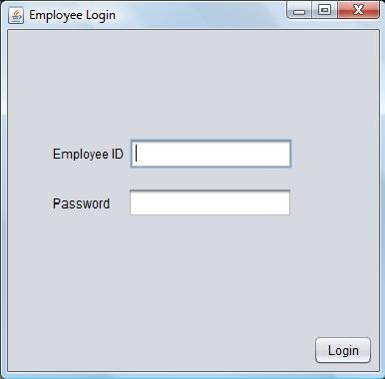
Employee then enters his or her login information and then click “Login”.
If the employee is an admin, the window showing all the operations that could be performed by an admin in the following window:
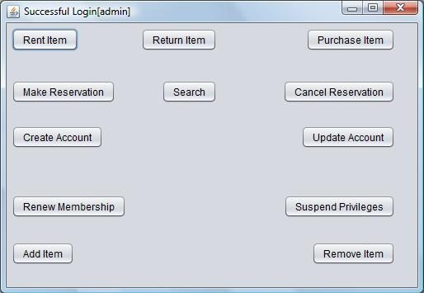
Otherwise, the following window is shown:
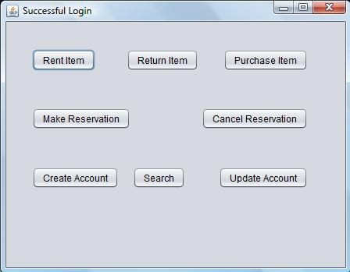

From this window, the operation that is to be performed is selected by clicking on the button that says what the customer wishes to do.

To Rent an Item:
- Click the button “Rent Item” in the Main Menu window shown above.
- The system then prompts for Membership Card to be scanned. For this prototype, we are testing the scanning by simply entering the member's id, which represents the membership card number. The input dialog box below pops up to perform this action:
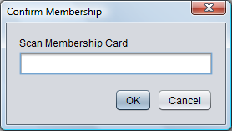
  - After the Membership card has been scanned the system shows the rent Item window displaying the member's ID and prompting for items to be rented. As seen below:
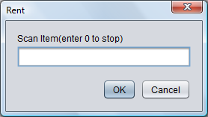
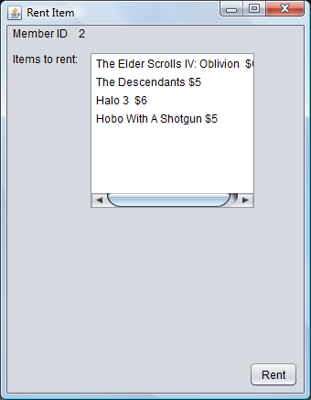

- After scanning all the items to be rented, click the “Rent” button the following window then appears.
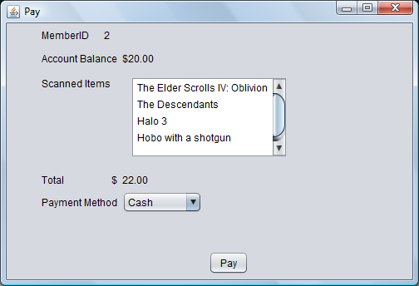

- This shows payment information. When the customer has paid, the employee clicks the “Pay” button and this records the payment in the database and prompts for a receipt to be printed. Now we just output certain information regarding the payment.
- Finally the Main Menu is displayed again.

Purchasing an Item
- Click the button “Purchase Item” in the Main Menu window shown above.
- The system then prompts for the items to be purchased to be scanned with the dialog box below
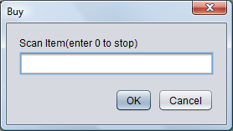
Once the item has been scanned(i.e. Item ID has been entered) its price and information is displayed and summed to a total in the window below. When all items have been scanned, enter 0 in the dialog box to stop expecting more items.
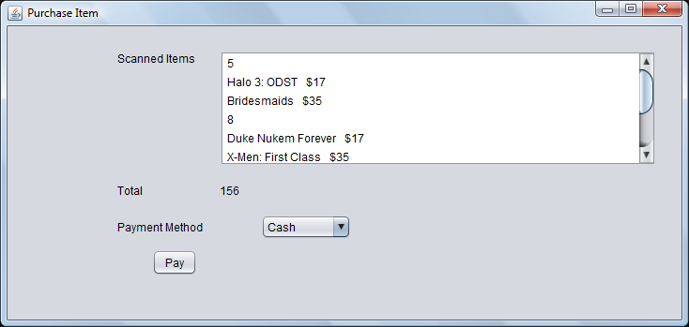
- After the customer has paid, select his or her mode of payment(i.e. Cash or Credit Card) and click the “Pay” button. The payment is then recorded and a receipt is printed.
- The system then returns to the Main Menu window.

Return Item

- Click the button “Return Item” in the Main Menu window shown above.
- The system then prompts for the membership card to be scanned, with the input dialog box shown below:

- The member ID is then displayed in the following window along with the member's account balance in the window below, while a dialog box repeatedly prompts for the items being returned to be scanned.

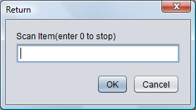
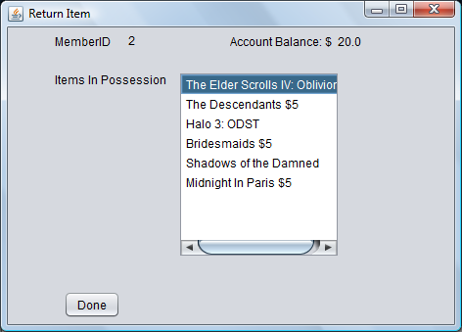

- After all items have been returned, enter 0 into the dialog box.
- Click “Done” button. This then updates the inventory, and returns to Main Menu window.

Make Reservation

- Click the button “Make Reservation” in the Main Menu window shown above.
- The system then prompts for the membership card to be scanned, with the input dialog box shown below:

3. The following window opens to specify what item is being reserved.

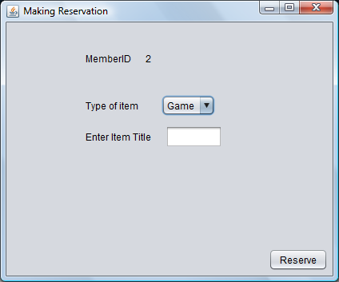
4.

Cancel Reservation

- Click the button “Cancel Reservation” in the Main Menu window shown above.
- The system then prompts for the membership card to be scanned, with the input dialog box shown below:

3. The following window opens to specify what item is being reserved.

Search

- Click the button “Search” in the Main Menu window shown above.
- The Search window as shown below opens:
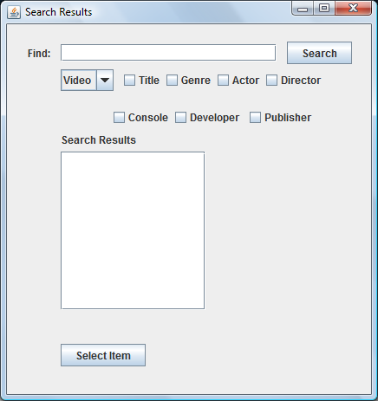
- One can search for any item(Game or Video) based on any criteria. For example if you want all movies where George Clooney acted. You would fill the text field with “George Clooney” as below, and check the “Actor” checkbox, defining the search criteria you wish to use. The window is as shown below after clicking “Search”:

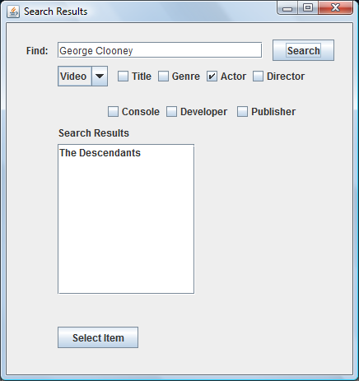

    - From the list in the “ Search Results” box, click on the appropriate result and then click “Select Item” . The next window shows the Item information:
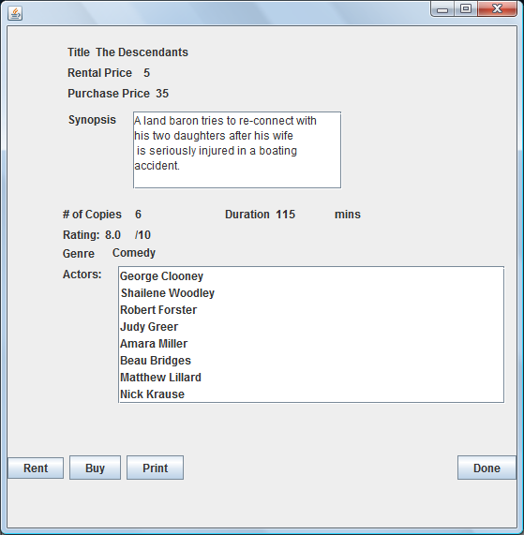

    - Click the button corresponding to the customer's request.
a. Clicking “Rent” goes through the same process as defined in Rent Item section above
b. Clicking “Buy” goes through the same process as defined in Purchase Item section above
c. Clicking “Print” would output all the movie information and return to the main menu
d. Clicking “Done” would return to the main menu

Create Account

- Click the button “Create Account” in the Main Menu window shown above.
- The window below is displayed, enter the customer's information:
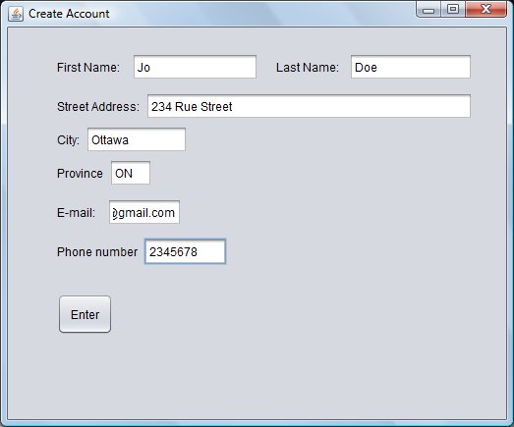

- Click “Enter”

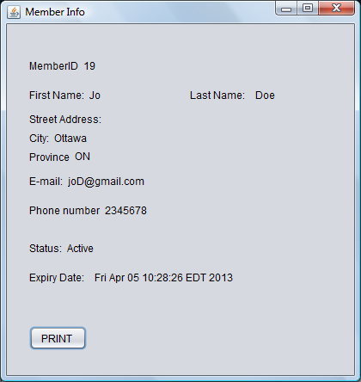

4. Click “Print”. This would print out the member information and in the full system, should print the membership card.

Update Account

- Click the button “Update Account” in the Main Menu window shown above.
- The system then prompts for the membership card to be scanned, with the input dialog box shown below:

3.The window below is opened, with the member's information already entered:
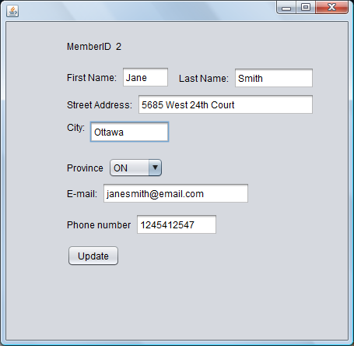
  - Make changes where the member requests and then click “Update” . This would update the database and return to the main menu.

Only admins have the privilege to perform the following operations and so any referral to Main Menu regards to the Main Menu[admin] window:

Renew Membership

- Click the button “Renew Membership” in the Main Menu window shown above.
- The system then prompts for the membership card to be scanned, with the input dialog box shown below:

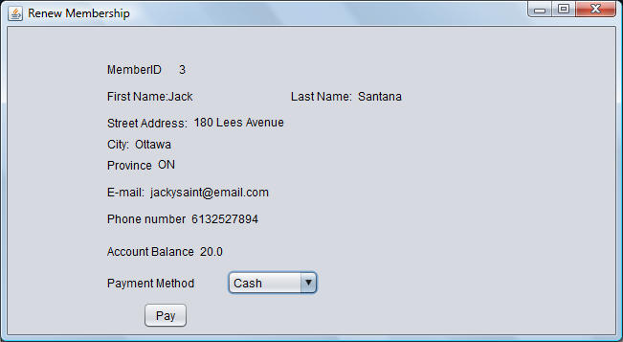
3. The following window is displayed, showing the member's information and account balance to pay

Suspend Privileges

Add Item

Remove Item

3.After customer has paid, select the payment method and click “Pay”. The payment would be recorded and the receipt would be printed. The window returns to main menu.

Suspend Privileges

- Click the button “Update Account” in the Main Menu window shown above.
- The system then prompts for the membership card to be scanned, with the input dialog box shown below:

3. The following window is displayed. Enter reason for suspension and click “Complete Suspension”
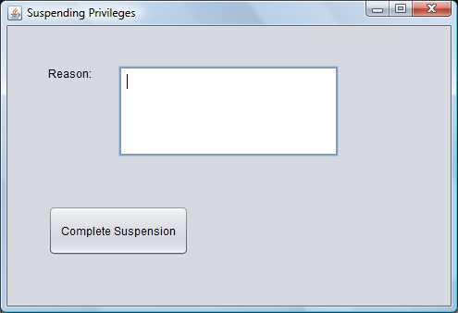

    - Member is suspend and system returns to Main Menu.

Add Item

- Click the button “Add Item” in the Main Menu window shown above.
- Click appropritate button, i.e. select if Item is a video or a game

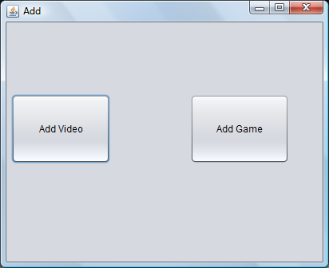
3.If “Add Video” is clicked, enter the video information as done below.
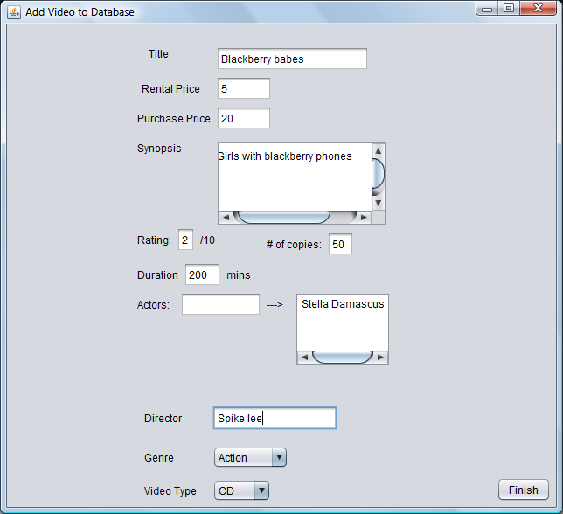
The actors are entered one at a time in the text field. Enter the Actors name and press Enter key.

- If “Add Game” is clicked, enter game information in the window below:
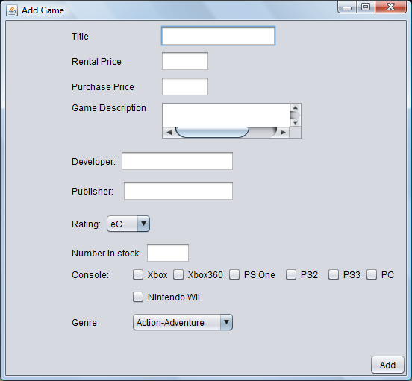
- Click “Add”. The item would be added to the database

