TESTING AND EVALUATION OF THE BANKING SYSTEM

NAME: Anieska Brown
COURSE: MSC COMPUTER SCIENCE
MODULE: SOFTWARE DEVELOPMENT

Test ID | Feature | Test Input | Expected Output | Actual  Output | Results
TC1 | Admin Login | id1188 / 1441 | Login successful | Login successful | Pass
TC2 | Admin Login | id1188 / 1442 | Login unsuccessful | Login unsuccessful | Pass
TC3 | Search Customer | Smith | Customer found | Customer found | Pass
TC4 | Search Customer | Brown | Not Found | Not Found | Pass
TC5 | Deposit | 100 | Balance increased | Balance increased | Pass
TC6 | Deposit invalid | -50 | Error message | Error shown | Pass
TC7 | Deposit invalid | abc | Error message | Error shown | Pass
TO8 | Withdraw | 50 | Balance decreases | Balanced decreased | Pass
TC9 | Withdraw invalid | -10 | Error message | Error shown | Pass
TC10 | Withdraw Invalid | 10000 | Insufficient funds | Error shown | Pass
TC11 | View Details | Smith | Full details shown | Details shown | pass
TC12 | Update Name | Adam → Aidan | Name updated | Updated | pass
TC13 | Update Address | New address | Address updated | Updated | pass
TC14 | Transfer | Churchil→ Abdallah £100 | Transfer successful | Successful | pass
TC15 | Transfer invalid | wrong acc no | Transfer fails | Failed | pass
TC16 | Transfer Invalid | -5 | Transfer fails | Error shown | pass
TC17 | View Admin Details | Option 5 | Admin info shown | info shown | pass
TC18 | Delete Customer (Admin) | id1188 | Customer deleted | Deleted | pass
TC19 | Delete Customer (Invalid Name) | Newman | Customer not found | Customer not found | pass
TC20 | Management Report | Option 6 | Report shown | Report shown | pass
TC21 | Delete  Customer (admin rights check) | Id3313  2442/smith | Access denied | Access denied | Pass

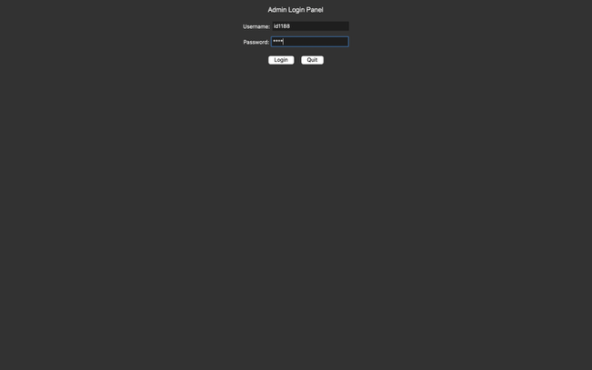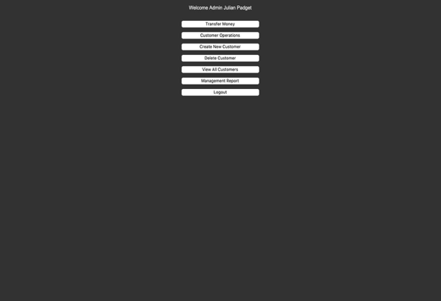
Figure 1: TC1 Admin Login(Success)

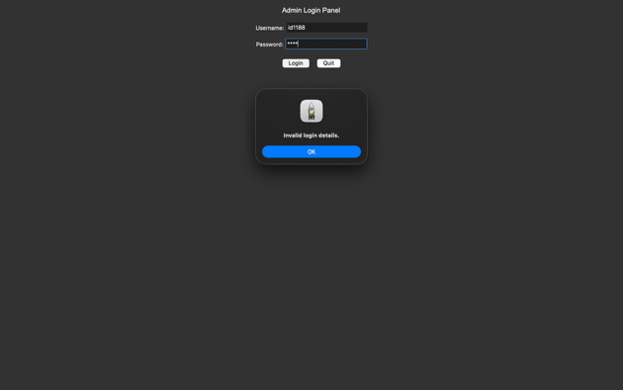
Figure 2: TC 2 Failed Login
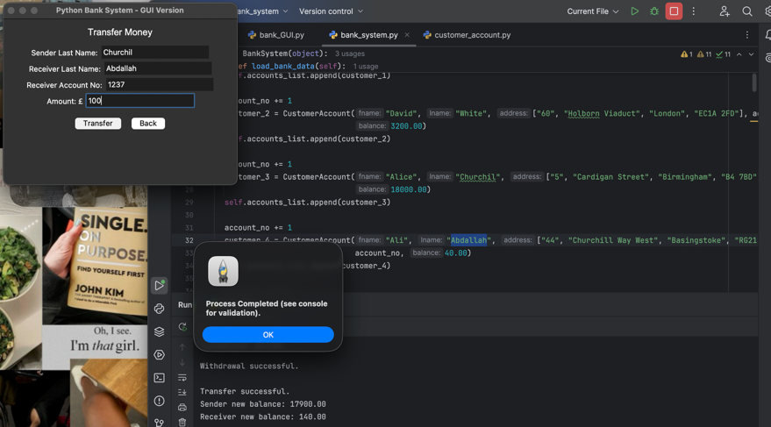
Figure 3: TC14 Transfer Successful

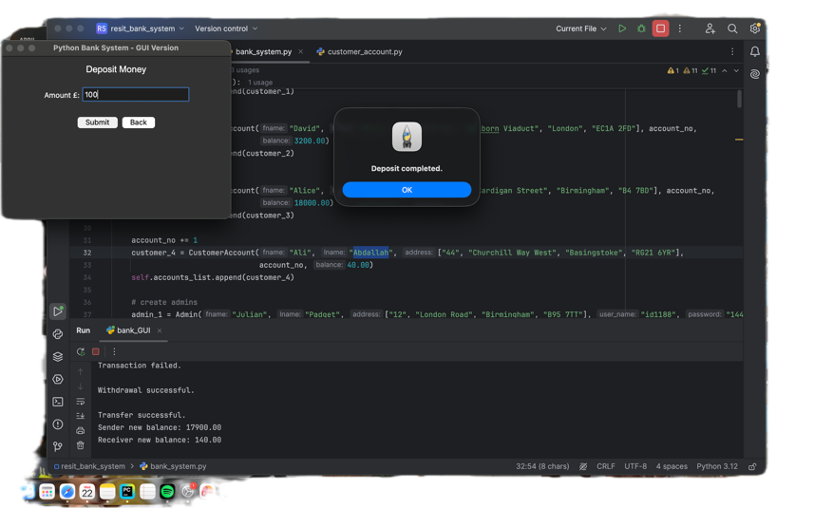
Figure 4: TC5 Deposit Successful

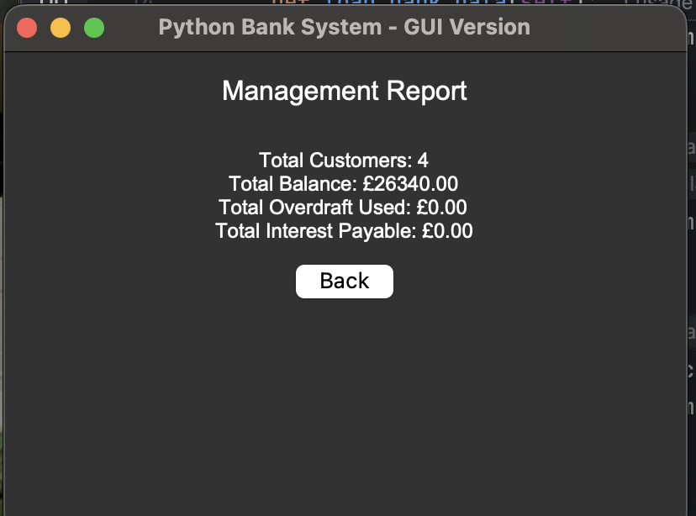
Figure 5: TC 20 Management Report

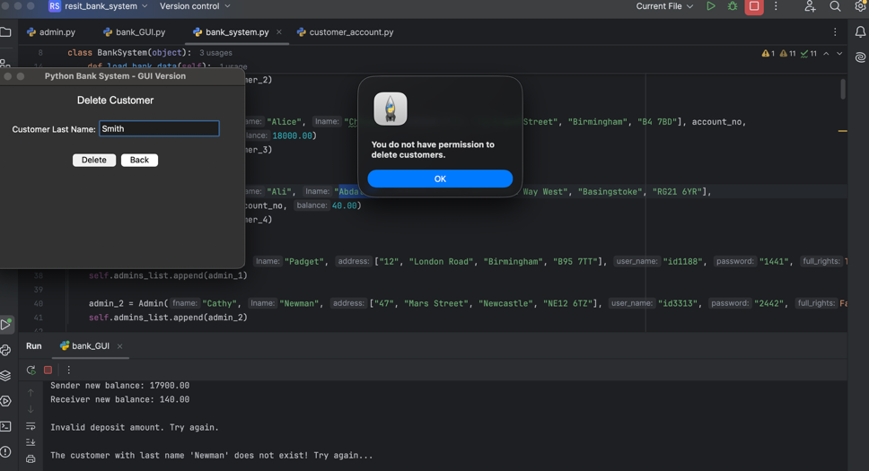
Figure 6: TC21 Access Denied
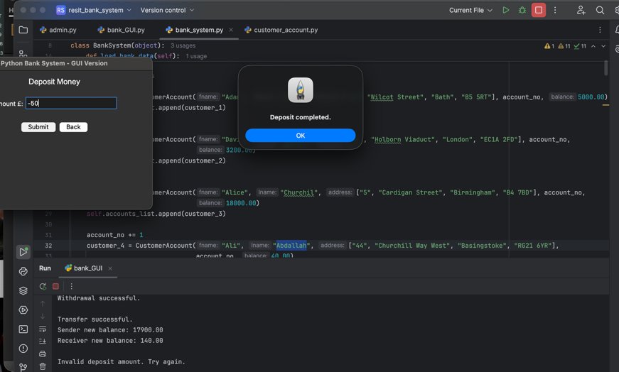
Figure: TC6 Deposit withdraw invalid

Create the necessary classes and functions which allow Admins to perform the following tasks:
- Admin Login | ☒
- Search for a particular customer to perform various banking operations on a customer bank account i.e. check balance, deposit or withdraw money etc. | ☒
- Deposit money into a customer account | ☒
- Withdraw money from a customer account | ☒
- Check current balance for a customer | ☒
- View customer details e.g. name and address | ☒
- Update customer information e.g. name and address | ☒
- Close a customer account i.e. remove customer from the system | ☒
- Update admin own information i.e. name and address | ☒
- Print all customers details | ☒
- Customers can have different types of bank account (e.g. current account, different types of saving account). Accounts will differ in their account name, interest rate and overdraft limit etc. | ☒
- The bank system should be able to store and load all customers’ data from and into a file. | ☒
- Transferring funds/money from one account to another. For example, an Admin can transfer funds from one customer account to another customer account. | ☒
- Admins can request a management report. This should show the following information; | ☒
- Total number of customers in the system | ☒
- The sum of all money the customers currently have in their bank account. | ☒
- Using individual account balance, the report should calculate the sum of interest rate payable to all accounts for one year, note, if customers have different account types, their rates will vary. | ☒
- Total amount of overdrafts currently taken by all customers. | ☒
- Development of a suitable Graphical User Interface (GUI) to perform all the above banking functions. | ☒

