1.

代码：

Date.jsp

<%@ **page** import="java.util.Calendar" %>  
<%@ **page** import="java.util.Date" %>  
<%@ **page** contentType="text/html;charset=UTF-8" language="java" %>  
<html>  
<head>  
 <title>Title</title>  
</head>  
<body>  
  
<%  
 String str = "";  
 Calendar c = Calendar.*getInstance*();  
 int hour = c.get(Calendar.*HOUR_OF_DAY*);  
  
 if(hour >= 0 && hour < 6) {  
 str = "早上好";  
 }  
 else if(hour >= 6 && hour <= 12) {  
 str = "上午好";  
 }  
 else if(hour > 12 && hour <= 18) {  
 str = "下午好";  
 }  
 else if(hour > 18 && hour <= 24) {  
 str = "晚上好";  
 }  
%>  
  
<%= str%>  
<br>  
<%= new Date()%>  
</body>  
</html>

截图：

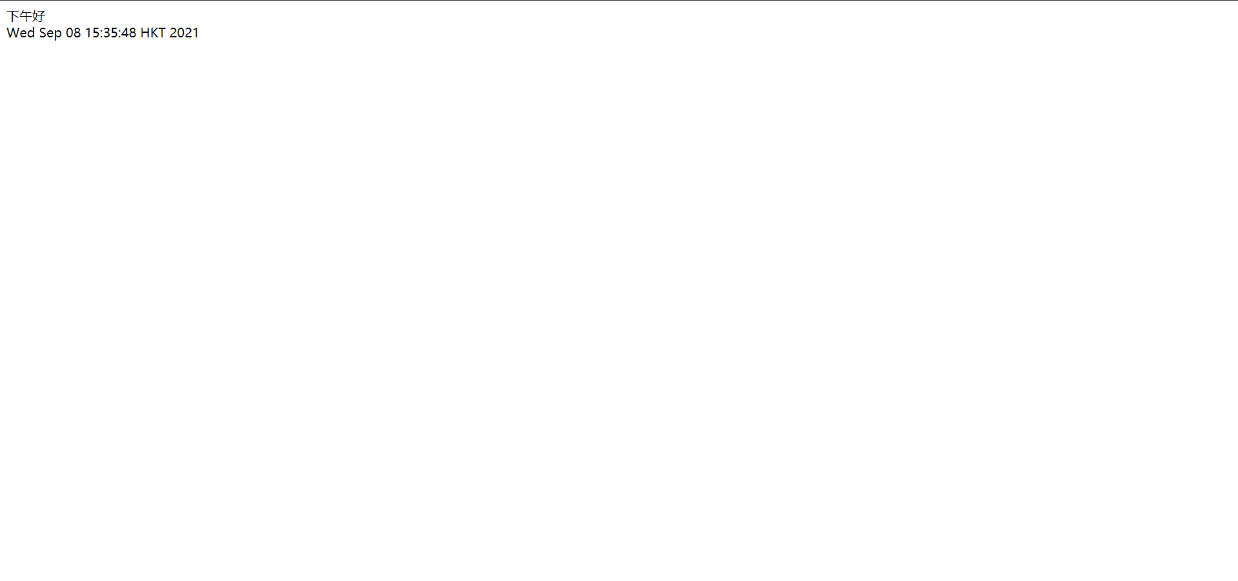

2.

代码：

1./work/calculate.jsp

<%@ **page** contentType="text/html;charset=UTF-8" language="java" %>  
<html>  
<head>  
 <title>Title</title>  
</head>  
<body>  
  
<**jsp:include** page="/Common/display.jsp">  
<**jsp:param** name="num" value="10"/>  
</**jsp:include**>  
  
<hr>  
  
<%@**include** file="../Common/calculate.jsp"%>  
  
</body>  
</html>

2.Common/calculate.jsp

<%@ **page** contentType="text/html;charset=UTF-8" language="java" %>  
<html>  
<head>  
 <title>Title</title>  
</head>  
<body>  
  
<%  
 double num = 20;  
 out.print(num + "的平方是:" + Math.*pow*(20, 2));  
%>  
  
</body>  
</html>

说明：

<%-- 可以采用include指令加载 --%>  
<%-- 因为虽然jsp:include是采用调用各不相同的参数  
 而include指令中的所使用的参数必须保持一致  
 但jsp:include需要在不同界面中调用相同参数  
 而include指令在不同页面中只需调用不同jsp文件进行显示即可  
--%>

截图：

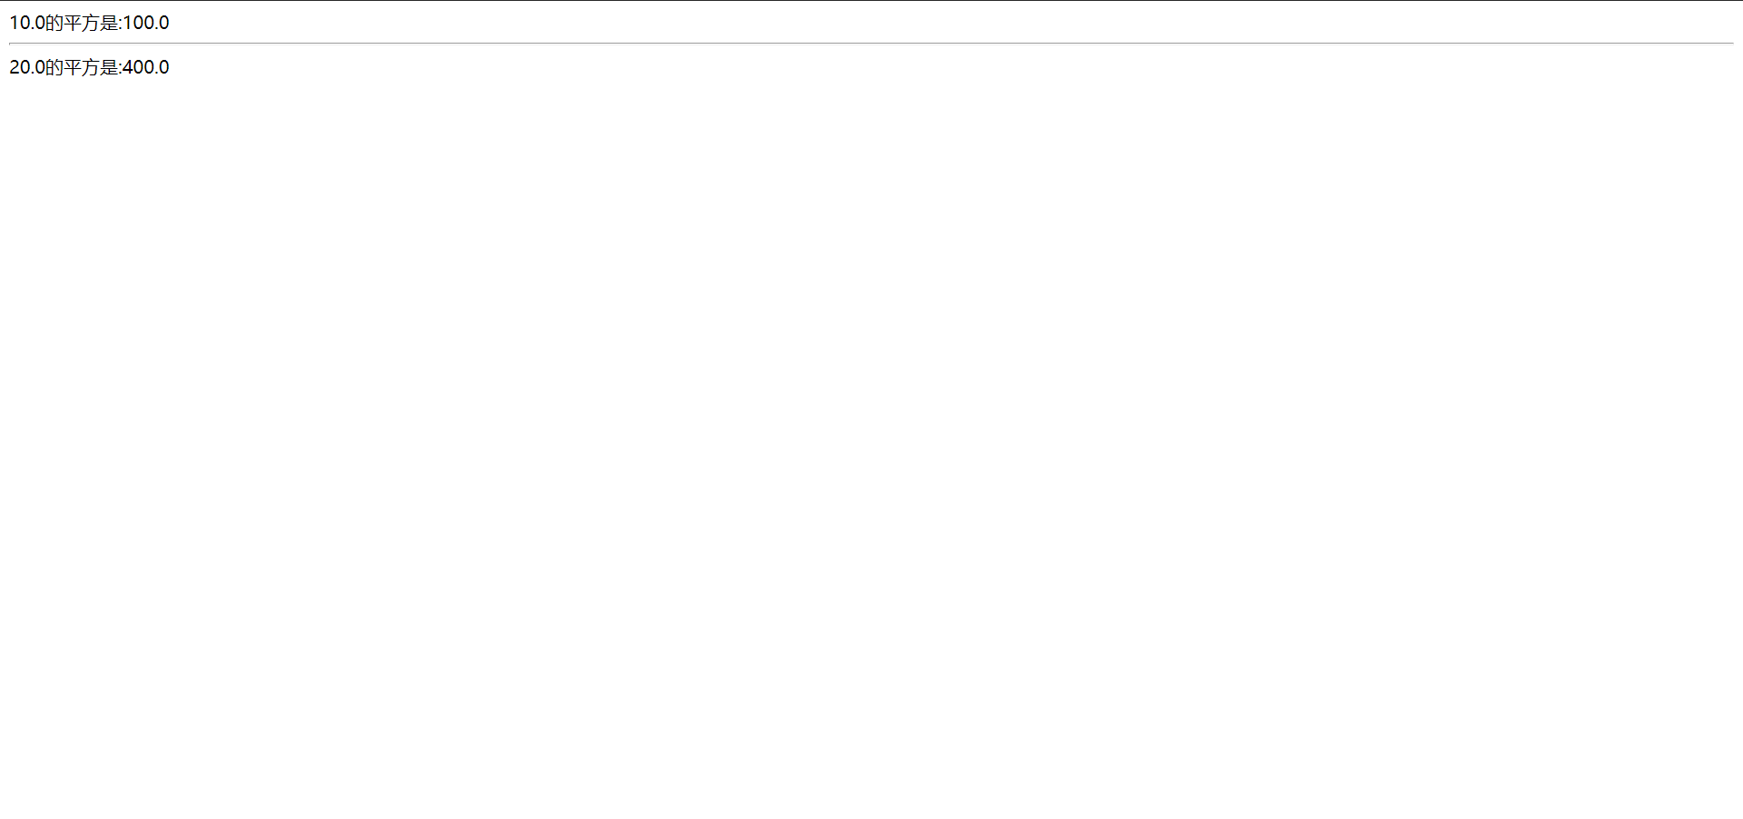

3.

代码：

1. work/book.jsp

<%@ **page** contentType="text/html;charset=UTF-8" language="java" %>  
<html>  
<head>  
 <title>Title</title>  
</head>  
<body>  
  
<form action="/Common/book.jsp" method="post">  
Plz choose one book: <br>  
<input type="radio" name="books" value="A"> A <br>  
<input type="radio" name="books" value="B"> B <br>  
<input type="radio" name="books" value="C"> C <br>  
<input type="submit" value="submit">  
</form>  
  
</body>  
</html>

1. Common/book.jsp

<%@ **page** contentType="text/html;charset=UTF-8" language="java" %>  
<html>  
<head>  
 <title>Title</title>  
</head>  
<body>  
  
<%  
 String book = request.getParameter("books");  
  
 if(book.equals("A")) {%>  
 <**jsp:forward** page="/Common/bookA.jsp">  
 <**jsp:param** name="bookName" value="aaa"/>  
 <**jsp:param** name="author" value="111"/>  
 </**jsp:forward**>  
 <%}  
 else if(book.equals("B")){%>  
 <**jsp:forward** page="/Common/bookB.jsp">  
 <**jsp:param** name="bookName" value="bbb"/>  
 <**jsp:param** name="author" value="222"/>  
 </**jsp:forward**>  
 <%}  
 else {%>  
 <**jsp:forward** page="/Common/bookC.jsp">  
 <**jsp:param** name="bookName" value="ccc"/>  
 <**jsp:param** name="author" value="333"/>  
 </**jsp:forward**>  
 <%}  
  
%>  
  
</body>  
</html>

3.Common/bookA.jsp

<%@ **page** contentType="text/html;charset=UTF-8" language="java" %>  
<html>  
<head>  
 <title>BookA</title>  
</head>  
<body>  
  
bookName:  
<%= request.getParameter("bookName")%> <br>  
Author:  
<%= request.getParameter("author")%> <br>  
  
</body>  
</html>

4.Common/bookB.jsp

<%@ **page** contentType="text/html;charset=UTF-8" language="java" %>  
<html>  
<head>  
 <title>bookB</title>  
</head>  
<body>  
  
bookName:  
<%= request.getParameter("bookName")%> <br>  
Author:  
<%= request.getParameter("author")%> <br>  
  
</body>  
</html>

5. Common/bookC.jsp

<%@ **page** contentType="text/html;charset=UTF-8" language="java" %>  
<html>  
<head>  
 <title>bookC</title>  
</head>  
<body>  
  
bookName:  
<%= request.getParameter("bookName")%> <br>  
Author:  
<%= request.getParameter("author")%> <br>  
  
</body>  
</html>

截图：

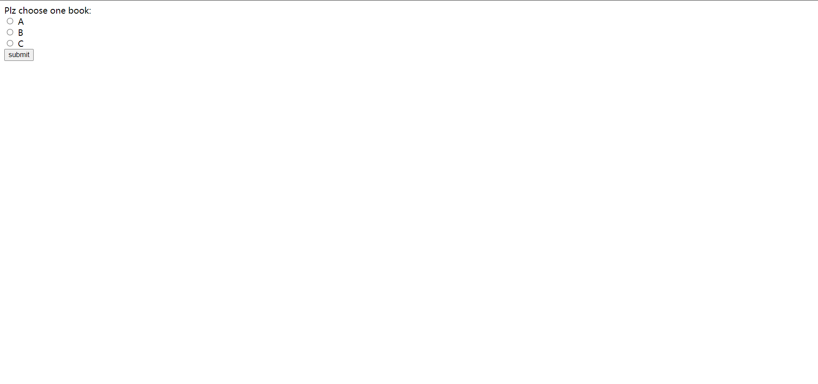

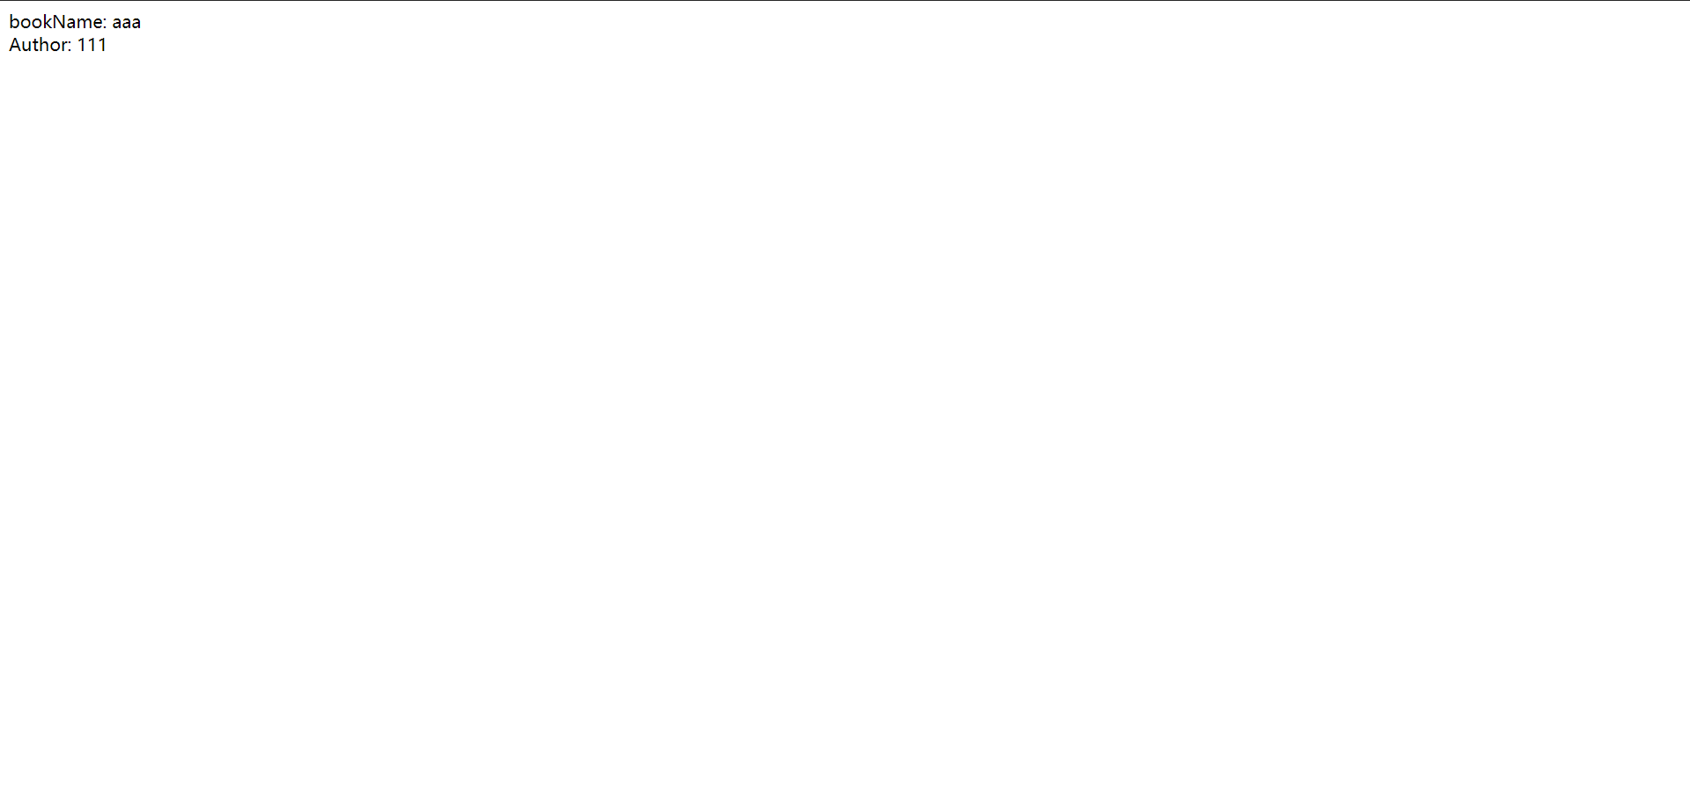

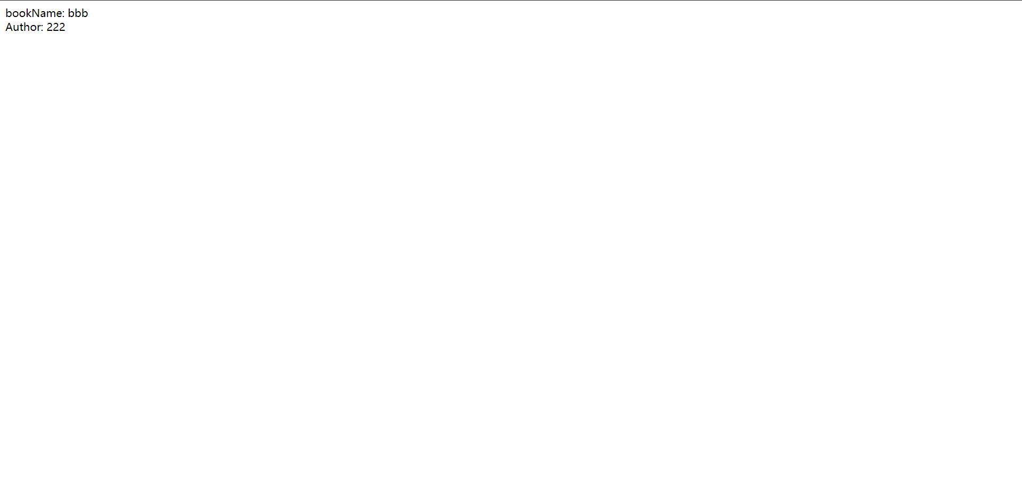

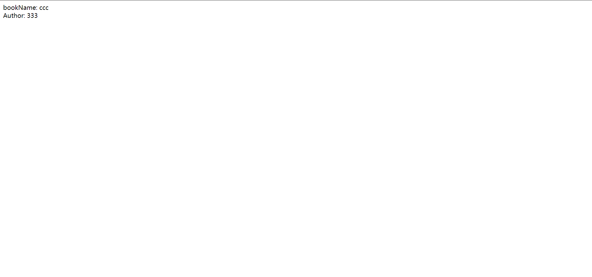

4.

代码：

1.work/input.jsp

<%@ **page** contentType="text/html;charset=UTF-8" language="java" %>  
<html>  
<head>  
 <title>Title</title>  
</head>  
<body>  
  
<form action="sum.jsp" method="post">  
 data1: <input type="text" name="data1"> <br>  
 date2: <input type="text" name="date2"> <br>  
 <input type="submit" value="submit"> <br>  
</form>  
  
</body>  
</html>

2.work/sum.jsp

<%@ **page** contentType="text/html;charset=UTF-8" language="java" %>  
<html>  
<head>  
 <title>Title</title>  
</head>  
<body>  
  
<%  
 String s1 = request.getParameter("data1");  
 String s2 = request.getParameter("date2");  
 double d1 = Double.*parseDouble*(s1);  
 double d2 = Double.*parseDouble*(s2);  
 double sum = d1 + d2;  
 request.setAttribute("d1", d1);  
 request.setAttribute("d2", d2);  
 request.setAttribute("sum", sum);  
  
 if(sum >= 0) {%>  
 <**jsp:forward** page="/Common/positive.jsp"></**jsp:forward**>  
 <%}  
 else{%>  
 <**jsp:forward** page="/Common/negative.jsp"></**jsp:forward**>  
 <%}  
  
%>  
  
</body>  
</html>

3.Common/positive.jsp

<%@ **page** contentType="text/html;charset=UTF-8" language="java" %>  
<html>  
<head>  
 <title>Title</title>  
</head>  
<body>  
<p>结果为正!</p>  
  
<hr>  
  
<%  
 Double d1 = (Double) request.getAttribute("d1");  
 Double d2 = (Double) request.getAttribute("d2");  
 Double sum = (Double) request.getAttribute("sum");  
%>  
  
<%= sum%>  
  
</body>  
</html>

4.Common/negative.jsp

<%@ **page** contentType="text/html;charset=UTF-8" language="java" %>  
<html>  
<head>  
 <title>Title</title>  
</head>  
<body>  
  
<p>结果为负!</p>  
  
<hr>  
  
<%  
 Double d1 = (Double) request.getAttribute("d1");  
 Double d2 = (Double) request.getAttribute("d2");  
 Double sum = (Double) request.getAttribute("sum");  
%>  
  
<%= sum%>  
  
</body>  
</html>

截图：

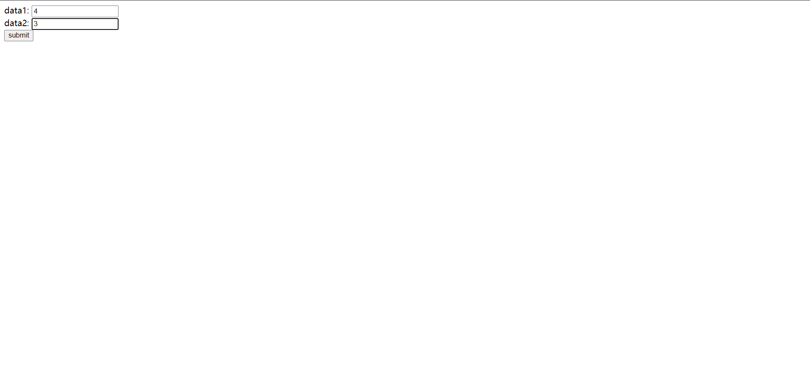

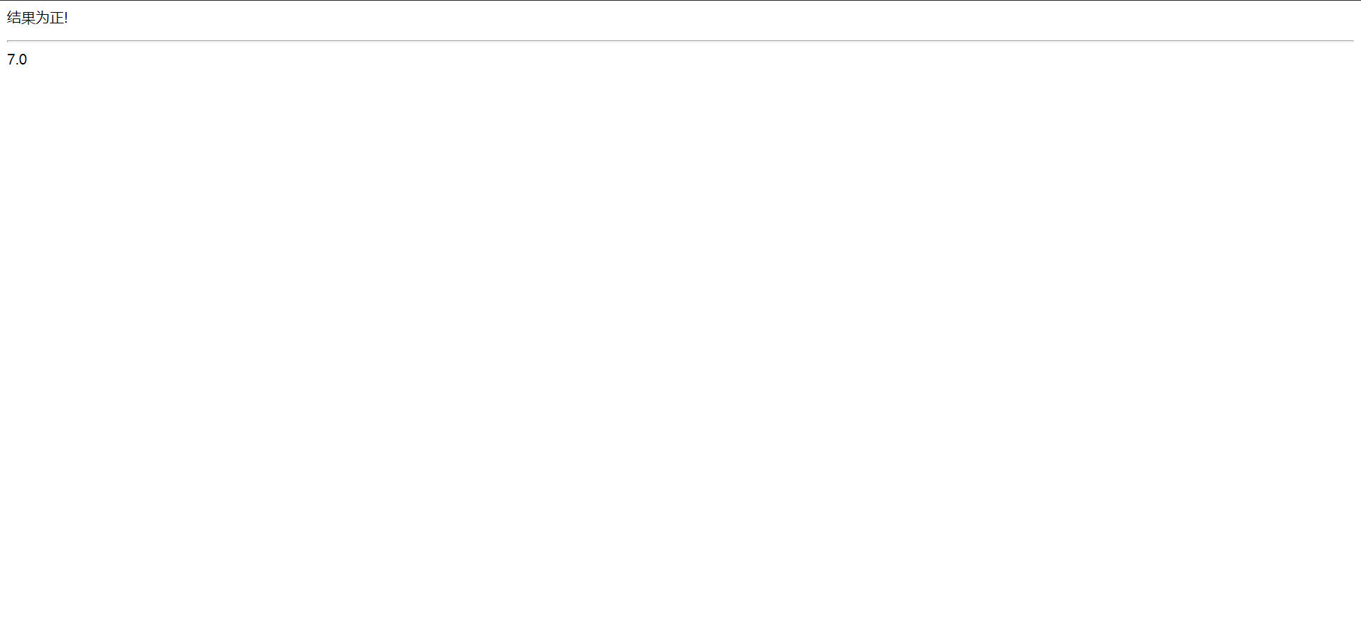

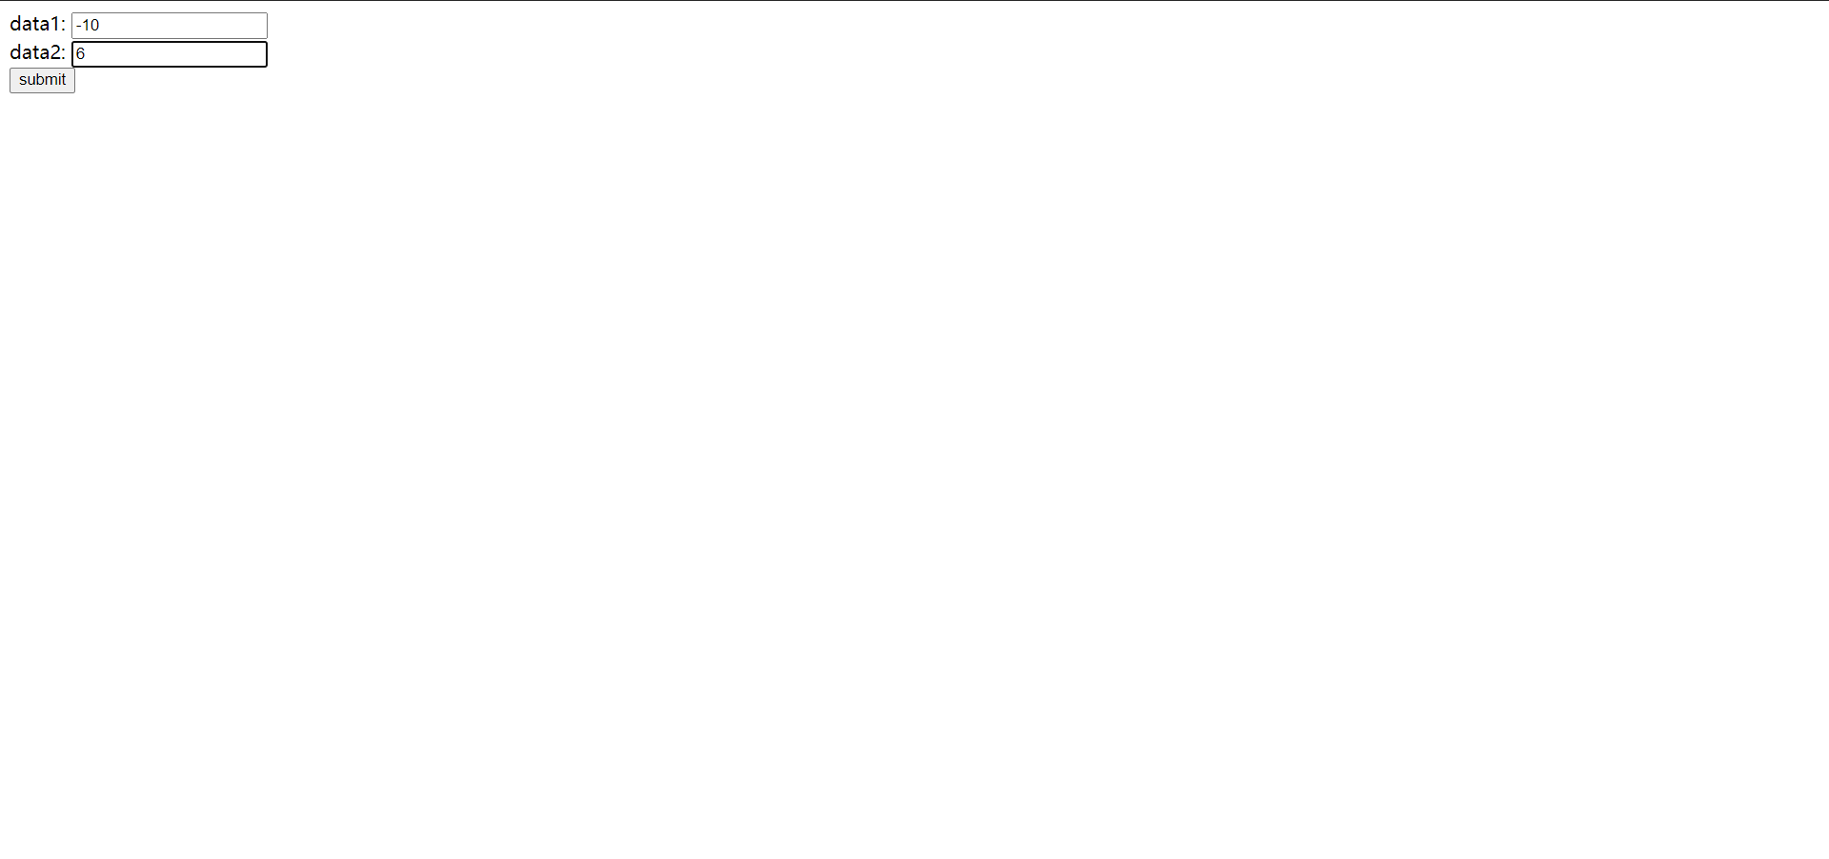

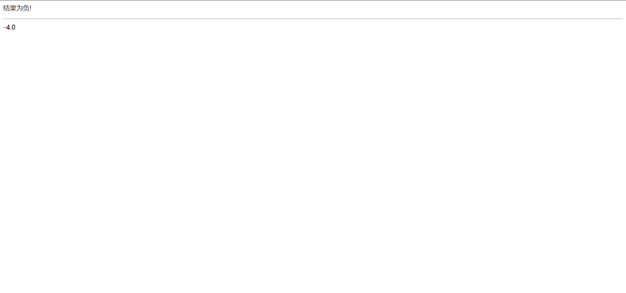

5.

代码：

1.form5/register.jsp

<%@ **page** contentType="text/html;charset=UTF-8" language="java" %>  
  
<html>  
<head>  
 <title>用户注册</title>  
</head>  
  
<script language="JavaScript">  
 function check() {  
 if(myform.password.value != myform.confim.value) {  
 alert("password wrong!");  
 myform.password.focus();  
 return false;  
 }  
 return true;  
 }  
</script>  
  
<body>  
  
<form action="appear.jsp" method="post" name="myform">  
 <table border="0" cellpadding="0" cellspacing="0" align="center" width="530">  
 <tr>  
 <td width="107" height="36">用户名：</td>  
 <td width="524"><input name="username" type="text" maxlength="16">(必填)</td>  
 </tr>  
 <tr>  
 <td width="107" height="36">密码：</td>  
 <td width="524"><input name="password" type="password">(必填)</td>  
 </tr>  
 <tr>  
 <td width="107" height="36">确认密码：</td>  
 <td width="524"><input name="confim" type="password"></td>  
 </tr>  
 <tr>  
 <td width="107" height="36">性别：</td>  
 <td width="524">  
 <input name="gen" type="radio" value="男" checked>男  
 <input name="gen" type="radio" value="女" class="input">女  
 </td>  
 </tr>  
 <tr>  
 <td width="107" height="36">爱好：</td>  
 <td width="524">  
 <input type="checkbox" name="hobbies" value="计算机">计算机  
 <input type="checkbox" name="hobbies" value="音乐">音乐  
 <input type="checkbox" name="hobbies" value="体育">体育  
 <input type="checkbox" name="hobbies" value="文学">文学  
 </td>  
 </tr>  
 <tr>  
 <td width="107" height="36">星座：</td>  
 <td width="524">  
 <select name="constellation">  
 <option value="白羊">白羊</option>  
 <option value="金牛">金牛</option>  
 <option value="双子">双子</option>  
 <option value="巨蟹">巨蟹</option>  
 <option value="狮子">狮子</option>  
 <option value="处女">处女</option>  
 <option value="天秤">天秤</option>  
 <option value="天蝎">天蝎</option>  
 <option value="射手">射手</option>  
 <option value="摩羯">摩羯</option>  
 <option value="水瓶">水瓶</option>  
 <option value="双鱼">双鱼</option>  
 </select>  
 </td>  
 </tr>  
 <tr>  
 <td width="107" height="36">个人简介：</td>  
 <td colspan="2">  
 <textarea name="self" cols="" rows="" style="width:250px;height:110px;font-size:12px;color:#666">  
 </textarea>  
 </td>  
 </tr>  
 <tr>  
 <td width="107" height="36">  
 <input type="submit" value="提交">  
 </td>  
 <td width="200" height="36">  
 <input type="reset" value="重置">  
 </td>  
 </tr>  
 </table>  
</form>  
</body>  
</html>

2.form5/appear.jsp

<%@ **page** contentType="text/html;charset=UTF-8" language="java" %>  
  
<html>  
<head>  
 <title>Title</title>  
</head>  
<body>  
  
<%  
 request.setCharacterEncoding("UTF-8");  
  
 String username = (String) request.getParameter("username");  
 String password = (String) request.getParameter("password");  
 String confirm = (String) request.getParameter("confirm");  
 String gen = (String) request.getParameter("gen");  
 String constellation = (String) request.getParameter("constellation");  
 String[] hobbies = request.getParameterValues("hobbies");  
 String self = (String) request.getParameter("self");  
  
%>  
  
您的姓名是：<%= username%> <br>  
  
您的密码是：<%= password%> <br>  
  
您的性别是：<%= gen%> <br>  
  
您的爱好是：  
<%  
 for (int i = 0; i < hobbies.length; i++) {  
 out.print(hobbies[i] + " ");  
 }  
%>  
<br>  
  
您的星座是：<%= constellation%> <br>  
  
您的个人简介是: <br>  
<%= self%>  
  
</body>  
</html>

截图：

