1.

代码：

1.work2/input.jsp

<%@ **page** contentType="text/html;charset=UTF-8" language="java" %>  
<html>  
<head>  
 <title>input</title>  
</head>  
<body>  
  
<form action="calculate.jsp" name="input" method="post">  
 <h3>请输入圆的半径：</h3>  
 <table>  
 <tr><td align="right">半径：</td>  
 <td><input name="radius"></td>  
 </tr>  
 <tr>  
 <td><input type="submit" value="提交"></td>  
 </tr>  
 </table>  
</form>

2.work2/calculate.jsp

<%@ **page** contentType="text/html;charset=UTF-8" language="java" %>  
<html>  
<head>  
 <title>Calculate</title>  
</head>  
<body>  
  
<**jsp:useBean** id="Circle" class="com.misaki.Circle.Circle" scope="request"/>  
<%  
 double radius = Double.*parseDouble*(request.getParameter("radius"));  
 Circle.setRadius(radius);  
 out.println("圆的周长：" + Circle.circleLength() + "<br> <br>");  
 out.println("圆的面积：" + Circle.circleArea());  
%>  
  
<hr>  
  
<**jsp:useBean** id="circle" class="com.misaki.Circle.Circle2" scope="request"/>  
<**jsp:setProperty** name="circle" property="radius"/>  
  
<%--Property内不能存在大写--%>  
圆的周长为：<**jsp:getProperty** name="circle" property="length"/> <br> <br>  
圆的面积为：<**jsp:getProperty** name="circle" property="area"/>  
  
  
</body>  
</html>

3.com.misaki.Circle.Circle

package com.misaki.Circle;  
  
***/**  
 * @title: Circle2  
 * @Author misaki  
 * @Date: 2021/9/8 21:39  
 * @Version 1.0  
 */***public class Circle {  
  
 private int number; //圆的编号  
 private double x; //圆心x值  
 private double y; //圆心y值  
 private double radius; //半径  
 private String color; //绘制颜色  
 private boolean fill; //是否填充  
  
  
 public int getNumber() {return number;} //成员number的get方法  
 public void setNumber(int number) {this.number = number;} //成员number的set方法  
 public double getX() {return x;}  
 public void setX(double x) { this.x = x;}  
 public double getY() {return y;}  
 public void setY(double y) { this.y = y;}  
 public double getRadius() { return radius; }  
 public void setRadius(double radius) {this.radius = radius;}  
 public String getColor() {return color;}  
 public void setColor(String color) {this.color = color;}  
 public boolean isFill() {return fill;}  
 public void setFill(boolean fill) {this.fill = fill;}  
  
 public Circle() {} // 公共无参构造方法，这里使用的是默认构造方法  
  
 public double circleArea(){return Math.*PI*\*radius*radius;} //计算圆面积的方法  
 public double circleLength(){return 2*Math.*PI*\*radius;} //计算圆周长的方法  
}

4.com.misaki.Circle.Circle2

package com.misaki.Circle;  
  
***/**  
 * @title: Circle  
 * @Author misaki  
 * @Date: 2021/9/8 19:51  
 * @Version 1.0  
 */***public class Circle2 {  
  
 private int number; //圆的编号  
 private double x; //圆心x值  
 private double y; //圆心y值  
 private double radius; //半径  
 private String color; //绘制颜色  
 private boolean fill; //是否填充  
 private double Length; //周长  
 private double Area; //面积  
  
 public int getNumber() {return number;} //成员number的get方法  
 public void setNumber(int number) {this.number = number;} //成员number的set方法  
 public double getX() {return x;}  
 public void setX(double x) { this.x = x;}  
 public double getY() {return y;}  
 public void setY(double y) { this.y = y;}  
 public double getRadius() { return radius; }  
 public void setRadius(double radius) {this.radius = radius;}  
 public String getColor() {return color;}  
 public void setColor(String color) {this.color = color;}  
 public boolean isFill() {return fill;}  
 public void setFill(boolean fill) {this.fill = fill;}  
 public void setArea(double area){this.Area = Area;}  
 public void setLength(double length){this.Length = Length;}  
  
 public Circle2() {} // 公共无参构造方法，这里使用的是默认构造方法  
  
 public double getArea(){  
 return Math.*PI*\*radius*radius;  
 } //计算圆面积的方法  
  
 public double getLength(){  
 return 2*Math.*PI*\*radius;  
 } //计算圆周长的方法  
}

截图：

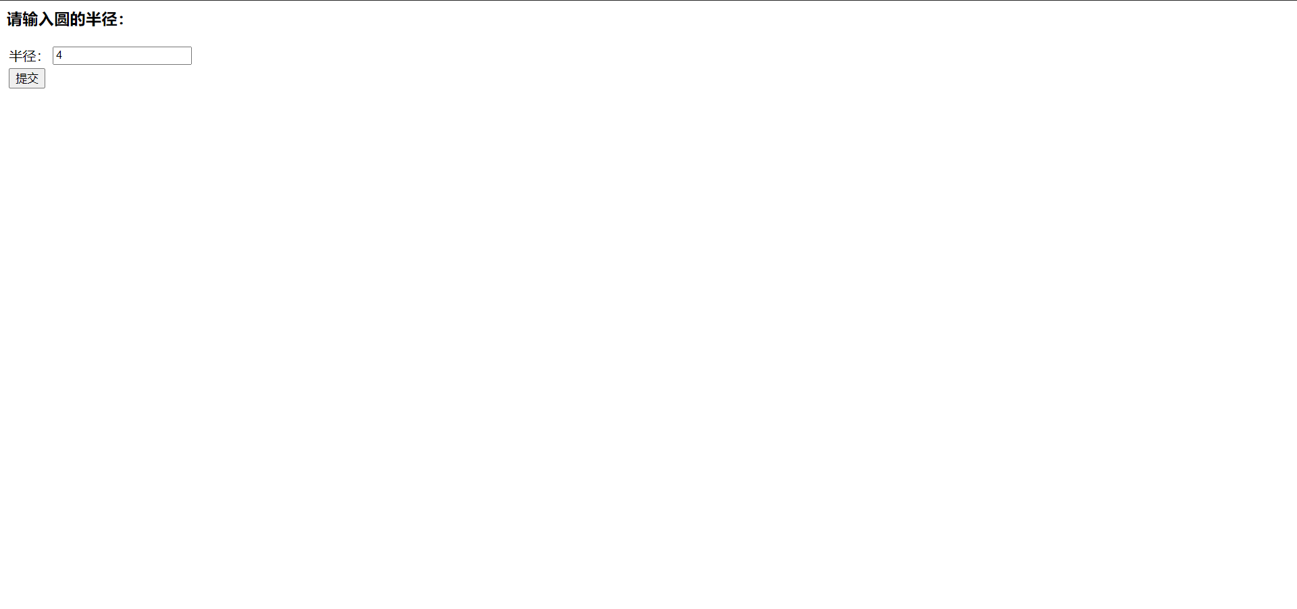

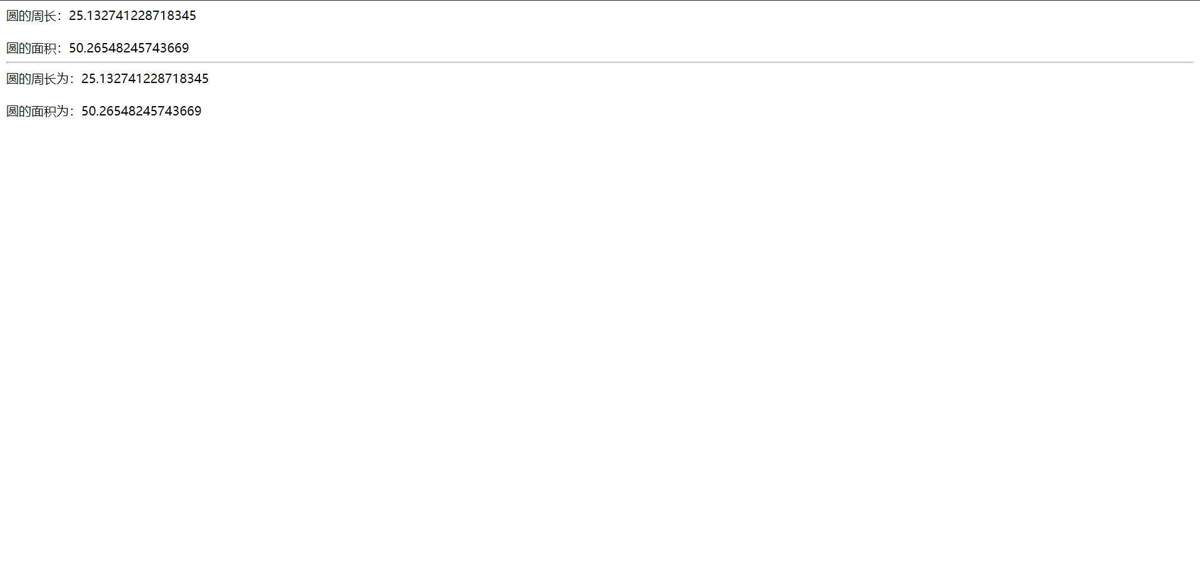

2.

代码：

1.work/register.jsp

<%@ **page** contentType="text/html;charset=UTF-8" language="java" %>  
<html>  
<head>  
 <title>Title</title>  
</head>  
<form action="output.jsp" method="post" name="myform">  
 <table border="0" cellpadding="0" cellspacing="0" align="center" width="530">  
 <tr>  
 <td width="107" height="36">姓名：</td>  
 <td width="524"><input name="name" type="text" maxlength="16" required="required"></td>  
 </tr>  
 <tr>  
 <td width="107" height="36">性别：</td>  
 <td width="524">  
 <input name="gen" type="radio" value="男" checked required="required">男  
 <input name="gen" type="radio" value="女" class="input" required="required">女  
 </td>  
 </tr>  
 <tr>  
 <td width="107" height="36">出生日期：</td>  
 <td width="524">  
 <input name="year" id="year" size="4" maxlength="4">&nbsp;年&nbsp;&nbsp;  
 <select name="month">  
 <option value=1>一月</option>  
 <option value=2>二月</option>  
 <option value=3>三月</option>  
 <option value=4>四月</option>  
 <option value=5>五月</option>  
 <option value=6>六月</option>  
 <option value=7>七月</option>  
 <option value=8>八月</option>  
 <option value=9>九月</option>  
 <option value=10>十月</option>  
 <option value=11>十一月</option>  
 <option value=12>十二月</option>  
 </select>&nbsp;月&nbsp;&nbsp;  
 <select name="day">  
 <option value=1>1</option>  
 <option value=2>2</option>  
 <option value=3>3</option>  
 <option value=4>4</option>  
 <option value=5>5</option>  
 <option value=6>6</option>  
 <option value=7>7</option>  
 <option value=8>8</option>  
 <option value=9>9</option>  
 <option value=10>10</option>  
 <option value=11>11</option>  
 <option value=12>12</option>  
 <option value=13>13</option>  
 <option value=14>14</option>  
 <option value=15>15</option>  
 <option value=16>16</option>  
 <option value=17>17</option>  
 <option value=18>18</option>  
 <option value=19>19</option>  
 <option value=20>20</option>  
 <option value=21>21</option>  
 <option value=22>22</option>  
 <option value=23>23</option>  
 <option value=24>24</option>  
 <option value=25>25</option>  
 <option value=26>26</option>  
 <option value=27>27</option>  
 <option value=28>28</option>  
 <option value=29>29</option>  
 <option value=30>30</option>  
 <option value=7>31</option>  
 </select>&nbsp;日  
 </td>  
 </tr>  
 <tr>  
 <td width="107" height="36">民族：</td>  
 <td width="524">  
 <input name="nation" type="text" required="required" >  
 </td>  
 </tr>  
 <tr>  
 <td width="107" height="36">个人简介：</td>  
 <td>  
 <textarea name="self" cols="" rows="" style="width:250px;height:110px;font-size:12px;color:#666">  
 </textarea>  
 </td>  
 </tr>  
 <tr>  
 <td width="200" height="36">  
 <input type="submit" value="提交">  
 </td>  
 </tr>  
 </table>  
</form>  
</html>

2.work/output.jsp

<%@ **page** contentType="text/html;charset=UTF-8" language="java" %>  
<html>  
<head>  
 <title>Title</title>  
</head>  
<body>  
  
<%  
 request.setCharacterEncoding("UTF-8");  
 response.setCharacterEncoding("UTF-8");  
%>  
  
<**jsp:useBean** id="user" class="com.misaki.User.User" scope="request"/>  
  
<**jsp:setProperty** name="user" property="name" param="name"/>  
<**jsp:setProperty** name="user" property="gen" param="gen"/>  
<**jsp:setProperty** name="user" property="year" param="year"/>  
<**jsp:setProperty** name="user" property="month" param="month"/>  
<**jsp:setProperty** name="user" property="day" param="day"/>  
<**jsp:setProperty** name="user" property="nation" param="nation"/>  
<**jsp:setProperty** name="user" property="self" param="self"/>  
  
姓名为：<**jsp:getProperty** name="user" property="name"/> <br>  
性别为：<**jsp:getProperty** name="user" property="gen"/> <br>  
出生年月：  
<**jsp:getProperty** name="user" property="year"/>年  
<**jsp:getProperty** name="user" property="month"/>月  
<**jsp:getProperty** name="user" property="day"/>日  
<br>  
民族：<**jsp:getProperty** name="user" property="nation"/> <br>  
个人介绍：<**jsp:getProperty** name="user" property="self"/>  
  
  
</body>  
</html>

3.com.misaki.User.User

package com.misaki.User;  
  
***/**  
 * @title: User  
 * @Author misaki  
 * @Date: 2021/9/9 9:07  
 * @Version 1.0  
 */***public class User {  
 private String name;  
 private String gen;  
 private String year;  
 private String month;  
 private String day;  
 private String nation;  
 private String self;  
  
 public String getName() {  
 return name;  
 }  
  
 public void setName(String name) {  
 this.name = name;  
 }  
  
 public String getGen() {  
 return gen;  
 }  
  
 public void setGen(String gen) {  
 this.gen = gen;  
 }  
  
 public String getYear() {  
 return year;  
 }  
  
 public void setYear(String year) {  
 this.year = year;  
 }  
  
 public String getMonth() {  
 return month;  
 }  
  
 public void setMonth(String month) {  
 this.month = month;  
 }  
  
 public String getDay() {  
 return day;  
 }  
  
 public void setDay(String day) {  
 this.day = day;  
 }  
  
 public String getNation() {  
 return nation;  
 }  
  
 public void setNation(String nation) {  
 this.nation = nation;  
 }  
  
 public String getSelf() {  
 return self;  
 }  
  
 public void setSelf(String self) {  
 this.self = self;  
 }  
  
 public User() {  
  
 }  
}

截图：

