实验一截图：

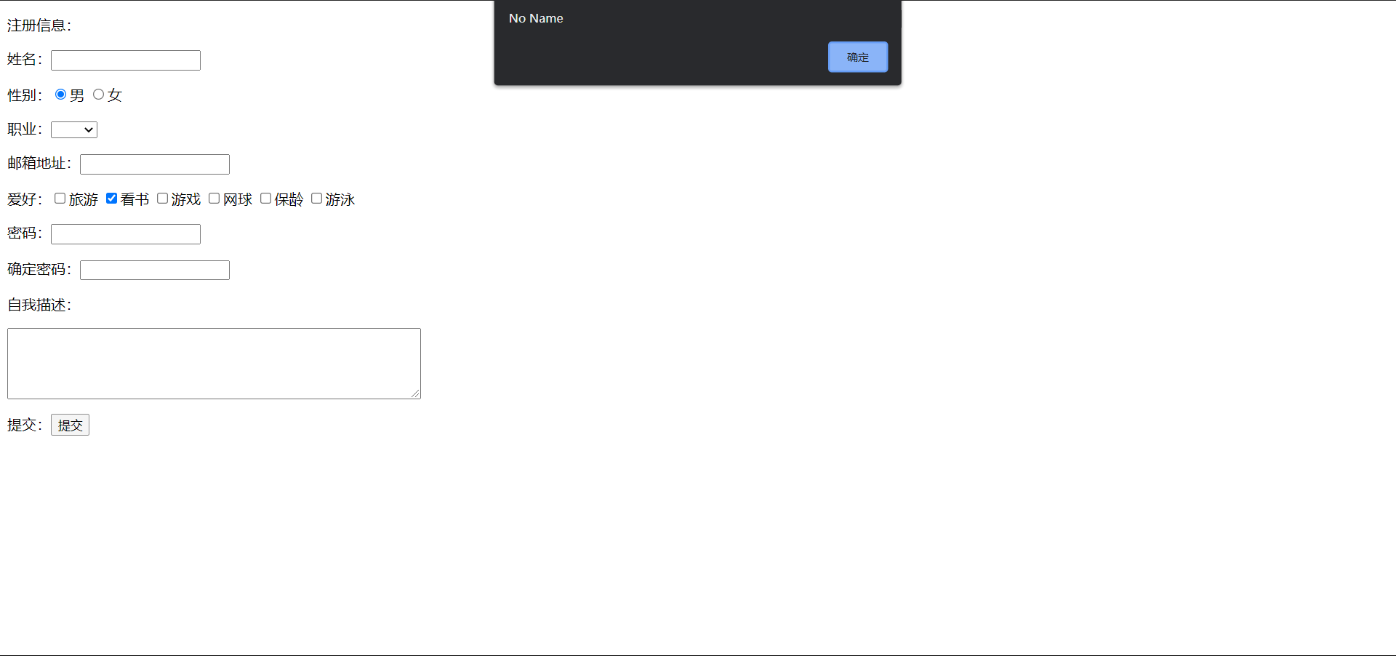

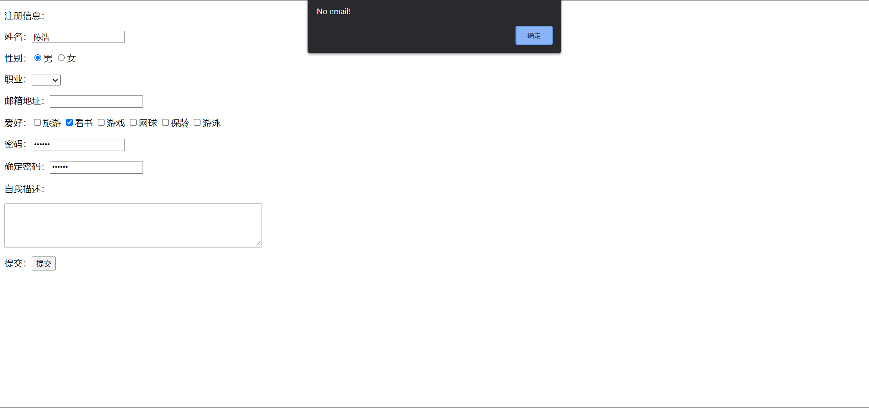

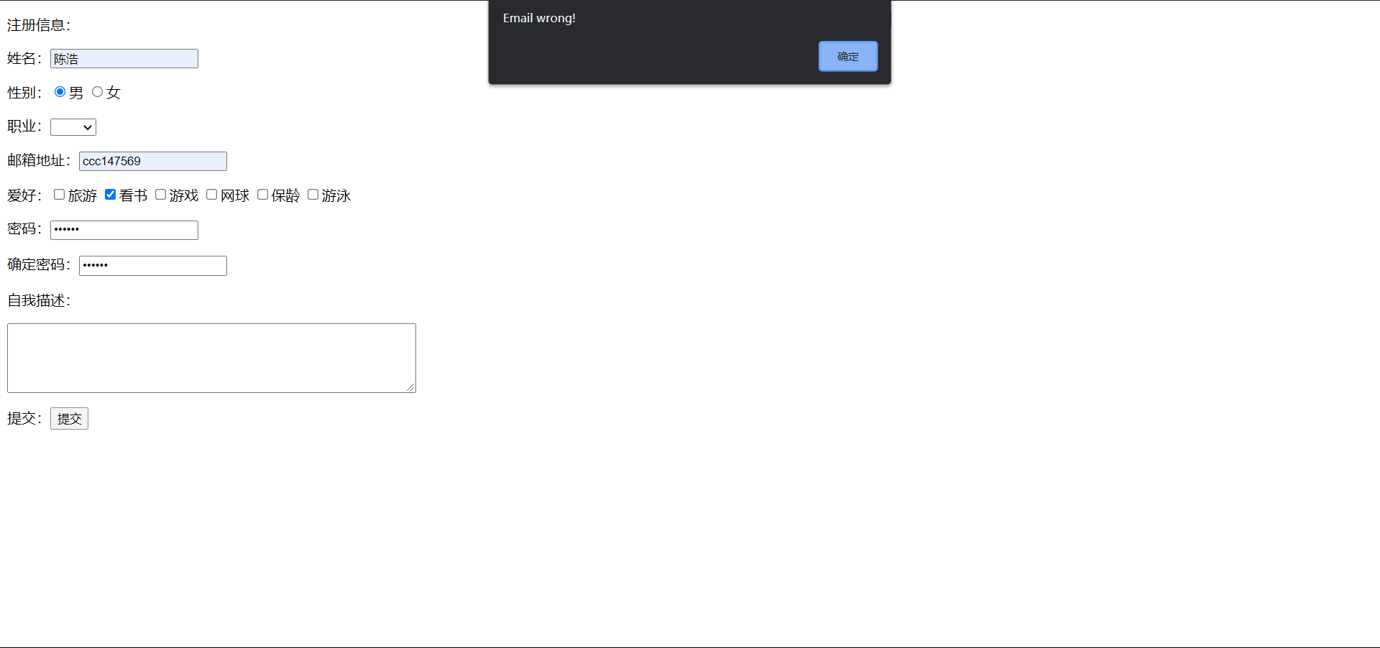

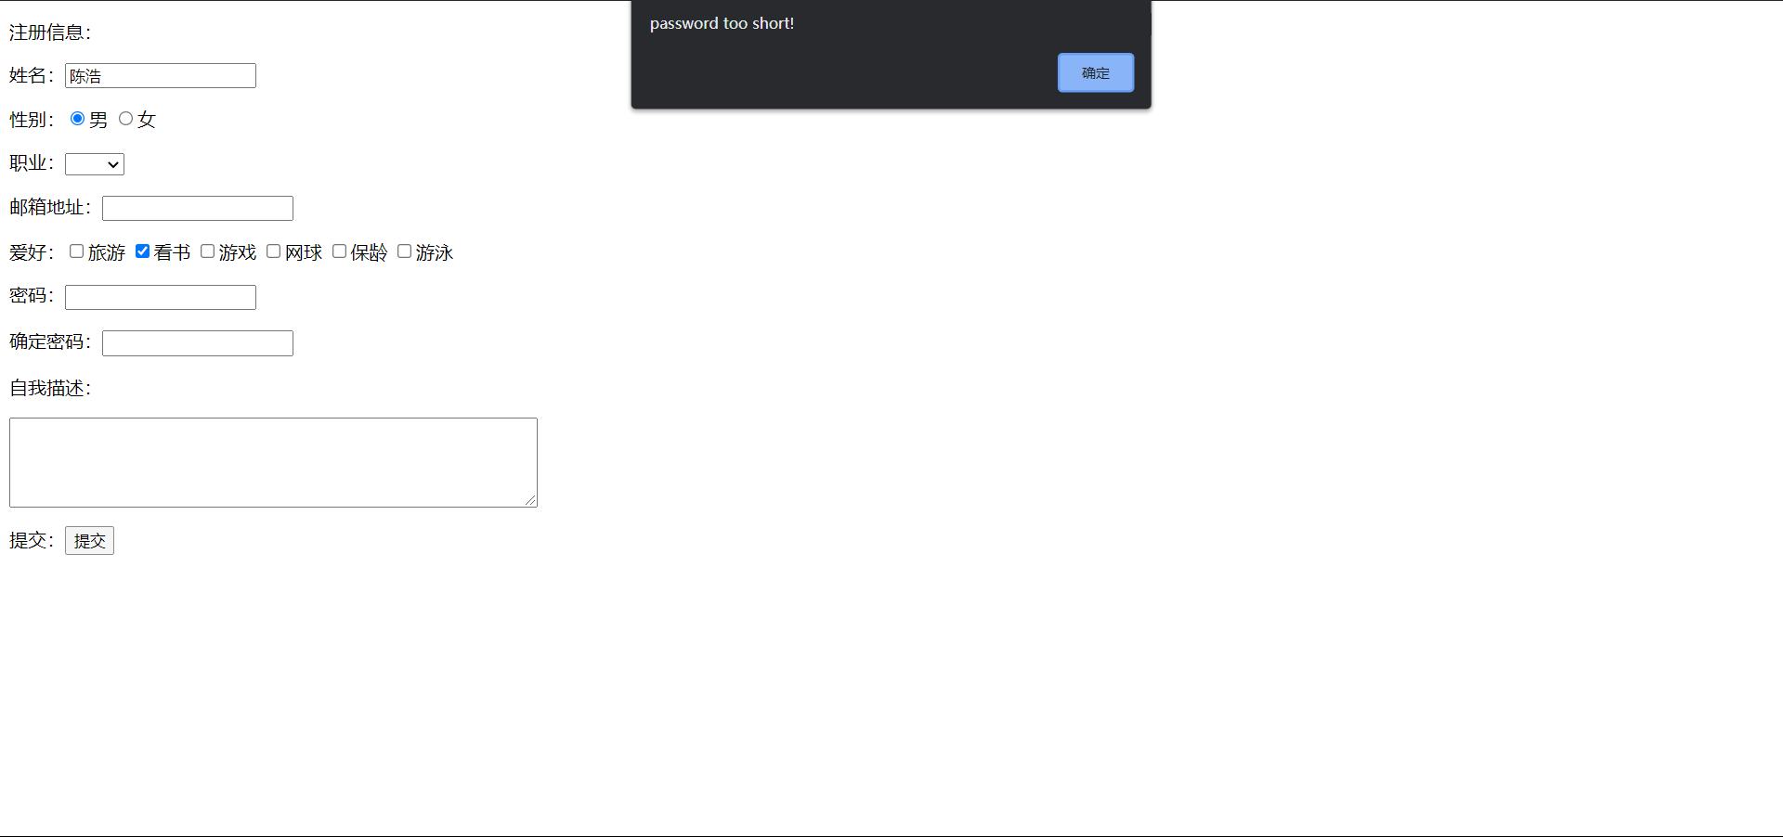

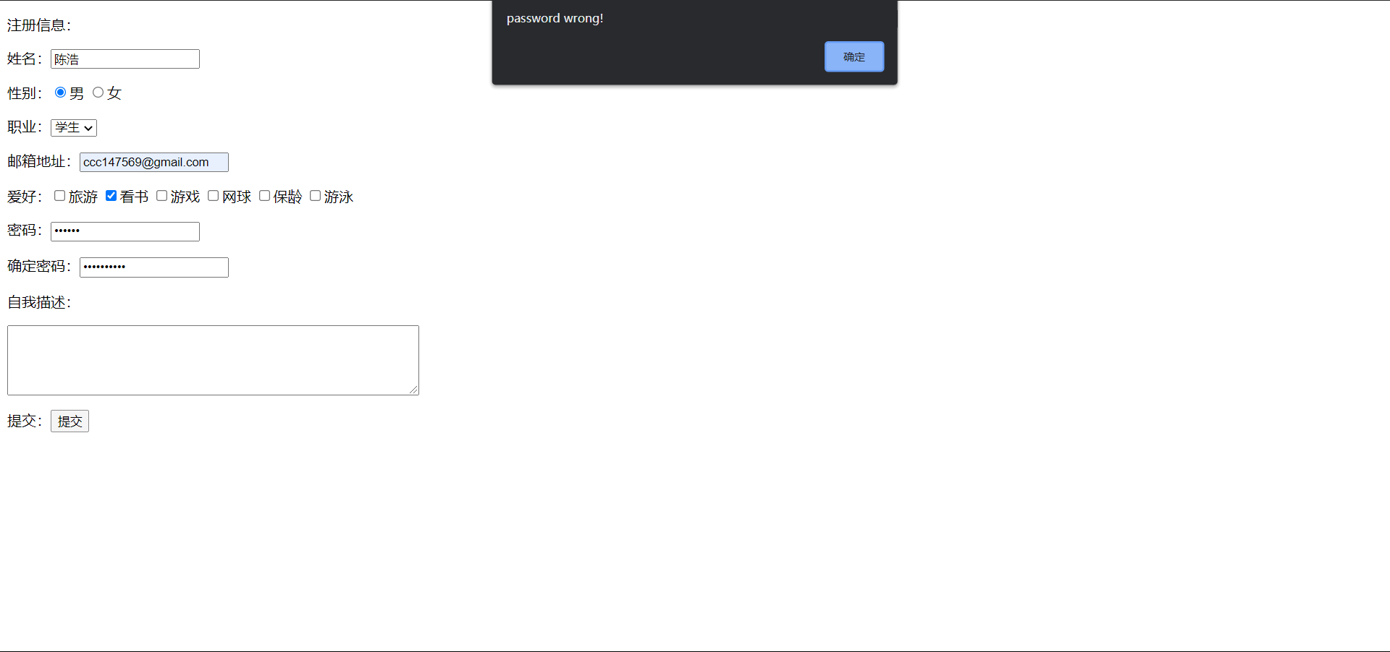

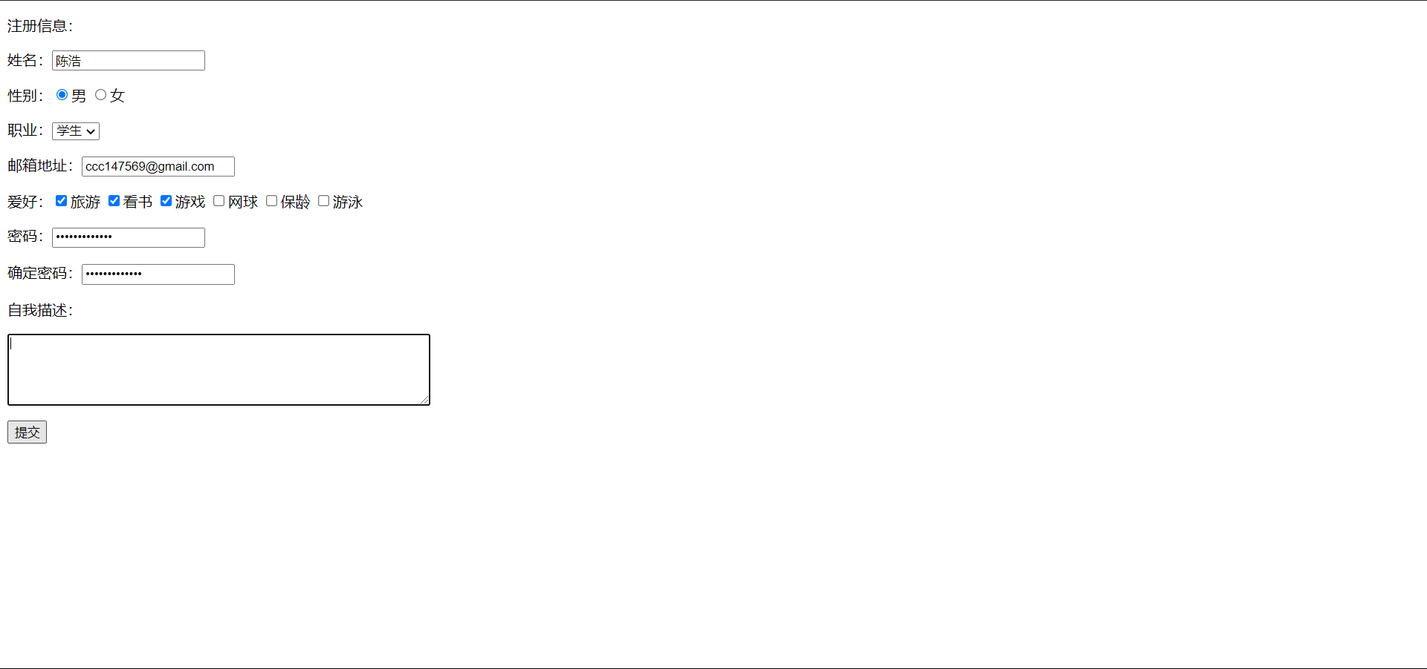

代码：

<%@ **page** language="java" contentType="text/html; charset=UTF-8" pageEncoding="UTF-8"%>  
<!DOCTYPE html PUBLIC "-//W3C//DTD HTML 4.01 Transitional//EN" "http://www.w3.org/TR/html4/loose.dtd">  
<html>  
<head><title>注册页面</title>  
 <script language="javascript">  
 function check(){  
 if(form1.name.value==""){  
 alert("No Name");  
 form1.name.focus();  
 return false;  
 }  
 if(form1.email.value==""){  
 alert("No email!");  
 form1.email.focus();  
 return false;  
 }  
 if(form1.pass.value!=form1.confim.value){  
 alert("password wrong!");  
 form1.pass.focus();  
 return false;  
 }  
 if(form1.email.value.indexOf('@',0)==-1||form1.email.value.indexOf('.',0)==-1){  
 alert("Email wrong!");  
 form1.email.focus();  
 return false;  
 }  
 if(form1.pass.value.length<6){  
 alert("password too short!");  
 form1.pass.focus();  
 return false;  
 }  
 return true;  
 }  
 </script>  
</head>  
<body>  
<form name="form1" method="POST">  
 <p>注册信息：  
 <p>姓名：<input type="text" name="name" size="20"></p>  
 <p>性别：<input type="radio" name="sex" value="男" checked>男  
 <input type="radio" name="sex" value="女">女</p>  
 <p>职业：<select size = "1" name = "work" >  
 <option selected value = "教师" ></option >  
 <option value="学生"> 学生 </option >  
 <option value="教师"> 教师 </option>  
 </select></p>  
 <p>邮箱地址：<input type="text" name="email" ></p>  
 <p>爱好：<input type="checkbox" name="cc" value="旅游">旅游  
 <input type="checkbox" name="cc" value="看书" checked>看书  
 <input type="checkbox" name="cc" value="游戏">游戏  
 <input type="checkbox" name="cc" value="网球">网球  
 <input type="checkbox" name="cc" value="保龄">保龄  
 <input type="checkbox" name="cc" value="游泳">游泳</p>  
 <p>密码：<input type="password" name="pass" size="20"></p>  
 <p>确定密码：<input type="password" name="confim" size="20"></p>  
 <p>自我描述：</p>  
 <p><textarea name="des" rows="5" cols="60" ></textarea></p>  
 <p><input type="submit" value="提交"onclick="check()"></p>  
</form>  
</body>  
</html>