**Report**

Optical Mark Recognition (OMR) is a technology used to process data that has been marked by hand, such as answer sheets, surveys, and ballots. OMR systems work by using a scanner to read marks made by a pencil or pen on a document and converting them into digital data. With advances in computer vision and machine learning techniques, OMR technology has become increasingly accurate and efficient, providing many benefits to educators, examiners, and government organizations.

OMR technology is particularly useful in rural areas where internet connectivity is limited, and electronic devices may not be readily available. In such areas, traditional methods of processing and evaluating answer sheets can be time-consuming and resource-intensive. OMR technology provides an effective solution by reducing the time and effort required to process answer sheets, allowing teachers to focus on more critical tasks such as teaching and mentoring students.

In addition to its usefulness in rural areas, OMR technology provides a more accessible and user-friendly method of evaluating exams. Traditionally, teachers would have to manually grade answer sheets, which is a time-consuming and tedious process. With OMR technology, the scanning and grading process can be automated, reducing the burden on teachers and increasing the accuracy of the grading process. This not only saves time and effort but also allows for more detailed and accurate grading of exams, which can help students identify areas where they need to improve.

Furthermore, OMR technology provides many other benefits to educators and examiners, including the ability to generate detailed reports and analyze data quickly and accurately. This can be particularly useful for government organizations that conduct large-scale exams, such as civil service examinations and college entrance exams. OMR technology allows for the quick processing of thousands of answer sheets, reducing the time and resources required to evaluate the exams.

In this paper, we will discuss the methodology for OMR detection using computer vision and machine learning techniques. We will explore various feature selection and classification techniques that can be used to improve the accuracy of OMR systems. We will also discuss the benefits of OMR technology, particularly in rural areas and for educators, examiners, and government organizations. Finally, we will evaluate our methodology on a dataset of standardized forms and demonstrate the effectiveness of computer vision and machine learning techniques in OMR detection.

In conclusion, OMR technology provides a more efficient and accurate method of processing and evaluating answer sheets. Its benefits extend beyond rural areas and include increased ease of use, reduced time and effort required for grading, and the ability to generate detailed reports and analyze data quickly and accurately. With continued advances in computer vision and machine learning techniques, OMR technology is poised to become even more valuable to educators, examiners, and government organizations in the future.

Working

Data Acquisition and Preprocessing: The first step in OMR detection using machine learning techniques is to acquire and preprocess the data. The data can be in the form of images or scanned documents. It is essential to ensure that the data is of high quality and free from any noise or distortion that could affect the accuracy of the OMR system. The images should be of high resolution, and the text should be clearly visible.

The preprocessing step involves cleaning the data and removing any unwanted elements that could interfere with the accuracy of the OMR system. This can include removing noise, smoothing the image, and enhancing the contrast. Several techniques can be used for image preprocessing, including thresholding, edge detection, and morphological operations.

Feature Extraction: The next step in OMR detection using machine learning techniques is feature extraction. This involves identifying and extracting relevant features from the input data that can be used to classify the marks on the document. Some of the features that can be extracted include the size, shape, and location of the marks.

There are several techniques that can be used for feature extraction, including image processing algorithms such as the Hough transform and edge detection. These techniques can be used to identify and extract features such as straight lines, circles, and other geometric shapes.

Feature Selection: After the features have been extracted, the next step is feature selection. This involves selecting the most relevant features that can be used to classify the marks on the document. Feature selection is important because it can improve the accuracy of the OMR system by reducing the dimensionality of the input data.

Several techniques can be used for feature selection, including Principal Component Analysis (PCA) and Linear Discriminant Analysis (LDA). These techniques can be used to identify the most significant features that contribute to the classification task.

Classification: The final step in OMR detection using machine learning techniques is classification. This involves using a machine learning algorithm to classify the marks on the document based on the extracted and selected features. There are several machine learning algorithms that can be used for classification, including Support Vector Machines (SVM), Random Forest, and Neural Networks.

The machine learning algorithm is trained on a labeled dataset of images that have been preprocessed, and features have been extracted and selected. The training data is used to teach the algorithm how to classify the marks on the document accurately. Once the algorithm has been trained, it can be used to classify new images.

Evaluation: Once the machine learning algorithm has been trained and the OMR system has been implemented, the next step is evaluation. This involves testing the accuracy of the OMR system using a test dataset of images that have not been used during the training phase. The accuracy of the system is measured using various performance metrics, such as precision, recall, and F1 score.

**METHODOLOGY (Working)**

In this paper we discuss about a real-time us of Image processing, form of signal processing for which the input is an image, such as a photograph or video frame, the output may be either an image or a set of characteristics or parameters related to the image as depends on the user need. Image processing is a computer-based technology used in almost every field like: 1. Medical Field Gamma ray imaging PET scan X-ray Imaging Medical CT 2. Robot Vision There are several robotic machines which work on the digital image processing. Through image processing technique robot finds their ways, for example, hurdle detection root and line follower robot 3. Pattern Recognition It involves the study of image processing; it is also combined with artificial intelligence such that computer-aided diagnosis, handwriting recognition and images recognition can be easily implemented. Nowadays, image processing is used for pattern recognition Biometrics Face Unlock Technology, Fingerprint Detection Social Media Apps and website Snapchat, Instagram filters are also real time and many more. One of the fields in which Image Processing is widely used is Education Field. One of the categories in Education field in Image Processing is used is used Analysis of OMR sheet and evaluation of marks according to that answered OMR. There are some steps that are followed in analysis of OMR.

NUMPY: NumPy is one of the core libraries in Python programming and provides support for arrays. An image is essentially a standard Numpy array containing pixels of data points. Therefore, by using basic NumPy operations, such as slicing, masking and fancy indexing, we can modify the pixel values of an image. The image can be loaded using skimage and displayed using matplotlib

OPENCV: OpenCV (Open Source Computer Vision Library) is one of the most widely used libraries for computer vision applications. OpenCV-Python is the python API for OpenCV. OpenCV-Python is not only fast since the background consists of code written in C/C++ but is also easy to code and deploy (due to the Python wrapper in foreground). This makes it a great choice to perform computationally intensive computer vision programs input. A series of convenience functions to make basic image processing functions such astranslation, rotation, resizing, skeletonization, displaying Matplotlib images, sorting contours, detecting edges, and much easier with OpenCV

Argparse: library to parse the command line arguments. It also calls vars on the object to turn the parsed command line arguments into a Python dictionary where the key to the dictionary is the name of the command line argument and the value is the value of the dictionary supplied for the command lineargument.

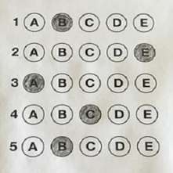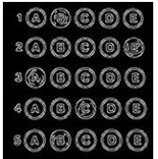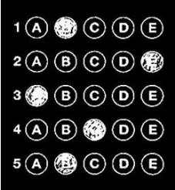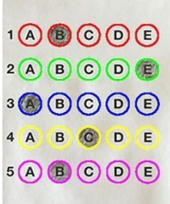

We get the background of the image is black, while the foreground is white after threshing. This binarization will allow us to once again apply contour extraction techniques to find each of the bubbles on questions this means that there exists four parallel lines passing through all the real circles we find it .we find this from Parallel Line Interpolation This is able to find majority of them. This means, that if we interpolate four parallel lines passing through detected circles centres, it will pass through missing circles too. Based on the idea above, the four parallel lines passing through detected circles and we know the equation of the first parallel lines.

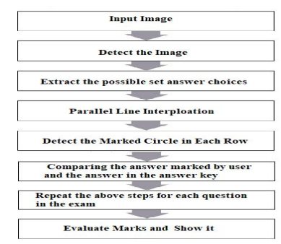

**RESULT**

We tested the code on straight images as well as on captured images. After full processing we were able to detect and evaluate these OMR sheets without leaving any circles and responses undetected and show results. However there were images where we were unable to detect few circles.