**TRF Summer internship and training course 2019 Task 2 Report**

**INDEX**

Group No.: 15

Project Title:Tic Tac Toe using Reinforced Deep Q Learning.

Member 1 Member 2

Name:Ganesh Tarone Name: Harjas Singh Gandhi

Div. & Roll no.: CS-D 36 Div. & Roll no.:CS-A 55

GR No.:11810810 GR No.: 11810144

E-mail ID:ganesh.tarone18@vit.edu E-mail ID: harjas.gandhi18@vit.edu

1. INTRODUCTION

Our Code of Tic Tac Toe uses nothing on the hardware level (before implementation) as it is totally designed on spyder IDE of anaconda. It uses deep learning libraries like tensorflow and Keras.

This model plays with us and it tries to win or make the game a tie depending upon the opponent.

2. WORKING METHODOLOGY

Approach includes of construction of two models each which gets trained according to the first choice made by the player.

The game works as firstly, the CPU plays with each other and store the results of each move in a list.

Here the CPU is given a reward for each profitable move that decreases the probability of opponent to win and thus each move has a reward point.

Among all such possible moves the CPU chooses the one with maximum rewards points and then successively proceeds till any one player wins.

3. INSIGHTS

Here firstly we faced challenge to how to train our model and hoe much should we train it, so that it should play properly, then we thought of 2000 be a perfect number which will include all the possibilities of any smart player will play.

Secondly, we faced the challenge of to decide who should start first then we came across a solution of both.

Separate models were trained for both where if opponent starts with x he is first and if he starts with o he is second.

4. RESULTS

Here we were able to achieve best accuracy for our model where result is if opponent plays well there is maximum chance of game to be drawn and if there is a slight mistake from opponent side CPU is more likely to win.

5. PHOTOS

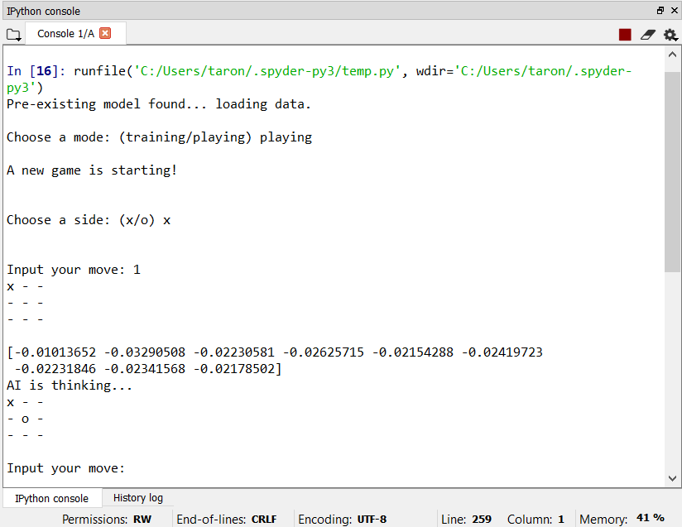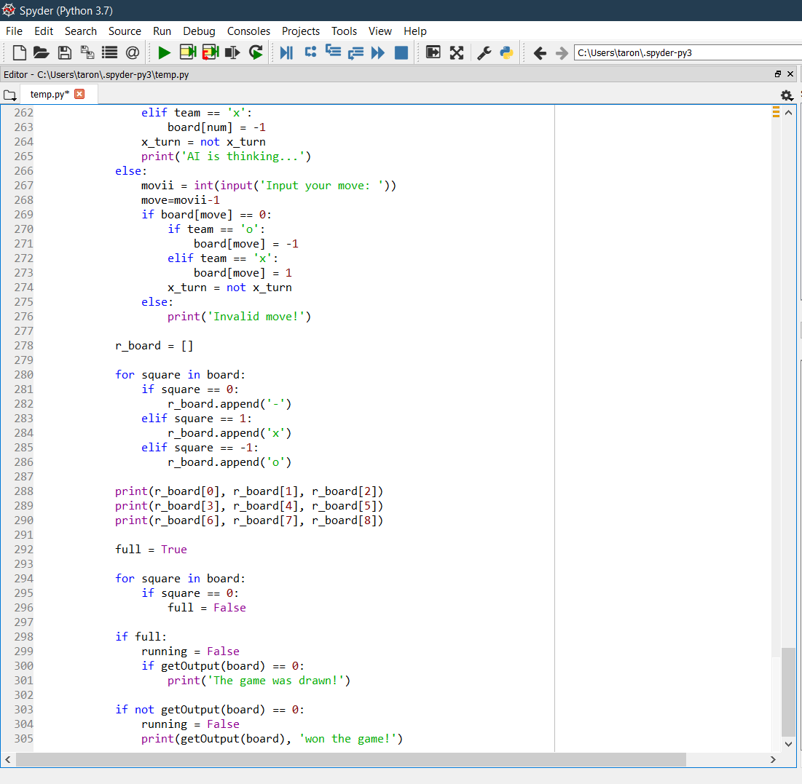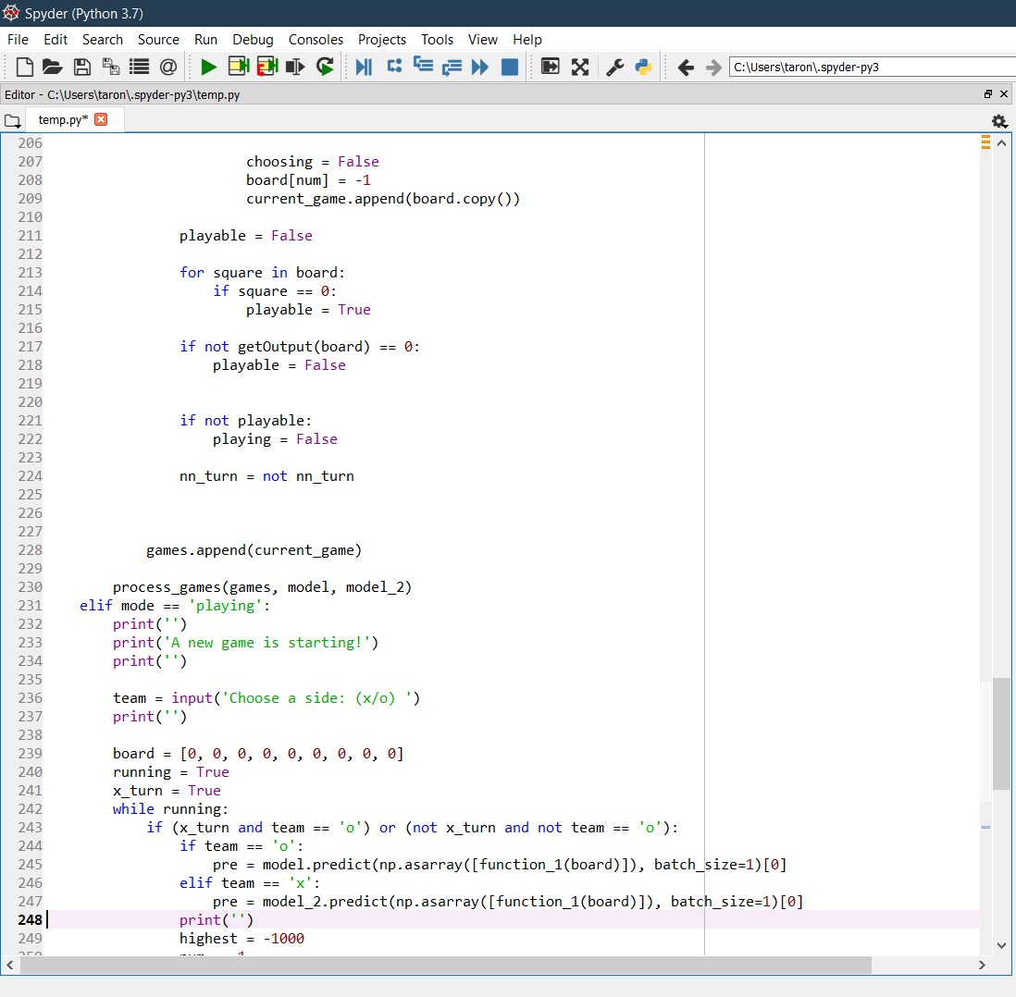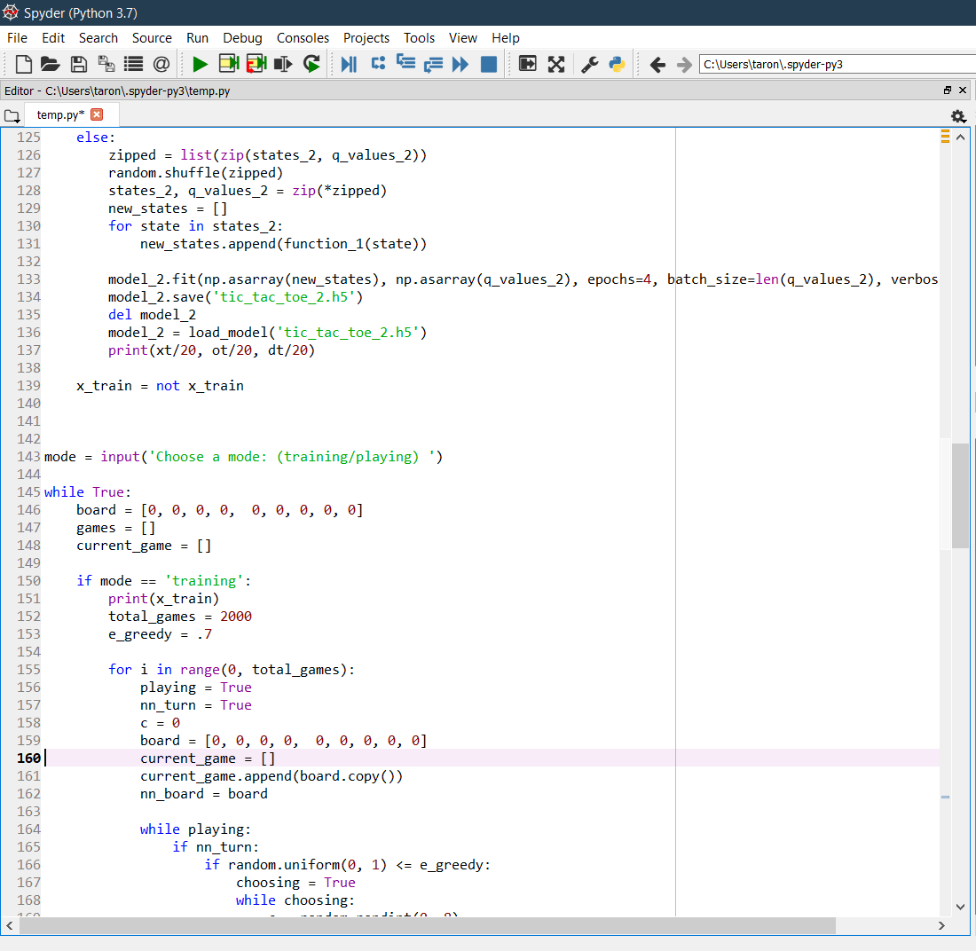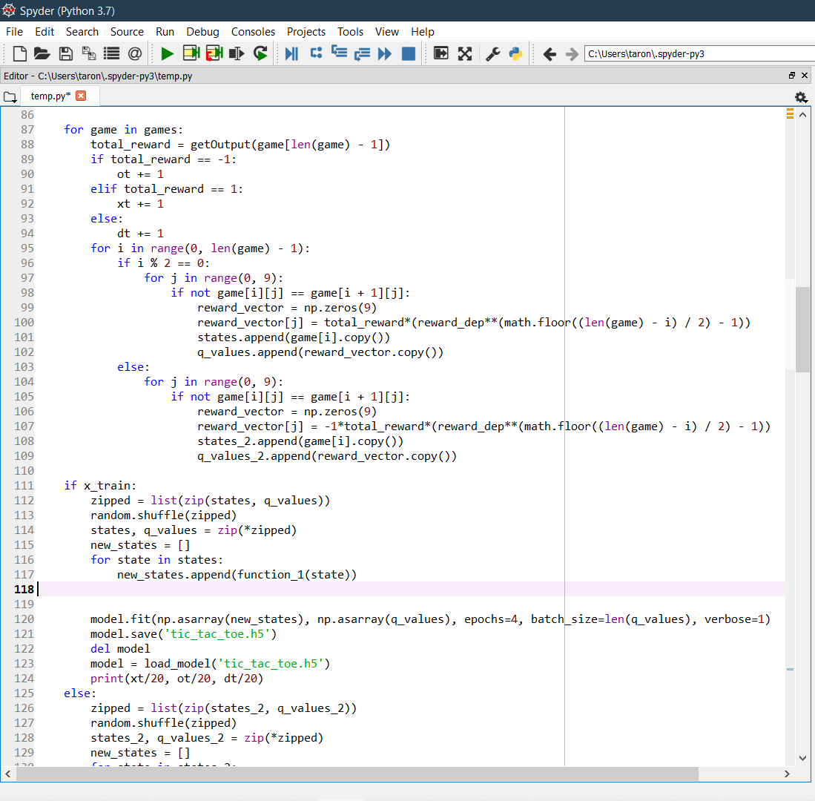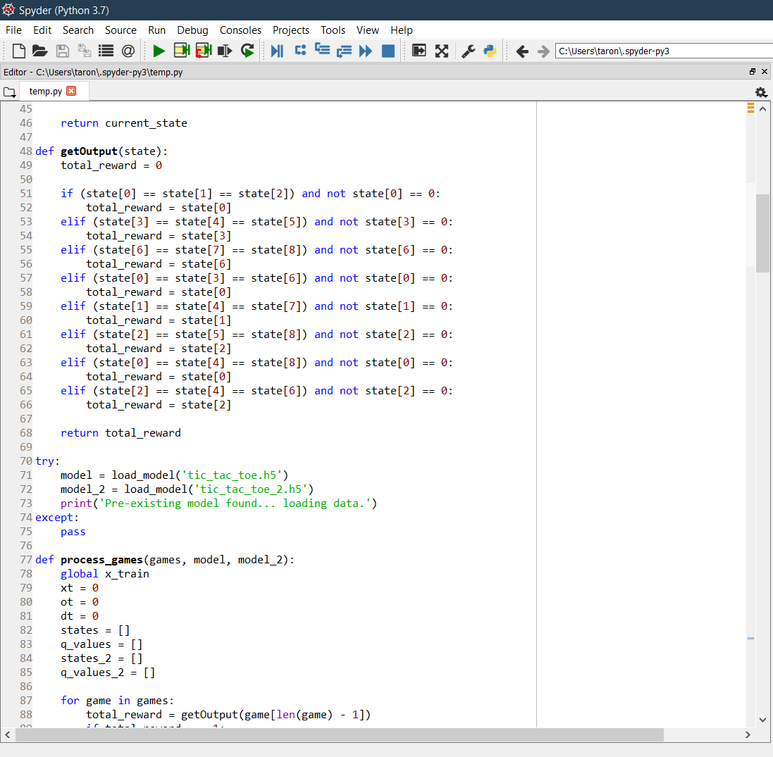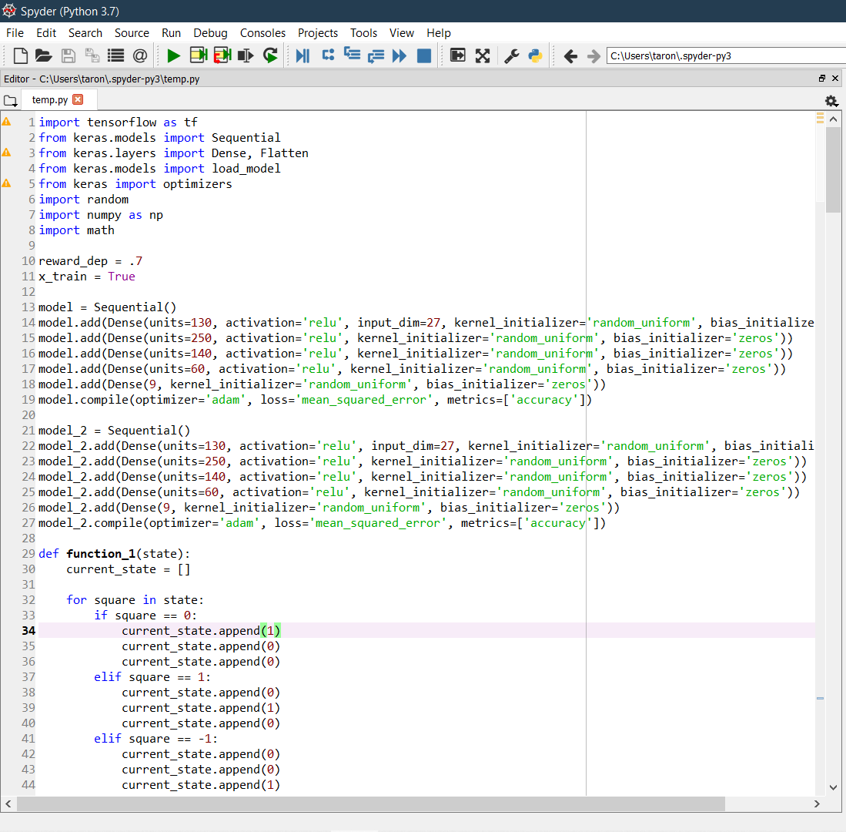

6. REFERENCES

Google,Deep Q learning ,Wikipedia etc.