**TRF Summer internship and training course 2019 Task 3 Report**

**INDEX**

Group No.: 15

Project Title:Tic Tac Toe using Reinforced Deep Q Learning and implementing it on Arduino Led board.

Member 1 Member 2

Name:Ganesh Tarone Name: Harjas Singh Gandhi

Div. & Roll no.: CS-D 36 Div. & Roll no.:CS-A 55

GR No.:11810810 GR No.: 11810144

E-mail ID: ganesh.tarone18@vit.edu E-mail ID: harjas.gandhi18@vit.edu

1. INTRODUCTION

Our Code of Tic Tac Toe uses nothing on the hardware level (before implementation) as it is totally designed on spyder IDE of anaconda. It uses deep learning libraries like tensorflow and Keras.

Here we have implemented our game with LED board in the format of a tic tac toe where red and blue colours represent different symbols of two players individually.

The model uses an Arduino Board with a bluetooth hc-05 module.

2. WORKING METHODOLOGY

Approach includes of construction of two models each which gets trained according to the first choice made by the player.

The game works as firstly, the CPU plays with each other and store the results of each move in a list.

Here the CPU is given a reward for each profitable move that decreases the probability of opponent to win and thus each move has a reward point.

Among all such possible moves the CPU chooses the one with maximum rewards points and then successively proceeds till any one player wins.

Then the command is transmitted through Bluetooth to the board via a library called Pyserial. The board acts according to the instruction sent.

3. INSIGHTS

Here firstly we faced challenge to how to train our model and hoe much should we train it, so that it should play properly, then we thought of 2000 be a perfect number which will include all the possibilities of any smart player will play.

Secondly, we faced the challenge of to decide who should start first then we came across a solution of both.

Separate models were trained for both where if opponent starts with x he is first and if he starts with o he is second.

Main challenge that we faced was how to send and receive commands between spyder and Arduino board then it was done with using a library in python and a Bluetooth module on Arduino board.

4. RESULTS

Here we were able to achieve best accuracy for our model where result is if opponent plays well there is maximum chance of game to be drawn and if there is a slight mistake from opponent side CPU is more likely to win.

Now first the board asks for input and then the python receives it and then process it and sends back the result via Bluetooth.

5. PHOTOS

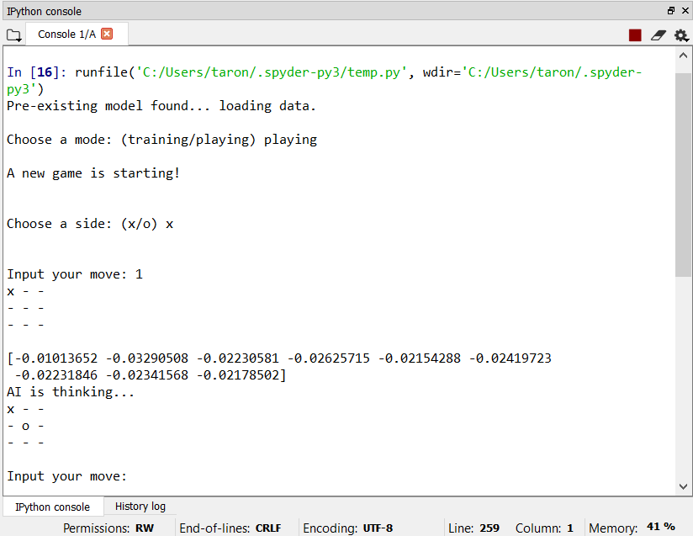

6. REFERENCES

Google, Deep Q learning, Wikipedia, Arduino, Pinout board diagram, hc-05 Bluetooth module, etc.