1. Problem Statement
Every day, news articles are published by different sources covering topics such as technology, politics, business, science and international affairs. Although information is readily available, keeping track of everything and understanding the bigger picture can be difficult. Readers often have to visit multiple websites, read several articles about the same event and manually connect the information to understand how a situation is developing.
Traditional news aggregators make it easier to access articles in one place, but they mainly focus on displaying headlines and content. They do not necessarily help readers understand how different articles are connected, identify the important people and organizations involved, or get a consolidated explanation of a topic. For example, several publishers might report different developments involving the same organization. A reader would need to go through those reports individually to understand the overall situation.
Another challenge is that news articles contain a large amount of unstructured text. Identifying important entities, organizing articles into relevant categories and understanding the tone of the reporting can require manual effort. Readers may also want answers to specific questions or a summary of the broader implications of a topic without having to read every available article.
This creates a need for a system that does more than collect news. It should help users organize information, discover connections between stories and understand topics through concise explanations. The goal of NEXUS is to make news exploration more structured and less time-consuming by combining news aggregation with automated text analysis and AI-generated insights.

2. Proposed Solution
NEXUS (News Exploration & Understanding System) is an AI-powered news intelligence application that combines news collection, Natural Language Processing (NLP) and Large Language Models (LLMs) to help users explore and understand news more effectively.
The system collects articles from multiple publishers through RSS feeds, with NewsAPI supporting selected workflows. The articles are normalized and stored in a database. NEXUS then processes the available text to extract named entities, estimate sentiment and assign topic categories. This information supports the organization and exploration of news through the application.
The Home page allows users to browse articles chronologically and filter them by category. The For You feed narrows the displayed articles according to selected categories. For deeper exploration, the News Navigator generates topic briefings from relevant article context, while the briefing interface presents generated explanations from perspectives such as Macro Impact, Market Reaction, Expert View and What to Watch.
NEXUS also includes Story Arcs, which groups articles that mention shared entities and generates a narrative around the collected coverage. This helps users explore potentially related reports instead of treating every headline as an isolated event. Additionally, conversational features allow users to ask questions about an article or topic and receive responses based on the context supplied to the language model.
By combining these capabilities, NEXUS aims to move beyond simply displaying news and provide tools for organizing, exploring and understanding it. Its generated explanations are intended to assist readers, rather than replace original articles or guarantee the accuracy of every interpretation.

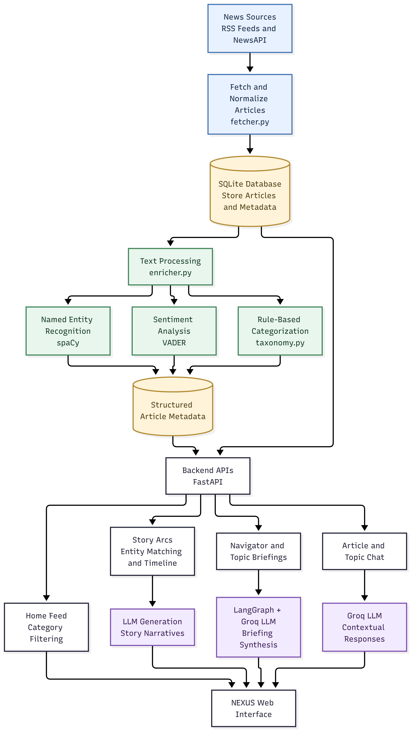
3. How NLP Helps in NEXUS
NLP is one of the main technologies that enables NEXUS to analyze news content rather than simply display it. Different techniques are used for different purposes: some extract structured information from articles, while others generate explanations in natural language.

3.1 Named Entity Recognition (spaCy)
Named Entity Recognition identifies important names in text, such as people, organizations, locations and products. NEXUS uses spaCy's pretrained en_core_web_sm model to extract these entities from article headlines and available summaries.
For example, an article mentioning Microsoft and OpenAI can have both organizations identified automatically. This information is stored with the article and helps NEXUS identify common entities across different reports. Story Arcs uses these shared entity names to group potentially related articles.
Without NER, the system would lose this automatically extracted entity information, making entity-based story grouping less effective.

3.2 Sentiment Analysis (VADER)
Sentiment analysis estimates whether the language in a text is positive, negative or neutral. NEXUS uses VADER to calculate sentiment scores from the available article text and assign sentiment labels.
For example, an article describing significant company losses may receive a negative sentiment score. This information contributes to the sentiment-related displays in the application, including Story Arcs, and provides another way to examine the tone of the available coverage.
However, sentiment does not determine whether an article is true, biased or indicative of future market performance. It only estimates the polarity expressed in the text.

3.3 Rule-Based Categorization
NEXUS uses a custom taxonomy defined in backend/taxonomy.py to assign articles to 18 categories through predefined keywords and regular-expression rules. These categories help organize the collected articles into topics and support the category filters in the Home interface.
For example, an article containing terms associated with processors, GPUs or chip manufacturing may match Technology-related rules. The For You feed uses selected categories to filter articles, allowing users to focus on their preferred subjects.
This is rule-based classification rather than a model trained on labelled news articles. Its effectiveness depends on how well the predefined rules cover the language used in the collected news.

3.4 LLM-Based Briefings and Conversational Features
While spaCy, VADER and the category rules extract or organize information, LLMs help NEXUS generate explanations in natural language. The application accesses language models through Groq, with LangGraph coordinating the briefing pipeline.
These models generate article and topic briefings, synthesize information from available articles and respond to questions through the chat features. The Navigator uses this capability to consolidate topic-related coverage, while the briefing interface presents generated perspectives such as Macro Impact and What to Watch.
This reduces the need for users to manually combine information from several reports. However, the model receives limited article context rather than complete articles, and its responses are not independently verified for factual accuracy.

3.5 Story Arcs: Connecting Related News
Story Arcs combines entity extraction, application logic and LLM generation. NEXUS identifies shared entity names across a limited collection of recent articles, groups articles using those matches and assembles information for the timeline and related displays. An LLM then generates the narrative description and What to Watch section.
For example, multiple articles mentioning the same organization may be grouped together, allowing users to explore the coverage associated with that organization. This makes it easier to discover potentially related reports, although sharing an entity does not necessarily mean that articles describe the same event or establish a causal relationship.
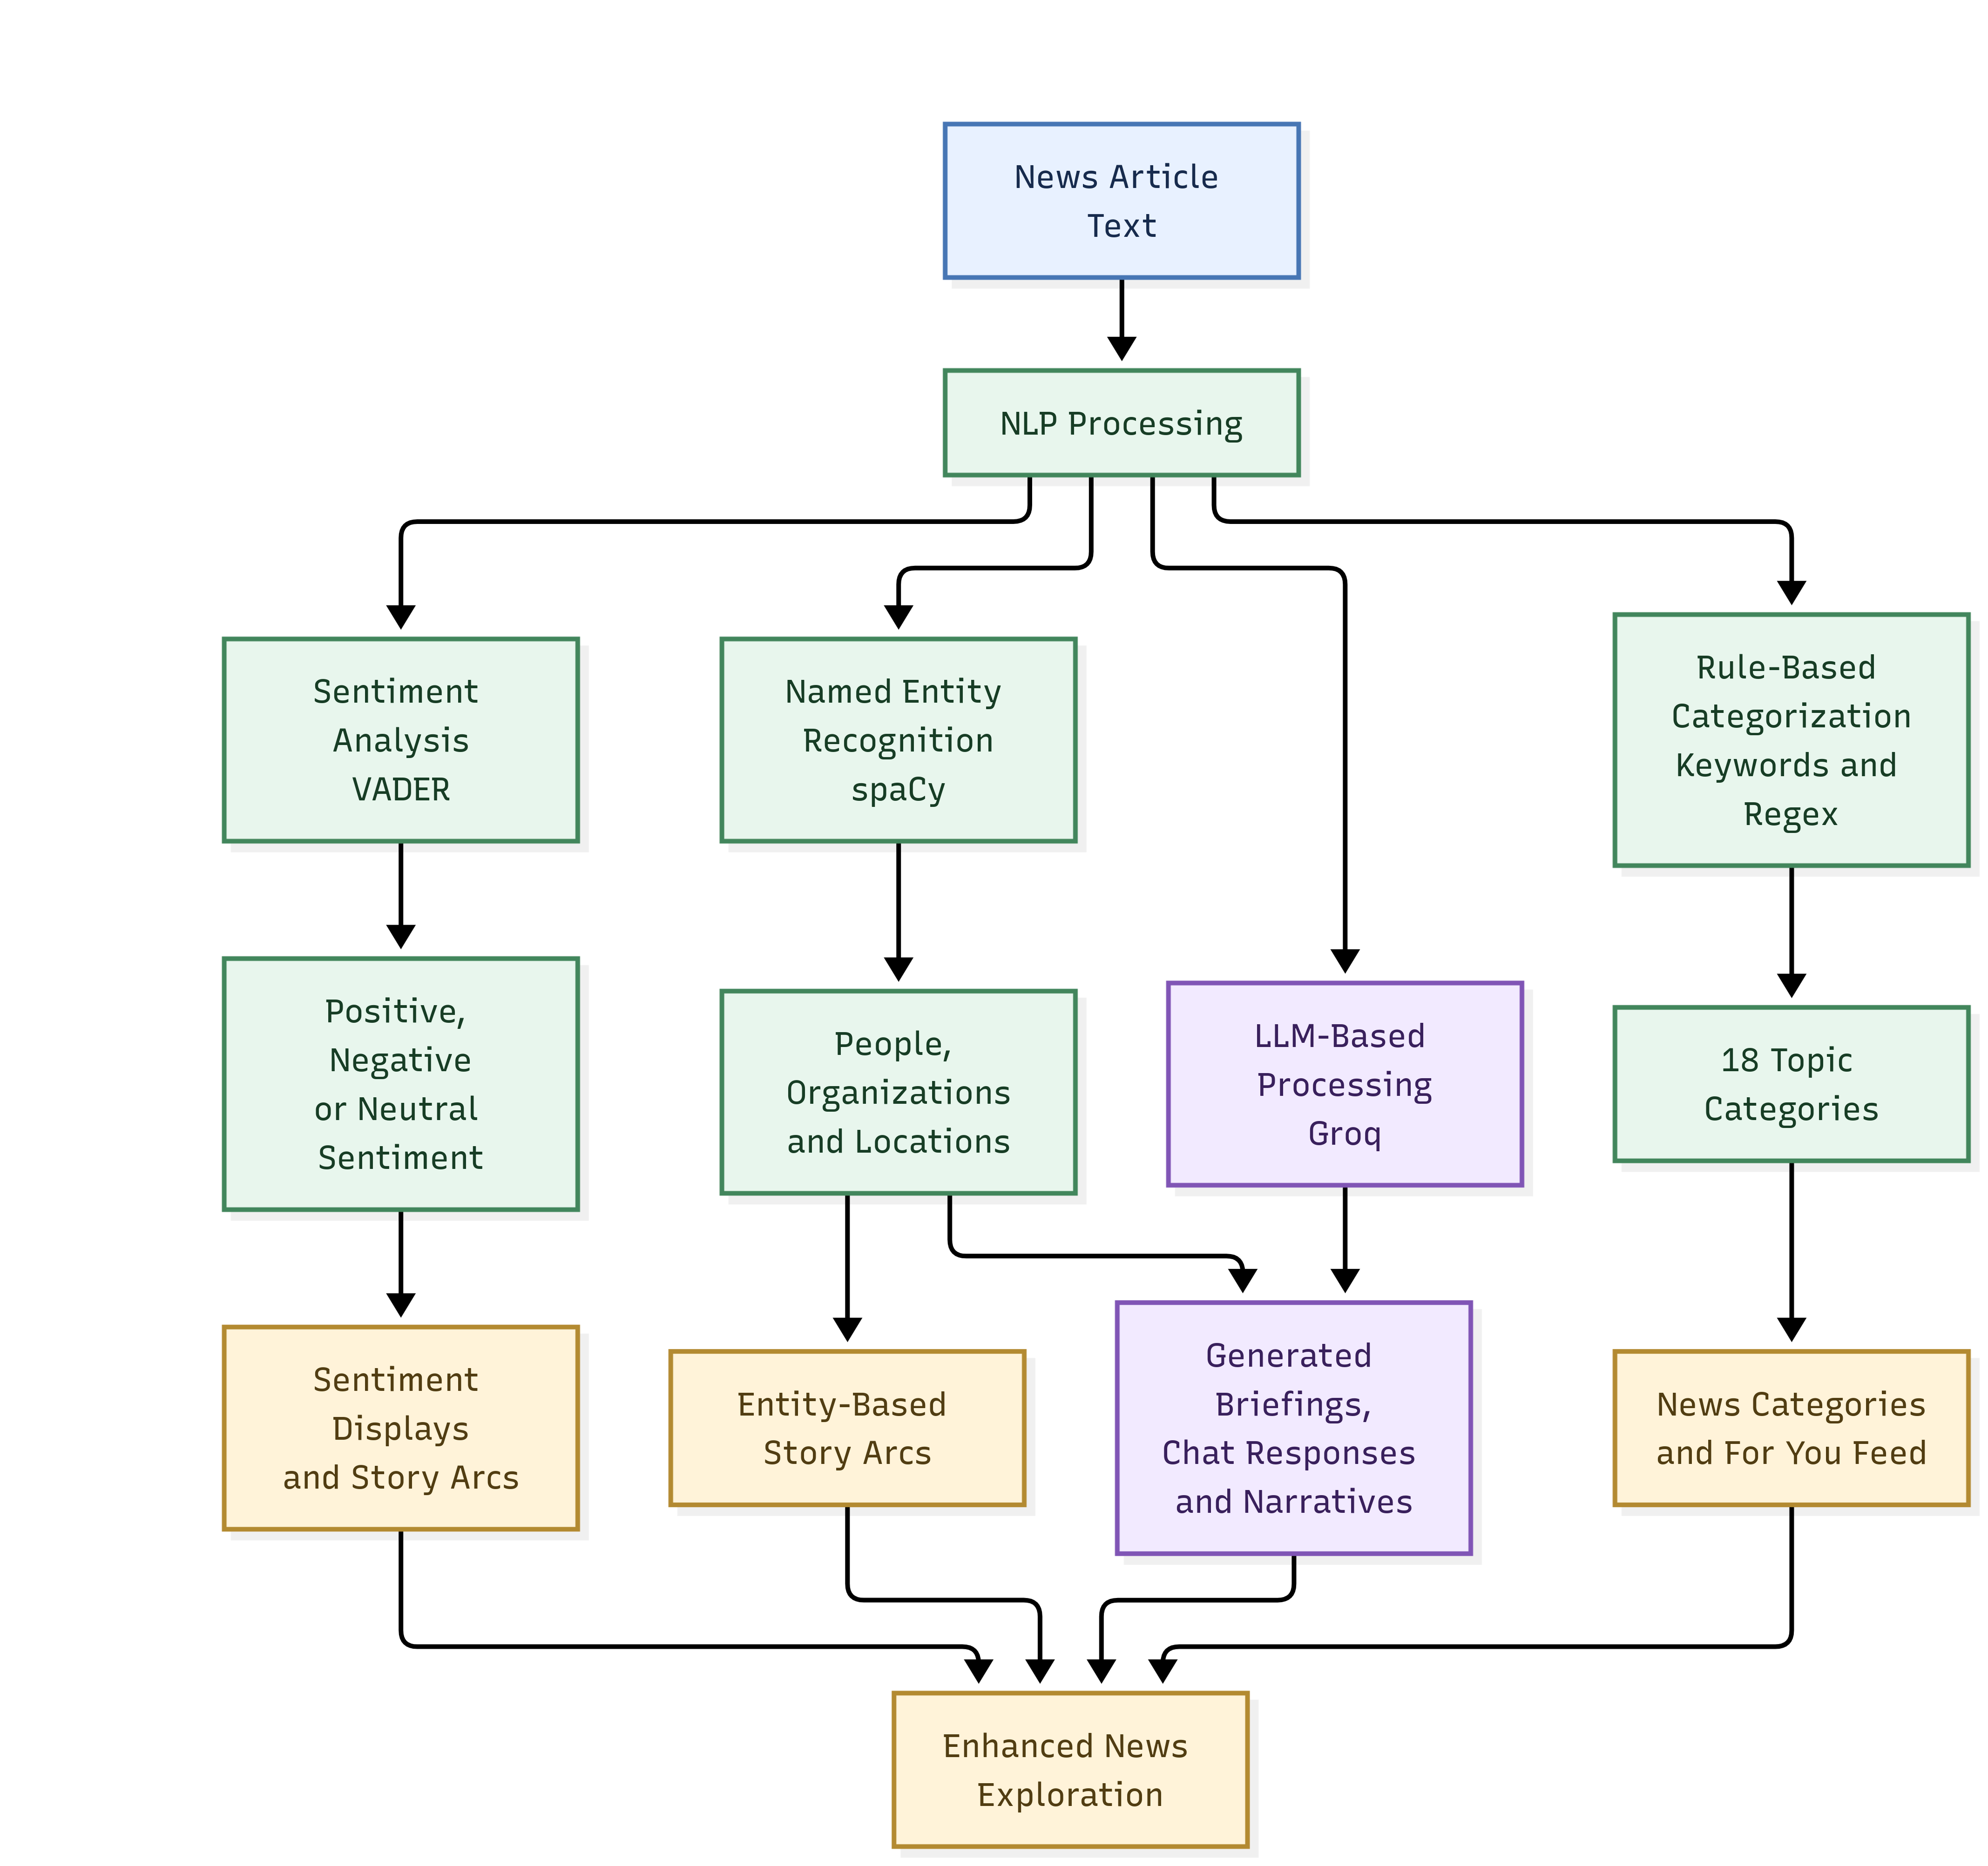

4. Files Implementing the NLP Features
The main backend files responsible for these capabilities are:
File | Purpose
backend/enricher.py | Extracts named entities and calculates sentiment.
backend/taxonomy.py | Defines the category-matching rules.
backend/categorization.py | Manages article-category mappings.
backend/agents/graph.py | Coordinates the briefing-processing pipeline.
backend/agents/synthesis_agent.py | Handles LLM prompts and generated responses.
backend/routers/story_arc.py | Groups articles by shared entities and generates Story Arc narratives.
backend/routers/chat.py | Handles conversational requests about news.

These components work alongside the feed, database and frontend code to make the NLP capabilities available through the NEXUS interface.

5. Overall Importance of NLP
The importance of NLP in NEXUS lies in its ability to transform raw news text into useful information. Named Entity Recognition identifies the people and organizations involved, sentiment analysis estimates the tone of the text, and rule-based categorization organizes articles into topics. LLMs then use the available context to generate briefings, narratives and conversational responses.
Without these capabilities, NEXUS could still collect and display news articles, but it would lose much of its automated text analysis and generated explanations. Its core news-browsing functionality would remain, while features such as entity-based Story Arcs, sentiment-related information and AI-generated briefings would be lost or degraded, depending on which components were removed.
NEXUS therefore demonstrates how established NLP techniques and LLMs can be combined in a practical application to make news easier to organize and explore. Evaluating the accuracy of its extracted information and the reliability of its generated responses remains an important area for future improvement.

