**LAB PROGRAM 6**

Set up a 2-node wireless network. Analyze TCP performance for this scenario with DSDV as routing protocol.

**CODE:**

set val(chan) Channel/WirelessChannel

set val(prop) Propagation/TwoRayGround

set val(netif) Phy/WirelessPhy

set val(mac) Mac/802_11

set val(ifq) Queue/DropTail/PriQueue

set val(ll) LL

set val(ant) Antenna/OmniAntenna

set val(x) 500

set val(y) 500

set val(ifqlen) 50

set val(nn) 2

set val(stop) 20.0

set val(rp) DSDV

set ns [new Simulator]

set tf [open 001.tr w]

$ns trace-all $tf

set nf [open 001.nam w]

$ns namtrace-all-wireless $nf

$val(x) $val(y) set prop [new $val(prop)]

set topo [new Topography]

$topo load_flatgrid $val(x) $val(y)

create-god $val(nn)

$ns node-config -adhocRouting $val(rp) \

-llType $val(ll) \

-macType $val(mac) \

-ifqType $val(ifq) \

-ifqLen $val(ifqlen) \

-antType $val(ant) \

-propType $val(prop) \

-phyType $val(netif) \

-channelType $val(chan) \

-topoInstance $topo \

-agentTrace ON \

-routerTrace ON \

-macTrace ON

#Creating Nodes

for {set i 0} {$i < $val(nn) } {incr i} {

set node_($i) [$ns node]

$node_($i) random-motion 0

}

#Initial Positions of Nodes

for {set i 0} {$i < $val(nn)} {incr i} {

$ns initial_node_pos $node_($i) 40

}

$ns at 1.1 "$node_(0) setdest 310.0 10.0 20.0"

$ns at 1.1 "$node_(1) setdest 10.0 310.0 20.0"

set tcp0 [new Agent/TCP]

set sink0 [new Agent/TCPSink]

$ns attach-agent $node_(0) $tcp0

$ns attach-agent $node_(1) $sink0

$ns connect $tcp0 $sink0

set ftp0 [new Application/FTP]

$ftp0 attach-agent $tcp0

$ns at 1.0 "$ftp0 start"

$ns at 18.0 "$ftp0 stop"

#Simulation Termination

for {set i 0} {$i < $val(nn) } {incr i} {

$ns at $val(stop) "$node_($i) reset";

}

$ns at $val(stop) "finish"

proc finish {} {

global ns tf nf

$ns flush-trace

close $tf

close $nf

exec nam 001.nam &

exit 0

}

$ns run

**TRACE FILE:**

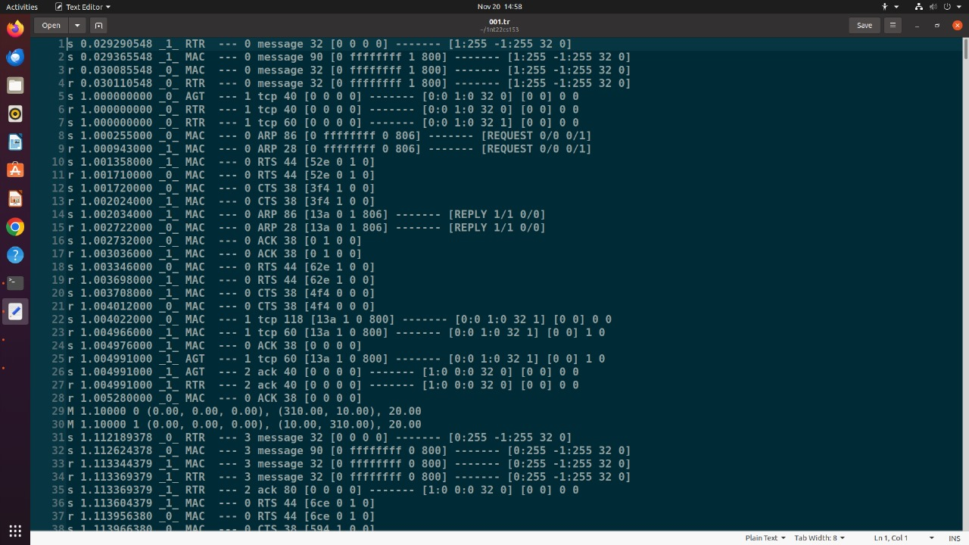**OUTPUT:**

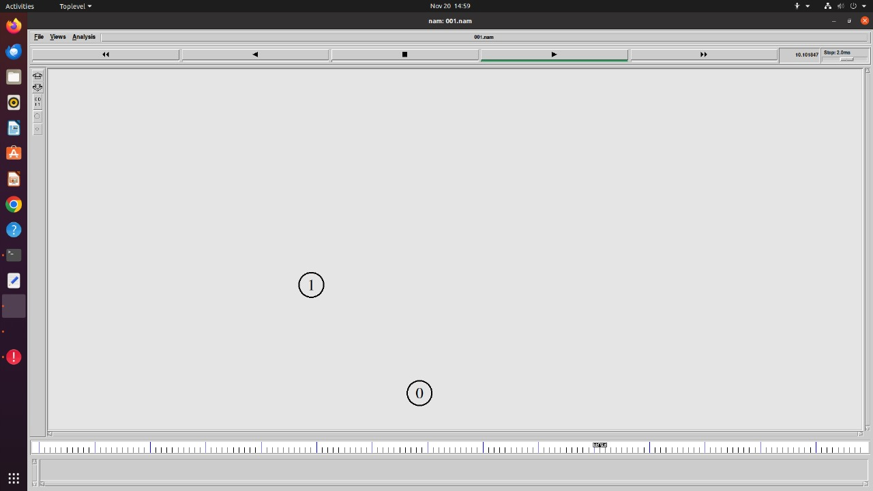

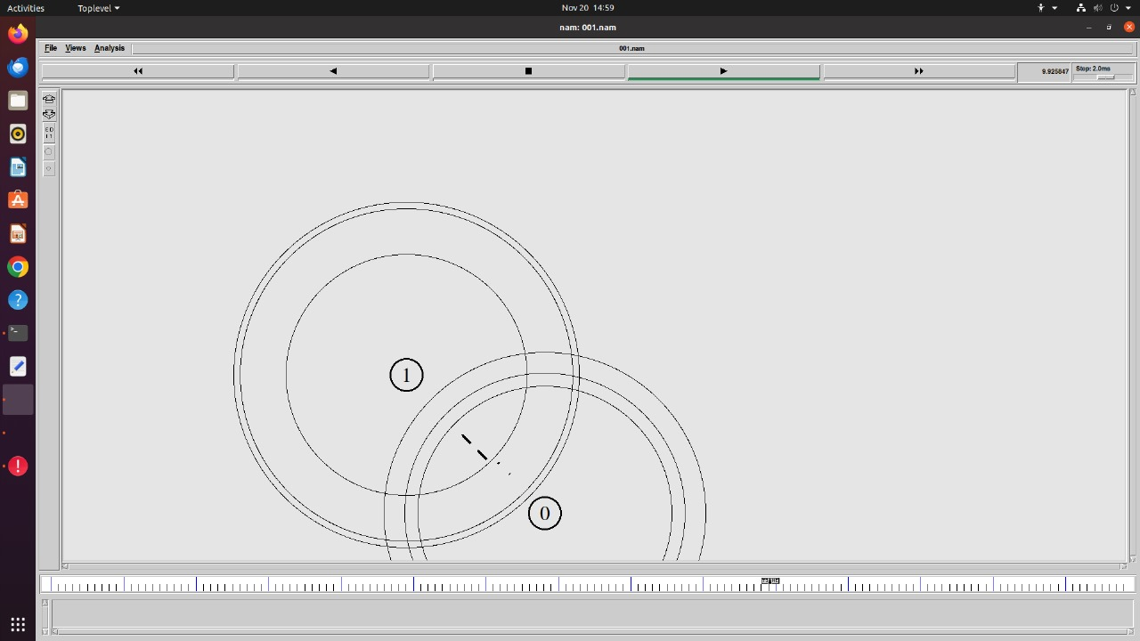

**LAB PROGRAM 7**

Set up a 3-node wireless network with node N1 between N0 and N2. As the nodes N0 and N2 move towards each other they exchange packets. As they move out of each other’s range they drop some packets. Analyze TCP performance for this scenario with AODV routing protocol.

**CODE**

set val(chan) Channel/WirelessChannel

set val(prop) Propagation/TwoRayGround

set val(netif) Phy/WirelessPhy

set val(mac) Mac/802_11

#set val(ifq) CMUPriQueue

set val(ifq) Queue/DropTail/PriQueue

set val(ll) LL

set val(ant) Antenna/OmniAntenna

set val(x) 500

set val(y) 400

set val(ifqlen) 50

set val(nn) 3

set val(stop) 60.0

set val(rp) AODV

set ns [new Simulator]

set tf [open 002.tr w]

$ns trace-all $tf

set nf [open 002.nam w]

$ns namtrace-all-wireless $nf $val(x) $val(y)

set prop [new $val(prop)]

set topo [new Topography]

$topo load_flatgrid $val(x) $val(y)

create-god $val(nn)

$ns node-config -adhocRouting $val(rp) \

-llType $val(ll) \

-macType $val(mac) \

-ifqType $val(ifq) \

-ifqLen $val(ifqlen) \

-antType $val(ant) \

-propType $val(prop) \

-phyType $val(netif) \

-channelType $val(chan) \

-topoInstance $topo \

-agentTrace ON \

-routerTrace ON \

-macTrace ON

for {set i 0} {$i < $val(nn) } {incr i} {

set node_($i) [$ns node]

$node_($i) random-motion 0

}

$node_(0) set x_ 5.0

$node_(0) set y_ 5.0

$node_(0) set z_ 0.0

$node_(1) set x_ 490.0

$node_(1) set y_ 285.0

$node_(1) set z_ 0.0

$node_(2) set x_ 150.0

$node_(2) set y_ 240.0

$node_(2) set z_ 0.0

for {set i 0} {$i < $val(nn)} {incr i} {

$ns initial_node_pos $node_($i) 40

}

#Topology Design

$ns at 0.0 "$node_(0) setdest 450.0 285.0 30.0"

$ns at 0.0 "$node_(1) setdest 200.0 285.0 30.0"

$ns at 0.0 "$node_(2) setdest 1.0 285.0 30.0"

$ns at 25.0 "$node_(0) setdest 300.0 285.0 10.0"

$ns at 25.0 "$node_(2) setdest 100.0 285.0 10.0"

$ns at 40.0 "$node_(0) setdest 490.0 285.0 5.0"

$ns at 40.0 "$node_(2) setdest 1.0 285.0 5.0"

set tcp0 [new Agent/TCP]

set sink0 [new Agent/TCPSink]

$ns attach-agent $node_(0) $tcp0

$ns attach-agent $node_(2) $sink0

$ns connect $tcp0 $sink0

set ftp0 [new Application/FTP]

$ftp0 attach-agent $tcp0

$ns at 10.0 "$ftp0 start"

for {set i 0} {$i < $val(nn) } {incr i} {

$ns at $val(stop) "$node_($i) reset";

}

$ns at $val(stop) "finish"

proc finish {} {

global ns tf nf

$ns flush-trace

close $tf

close $nf

exec nam 002.nam &

exit 0

}

$ns run

**TRACEFILE**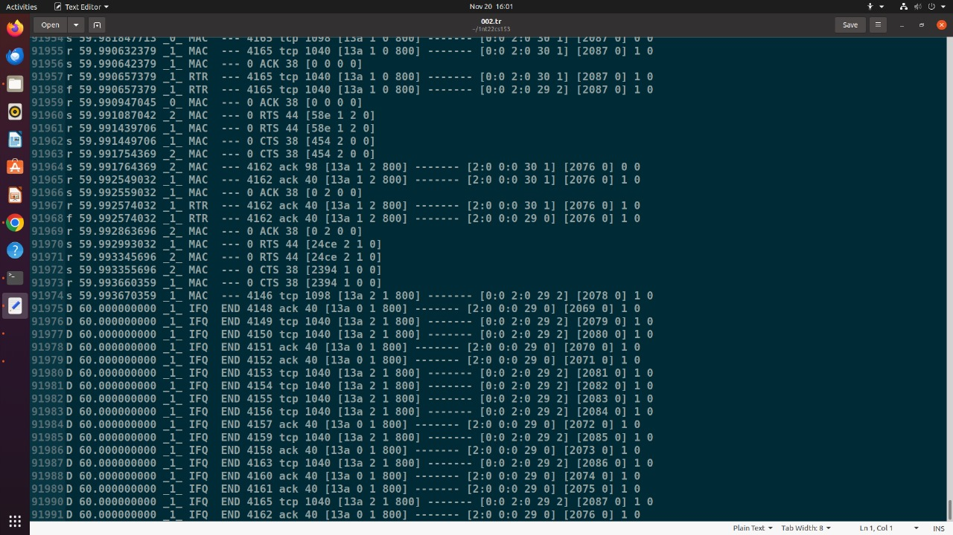

**OUTPUT:**

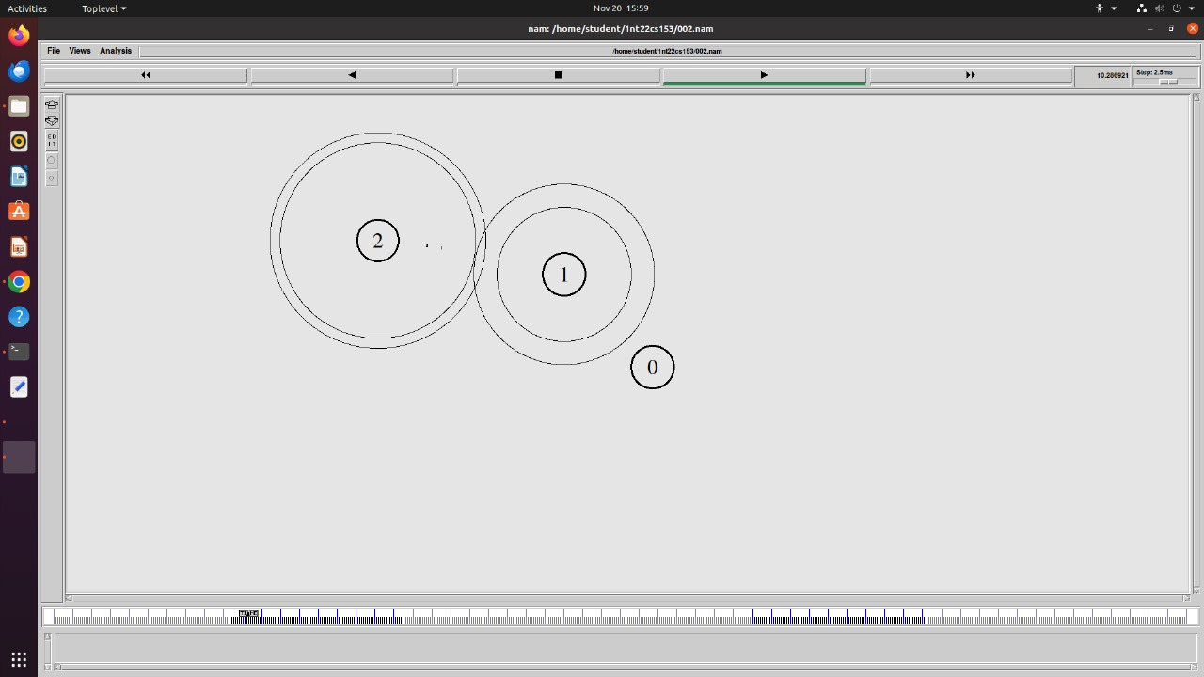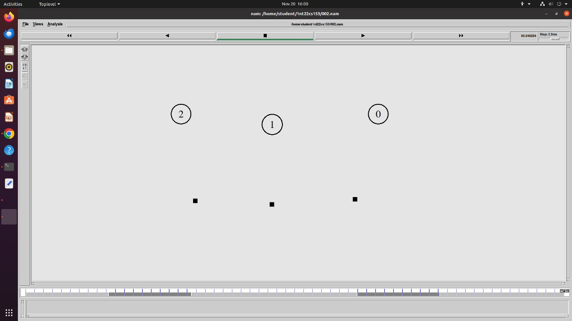

**LAB PROGRAM 8**

Set up a 6-node wireless network; analyze TCP performance when nodes are static and mobile

**CODE:**

set val(chan) Channel/WirelessChannel

set val(prop) Propagation/TwoRayGround

set val(netif) Phy/WirelessPhy

set val(mac) Mac/802_11

set val(ifq) Queue/DropTail/PriQueue

set val(ll) LL

set val(ant) Antenna/OmniAntenna

set val(x) 500

set val(y) 500

set val(ifqlen) 50

set val(nn) 50

set val(stop) 100.0

set val(rp) AODV

set val(sc) "mobile"

set val(cp) "transmit"

set ns [new Simulator]

set tf [open 003.tr w]

$ns trace-all $tf

set nf [open 003.nam w]

$ns namtrace-all-wireless $nf $val(x) $val(y)

set prop [new $val(prop)]

set topo [new Topography]

$topo load_flatgrid $val(x) $val(y)

set god_ [create-god $val(nn)]

$ns node-config -adhocRouting $val(rp) \

-llType $val(ll) \

-macType $val(mac) \

-ifqType $val(ifq) \

-ifqLen $val(ifqlen) \

-antType $val(ant) \

-propType $val(prop) \

-phyType $val(netif) \

-channelType $val(chan) \

-topoInstance $topo \

-agentTrace ON \

-routerTrace ON \

-macTrace ON

for {set i 0} {$i < $val(nn) } {incr i} {

set node_($i) [$ns node]

$node_($i) random-motion 0

}

for {set i 0} {$i < $val(nn) } {incr i} {

set xx [expr rand()*500]

set yy [expr rand()*400]

$node_($i) set X_ $xx

$node_($i) set Y_ $yy

}

#Initial Positions of Nodes

for {set i 0} {$i < $val(nn)} {incr i} {

$ns initial_node_pos $node_($i) 40

}

#puts "Loading scenario file..."

#source $val(sc)

puts "Loading connection file..."

source $val(cp)

for {set i 0} {$i < $val(nn) } {incr i} {

$ns at $val(stop) "$node_($i) reset";

}

proc finish {} {

global ns tf nf

$ns flush-trace

close $tf

close $nf

exec nam 003.nam &

exit 0

}

$ns run

Desktop> ns-2.35all_in_one >ns-2.35>>indeputils>cmu-scen-gen>cbrgen.tcl nodes: 50, max conn: 25, send rate: 20.0, seed: 1.0

Desktop>ns-2.35all_in_one>ns-2.35>indeputils>cmu-scengen>setdest>setdest.h version: 1, nodes: 50, pause: 1.00, max time: 100.0, max speed: 20.00, max x: 500.00, max y: 500.00

**TRACEFILE:**

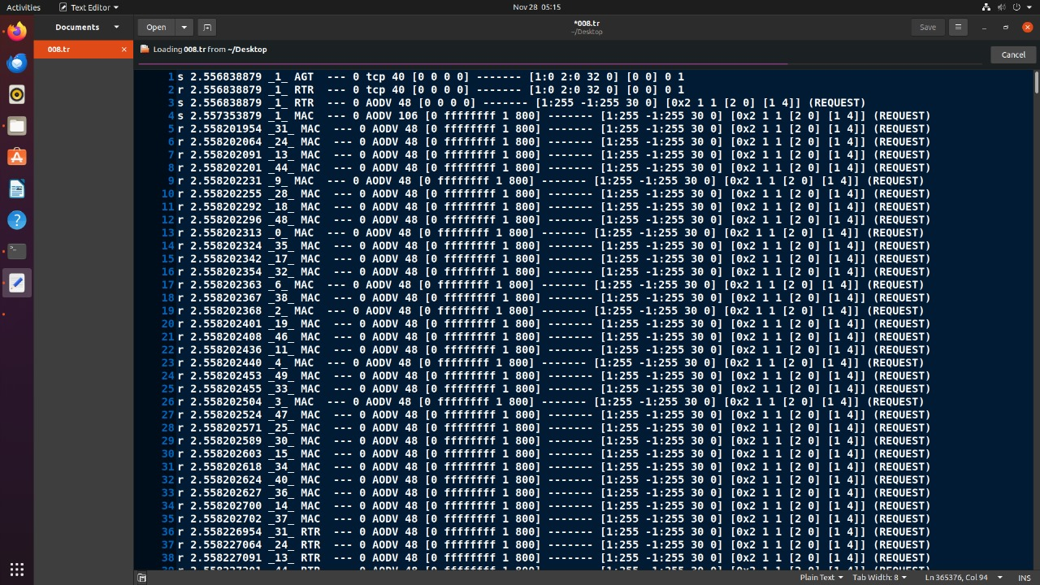

**OUTPUT:**

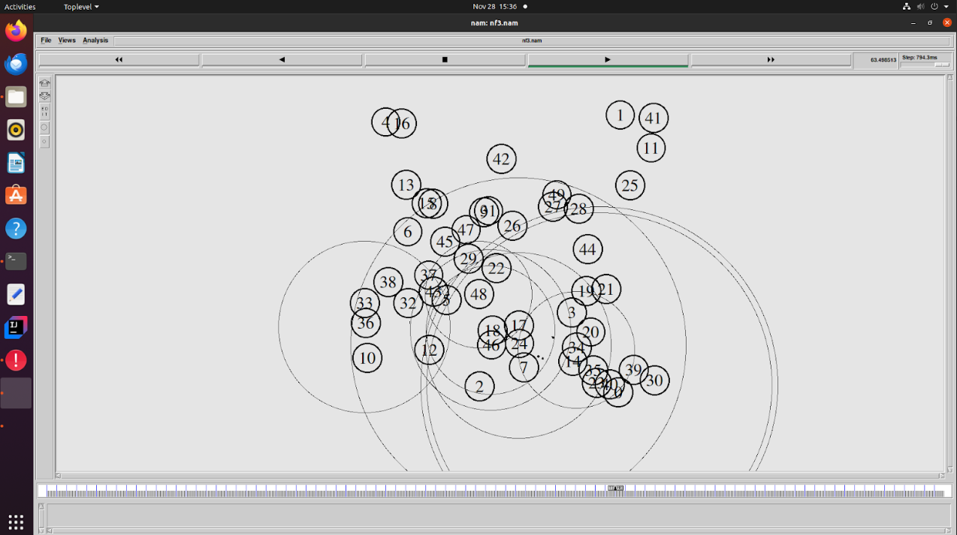

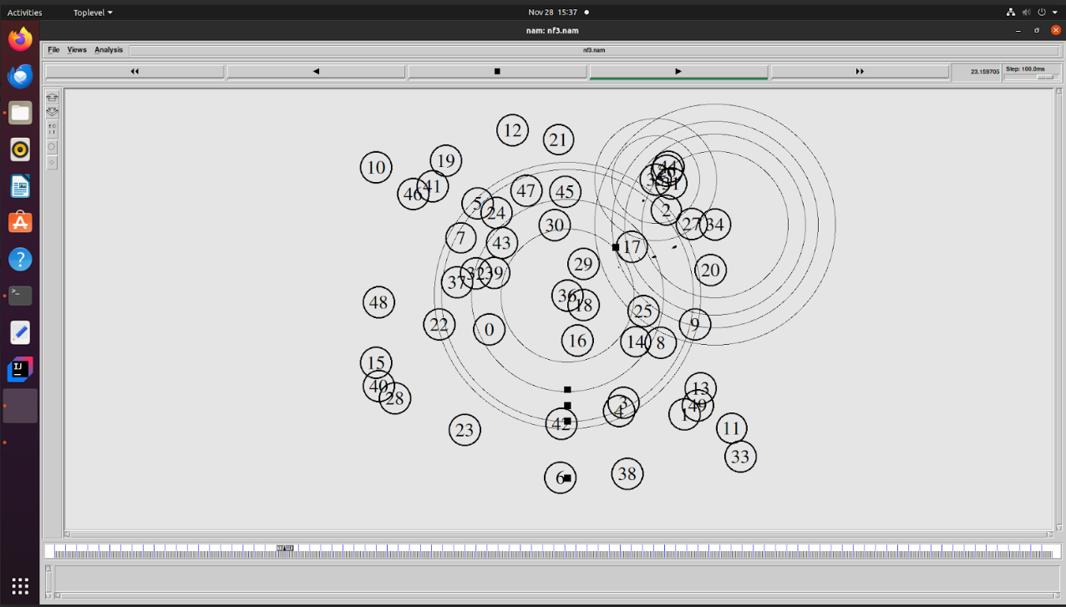

**LAB PROGRAM 9**

Write a TCL script to simulate the following scenario. Consider six nodes, (as shown in the figure below) moving within a flat topology of 700m x 700m. The initial positions of nodes are: n0(150, 300), n1(300, 500), n2(500, 500), n3 (300, 100), n4(500, 100) and n5(650, 300) respectively. A TCP connection is initiated between n0 (source) and n5 (destination) through n3 and n4 i.e., the route is 0-3-4-5. At time t = 3 seconds, the FTP application runs over it. After time t = 4 seconds, n3(300,100) moves towards n1(300, 500) with a speed of 5.0m/sec and after some time the path breaks. The data is then transmitted with a new path via n1 and n2 i.e., the new route is 0-1-2-5. The simulation lasts for 60 secs. In the above-said case both the routes have equal cost. Use DSR as the routing protocol and the IEEE 802.11 MAC protocol.

**CODE:**set val(chan) Channel/WirelessChannel

set val(prop) Propagation/TwoRayGround

set val(netif) Phy/WirelessPhy

set val(mac) Mac/802_11

#set val(ifq) Queue/DropTail/PriQueue

set val(ifq) CMUPriQueue

set val(ll) LL

set val(ant) Antenna/OmniAntenna

set val(x) 700

set val(y) 700

set val(ifqlen) 50

set val(nn) 6

set val(stop) 60.0

set val(rp) DSR

set ns [new Simulator]

set tf [open 004.tr w]

$ns trace-all $tf

set nf [open 004.nam w]

$ns namtrace-all-wireless $nf $val(x) $val(y)

set prop [new val(prop)]

set topo [new Topography]

$topo load_flatgrid $val(x) $val(y)

set god_ [create-god $val(nn)]

$ns node-config -adhocRouting $val(rp) \

-llType $val(ll) \

-macType $val(mac) \

-ifqType $val(ifq) \

-ifqLen $val(ifqlen) \

-antType $val(ant) \

-propType $val(prop) \

-phyType $val(netif) \

-channelType $val(chan) \

-topoInstance $topo \

-agentTrace ON \

-routerTrace ON \

-macTrace ON

for {set i 0} {$i < $val(nn) } {incr i} {

set node_($i) [$ns node]

$node_($i) random-motion 0

}

$node_(0) set X_ 150.0

$node_(0) set Y_ 300.0

$node_(0) set Z_ 0.0

$node_(1) set X_ 300.0

$node_(1) set Y_ 500.0

$node_(1) set Z_ 0.0

$node_(2) set X_ 500.0

$node_(2) set Y_ 500.0

$node_(2) set Z_ 0.0

$node_(3) set X_ 300.0

$node_(3) set Y_ 100.0

$node_(3) set Z_ 0.0

$node_(4) set X_ 500.0

$node_(4) set Y_ 100.0

$node_(4) set Z_ 0.0

$node_(5) set X_ 650.0

$node_(5) set Y_ 300.0

$node_(5) set Z_ 0.0

for {set i 0} {$i < $val(nn)} {incr i} {

$ns initial_node_pos $node_($i) 40

}

$ns at 1.0 "$node_(0) setdest 160.0 300.0 2.0"

$ns at 1.0 "$node_(1) setdest 310.0 150.0 2.0"

$ns at 1.0 "$node_(2) setdest 490.0 490.0 2.0"

$ns at 1.0 "$node_(3) setdest 300.0 120.0 2.0"

$ns at 1.0 "$node_(4) setdest 510.0 90.0 2.0"

$ns at 1.0 "$node_(5) setdest 640.0 290.0 2.0"

$ns at 4.0 "$node_(3) setdest 300.0 500.0 5.0"

set tcp0 [new Agent/TCP]

set sink0 [new Agent/TCPSink]

$ns attach-agent $node_(0) $tcp0

$ns attach-agent $node_(5) $sink0

$ns connect $tcp0 $sink0

set ftp0 [new Application/FTP]

$ftp0 attach-agent $tcp0

$ns at 5.0 "$ftp0 start"

$ns at 60.0 "$ftp0 stop"

for {set i 0} {$i < $val(nn) } {incr i} {

$ns at $val(stop) "$node_($i) reset";

}

$ns at $val(stop) “finish”

proc finish {} {

global ns tf nf

$ns flush-trace

close $tf

close $nf

exec nam 003.nam &

exit 0

}

$ns run

**OUTPUT:**

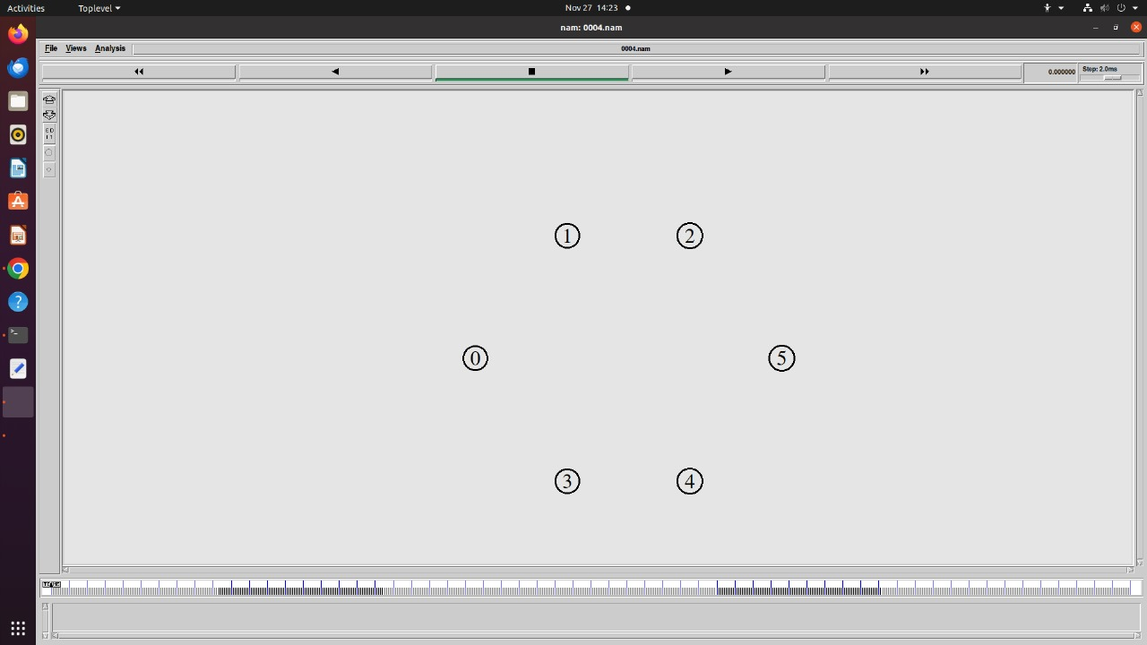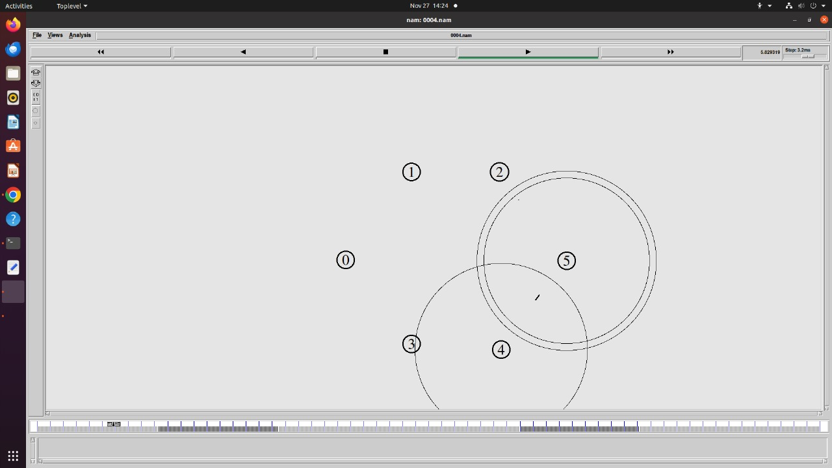 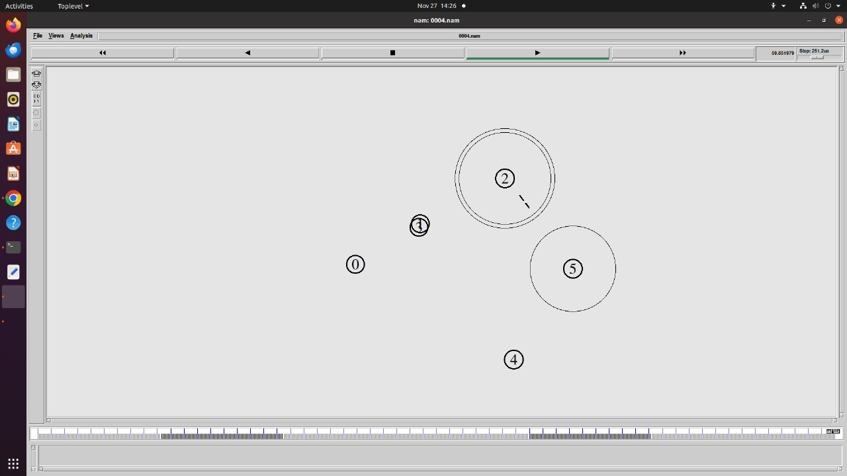

**LAB PROGRAM 10**

Set up a wireless network with mobile nodes, induce 1 to 10% error to the network using a uniform error model. Plot the congestion window for TCP connections. Write your observation on TCP performance as errors increase in the network.

**CODE:**

set val(chan) Channel/WirelessChannel

set val(prop) Propagation/TwoRayGround

set val(netif) Phy/WirelessPhy

set val(mac) Mac/802_11

set val(ifq) Queue/DropTail/PriQueue

set val(ll) LL

set val(ant) Antenna/OmniAntenna

set val(x) 500

set val(y) 500

set val(ifqlen) 50

set val(nn) 5

set val(stop) 50.0

set val(rp) AODV

set ns [new Simulator]

set tf [open 006.tr w]

$ns trace-all $tf

set cwind1 [open win10.tr]

set cwind2 [open win11.tr]

set nf [open 006.nam w]

$ns namtrace-all-wireless $nf $val(x) $val(y)

set prop [new $val(prop)]

set topo [new Topography]

$topo load_flatgrid $val(x) $val(y)

create-god $val(nn)

# Node Configuration

$ns node-config -adhocRouting $val(rp) \

-llType $val(ll) \

-macType $val(mac) \

-ifqType $val(ifq) \

-ifqLen $val(ifqlen) \

-antType $val(ant) \

-propType $val(prop) \

-phyType $val(netif) \

-channelType $val(chan) \

-topoInstance $topo \

-agentTrace ON \

-routerTrace ON \

-macTrace ON \

-IncomingErrProc "uniformErr" \

-OutgoingErrProc "uniformErr"

proc uniformErr {} {

set err [new ErrorModel]

$err unit pkt

$err set rate_ 0.01

return $err

}

# Creating Nodes

for {set i 0} {$i < $val(nn)} {incr i} {

set node_($i) [$ns node]

$node_($i) random-motion 0

}

# Initial Positions of Nodes

for {set i 0} {$i < $val(nn)} {incr i} {

$ns initial_node_pos $node_($i) 40

}

# Topology Design

$ns at 1.0 "$node_(0) setdest 10.0 10.0 50.0"

$ns at 1.0 "$node_(1) setdest 10.0 100.0 50.0"

$ns at 1.0 "$node_(4) setdest 50.0 50.0 50.0"

$ns at 1.0 "$node_(2) setdest 100.0 100.0 50.0"

$ns at 1.0 "$node_(3) setdest 100.0 10.0 50.0"

# Generating Traffic

set tcp [new Agent/TCP]

set sink [new Agent/TCPSink]

$ns attach-agent $node_(0) $tcp

$ns attach-agent $node_(2) $sink

$ns connect $tcp $sink

set ftp [new Application/FTP]

$ftp attach-agent $tcp

$ns at 1.0 "$ftp start"

$ns at 50.0 "$ftp stop"

set tcp1 [new Agent/TCP]

set sink1 [new Agent/TCPSink]

$ns attach-agent $node_(1) $tcp1

$ns attach-agent $node_(2) $sink1

$ns connect $tcp1 $sink1

set ftp1 [new Application/FTP]

$ftp1 attach-agent $tcp1

$ns at 1.0 "$ftp1 start"

$ns at 50.0 "$ftp1 stop"

# Simulation Termination

for {set i 0} {$i < $val(nn)} {incr i} {

$ns at $val(stop) "$node_($i) reset"

}

proc pw {tcpsource file} {

global ns

set 0.2

set cwnd [$tcpsource set cwnd_]

puts $file “$now $cwind”

$ns at [expr $now + $time] “pw $tcpsource $file”

}

$ns 1.0 “pw $tcp $cwind1”

$ns 1.0 “pw $tcp1 $cwind2”

$ns at $val(stop) “finish”

proc finish {} {

global ns tf nf

$ns flush-trace

close $tf

close $nf

exec nam 003.nam &

exit 0

}

**OUTPUT:** 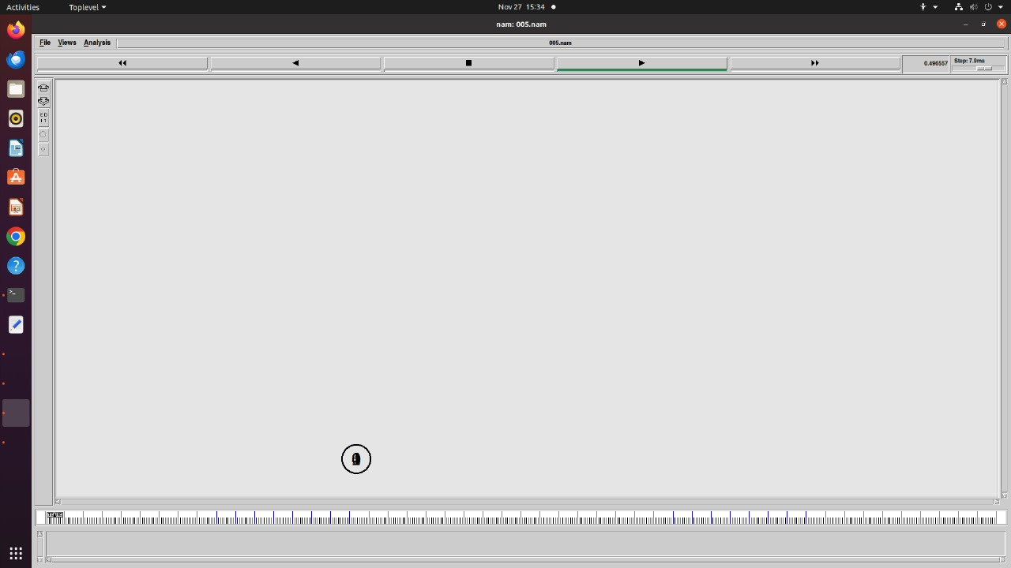

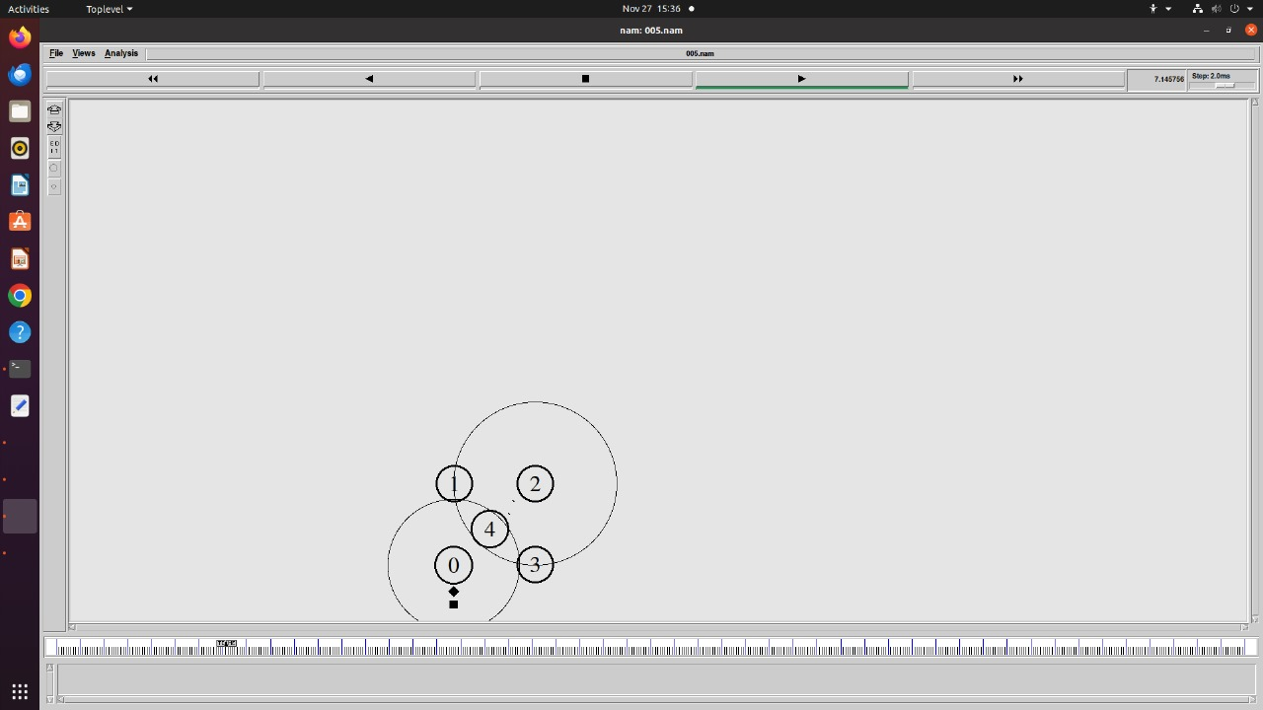

**CONGESTION WINDOW**

**(tcp)**

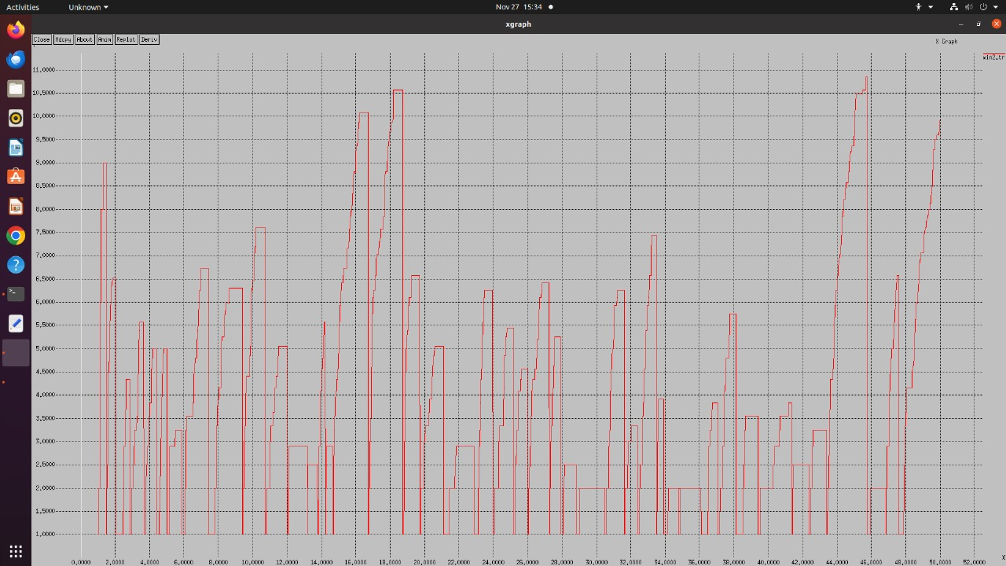

**(tcp1)**

