

**Project Report**

**Development of Personal Finance Tracker System For Budget Management**

**Course Code: CSE2116**

**Course Title: Software Development Project-I and Industrial Tour**

|  |  |
| --- | --- |
| **Submitted By**  Anik Bhattacharjee  ID: CE22053  Saif khan  ID: CE22051  Session: 2021-22 | **Supervised By**  Lubna Yasmin Pinky  Assistant Professor,  Dept. of CSE, MBSTU |

Department of Computer Science and Engineering,

Mawlana Bhashani Science and Technology University

Santosh, Tangail-1902

Table of Contents

1. Introduction 3

1.1 Technical Aspects and Background 3

1.2 Objective of the Project 3

1.3 Scope of the Project 4

1.4 Benefit or Significance of the Project 4

2. Requirement Analysis 5

2.1 Feasibility Study 5

2.2 System Requirements 5

2.3 User Requirements 5

3. System Design 6

3.1 Architecture of the Project 6

3.2 Workflow of the Project 7

4. Implementation and Testing 8

4.1 Implementation of the Project 8

4.2 Result [Screenshots] 8

4.3 Testing 16

5. Conclusion 17

**List of Figures:**

Figure 1: Block Diagram of Personal finance trackers System 6

Figure 2**:** Workflow of Personal finance trackers System 7

Figure 3**:** Home and choice Menu 8

Figure 4**:** Add Income 9

Figure 5:Add Expense 9

Figure 6: Set a Budget 10

Figure 7: Set a goal 10

Figure 8: Savings for a goal 11

Figure 9: Monthly Report 11

Figure 10: Overall Report 12

Figure 11: View Transactions 12

Figure 12: Update a transactions 13

Figure 13: About Developer’s 13

Figure 14: View Transaction after updating 14

Figure 15: Overall Report after updating 14

Figure 16: Existing program 15

# **1. Introduction**

### **1.1 Technical Aspects and Background**

The **Personal Finance Tracker** is built entirely using the **C programming language**, demonstrating its versatility for creating structured and efficient programs. It uses **structs** to define and manage financial data like income, expenses, budgets, and goals. File handling is implemented to save and retrieve data, ensuring persistence between sessions.

The program employs modular functions for tasks like adding, updating, or deleting transactions, generating reports, and managing budgets and goals. Features like date-based filtering, category-wise expense tracking, and goal progress calculation make it comprehensive and user-friendly.

This project was developed as part of a **second-year software development course**, showcasing the application of core programming concepts. It is a functional, real-world system designed to improve financial planning and is a milestone in the academic journey of us.

### **1.2 Objective of the Project**

* **Simplify Financial Management**: Develop a tool to make managing personal finances easy and efficient.
* **Track Income and Expenses**: Provide a system to record, categorize, and analyze financial transactions.
* **Enable Budgeting**: Help users set and adhere to budgets for better financial control.
* **Support Financial Goals**: Allow users to define and monitor progress toward achieving financial targets.
* **Generate Reports**: Provide clear and detailed financial summaries for better understanding and decision-making.
* **Enhance Technical Knowledge**: Apply programming skills, especially in C, to create a functional project.
* **Promote Financial Awareness**: Educate users on their spending patterns and improve saving habits.
* **Encourage Practical Learning**: Combine theoretical knowledge with real-world application to enhance problem-solving skills.

The objective of this project is to create a personal finance tracker that helps users manage their income, expenses, budgets, and financial goals effectively. It aims to simplify financial tracking while providing insights for better financial decision-making.

### **1.3 Scope of the Project**

The system helps users manage their finances, including tracking income, expenses, and savings goals.

* **Transaction Recording**: Users can input, edit, and delete income and expense transactions.
* **Budget Tracking**: The system allows users to set budgets and track their spending against predefined limits.
* **Financial Goal Setting**: Users can set financial goals and monitor their progress toward achieving them.
* **Financial Reports**: The project generates monthly and overall reports to give insights into financial performance.
* **Data Backup**: It ensures data is securely stored and can be loaded or saved for future use.
* **User-Friendly Interface**: The system offers a simple, easy-to-use interface for seamless interaction with the platform.

### **1.4 Benefit or Significance of the Project**

This project offers significant benefits to users and the broader community:

* **Financial Awareness**: Helps users better understand and manage their finances, leading to improved money management habits.
* **Budget Control**: By tracking income and expenses, users can stick to their budget and avoid overspending.
* **Goal Achievement**: Users can set and track financial goals, leading to better savings and investment outcomes.
* **Convenience**: Offers a user-friendly platform for managing finances at any time, from anywhere.
* **Data-Driven Insights**: Provides valuable insights through financial reports, aiding in informed decision-making.
* **Security**: Ensures secure data management, minimizing the risk of data loss or unauthorized access.
* **Ease of Use**: Simplifies complex financial tasks for individuals with little to no financial background.

# 

# **2. Requirement Analysis**

### **2.1 Feasibility Study**

* **Technical Feasibility**: The project can be developed using widely available technologies like Python for backend, React for frontend, and MySQL for database. Cloud services (AWS, Google Cloud) will be used for hosting, making the infrastructure scalable and reliable.
* **Operational Feasibility**: The application will have an easy-to-use interface, ensuring that users with minimal technical knowledge can interact with it effectively. Regular user feedback will be incorporated for improvements.
* **Economic Feasibility**: The project will utilize open-source tools to keep costs low. Potential revenue can be generated through a freemium model, ads, or subscription-based features.

### **2.2 System Requirements**

The successful execution of the **Personal Finance Tracker** System necessitates a set of system requirements. These include:

* + Operating System: Windows, Linux, MacOS
  + CPU: 1 GHz single core CPU or higher
  + RAM: 512 MB or more
  + Code blocks IDE

### **User Requirements**

### . To effectively use the system, users need:

* **Navigating the Interface**: Users should be familiar with the basic layout of the application, including menus, buttons, and key features.
* **Task/Project Management**: Users need to know how to create, update, and manage tasks or projects, including adding deadlines, descriptions, and assigning tasks to team members.
* **Search Functionality**: Users should know how to use the search feature to find specific tasks, projects, or resources.
* **Collaboration Features**: Users should understand how to collaborate with team members in real-time, such as commenting, updating tasks, or sharing project progress.
* **Notifications**: Users should know how to enable or disable notifications and understand how to respond to them.
* **Security Features**: Users must be aware of how to securely log in, manage their passwords, and protect their account information.
* **Data Management**: Users need to know how to store, edit, and delete data safely within the system.
* **Generating Reports**: Users should understand how to generate and view reports to track progress.
* **Help and Support**: Users should know how to access the help or support sections if they need assistance.

In summary, users should have basic knowledge of navigating the application, managing tasks or projects, using collaboration tools, and ensuring their account and data are secure.

# 

# **3. System Design**

### **3.1 Architecture of the Project**

Input Operations

(Add Income, Add Expense, Set Budget, Set Goals, etc.)

User Interface

(Command Line Menu)

User Interface

(Command Line Menu)

Processing Layer

(Data Manipulation, Reports,

Budget Tracking, Goal Updates)

Data Storage

(File Operations: Save/Load)

Output Layer

(Reports, Transaction Logs, Budget Comparisons, Goal Progress)

Figure : Block Diagram of **Personal Finance Tracker** System

### 

### **3.2 Workflow of the Project**

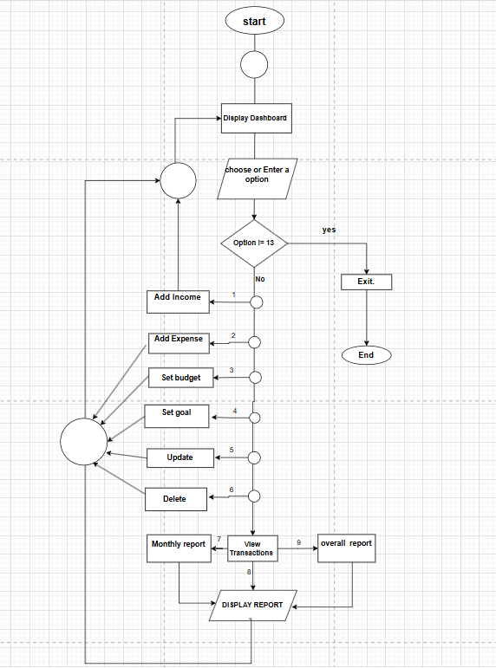

Figure 2**:** Workflow of **Personal Finance Tracker** System

# 

# **4. Implementation and Testing**

### **4.1 Implementation of the Project**

This Personal Finance Tracker is a C program designed to help individuals manage their personal finances. It allows users to record and track incomes, expenses, budgets, and financial goals. The program provides reports to summarize financial data and supports saving and loading data for con.

**Features**

1. **Add Income:** Record the source, amount, and date of income.
2. **Add Expense:** Record expenses with details like category, amount, and date.
3. **Set Budget:** Allocate budgets for specific categories.
4. **Set Financial Goal:** Define financial savings goals with a target amount and due date.
5. **Add Savings to Goals:** Track progress toward achieving financial goals.
6. **Generate Monthly Report:** View income, expenses, and savings for a specific month.
7. **Generate Overall Report:** Summarize total income, expenses, savings, and budget progress.
8. **View Transactions:** Display all recorded income and expenses.
9. **Update Transaction:** Modify existing income or expense records.
10. **Delete Transaction:** Remove specific income or expense records.
11. **Delete All Data:** Clear all saved data.
12. **About Us:** Information about the project creators.

### **4.2 Result [Screenshots]**

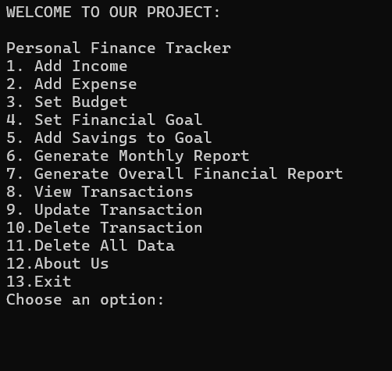

Figure 3**:** Home Menu and choice menu.

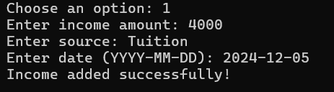

Figure 4**:** Add Income

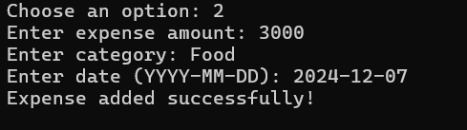

Figure 5:Add Expenses

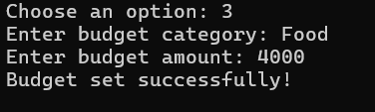

Figure 6: Set a Budget

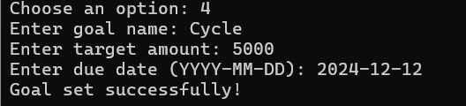

Figure 7: Set a goal

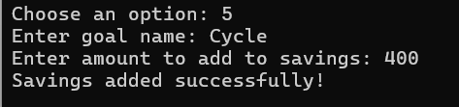

Figure 8: Savings for a goal

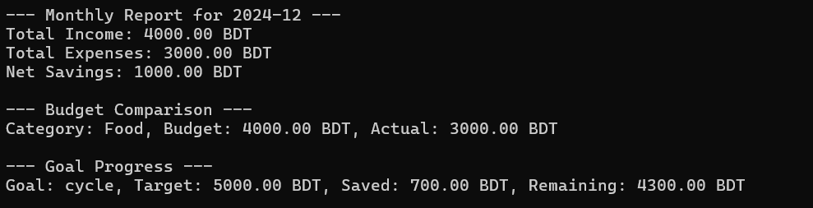

Figure 9: Monthly Report

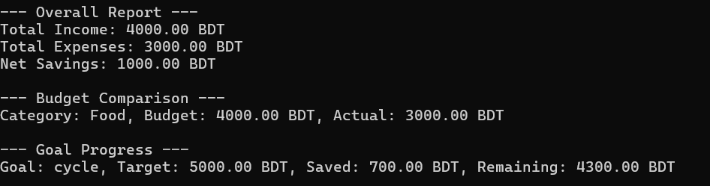

Figure 10: Overall Report

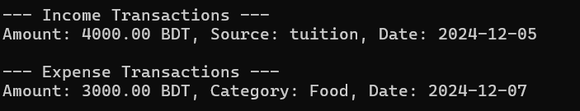

Figure 11: View Transactions

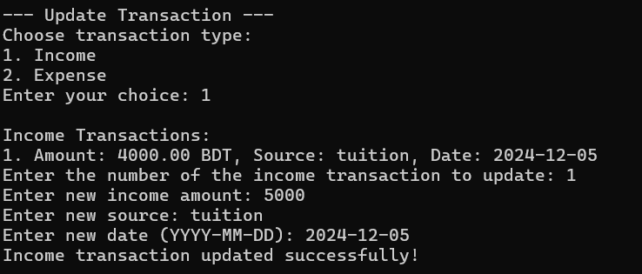

Figure 12: Update a Transaction

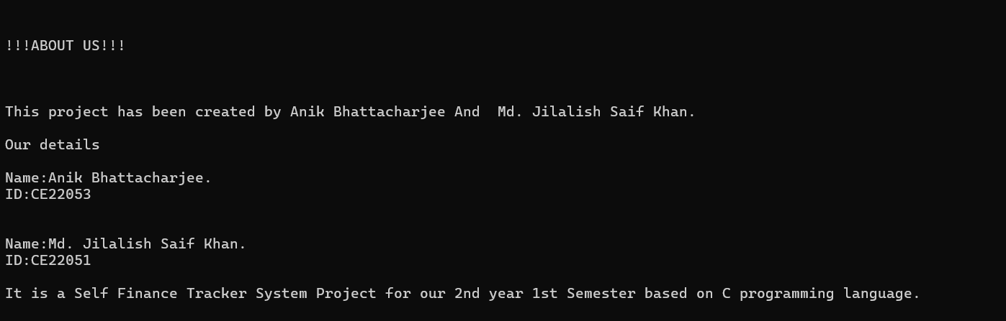

Figure 13: About Developer’s

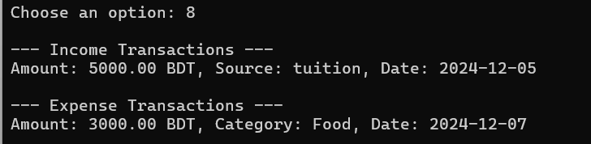

Figure 14:View Transaction after Updating

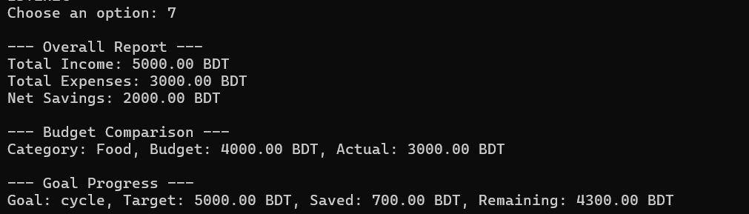

Figure 15: Overall reports after updating

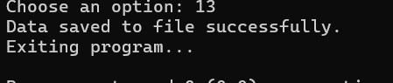

Figure *16*: Exiting program

### 

### **4.3 Testing**

The testing phase of the The Personal Finance Tracker System involved rigorous assessment of its functionalities, ensuring robustness and reliability. Various test cases were designed to validate the system's performance:

**Test Scenarios:**

1. **Adding Transactions:**
   * Add various incomes and expenses to ensure data is recorded correctly.
2. **Generating Reports:**
   * Verify monthly and overall reports for accuracy in calculations.
3. **Updating and Deleting Transactions:**
   * Test updates and deletions for both income and expense entries.
4. **Budget and Goal Management:**
   * Create budgets and goals, check progress tracking, and ensure savings additions are reflected correctly.
5. **Data Saving and Loading:**
   * Confirm data persists after exiting and reopening the program.
6. **User Interaction:**
   * Test menu navigation for proper functioning and invalid input handling.

.

The testing process ensured that the system meets the specified requirements and operates reliably under various conditions.

# **5. Conclusion**

The **Personal Finance Tracker** is a user-friendly tool designed to help individuals manage their finances effectively. By tracking income, expenses, budgets, and financial goals, it provides a comprehensive view of one's financial health. The system allows for seamless data management, including adding, updating, and deleting transactions. It also generates detailed monthly and overall financial reports to support better decision-making. This project demonstrates the practical application of C programming in developing a functional and efficient financial management system, making financial planning simpler and more accessible.

---------------------------------------------Signature of supervisor