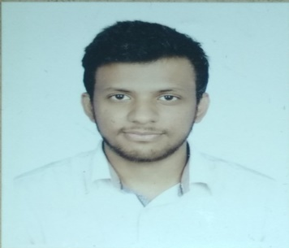

**ANIK ACHARJYA**

**Address**:152/1 Boro Mogbazar,Dhaka -1217

**Contact No**: 01775639850

**E-mail**: [acharjee180@gmail.com](mailto:acharjee180@gmail.com)

**SUMMARY**

Looking for a challenging position in the field of computing and research field of a progressive organization which provides me the opportunity to improve my skills and knowledge to growth along with the organization objective.

**SKILLS**

***Programming Language*:** HTML, CSS, Php, , Java Script, JQuery

***Framework:*** Laravel,vue.js

***CMS*:** WordPress

***Software:*** Code Blocks, MS Visual Studio, Net beans, Sublime Text, Atom

***Operating System*:** Microsoft Windows

***Database*:** MySQL

**ACADEMIC PROJECT**

* **Load Balance Management System**

***Summary*:** A load balance management system for managing University Department all course marge split process and attendance system.

***Language*:**  HTML, PHP, MySQL, JavaScript, JQuery, Ajax

* **Online Shopping System**

***Summary*:** Online Shopping is a form of electronic commerce which allows consumers to directly buy goods or services from a seller over the internet using a web browser.

***Language*:** HTML,CSS,PHP,MySQL

* **Online News Portal**

***Language*:** php, Laravel Framework

* **Inventory Management System**

***Language*:** php ,Laravel Framework

**EDUCATIONAL QUALIFICATION**

**Bachelor of Computer Science And Engineering (B.sc in CSE)**

***Institution*** : Stamford University Bangladesh

***Passing Year*** : 2019

**Higher Secondary School Certificate (HSC)**

***Institution*** : Kazi Mohammad Shafiqul Islam College

***Board*** : Cumilla

***Passing Year*** : 2014

***Group*** : Science

**Secondary School Certificate (SSC)**

***Institution*** : Nidarabad Union High School

***Board*** : Cumilla

***Passing Year*** : 2012

***Group*** : Science

**TRAINING SUMMARY**

***Training Title*:** SEIP(Skills for Employment Investment Program)

***Topic*:** Web Design

***Country*:** Bangladesh

***Institute:*** BITM (BASIS Institute of Technology & Management)

***Location*:** BDBL Bhaban, 12,kawran Bazar,Dhaka-1215

***Year*:** 2018

***Duration*:** 3 Month

**PERSONAL INFORMATION**

***Father’s Name*:** Atindra Acharjya

***Mother’s Name*:** Khela Rani Acharjya

***Mailing Address*:** 152/1 Boro Mogbazar,Dhaka -1217

***Permanent Address:*** Harashpur, Pak.Harashpur, Bijoynagar, Brahmanbaria.

***Date of Birth*:** January 10, 1996

***Sex*:** Male

***Marital Status*:** Single

***Religion*:** Shanaton.

***Nationality*:** Bangladeshi (By Birth)

Anik Acharjya