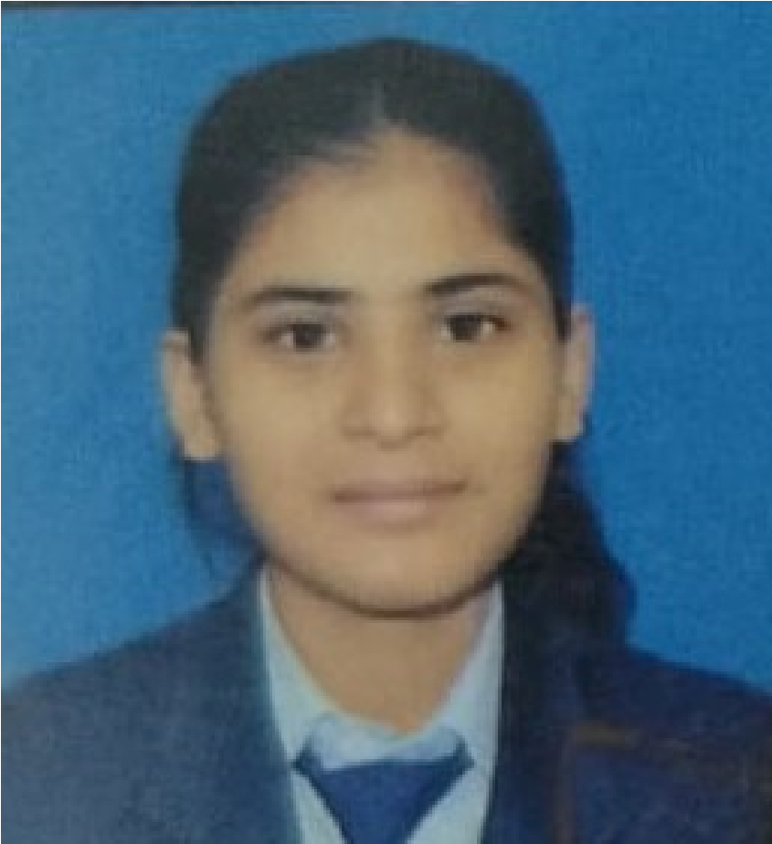

9825208545
shah
mail.com
@g
udi22
g
PERSONALINFORMATION:
SKILLS
FFATHER’S NAME: MOHAN SHAH
DOB

:

2004/10/08
GENDER :

FEMALE

Permanent Address:
Mahagadhimai,Bara-7,Nepal

Computational and Analytical skills.
Leadership skills.
Interpersonal and communication skills.
Continuous learning and willingness to
improve with experience.
Optimum utilization of time with best use of
knowledgeand technology
COMPUTER
KNOWLEDGE

Proficiency in handling of Microsoft
Word,Excel, PowerPoint etc.
Himani
Shah
SOCIAL MOBILIZER
EDUCATIONAL HISTORY
Year-Pursuing
Tribhuvan University
BBA 4
YEAR

ND
8
SEMESTER
TH
Grade-A
Year-2021
HIMALAYAN SECONDARY SCHOOL,
Birgunj
10+2
WORK EXPERIENCE
Conduct day-to-day project coordination,
planning, and implementation.
Social Mobilzer
G.H.P. SECONDARY SCHOOL, Birgunj,Parsa
Grade-A+
Year-2019
S.E.E
Duration-2081-06-01 to 2082-08-23

