MULTI-OUTLET F&B PLATFORM
Architecture Documentation
Database design (ERD), scaling plan, microservices evolution and offline POS strategy
PROJECT | Multi-Outlet F&B Platform (HQ + Outlet POS)
DOCUMENT | Architecture Documentation
VERSION | 1.0
DATE | 30 September 2026
REPOSITORY | github.com/Anik720/multi-outlet-fnb-platform
TECHNOLOGY | Node.js · Express · PostgreSQL · Prisma · React · Docker
SUMMARY
F&B HQ / multi-outlet platform: HQ owns the master menu, assigns items to outlets with optional price overrides, and monitors sales. Outlets sell, deduct their own stock and issue their own sequential receipts.

Contents
1. System overview 3
2. ERD: database schema and relationships 5
Data dictionary 6
Key design decisions 9
Indexes and the queries they serve 10
3. Critical flow: creating a sale 11
4. Scaling plan: 10 outlets, 100,000 transactions/month 12
4.1 Sizing the problem 12
4.2 Database scaling strategies 12
4.3 Reporting performance considerations 12
4.4 Infrastructure considerations 14
4.5 Architectural evolution 15
5. Evolving to microservices 16
5.1 Guiding principle 16
5.2 Proposed services 16
5.3 The hard part: consistency across services 17
5.4 Migration path (strangler fig) 17
6. Offline POS mode strategy (POS + KDS) 18
6.1 Goals 18
6.2 Outlet edge architecture 18
6.3 POS ↔ KDS communication while offline 18
6.4 Offline sales and receipt numbers 19
6.5 Sync protocol when the internet reconnects 19
6.6 What is already implemented in this codebase 20

1. System overview
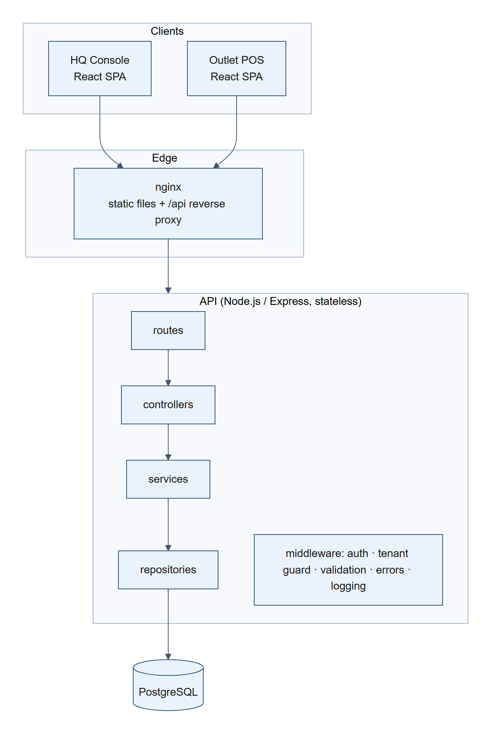
Figure 1. System overview: clients, edge proxy, layered stateless API and PostgreSQL
Layer | Responsibility | Knows about HTTP? | Knows about SQL?
routes | URL + method → middleware chain (auth, role, tenant guard, validation) → controller | yes | no
controllers | Read validated input from req.valid, call one service, shape the HTTP response (status, headers) | yes | no
services | Business rules, transactions, orchestration of repositories, domain errors | no | no
repositories | All data access (Prisma queries + raw SQL where locking/window functions are needed) | no | yes
validators | zod schemas; the single source of truth for request shapes and TS types | – | –
mappers | DB rows → API DTOs (Decimal → number, BigInt → number, hide password hashes) | – | –

Cross-cutting concerns: env config validated at boot (fail fast) · structured JSON logs (pino) with a request id propagated from nginx · helmet security headers · CORS allow-list · rate-limited login · centralised error middleware that turns domain errors and DB constraint violations into consistent { error: { code, message, details, requestId } } responses · liveness/readiness probes · graceful shutdown.
Security model: JWT bearer tokens. HQ_ADMIN can reach everything. OUTLET_STAFF is bound to one outlet (users.outlet_id, enforced by a CHECK). The authorizeOutlet middleware rejects any /outlets/:outletId/** request for another outlet, so tenant isolation is enforced server-side, not by the UI.

2. ERD: database schema and relationships
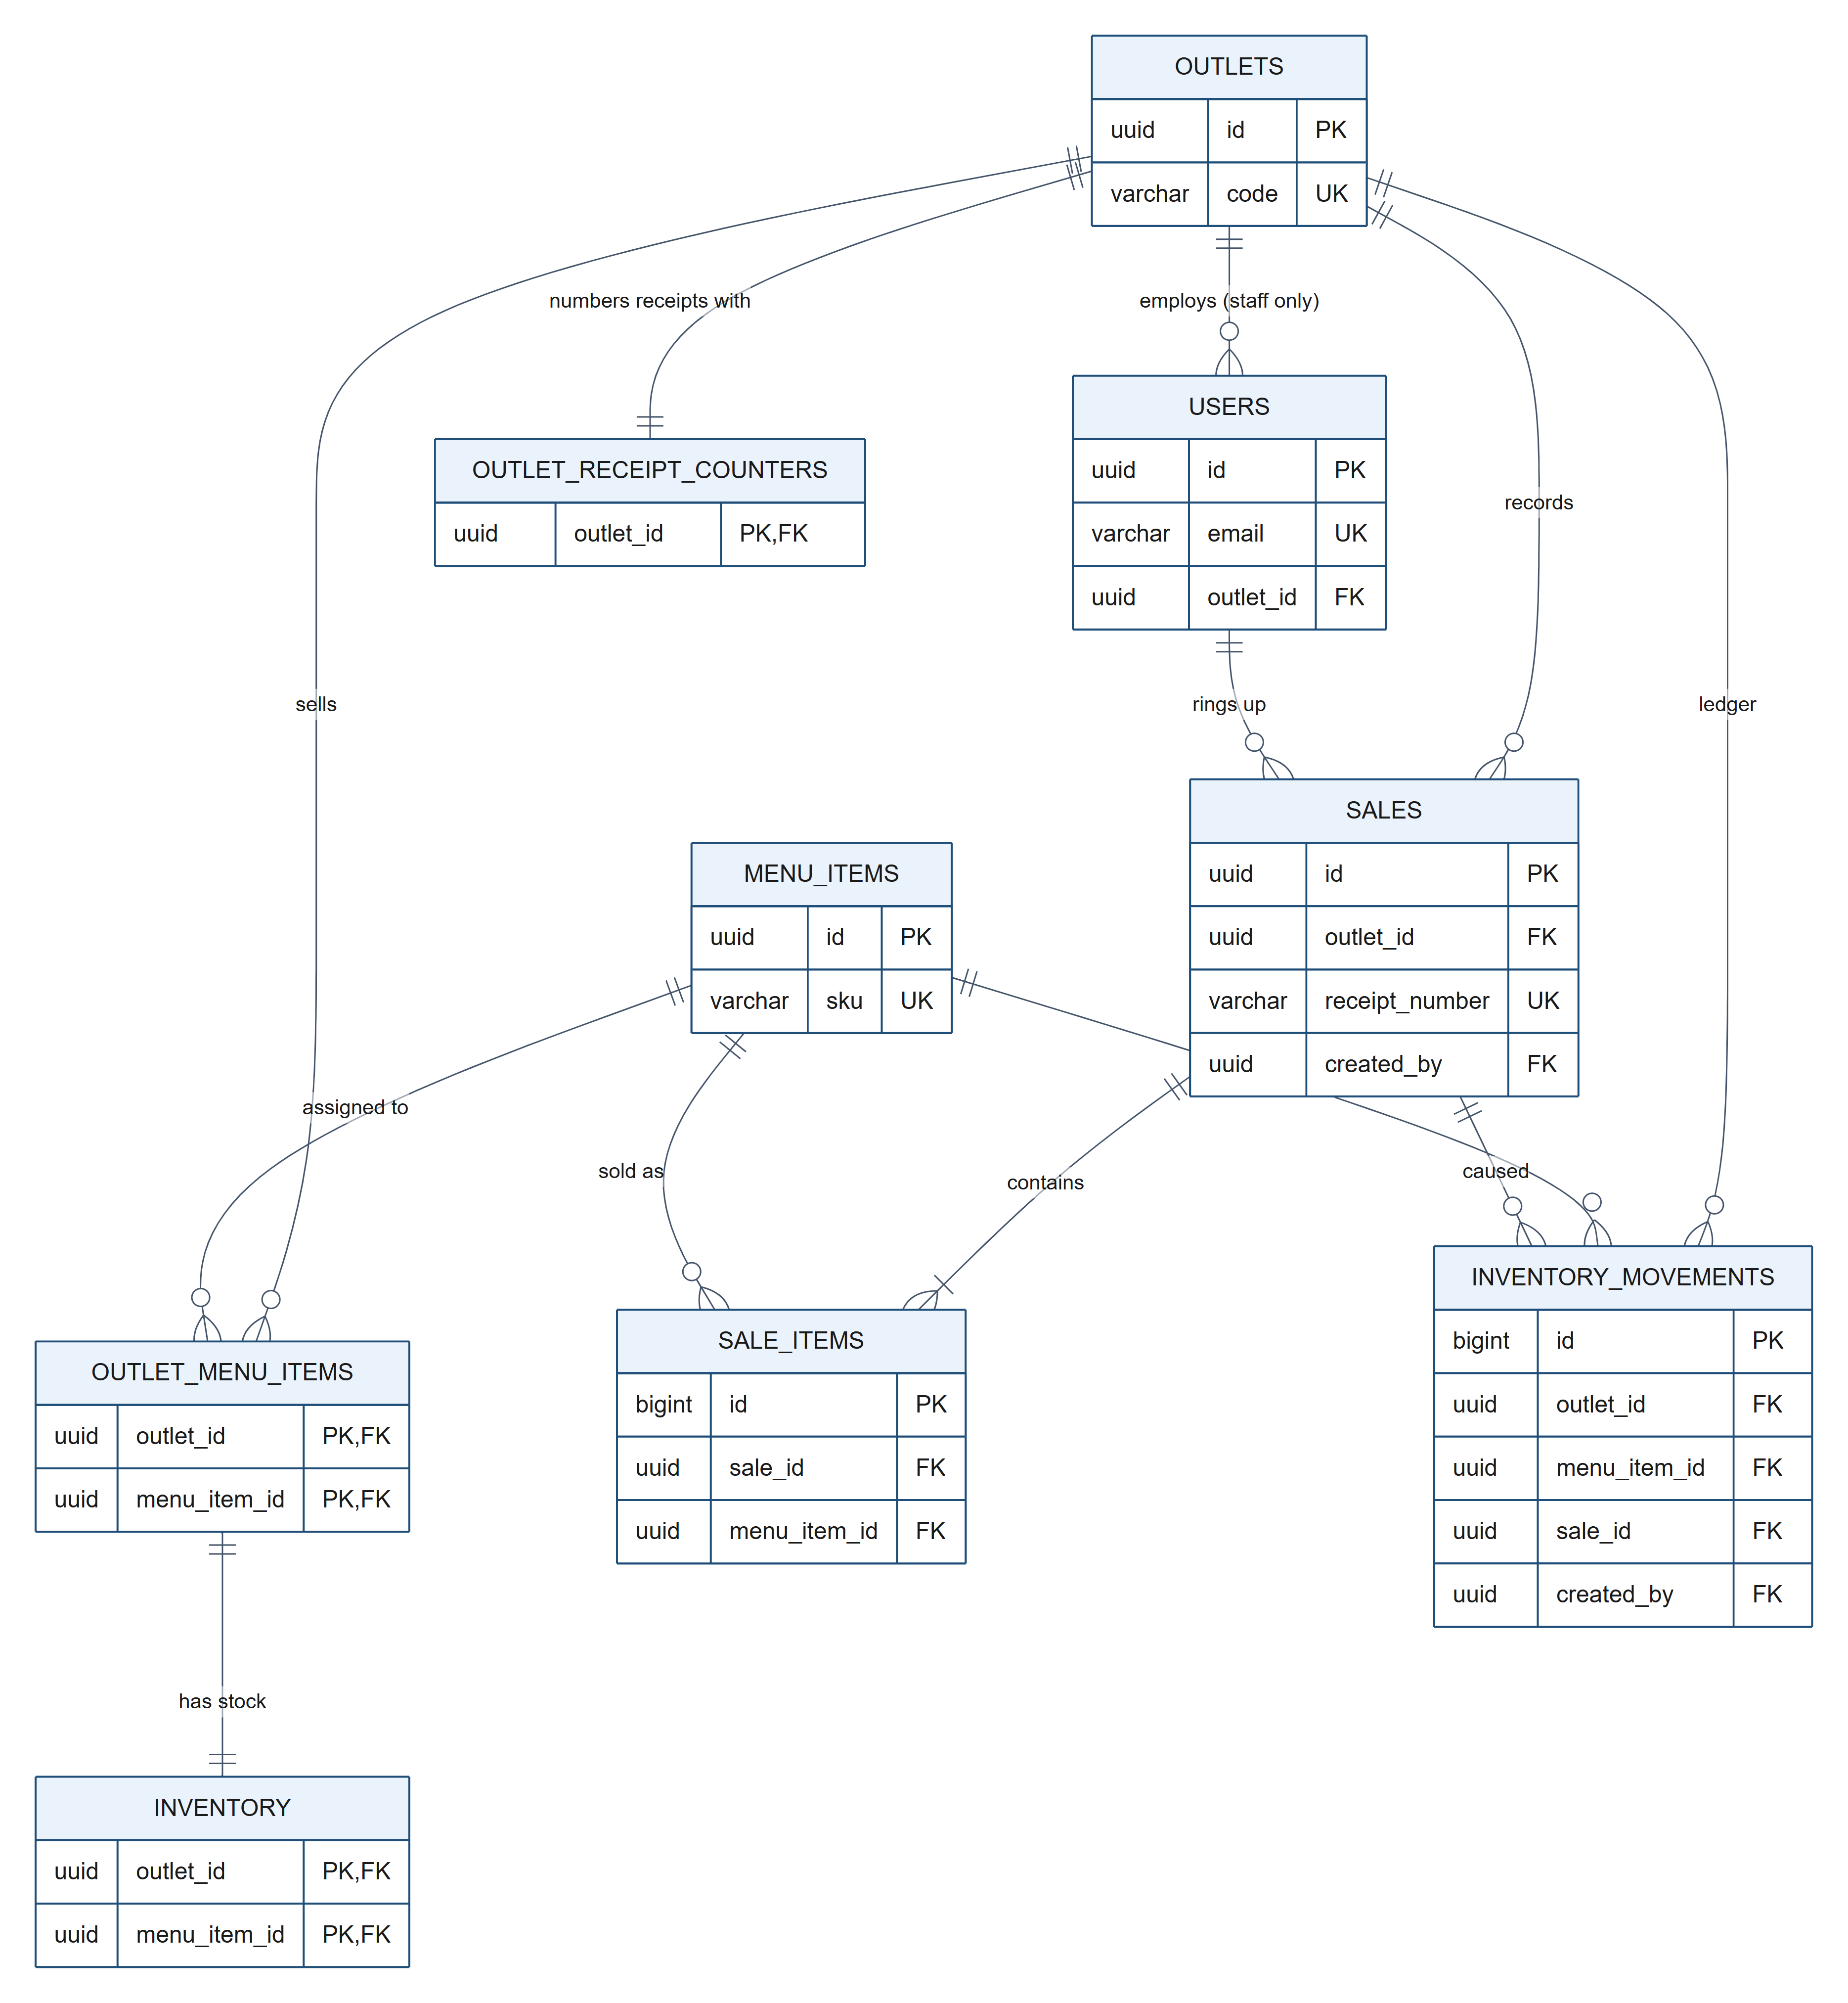
Figure 2. Entity-relationship diagram (tables, keys and relationships)
The diagram shows every table with its primary, foreign and unique keys. Column-level detail, types and CHECK constraints are listed in the data dictionary below.

Data dictionary

outlets
Outlets (branches) of the company. code is the immutable receipt prefix.
Column | Type | Key | Constraints / notes
id | uuid | PK
code | varchar | UK | CHECK ^[A-Z0-9-]{2,20}$, receipt prefix
name | varchar
address | text
is_active | bool
created_at | timestamptz
updated_at | timestamptz

users
HQ administrators and outlet staff. Staff accounts are bound to exactly one outlet.
Column | Type | Key | Constraints / notes
id | uuid | PK
email | varchar | UK | unique on lower(email)
password_hash | text |  | bcrypt
full_name | varchar
role | enum |  | HQ_ADMIN | OUTLET_STAFF
outlet_id | uuid | FK | NULL for HQ, required for staff (CHECK)
is_active | bool

menu_items
The HQ-owned master menu.
Column | Type | Key | Constraints / notes
id | uuid | PK
sku | varchar | UK
name | varchar
description | text
category | varchar |  | indexed
base_price | numeric(12,2) |  | CHECK >= 0
is_active | bool

outlet_menu_items
Assignment of master menu items to outlets, with an optional per-outlet price override.
Column | Type | Key | Constraints / notes
outlet_id | uuid | PK, FK
menu_item_id | uuid | PK, FK
price_override | numeric(12,2) |  | NULL = use base_price, CHECK >= 0
is_available | bool

inventory
Stock on hand per outlet and assigned menu item.
Column | Type | Key | Constraints / notes
outlet_id | uuid | PK, FK
menu_item_id | uuid | PK, FK | composite FK -> outlet_menu_items
quantity | int |  | CHECK >= 0
updated_at | timestamptz

outlet_receipt_counters
Gap-free, per-outlet receipt sequence, incremented inside the sale transaction.
Column | Type | Key | Constraints / notes
outlet_id | uuid | PK, FK
last_value | bigint |  | CHECK >= 0

sales
Sale header carrying the per-outlet sequential receipt number.
Column | Type | Key | Constraints / notes
id | uuid | PK
outlet_id | uuid | FK
receipt_seq | bigint |  | UNIQUE (outlet_id, receipt_seq)
receipt_number | varchar | UK | e.g. DHK-GUL-00000042
idempotency_key | varchar |  | UNIQUE (outlet_id, idempotency_key)
item_count | int |  | CHECK > 0
total_amount | numeric(12,2) |  | CHECK >= 0
created_by | uuid | FK
client_created_at | timestamptz |  | when the POS rang it up (offline)
created_at | timestamptz

sale_items
Sale lines with snapshots of item name and effective price at the time of sale.
Column | Type | Key | Constraints / notes
id | bigint | PK
sale_id | uuid | FK
menu_item_id | uuid | FK | UNIQUE (sale_id, menu_item_id)
item_name | varchar |  | snapshot
unit_price | numeric(12,2) |  | snapshot of effective price
quantity | int |  | CHECK > 0
line_total | numeric(12,2)

inventory_movements
Append-only stock ledger used for audit and reconciliation.
Column | Type | Key | Constraints / notes
id | bigint | PK
outlet_id | uuid | FK
menu_item_id | uuid | FK
change | int |  | CHECK <> 0
quantity_after | int |  | CHECK >= 0
reason | enum |  | RESTOCK | ADJUSTMENT | WASTAGE | SALE
sale_id | uuid | FK
note | text
created_by | uuid | FK
created_at | timestamptz

Key design decisions
Decision | Why
outlet_menu_items join table with nullable price_override | Many-to-many between outlets and the master menu. effective_price = COALESCE(price_override, base_price), so a change to the HQ base price automatically flows to every outlet that hasn't overridden it.
inventory separate from outlet_menu_items | Stock rows are the hottest rows in the system (updated on every sale). Keeping them apart from menu configuration means a price change never contends with checkout locks.
Composite FK inventory → outlet_menu_items | Stock cannot exist for an item that isn't assigned to the outlet; unassigning cascades the stock row away. The rule lives in the schema, not only in code.
CHECK (quantity >= 0) | Negative stock is impossible even if a future code path forgets the application-level guard.
Receipt counter table (not a SEQUENCE) | PostgreSQL sequences are non-transactional: a rolled-back sale would burn a number and leave a gap. A counter row updated inside the sale transaction is gap-free, per outlet, and rolls back with the sale.
UNIQUE (outlet_id, receipt_seq) + UNIQUE (receipt_number) | Belt-and-braces: even a bug could never issue a duplicate receipt.
UNIQUE (outlet_id, idempotency_key) | Makes POST /sales safely retryable (network timeouts, offline POS replay).
Price + name snapshot on sale_items | Historical sales and reports stay correct after menu prices or names change.
inventory_movements ledger | Every stock change (sale, restock, wastage, correction) is auditable; stock can be reconciled from the ledger.
NUMERIC(12,2) for money, integer cents in code | No floating-point rounding errors anywhere.
UUID primary keys (gen_random_uuid()) | Non-guessable ids in URLs; ids can be generated by clients/offline devices and merged without collisions.

Indexes and the queries they serve
Index | Serves
outlet_menu_items (outlet_id, menu_item_id) PK | "menu for outlet X" (the most frequent read)
outlet_menu_items (menu_item_id) | "which outlets sell item Y", FK checks on menu_items
inventory (outlet_id, menu_item_id) PK | stock lookups + SELECT … FOR UPDATE at checkout
sales (outlet_id, created_at DESC) | outlet sales history (paginated), outlet-scoped reports
sales (created_at) | company-wide date-range reports
sale_items (sale_id, menu_item_id) unique | loading a sale's lines; the join in top-items reports
sale_items (menu_item_id) | per-item sales analysis, FK checks
inventory_movements (outlet_id, menu_item_id, created_at DESC) | stock history per outlet/item
inventory_movements (sale_id) | ledger entries for a sale
users (lower(email)) unique | case-insensitive login lookup
users (outlet_id), menu_items (category), outlets (code), menu_items (sku) | filters + FK checks

3. Critical flow: creating a sale
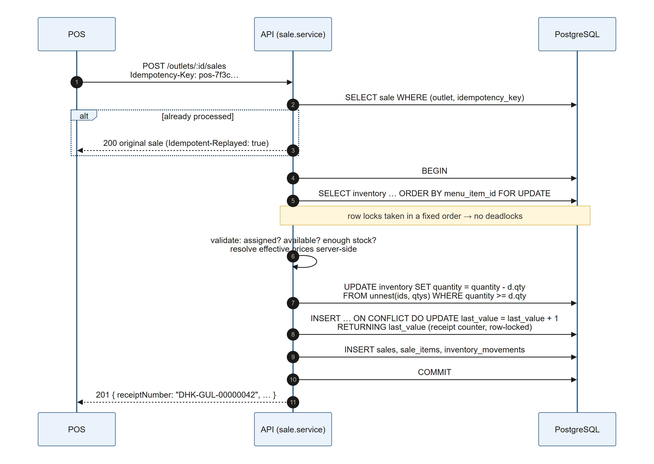
Figure 3. Sale creation: one transaction with ordered row locks and a per-outlet receipt counter

Why it is correct under concurrency
- No overselling: concurrent sales of the same item serialise on the inventory row lock. The second transaction re-reads the committed quantity after the first commits (READ COMMITTED + FOR UPDATE), so it sees the real remaining stock. The guarded UPDATE … WHERE quantity >= qty and the CHECK constraint are two more independent safety nets.
- Sequential, unique, gap-free receipts per outlet: the counter row is locked until COMMIT/ROLLBACK, so only one transaction per outlet holds "the next number" at a time; a failed sale rolls its number back. Different outlets have different counter rows and never block each other. The lock is taken last to keep the per-outlet critical section as short as possible.
- No deadlocks: every transaction locks inventory rows in menu_item_id order, then the counter. A consistent global lock order makes lock cycles impossible.
- All-or-nothing: one DB transaction; any error rolls back stock, receipt number, sale and ledger.
- Retry-safe: idempotency key pre-check + unique constraint. If two identical requests race, the loser's unique violation is caught and the winner's sale is returned.

These properties are verified by integration tests against a real PostgreSQL (backend/tests/sales.test.ts): 30 parallel requests against stock 10 → exactly 10 sales, receipts 1..10, stock 0; two outlets selling concurrently keep independent gap-free sequences; 8 concurrent requests with the same idempotency key → exactly one sale; opposite-order carts → no deadlock.

4. Scaling plan: 10 outlets, 100,000 transactions/month

4.1 Sizing the problem
Metric | Estimate
Transactions / month | 100,000
Average | ≈ 3,300 / day ≈ 0.04 TPS
Peak (lunch/dinner: ~15% of a day's sales in the busiest hour, ×3 safety) | ≈ 500 / hour ≈ 0.4 TPS
Sale items (≈ 3 lines / sale) | ≈ 300k rows / month → 3.6M rows / year
Inventory movements | ≈ 3.6M rows / year
Storage (sales + items + ledger, with indexes) | ≈ 2–3 GB / year

Conclusion: this is a modest OLTP load. A single, well-indexed PostgreSQL instance handles it with headroom of two or more orders of magnitude. The current design (stateless API, row-level locks scoped per outlet, per-outlet counters) already avoids global hot spots. The work is mostly about reliability, reporting efficiency and operability, not raw throughput. The plan below is staged so each step is taken when a metric says so, not up front.

4.2 Database scaling strategies
Stage | Action | Trigger
1 | Managed PostgreSQL (RDS / Cloud SQL / Neon) with automated backups, PITR, Multi-AZ standby for failover | Day 1 in production
2 | Connection pooling with PgBouncer (transaction mode) or RDS Proxy; small per-instance pools in the app | > 3–4 API instances, or serverless API
3 | Read replica for reporting and HQ dashboards; the app gets a separate read-only Prisma client | Reports noticeably load the primary (p95 checkout latency rises during report runs)
4 | Partition sales, sale_items, inventory_movements by month (declarative range partitioning on created_at) | ~50M+ rows, or when retention/archival is needed; old partitions detach to cheap storage
5 | Archive cold data (> 2 years) to object storage (Parquet) queried via the warehouse | Storage cost / backup time
– | Keep: row-level locks per outlet (no table locks), short transactions, EXPLAIN ANALYZE on every new report query, pg_stat_statements to find slow queries | Always

Sharding is not needed at this scale. If it ever were (hundreds of outlets, multiple countries), outlet_id is the natural shard key: every write transaction is already scoped to one outlet.

4.3 Reporting performance considerations
The current reports aggregate raw sales/sale_items on each request. That's fine for thousands of rows per outlet and for the seeded data, but the cost grows linearly with history. The plan:
- Pre-aggregated rollup table daily_outlet_item_sales (date, outlet_id, menu_item_id, qty, revenue, txn_count), maintained incrementally (upsert in the sale transaction or from an outbox consumer). "Revenue by outlet" and "top 5 items" then read ~10 outlets × ~50 items × N days, which stays small no matter how many transactions there are. (A materialized view refreshed CONCURRENTLY every few minutes is the simpler first step.)
- Hybrid freshness: rollups for closed days + live query for today only → real-time dashboards at constant cost.
- Serve reports from the read replica so a heavy HQ query can never slow down a checkout.
- Cache hot dashboard queries in Redis for 30–60s, keyed by (report, range); invalidated or simply left to expire.
- Covering indexes where plans show heap fetches, e.g. sales (outlet_id, created_at) INCLUDE (total_amount) for revenue-by-outlet as an index-only scan.
- Analytics beyond operational reports (cohorts, basket analysis, forecasting) go to a warehouse (BigQuery / Redshift / ClickHouse) fed by CDC (Debezium) or nightly exports. OLAP never runs on the OLTP primary.
- Time zones: aggregate by outlet-local business day (store an outlet.timezone, compute business_date at write time) so "today's sales" matches the outlet's day, not UTC.

4.4 Infrastructure considerations
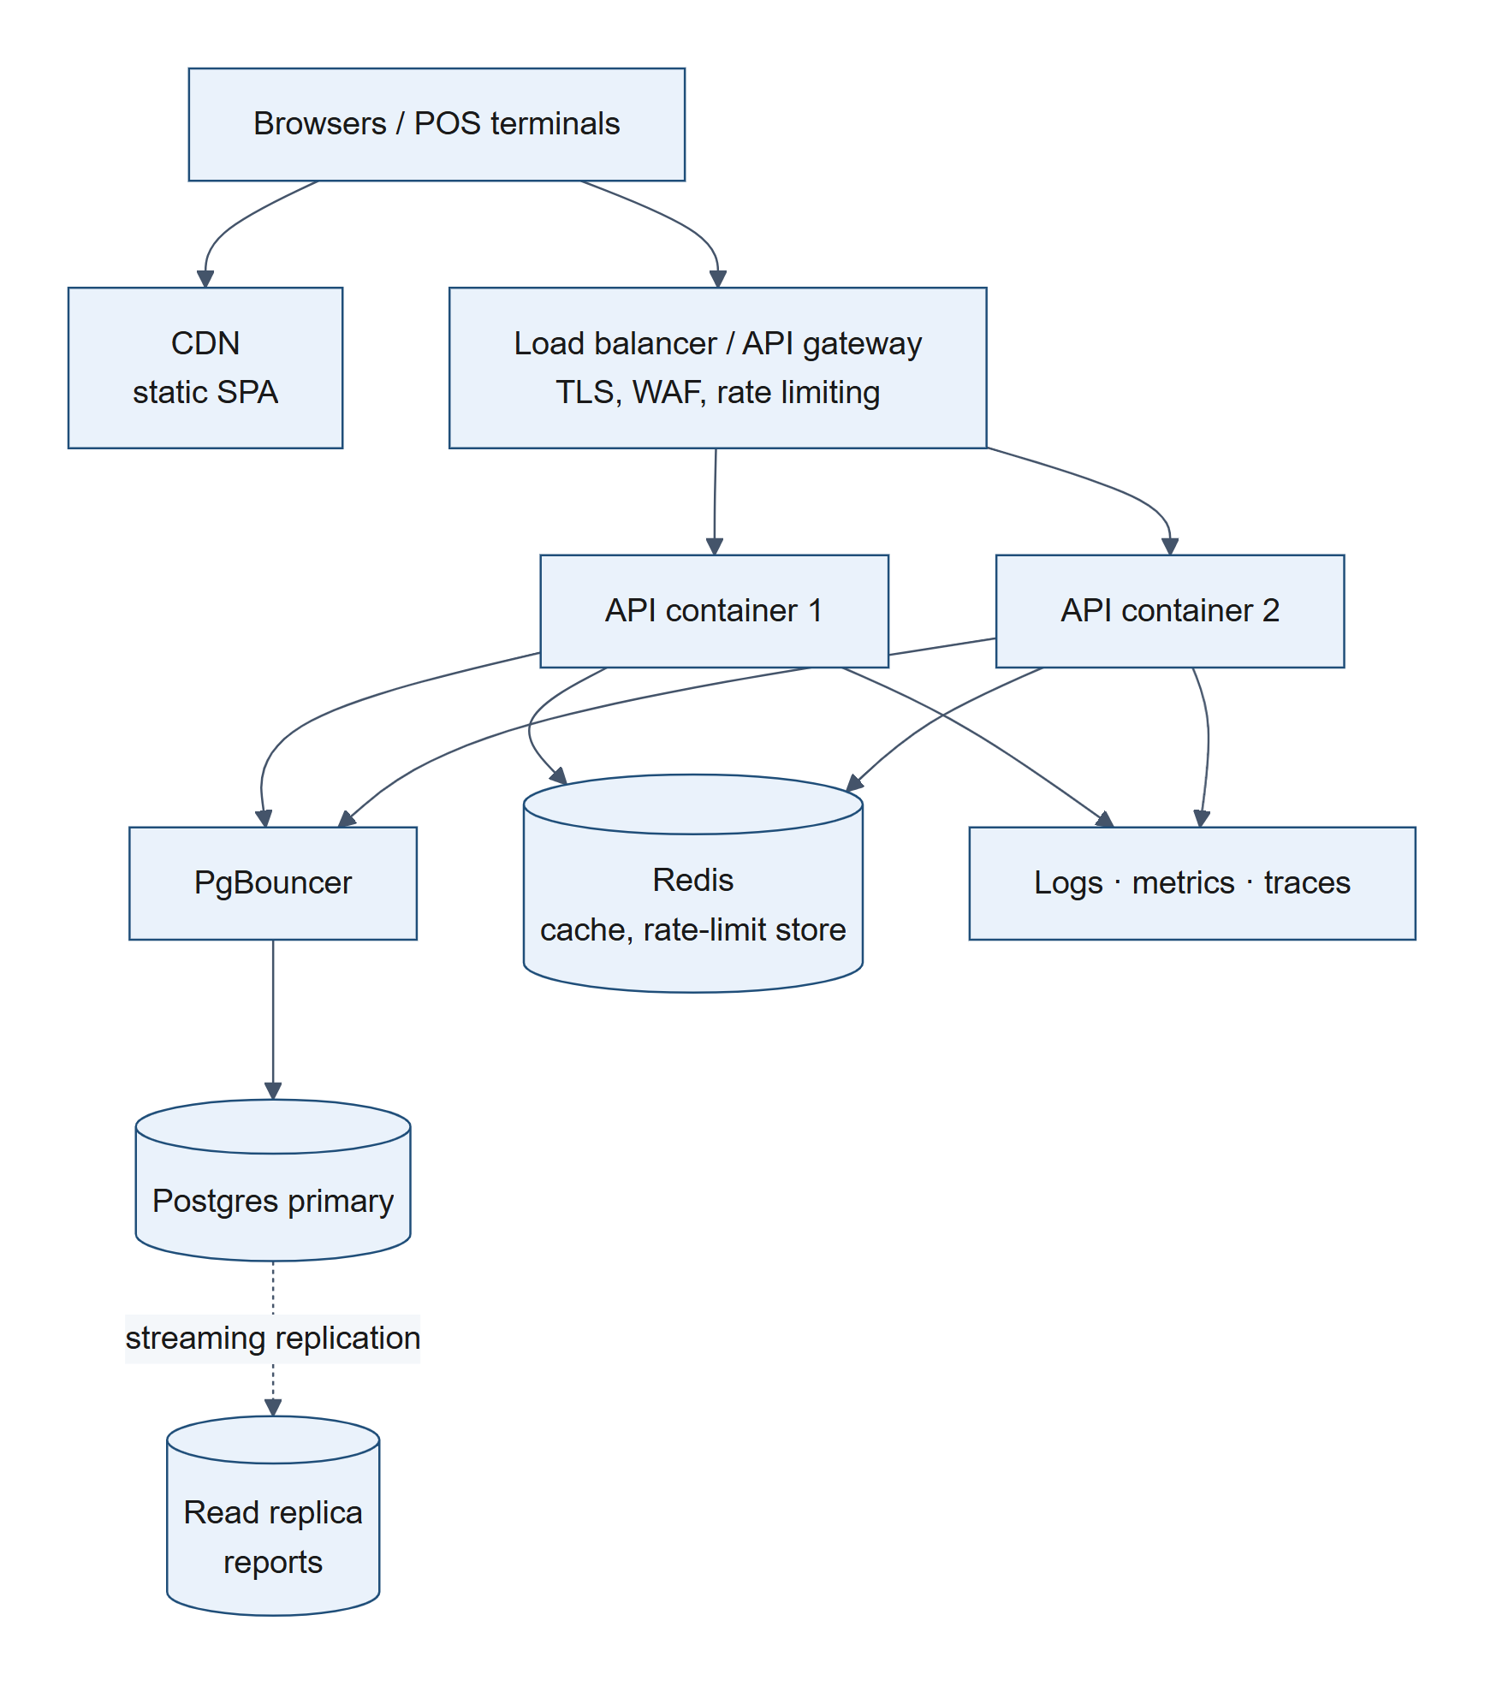
Figure 4. Target infrastructure for the scaled deployment
- Stateless API containers (already true: JWT auth, no in-memory session) behind a load balancer on ECS Fargate / Cloud Run / Kubernetes; autoscale on CPU and p95 latency; minimum 2 instances across AZs.
- Frontend on a CDN (S3 + CloudFront / Netlify): static, cached, globally fast.
- CI/CD: lint → typecheck → tests against a real Postgres service container → build image → run prisma migrate deploy as a one-off release job → rolling / blue-green deploy. Migrations are written expand-then-contract so old and new versions can run side by side.
- Secrets in a secrets manager (not env files); JWT_SECRET rotation via key ids.
- Observability: structured logs with request ids (already emitted) shipped to a log platform; RED metrics (rate, errors, duration) per endpoint; OpenTelemetry tracing; alerts on checkout error rate, p95 latency, DB connections, replication lag, and INSUFFICIENT_STOCK spikes (a business signal).
- Reliability: health/readiness probes (already implemented), graceful shutdown (already implemented), PITR backups with regular restore drills, documented RPO/RTO.
- Security: TLS everywhere, WAF, per-user rate limiting, audit log for HQ actions (price changes, assignments), refresh tokens with short-lived access tokens, and optional SSO for HQ staff.

4.5 Architectural evolution
- Now: modular monolith. Layers are already separated and modules are cohesive (catalog, outlet menu, inventory, sales, reporting). This is the right shape for this load and team size.
- Transactional outbox. Write sale.completed / stock.adjusted events to an outbox table in the same transaction as the sale; a relay publishes them to a queue (SQS/SNS, RabbitMQ, or Kafka). This decouples side effects (rollups, notifications, loyalty, KDS, accounting export) without dual-write bugs.
- Async projections. Reporting rollups, low-stock alerts and the warehouse feed become consumers of those events.
- Extract services where boundaries are proven (see §5), starting with reporting, the one that benefits most from independent scaling and storage.
- Offline-first POS at the edge (see §6), which also improves resilience at every scale.

5. Evolving to microservices

5.1 Guiding principle
Split along business capabilities with clear data ownership, and only when there is a concrete reason: independent scaling, independent release cadence, a different team, or a different storage/consistency model. The current layering (routes → controllers → services → repositories) and module boundaries are deliberately the seams along which services would be cut.

5.2 Proposed services
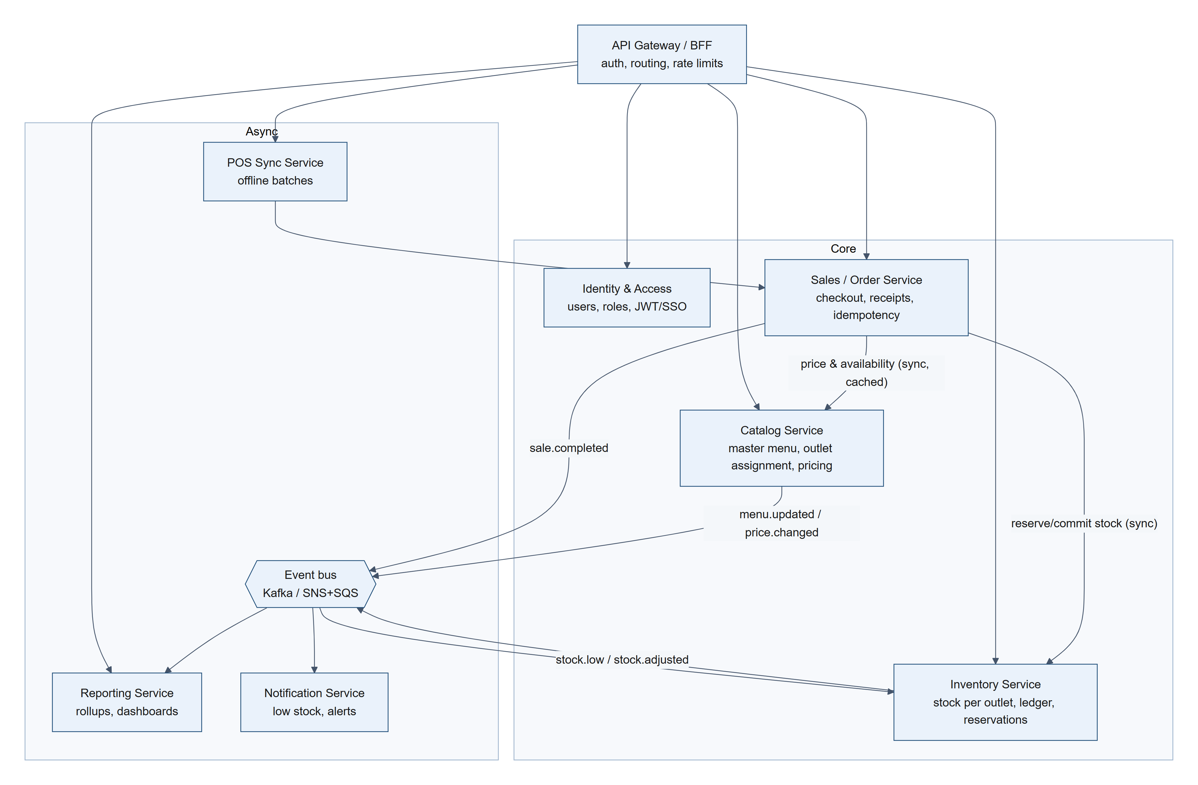
Figure 5. Proposed microservice decomposition and event flows
Service | Owns (its own DB/schema) | Why separate
Identity & Access | users, roles, outlet membership, sessions | Security-sensitive, reused by every service; SSO/MFA evolve independently
Catalog | menu_items, outlet_menu_items (prices, availability) | Read-heavy, rarely written, highly cacheable; HQ's domain; publishes menu.updated so outlets/POS can cache menus
Inventory | inventory, inventory_movements | The contention hot spot; may later add recipes/ingredients, suppliers, purchase orders, which is a large domain of its own
Sales / Order | sales, sale_items, receipt counters, idempotency keys | The critical write path; scales with transaction volume; strongest consistency needs
Reporting | read-optimised projections (rollups, warehouse) | Completely different access pattern (OLAP), scales independently, must never slow checkout
POS Sync | device registry, sync cursors, batch status | Handles offline replay, device auth and conflicts (see §6)
Notification | templates, delivery log | Pure event consumer

5.3 The hard part: consistency across services
In the monolith, "deduct stock + issue receipt + record sale" is one ACID transaction. Across services it becomes a saga:
- Order service creates the sale as PENDING and calls Inventory reserve(items, saleId) (idempotent, keyed by saleId).
- On success → Order allocates the receipt number (still a local per-outlet counter), marks the sale COMPLETED, and publishes sale.completed through its outbox.
- Inventory consumes sale.completed and converts the reservation to a deduction; on sale.failed or a reservation timeout it releases stock (compensation).

Supporting patterns: transactional outbox + idempotent consumers (at-least-once delivery), correlation ids across services, contract-tested APIs, schema-versioned events.

5.4 Migration path (strangler fig)
- Enforce module boundaries inside the monolith (no cross-module table access; modules talk through service interfaces). The layered code already mostly does this.
- Introduce the outbox + event bus while still a monolith.
- Extract Reporting first: read-only, event-fed, lowest risk, highest benefit.
- Extract Catalog (read-mostly, simple consistency).
- Extract Inventory + Order last, together with the saga, only if scale or team structure demands it.

Honest trade-off: at 10 outlets and 100k transactions/month, a well-structured modular monolith is cheaper to run, simpler to operate and more consistent. Microservices should be adopted incrementally, when organisational or scaling pressure actually appears.

6. Offline POS mode strategy (POS + KDS)

6.1 Goals
- An outlet keeps taking orders, printing receipts and cooking with no internet.
- When connectivity returns, every offline sale reaches HQ exactly once, in order, with stock and reports reconciled.
- POS and Kitchen Display System (KDS) keep talking to each other on the local network throughout.

6.2 Outlet edge architecture
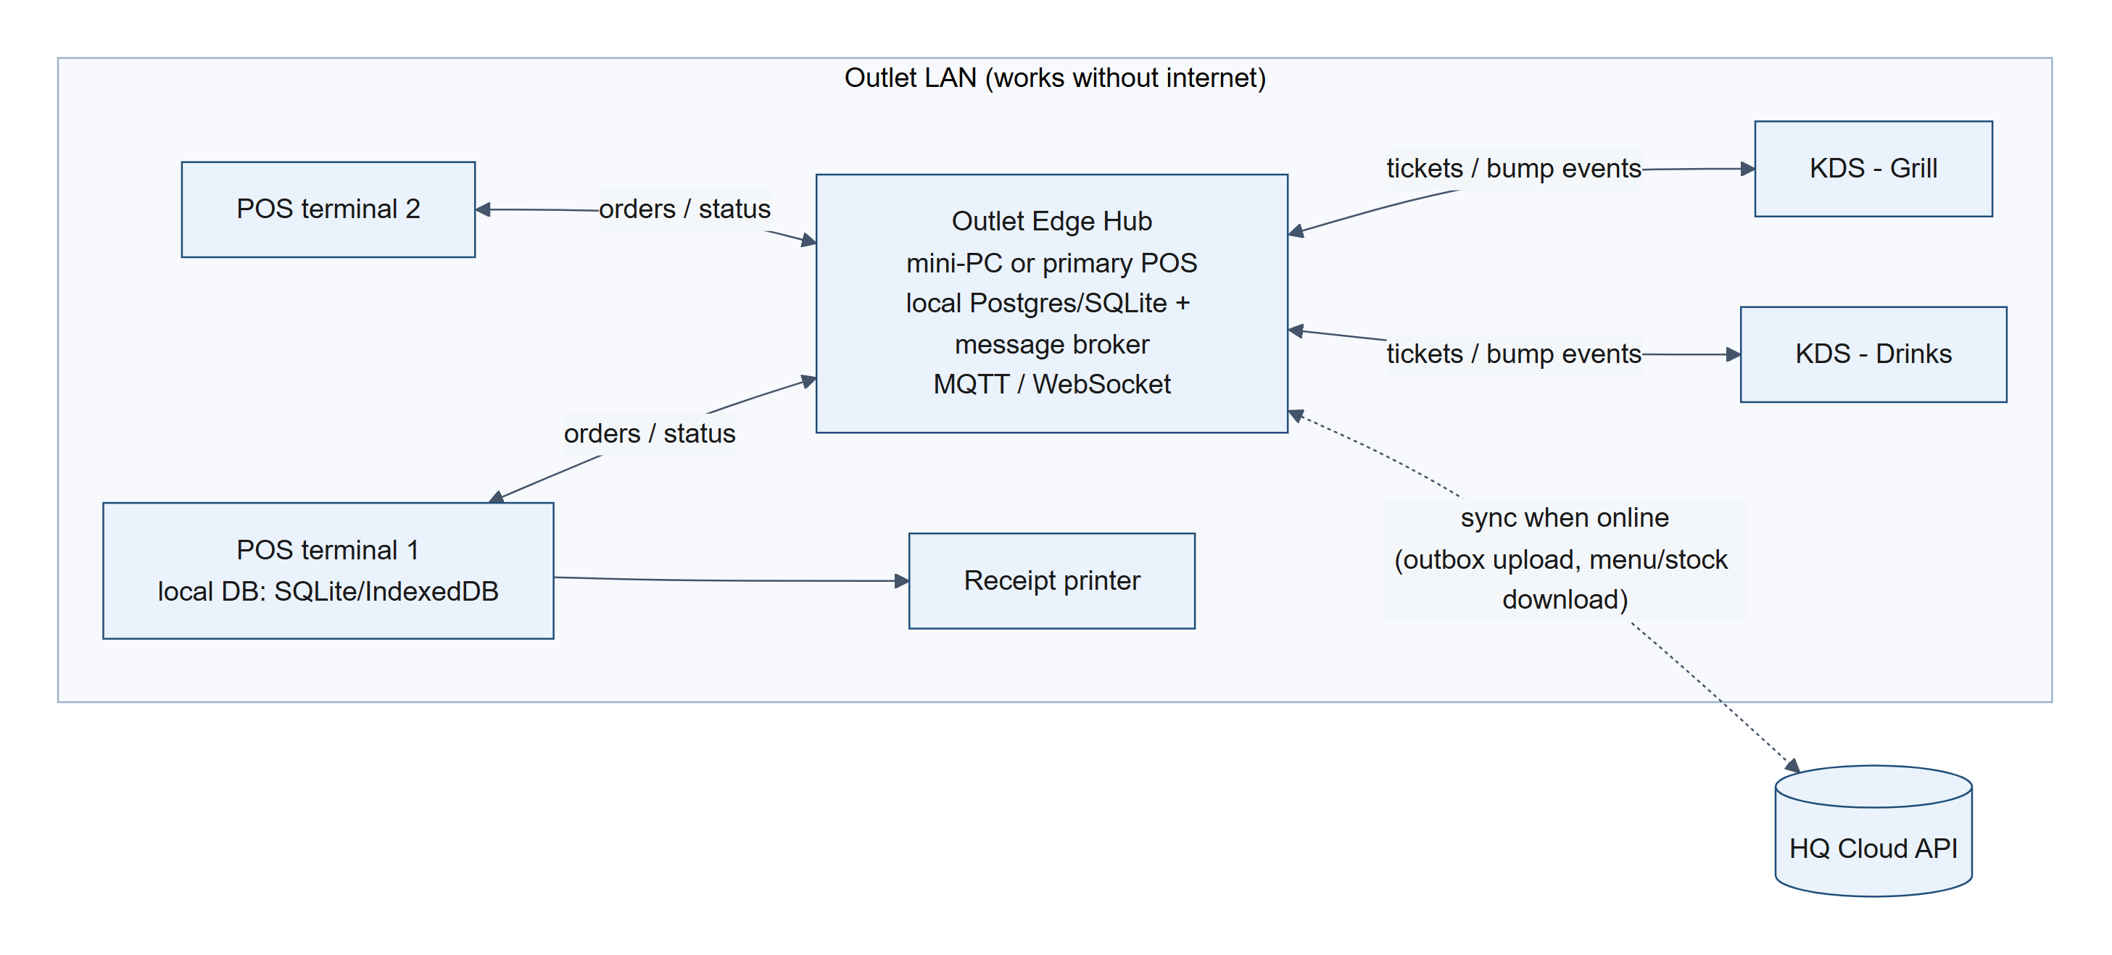
Figure 6. Outlet edge architecture: POS and KDS on the local network
- Local-first POS: every terminal has its own durable store (SQLite in a native/Electron app, IndexedDB in a PWA). The UI always writes locally first; the network is never on the critical path of ringing up a sale.
- Outlet Edge Hub: a small always-on device (or the primary POS) running a local database and a lightweight message broker (MQTT such as Mosquitto, or a WebSocket server). It is the outlet's source of truth while offline and the single sync gateway to HQ.
- Service discovery on the LAN via mDNS or a fixed local IP, so terminals and KDS find the hub without internet or cloud DNS.

6.3 POS ↔ KDS communication while offline
- POS creates an order → publishes order.created to the hub topic outlet/{id}/kitchen (MQTT QoS 1, persistent session), or directly on the LAN WebSocket.
- The hub routes items to the right station (grill, drinks) using station mappings from the cached menu; each KDS subscribes to its station topic.
- The KDS shows the ticket; cooks publish item.started / order.bumped back; POS updates order status in real time.
- Reliability: QoS 1 (at-least-once) plus idempotent handlers keyed by orderId + event id; a KDS that reconnects replays missed messages from its persistent session; each device also keeps a local copy of open tickets, so a hub reboot doesn't lose the kitchen queue.
- Hub failure fallback: POS can print kitchen chit tickets on a local printer, and terminals can fail over to peer-to-peer WebSocket with a designated backup hub.

Nothing in this loop touches the internet, so kitchen operations are identical online and offline.

6.4 Offline sales and receipt numbers
- Each sale gets a client-generated UUID (saleId), which doubles as the Idempotency-Key. It is created once, stored with the sale, and never regenerated.
- Offline receipt numbers must be unique without a central counter. Two options:
  - Device-prefixed numbering (recommended): {OUTLET}-{DEVICE}-{seq}, e.g. DHK-GUL-T2-000731. Each terminal owns its own monotonic, gap-free local sequence, so numbers are unique by construction and printable immediately.
  - Block allocation: while online, the hub leases a block of numbers (e.g. 1001–2000) from HQ's per-outlet counter; offline terminals draw from their local block.
- The official HQ receipt number (the per-outlet sequence this API issues) can be assigned at sync time and linked to the offline number; both are stored (client_receipt_number, receipt_number), and the printed receipt remains valid.
- client_created_at (already in the schema and API) stores when the sale actually happened, so reports attribute offline sales to the right hour/day instead of the sync time.

6.5 Sync protocol when the internet reconnects
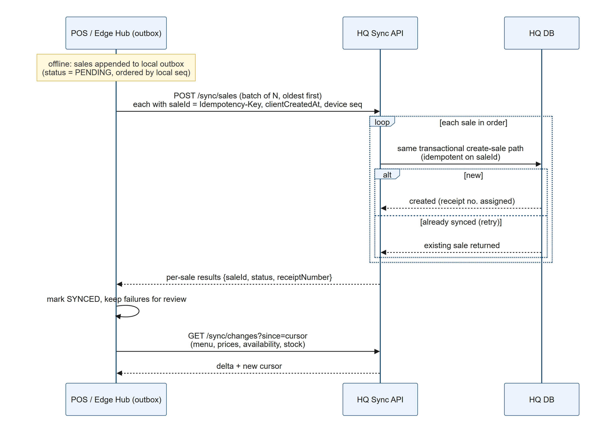
Figure 7. Offline sync protocol when connectivity returns
Details:
- Outbox pattern on the device. A sale is committed locally together with an outbox record in one local transaction. A background sync worker drains the outbox oldest-first with exponential backoff and jitter; it resumes after crashes and reboots.
- Idempotency end-to-end. The server already supports Idempotency-Key with a unique constraint, so resending a batch after a timeout never double-charges or double-deducts stock. This is implemented and tested in this repository.
- Batching and ordering. Batches of e.g. 50, processed in device order; each sale is its own transaction so one bad sale doesn't block the rest; per-sale results come back.
- Stock conflicts: sales are facts. Food already served cannot be un-sold. Offline, the device keeps a local projection of stock (last server snapshot minus local sales) and warns or blocks at zero. At sync time, if the server would go negative, the sync path accepts the sale and records a stock_discrepancy ledger entry, holding stock at 0 instead of rejecting the sale. HQ gets a reconciliation report. The normal online path keeps rejecting oversells, so the invariant "stock never negative" still holds, and every exception is explicit and auditable.
- Price conflicts. The sale keeps the price the customer actually paid (snapshotted on the device from its cached menu version, sent with menuVersion). If HQ changed the price meanwhile, the sale is still accepted and flagged for review.
- Downstream sync (HQ → outlet). Menu, prices, availability and stock are pulled as deltas since a cursor (updated_at/version), or pushed via WebSocket/SSE when online. Devices always keep the last full snapshot, so they can boot and sell offline.
- Clock skew. Devices sync time via NTP when online; the server records both client_created_at and its own created_at, and rejects or flags absurd client timestamps.
- Security. Each device has its own credential (device token or mTLS) scoped to one outlet; the local DB is encrypted at rest; offline sessions use PINs validated against a cached, hashed staff list.
- Visibility. POS shows a clear "Offline · 12 sales pending sync" indicator; HQ sees last-sync time per device and alerts on devices that haven't synced within N hours.

6.6 What is already implemented in this codebase
Capability | Status
Idempotent POST /sales via Idempotency-Key (unique per outlet, race-safe) | implemented + tested
clientCreatedAt stored separately from server created_at | implemented
POS UI keeps one idempotency key per checkout attempt, so retries are safe | implemented
Server-side price resolution + price/name snapshots on sale lines | implemented
Inventory ledger for reconciliation | implemented
Local outbox, edge hub, KDS messaging, batch sync endpoint | designed above

