

**Malaysia-Japan International Institute of Technology**

**(MJIIT)**

SEMESTER 2/20232024

**SYSTEM ANALYSIS AND DESIGN**

**COURSE CODE: SECD2613**

**SECTION 15**

**TITLE**

Project 3:System Design for Task Management Application

**LECTURERS**

DR. SADIATUL HAMIDAH BINTI ABD HAMID

**GROUP**

4

|  |  |
| --- | --- |
| **Name** | **Matric ID** |
| Tahiya Nuzhath Khan | A23MJ4025 |
| Pranto Anik Islam | A23MJ4024 |
| Pashmia Binte Walid | A23MJ4023 |

**System Design for Task Management Application**

# 1.0 Overview of the Project

The project proposes the development of a task management application designed to enhance organization, observing the deadlines, and progress tracking for both individual and joint projects. The application will offer a user-friendly interface, powerful collaboration features, and efficient notification systems, presenting to a larger audience range from individuals to large teams.

# 2.0 Problem Statement

In today's dynamic and fast-paced environment, managing tasks efficiently is essential for success. Traditional methods such as pen-and-paper or basic to-do lists often fall short when dealing with complex projects. Many existing task management applications lack intuitive interfaces, inclusive collaboration features, and punctual notification systems, making it difficult for users to manage their tasks effectively. This gap in the market demands a comprehensive, user-friendly task management solution that addresses these problems.

# 3.0 Proposed Solutions

* User-Friendly Interface:

Develop an intuitive and easy-to-navigate interface through thorough planning, lay outing, and user feedback.

* Task Organization:

Enable the creation, categorization, and prioritization of tasks to facilitate efficient organization.

* Deadline Management and Notifications:

Implement features for setting deadlines and automated notifications to ensure tasks are completed on time.

* Progress Tracking:

Merge tools for visualizing project advancement, allowing users to monitor progress and identify potential roadblocks.

* Collaboration Features:

Offer seamless collaboration tools, including task assignments, communication features, sharing progress updates etc. to enhance teamwork.

* Agile Development:

Utilize an Agile methodology for monotonous development, allowing for continuous improvement and responsiveness to user feedback.

By implementing these solutions, the proposed task management application aims to provide a comprehensive tool that improves task efficiency and project success for both individuals and teams.

# 4.0 Information gathering process

## 4.1 Method used

To gather comprehensive information for the development of the task management application, the following methods were utilized:

* Interviews: In-depth discussions with potential users, project managers, and team leaders to understand their needs, challenges and preferences.
* Questionnaires: Surveys distributed to a larger audience to collect quantitative data on user experiences and expectations.
* Observations: Direct observation of current task management practices in various organizational settings to identify inefficiencies and areas for improvement.

## 4.2 Summary from method used

**Interviews:**

* + Example: Conducted with 10 project managers across different industries.
  + Insights: Project managers emphasized the need for better progress tracking and integration of collaboration tools within the task management system.

**Questionnaires:**

* + Example: Distributed to 200 potential users including freelancers, small business owners, and corporate teams.
  + Insights: 75% of respondents found existing tools lacking in user-friendliness. 80% mentioned the need for more reliable notification systems.

**Observations:**

* + Example: Observations conducted in three different companies.
  + Insights: Teams often rely on email and chat applications for communication, leading to fragmented task tracking and missed deadlines.

# 5.0 Requirement Analysis (Based on AS-IS Analysis)

## 5.1 Current Business Process (Scenarios, Workflow)

**Scenarios**:

- Individual Users: Use basic to-do lists or calendar apps for personal task management.

- Small Teams: Use a mix of email, spreadsheets, and basic task management tools.

- Large Teams: Utilize complex project management tools but face usability and integration issues.

**Workflow:**

1. Task Creation: Tasks are created manually by users or team leads.
2. Task Assignment: Tasks are assigned through email or task management tools.
3. Progress Tracking: Teams use spreadsheets or software to track progress.
4. Deadline Management: Deadlines are tracked manually or through calendar notifications.
5. Communication: Happens via email or chat applications.

## 5.2 Functional Requirements (Input, Process, and Output)

* Input**:**
* Task details (title, description, deadline, priority)
* User information (name, role, email)
* Project information (name, description, timeline)
* Process**:**
  + Task creation and categorization
  + Task assignment and re-assignment
  + Deadline setting and notification scheduling
  + Progress tracking and reporting
  + Collaboration and communication facilitation
* Output:
  + Task lists and detailed task views
  + Notification alerts and reminders
  + Progress reports and visualizations (e.g. Gantt charts)
  + Communication logs and task comments

## 5.3 Non-functional Requirements (Performance and Control)

* Performance:
* Application load time should be under 2 seconds.
* Task updates should be reflected in real-time.
* Notifications should be delivered within 1 minute of the scheduled time.
* Control**:**
  + User authentication and authorization
  + Data encryption and secure communication
  + Regular backups and data recovery processes

## 5.4 Logical DFD AS-IS System

### Context Diagram:

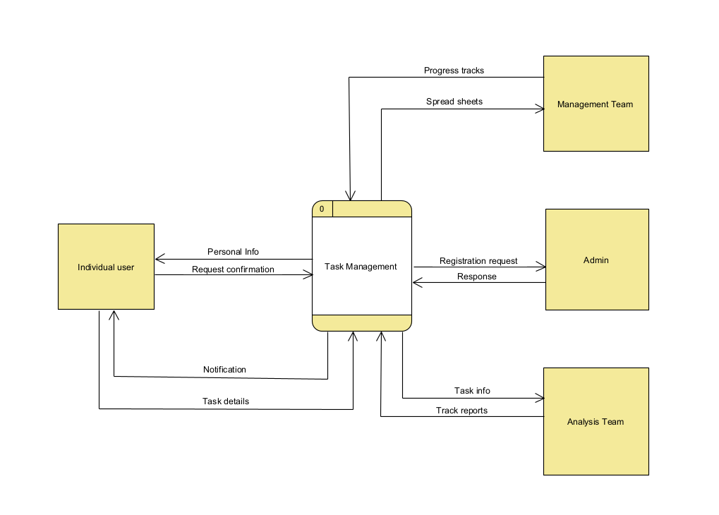

Figure 1: Context diagram

### Diagram 0:

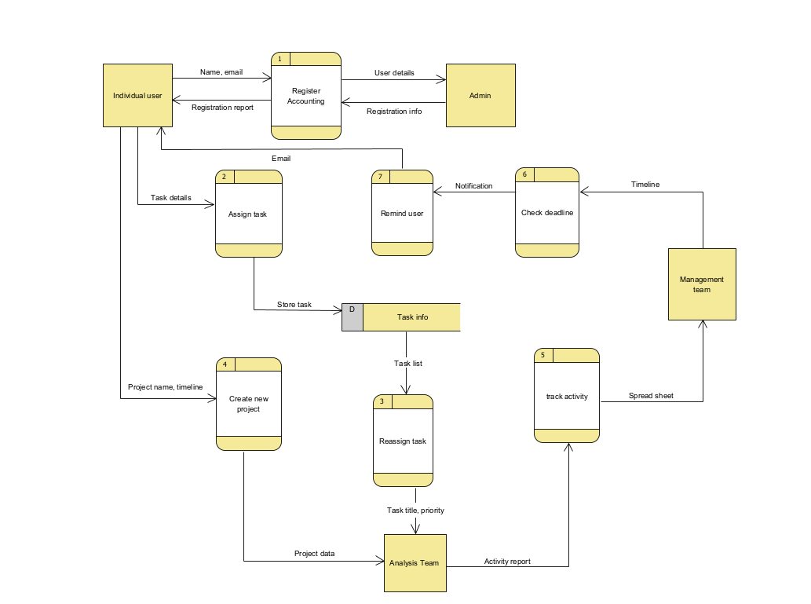

Figure 2: Diagram 0

*Figure 3 : Child diagram*

# 6.0 System Analysis and Specifications

## 6.1 Logical DFD

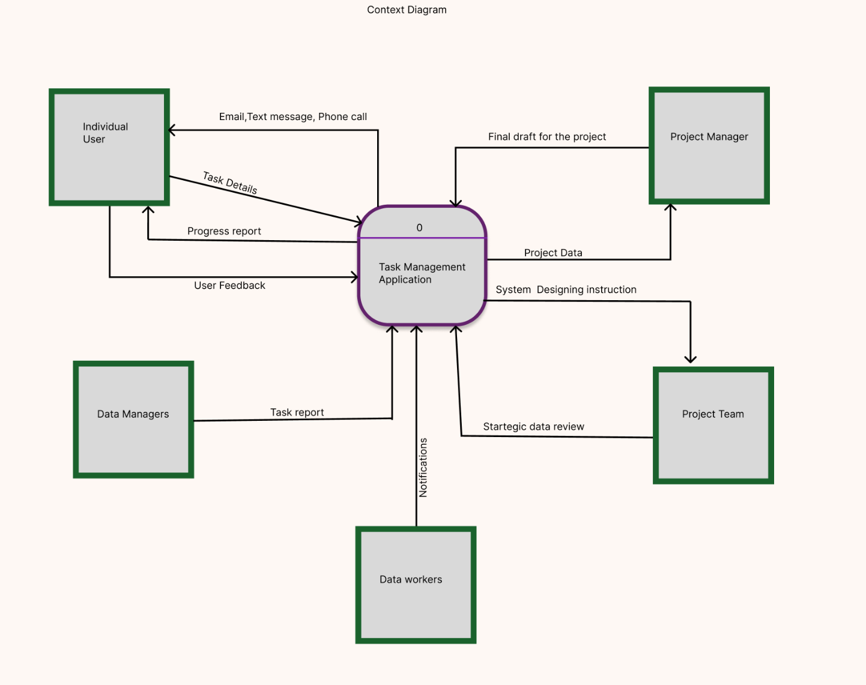

Figure 3: Context Diagram

Figure 4: Diagram 0

Link to view the work in figma :

<https://www.figma.com/design/yjBtZVqFIcnWCnfalVcDLn/Untitled?t=U7ZVOvU4KjT1oiOB-1>

## 6.2 Process Specification:

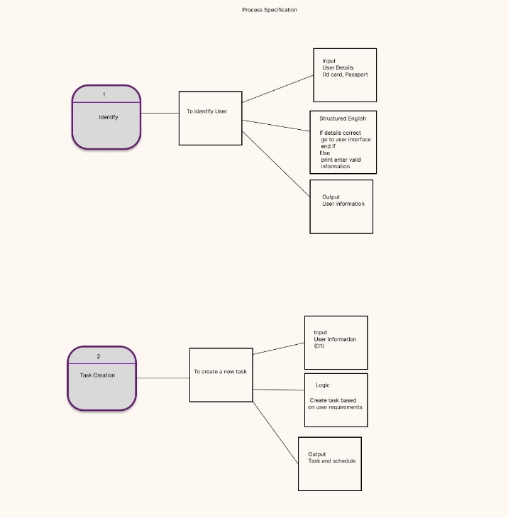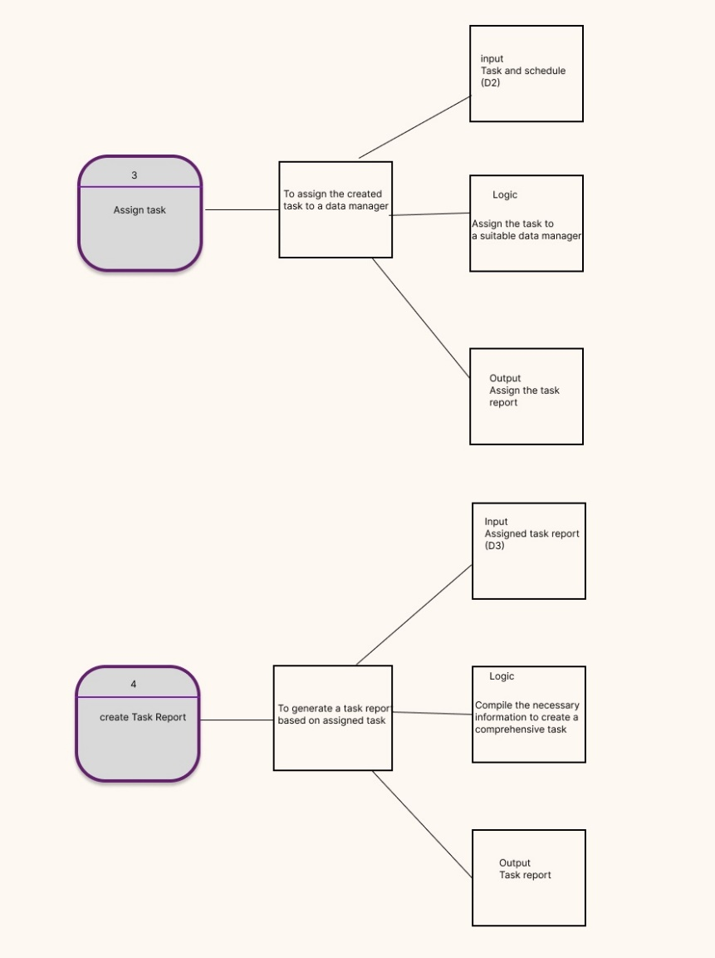

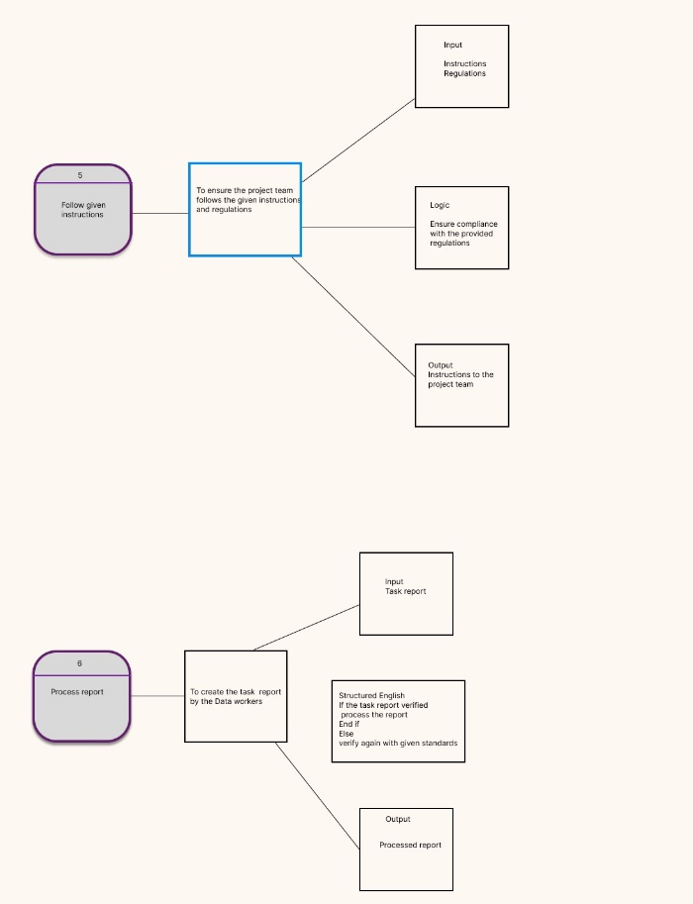

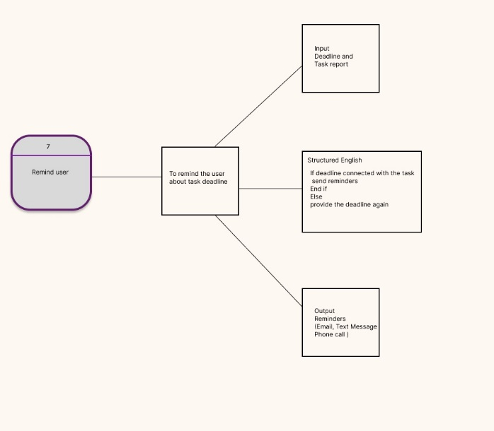

Link:

<https://www.figma.com/design/yjBtZVqFIcnWCnfalVcDLn/Untitled?node-id=0-1&t=pptjeCBiOaHVsOsM-1>

# 7.0 Physical System Design

## 7.1. Physical DFD TO- BE system

### Diagram 0

### Child Diagram

<https://www.figma.com/design/yjBtZVqFIcnWCnfalVcDLn/Untitled?t=U7ZVOvU4KjT1oiOB-1>

### Partitioning:

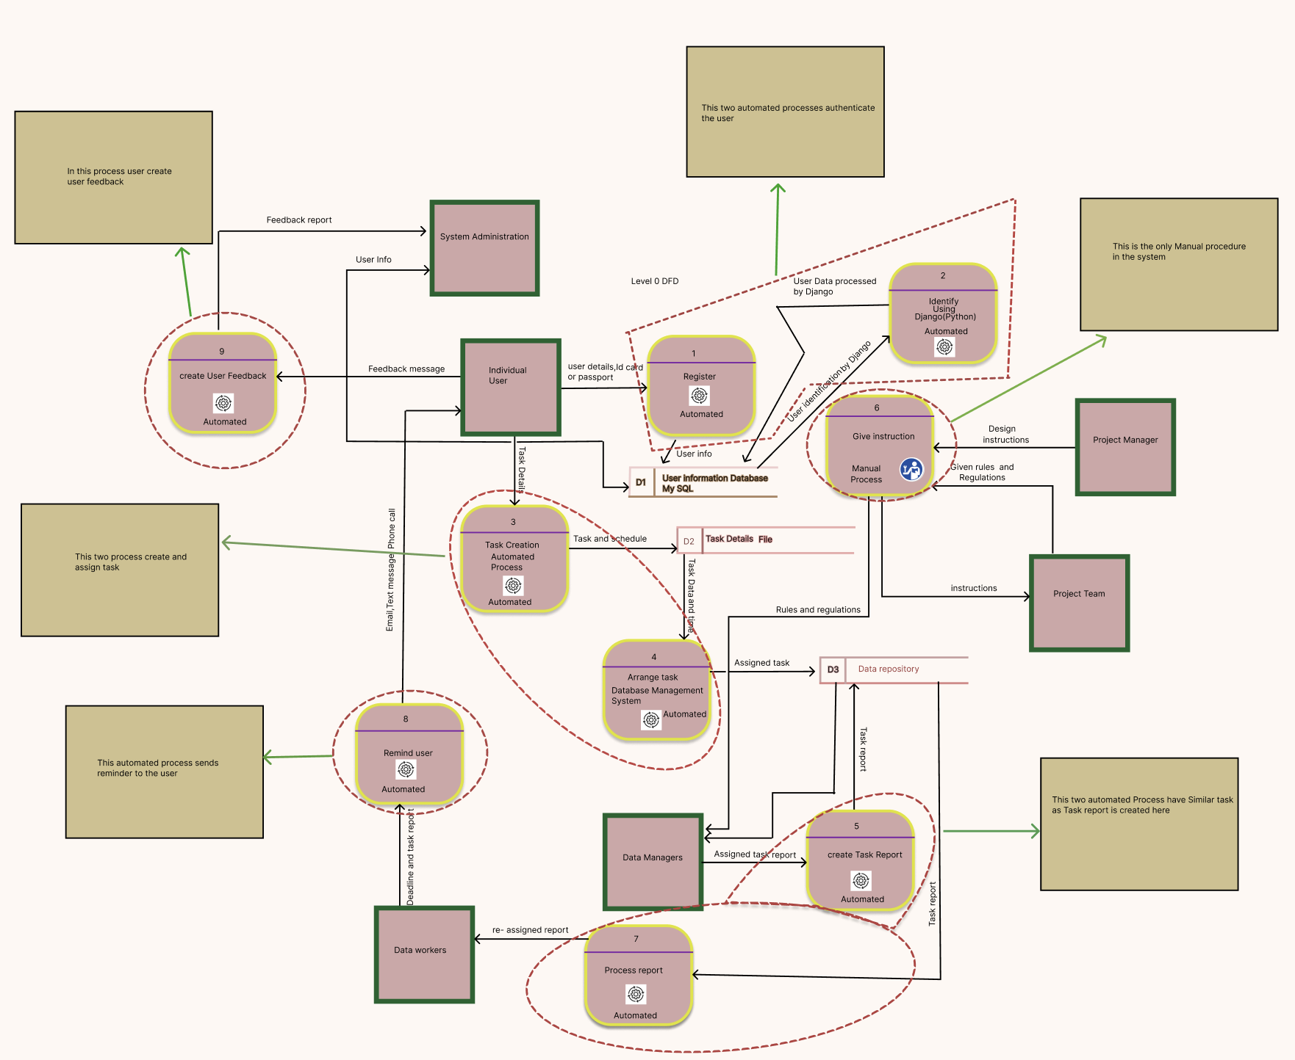

View the portioning work at :<https://www.figma.com/design/yjBtZVqFIcnWCnfalVcDLn/Untitled?t=IOTYhfEv98REy2TX-1>

### CRUD Matrix:

|  |  |  |  |  |  |  |
| --- | --- | --- | --- | --- | --- | --- |
| Process | Task  creation | Assigninig Task | Deadline Menagement | Tracking Progress | User management | Noitfications |
| Task Management | C | U | U | U | R | R |
| User Information | R | R | R | R | C,R,U,D | R |
| Reminder | R | R | C | R | R | C,R,U,D |
| Tracking Progress | R | R | R | C,U | R | R |
| User Feedback |  |  |  |  | R | R |

### Event Response Table:

|  |  |  |  |  |  |
| --- | --- | --- | --- | --- | --- |
| Event | Source | Trigger | Activity | Response | Destination |
| User Login | User | User Id and Password | Authenticate  user | Home page | Administration |
| Task Creation | User | User input | Save task | Notify assigned user | User |
| Task status update | Data workers | Task details | Update progress tracking | Notify Assinged user | User |
| Task Deadline Approaching | Data workers | Task and deadline | Send reminder notification | Bell icon notification | User |

Structured chart

### System Architecture:

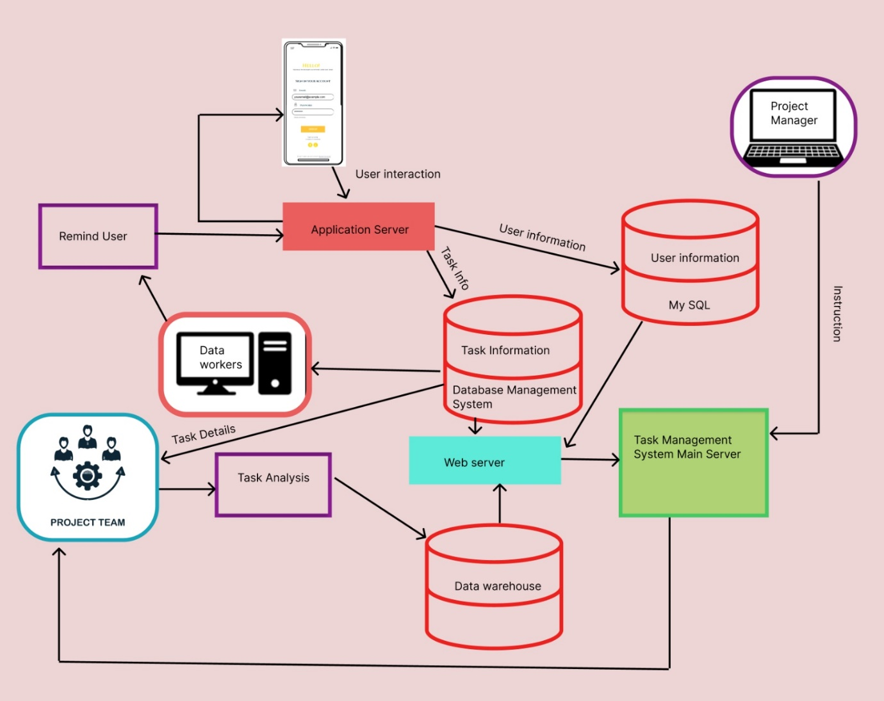

Link: <https://www.figma.com/design/VkOkfTHKudV4TGl1g6FEgM/Untitled?node-id=0-1&t=PZYSzpKmkQvL9xXJ-1>

# 8.0 System Wireframe

### Graphical User Interface:

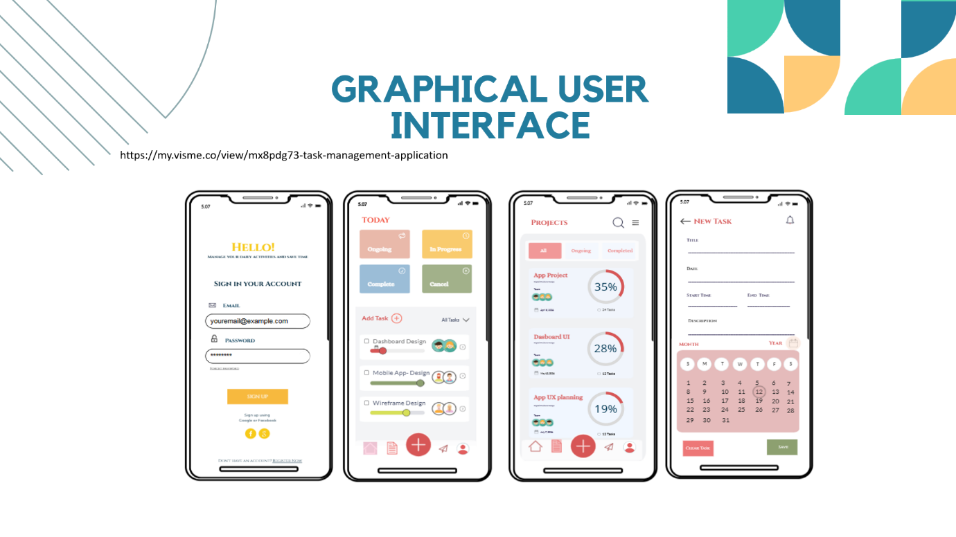

### Link of Wireframe design:

<https://www.figma.com/design/29EqFlk5tuyPMst02809Dx/Task-management-application-Wireframe-Design?node-id=221-56229&t=WJd8a6tVKW75D4FJ-1>

### User Manual:

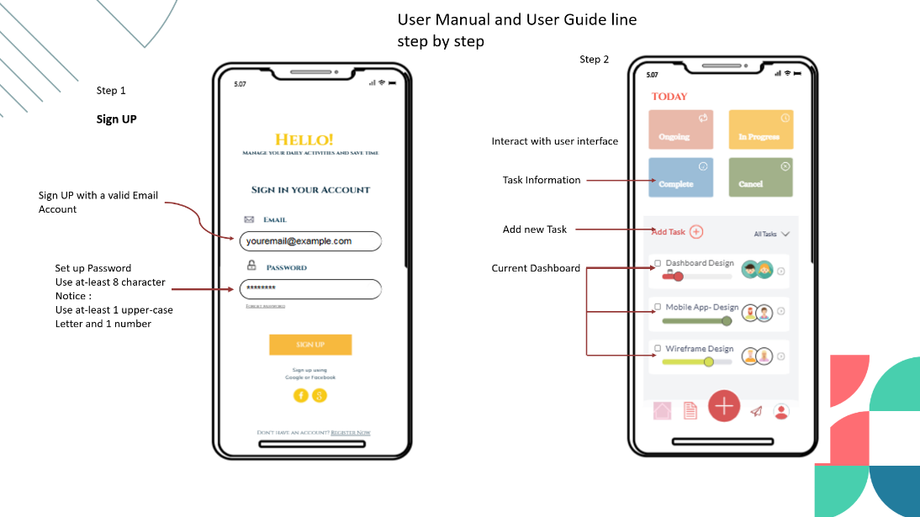

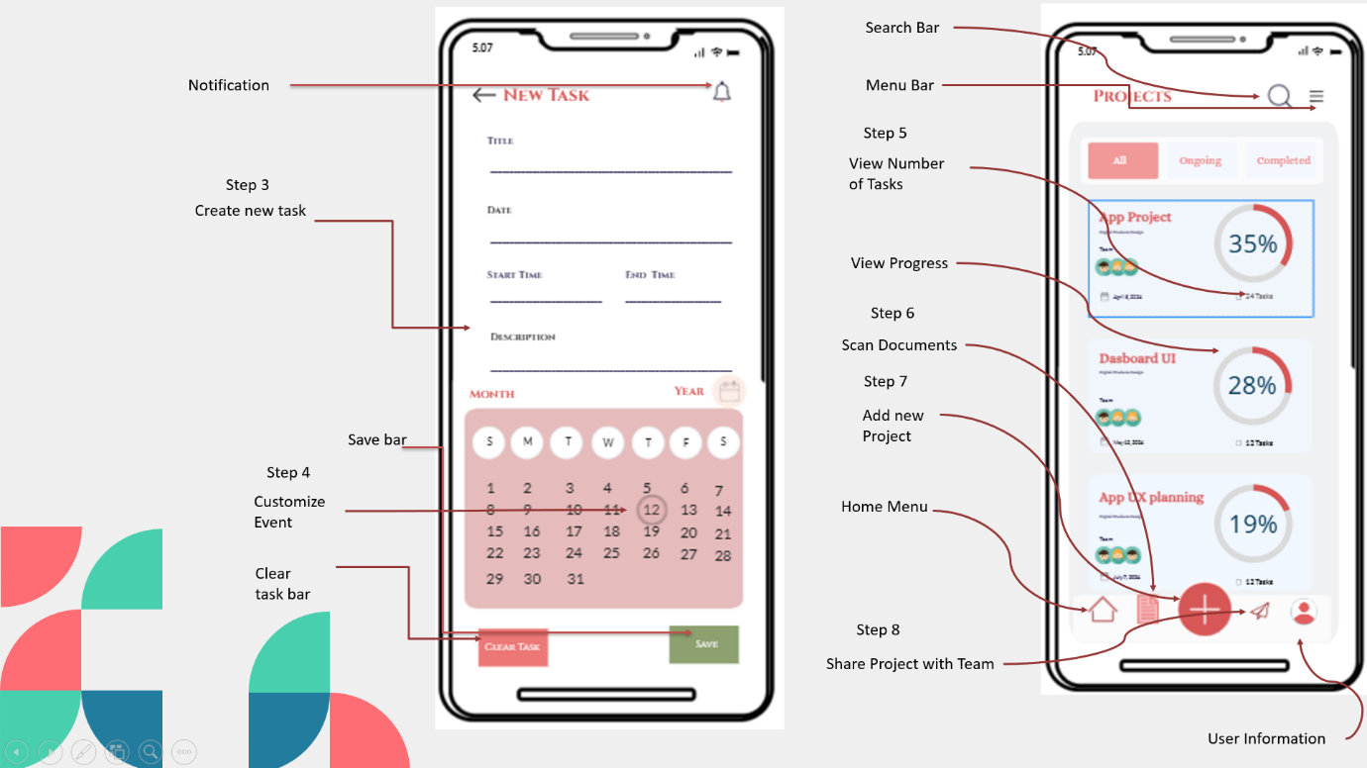

# 9.0 Summary of the proposed system

## Conclusion:

This task management application has the potential to empower individuals and teams to achieve enhanced productivity and project success. By combining intuitiveness, valuable functionalities, and a user-centric approach, this application will stand out in the market and contribute significantly to efficient task management.