GLOBAL MART | RETAIL ORDERS ANALYTICS
Solution Guide
Retail Orders & Global Mart Sales Analytics - Complete Step-by-Step Solution
Tools: Python (Pandas, Kaggle API) | SQL | Power BI
Dataset: Global Mart retail orders, 9,994 order lines, Jan 2022 - Dec 2023

1. What Is in the Pack and How to Run It
Read this first: what is real and what is synthetic
The dataset is synthetic. I could not download the original Kaggle file from this environment, so data/orders.csv was generated to the same 16-column schema, naming quirks and dirty ship-mode values as ankitbansal06/retail-orders (9,994 rows, Jan 2022 - Dec 2023). All numbers in this guide come from that file and will not match the original Kaggle data.
What was tested: the Python pipeline and all 19 SQL queries were executed end to end on SQLite. The SQL is written in portable ANSI SQL for SQL Server / PostgreSQL / MySQL 8, but I did not run it on SQL Server itself. The Power BI file (.pbix) cannot be generated outside Power BI Desktop, so section 4 gives an exact build recipe plus ready-to-paste M, DAX and theme files.

1.1 Folder structure
Retail_Orders_Project/
README.md
data/
orders.csv <- RAW dataset (9,994 rows, 16 columns, dirty ship_mode)
orders.csv.zip <- same file zipped, as Kaggle delivers it
orders_cleaned.csv <- output of step 1 (32 columns)
globalmart.db <- SQLite database created by step 1
sql_results/Q01..Q19.csv <- result of every SQL query
scripts/
generate_raw_dataset.py <- rebuilds the synthetic raw file (seed 42)
ingest_and_clean.py <- Kaggle API -> unzip -> clean -> engineer -> validate -> SQL
run_sql_pack.py <- runs all 19 queries and saves results
build_reference_charts.py <- reference chart images
sql/
01_create_table_sqlserver.sql
02_analysis_queries.sql
powerbi/
01_power_query_m.txt 02_dax_measures.txt 03_theme_globalmart.json
docs/ 01_Project_Requirements.docx 02_Solution_Guide.docx

1.2 Run order
pip install pandas numpy sqlalchemy kaggle pyodbc

# 1) (optional) rebuild the synthetic raw file
python scripts/generate_raw_dataset.py

# 2) ingest -> unzip -> clean -> engineer -> validate -> load to SQL
python scripts/ingest_and_clean.py --source local # bundled file, works offline
python scripts/ingest_and_clean.py --source kaggle # real Kaggle file (needs API token)

# 2b) load into SQL Server instead of SQLite
python scripts/ingest_and_clean.py --source local --db "mssql+pyodbc://@localhost/GlobalMart?driver=ODBC+Driver+17+for+SQL+Server&trusted_connection=yes"

# 3) run the SQL pack on SQLite and save every result
python scripts/run_sql_pack.py

2. Step 1 - Python: Ingest, Clean, Engineer, Load
The script scripts/ingest_and_clean.py follows the six bullets in the project process. Each stage is a function so you can explain and test it separately.
Stage | Function | What it does | Why
Ingest | ingest() | Authenticates with the Kaggle API (kaggle.json or env vars) and downloads orders.csv; --source local uses the bundled zip | Reproducible, token-based access instead of manual download
Unzip | unzip() | Extracts the archive with zipfile; passes through a plain CSV untouched | Kaggle delivers a zip
Clean | clean() | Reads with na_values=['Not Available','unknown'], renames columns to snake_case, trims text, fills missing ship_mode with 'Unknown', casts dates / numbers, restores 5-digit ZIPs, drops duplicate order ids | Fake values would otherwise appear as extra ship-mode categories in Power BI
Engineer | engineer() | Builds discount, sale_price, profit, gross / net revenue, total_profit, margin %, date parts, loss flag and discount band | One definition of every money field for Python, SQL and Power BI
Validate | validate() | 10 assertions (unique ids, no nulls in key columns, price and quantity ranges, sale_price <= list_price, no fake ship modes, one category per sub-category) | Stops a bad load before it reaches the database
Load | load_to_sql() | Writes table df_orders via SQLAlchemy (SQLite by default; SQL Server, PostgreSQL, MySQL via a URL) | Relational store for SQL analysis and Power BI

2.1 The key cleaning code
# treat the dataset's two fake values as missing when reading
df = pd.read_csv(csv_path, na_values=["Not Available", "unknown", "N/A", ""])

# standard column names: 'Ship Mode' -> 'ship_mode', 'cost price' -> 'cost_price'
df.columns = df.columns.str.strip().str.lower().str.replace(" ", "_", regex=False)

# missing ship mode -> explicit bucket (keeps the order and its revenue)
df["ship_mode"] = df["ship_mode"].fillna("Unknown")

df["order_date"] = pd.to_datetime(df["order_date"], format="%Y-%m-%d")
df["postal_code"] = df["postal_code"].astype(str).str.zfill(5) # 2110 -> 02110

2.2 Feature engineering
df["discount"] = (df["list_price"] * df["discount_percent"] / 100).round(2)
df["sale_price"] = (df["list_price"] - df["discount"]).round(2)
df["profit"] = (df["sale_price"] - df["cost_price"]).round(2)

df["gross_revenue"] = df["list_price"] * df["quantity"] # PRE-discount
df["discount_amount"] = df["discount"] * df["quantity"]
df["net_revenue"] = df["sale_price"] * df["quantity"] # POST-discount
df["total_profit"] = df["profit"] * df["quantity"]

2.3 Output of the run on the bundled file
[clean] rows read=9,994 | ship_mode fixed=96 | duplicate order_id removed=0
[validate] PASS (all 10 checks)
[load] 9,994 rows -> table 'df_orders'

[summary] orders 9,994 | 2022-01-01 -> 2023-12-31
gross revenue 3,184,594 | net revenue 3,061,720 | total profit 867,219

The 96 repaired ship-mode rows are the injected dirty values: 38 'Not Available', 32 'unknown' and 26 blank.

3. Step 2 - SQL Analysis
File: sql/02_analysis_queries.sql (19 titled queries). Table: df_orders. For SQL Server run sql/01_create_table_sqlserver.sql first if you want explicit data types, then set if_exists="append" in the loader. Top-N is done with ROW_NUMBER() so no TOP / LIMIT is needed.
Query | Purpose | Business question
Q01 | Row count, distinct orders, unknown ship modes, date range | Data quality
Q02 | Total orders, units, pre-discount revenue, discount, post-discount revenue, profit, rates | BQ1, BQ2
Q03-Q04 | Revenue and profit by year and by month | BQ1, BQ3
Q05-Q06 | Top 10 products by revenue and by profit | BQ4
Q07 | Top 5 products in each region (partitioned window) | BQ5
Q08-Q10 | Regional totals, city ranking, segment x region matrix | BQ6
Q11 | Ship mode orders, share, order value, margin | BQ7
Q12-Q13 | Discount rate vs margin by category and sub-category | BQ8
Q14 | Discount effectiveness: units, margin and loss lines per discount level | BQ9
Q15 | Loss-making products | BQ10
Q16-Q18 | 2022 vs 2023 by month, peak month per category, fastest profit growth | BQ3, BQ11
Q19 | Sub-categories ranked by share of deeply discounted lines with their margin | BQ12

3.1 Example queries

Q02 - Headline KPIs (pre vs post discount)
SELECT COUNT(*) AS total_orders,
SUM(quantity) AS total_units,
ROUND(SUM(gross_revenue), 2) AS revenue_pre_discount,
ROUND(SUM(discount_amount), 2) AS total_discount_given,
ROUND(SUM(net_revenue), 2) AS revenue_post_discount,
ROUND(SUM(total_profit), 2) AS total_profit,
ROUND(100.0 * SUM(discount_amount) / SUM(gross_revenue), 2) AS discount_rate_pct,
ROUND(100.0 * SUM(total_profit) / SUM(net_revenue), 2) AS profit_margin_pct
FROM df_orders;

Q07 - Top 5 products in each region
WITH region_product AS (
SELECT region, product_id, SUM(net_revenue) AS revenue
FROM df_orders
GROUP BY region, product_id
), ranked AS (
SELECT *, ROW_NUMBER() OVER (PARTITION BY region ORDER BY revenue DESC) AS rn
FROM region_product
)
SELECT region, rn AS rank_no, product_id, ROUND(revenue, 2) AS revenue
FROM ranked WHERE rn <= 5
ORDER BY region, rn;

Q16 - 2022 vs 2023 by month (conditional-aggregation pivot)
WITH monthly AS (
SELECT order_month,
SUM(CASE WHEN order_year = 2022 THEN net_revenue ELSE 0 END) AS sales_2022,
SUM(CASE WHEN order_year = 2023 THEN net_revenue ELSE 0 END) AS sales_2023
FROM df_orders GROUP BY order_month
)
SELECT order_month, ROUND(sales_2022,2) AS sales_2022, ROUND(sales_2023,2) AS sales_2023,
ROUND(100.0 * (sales_2023 - sales_2022) / sales_2022, 2) AS yoy_growth_pct
FROM monthly ORDER BY order_month;

3.2 Results on the bundled dataset

Q02 - Headline KPIs
Measure | Value
total orders | 9,994
total units | 31,675
revenue pre discount | 3,184,594.00
total discount given | 122,874.48
revenue post discount | 3,061,719.52
total profit | 867,218.52
discount rate pct | 3.86
profit margin pct | 28.32
avg order value | 306.36

Q03 - By year
order year | orders | units | revenue pre discount | revenue post discount | total profit | margin pct
2022 | 4,570 | 14,450 | 1,416,478.00 | 1,361,916.25 | 392,188.25 | 28.80
2023 | 5,424 | 17,225 | 1,768,116.00 | 1,699,803.27 | 475,030.27 | 27.95

Q08 - Regional totals
region | orders | revenue pre discount | revenue post discount | total profit | discount rate pct | margin pct | share of total pct
West | 2,956 | 924,514.00 | 889,856.69 | 252,531.69 | 3.75 | 28.38 | 29.06
Central | 2,828 | 858,034.00 | 822,184.57 | 236,911.57 | 4.18 | 28.81 | 26.85
East | 2,533 | 847,342.00 | 815,637.28 | 227,458.28 | 3.74 | 27.89 | 26.64
South | 1,677 | 554,704.00 | 534,040.98 | 150,316.98 | 3.73 | 28.15 | 17.44

Q09 - Top 10 cities by revenue
rev rank | city | state | region | orders | revenue | profit | margin pct
1 | New York City | New York | East | 753 | 245,227.65 | 66,099.65 | 26.95
2 | Los Angeles | California | West | 598 | 181,311.07 | 51,803.07 | 28.57
3 | San Francisco | California | West | 499 | 156,304.33 | 42,130.33 | 26.95
4 | Seattle | Washington | West | 456 | 150,225.42 | 43,144.42 | 28.72
5 | Philadelphia | Pennsylvania | East | 483 | 146,235.73 | 41,779.73 | 28.57
6 | Houston | Texas | Central | 446 | 133,436.77 | 40,392.77 | 30.27
7 | Chicago | Illinois | Central | 396 | 102,226.42 | 28,758.42 | 28.13
8 | Portland | Oregon | West | 254 | 74,404.83 | 22,165.83 | 29.79
9 | Atlanta | Georgia | South | 185 | 67,320.60 | 19,241.60 | 28.58
10 | Miami | Florida | South | 204 | 67,045.05 | 17,471.05 | 26.06

Q05 - Top 10 products by revenue
rank no | product id | category | sub category | units | revenue | profit
1 | TEC-PH-10001208 | Technology | Phones | 153 | 109,616.13 | 25,619.13
2 | OFF-BI-10004342 | Office Supplies | Binders | 1,083 | 83,827.71 | 23,179.71
3 | FUR-TA-10001133 | Furniture | Tables | 127 | 67,189.44 | 11,182.44
4 | TEC-PH-10001576 | Technology | Phones | 81 | 49,533.12 | 16,809.12
5 | TEC-CO-10002851 | Technology | Copiers | 20 | 44,157.75 | 14,537.75
6 | FUR-CH-10000405 | Furniture | Chairs | 131 | 36,288.00 | 11,660.00
7 | TEC-PH-10000513 | Technology | Phones | 51 | 33,567.52 | 9,444.52
8 | TEC-PH-10000684 | Technology | Phones | 52 | 32,322.24 | 11,418.24
9 | TEC-MA-10000596 | Technology | Machines | 22 | 28,426.97 | 5,942.97
10 | TEC-PH-10002600 | Technology | Phones | 33 | 26,179.82 | 10,999.82

Q11 - Ship mode performance
ship mode | orders | order share pct | revenue post discount | avg order value | margin pct
Standard Class | 5,758 | 57.61 | 1,779,545.43 | 309.06 | 28.56
Second Class | 1,957 | 19.58 | 582,584.84 | 297.69 | 27.92
First Class | 1,604 | 16.05 | 500,431.23 | 311.99 | 28.22
Same Day | 579 | 5.79 | 177,370.37 | 306.34 | 27.14
Unknown | 96 | 0.96 | 21,787.65 | 226.95 | 31.93

Q12 - Category: discount rate vs margin
category | revenue pre discount | discount given | discount rate pct | revenue post discount | total profit | margin pct
Furniture | 1,048,115.00 | 43,892.13 | 4.19 | 1,004,222.87 | 239,670.87 | 23.87
Office Supplies | 929,405.00 | 35,350.69 | 3.80 | 894,054.31 | 285,431.31 | 31.93
Technology | 1,207,074.00 | 43,631.66 | 3.61 | 1,163,442.34 | 342,116.34 | 29.41

Q14 - Discount effectiveness
discount percent | order lines | avg units per line | revenue post discount | total profit | margin pct | loss making lines
2 | 2,968 | 3.18 | 915,947.20 | 269,197.20 | 29.39 | 3
3 | 2,736 | 3.18 | 853,889.06 | 250,869.06 | 29.38 | 3
4 | 2,198 | 3.15 | 668,002.56 | 193,495.56 | 28.97 | 3
5 | 1,414 | 3.16 | 435,843.85 | 119,531.85 | 27.43 | 1
10 | 412 | 3.18 | 115,260.30 | 23,356.30 | 20.26 | 6
15 | 184 | 3.15 | 54,409.35 | 8,696.35 | 15.98 | 1
20 | 82 | 2.99 | 18,367.20 | 2,072.20 | 11.28 | 5

Q15 - Loss-making products
product id | category | sub category | units | revenue | profit | avg discount pct
FUR-TA-10004077 | Furniture | Tables | 6 | 2,278.80 | -49.20 | 10.00
FUR-TA-10000986 | Furniture | Tables | 5 | 932.00 | -38.00 | 20.00
FUR-TA-10003962 | Furniture | Tables | 4 | 1,404.00 | -28.00 | 10.00
OFF-BI-10002540 | Office Supplies | Binders | 33 | 159.20 | -5.80 | 3.82

4. Step 3 - Power BI Dashboard Build Recipe

4.1 Connect and model
- Open Power BI Desktop. Home > Get data > Text/CSV and select data/orders_cleaned.csv (or SQL Server with server localhost, database GlobalMart, Import mode). To paste ready-made code instead, use Transform data > Advanced Editor and paste Option A or B from powerbi/01_power_query_m.txt.
- Create a blank query named dim_date, paste the date-table M code from the same file, and click Close & Apply.
- In Model view create the relationship dim_date[Date] (one) to df_orders[order_date] (many), single direction. Select dim_date, Table tools > Mark as date table, choose Date.
- Select Month in dim_date and Sort by column Month No. Do the same for df_orders order_month_name sorted by order_month.
- Home > Enter data, create an empty table named _Measures, and paste the measures from powerbi/02_dax_measures.txt one at a time (New measure).
- View > Themes > Browse for themes and load powerbi/03_theme_globalmart.json.
- Format measures: Discount Rate %, Profit Margin %, Revenue YoY % as percentage (1 decimal); revenue and profit as currency with no decimals.

4.2 Core DAX measures
Revenue Pre Discount = SUM ( df_orders[gross_revenue] )
Revenue Post Discount = SUM ( df_orders[net_revenue] )
Total Profit = SUM ( df_orders[total_profit] )
Total Orders = DISTINCTCOUNT ( df_orders[order_id] )

Discount Rate % = DIVIDE ( SUM ( df_orders[discount_amount] ), [Revenue Pre Discount] )
Profit Margin % = DIVIDE ( [Total Profit], [Revenue Post Discount] )

Revenue PY = CALCULATE ( [Revenue Post Discount], SAMEPERIODLASTYEAR ( dim_date[Date] ) )
Revenue YoY % = DIVIDE ( [Revenue Post Discount] - [Revenue PY], [Revenue PY] )

City Revenue Rank = RANKX ( ALL ( df_orders[city] ), [Revenue Post Discount], , DESC, DENSE )

Margin Colour = SWITCH ( TRUE (), [Profit Margin %] < 0.15, "#C0392B",
[Profit Margin %] < 0.25, "#F4A261", "#2A9D8F" )

The full set (about 25 measures including YTD, profit YoY, deep-discount share and dynamic titles) is in powerbi/02_dax_measures.txt.

4.3 Page layout

Page 1 - Sales Overview
- Slicers (top row): Year, Region, Category, Segment
- KPI cards: Total Orders, Revenue Pre Discount, Revenue Post Discount, Total Profit, Discount Rate %, Profit Margin %
- Line chart: Revenue Post Discount by Month with Year in the legend (2022 vs 2023 on one chart)
- Clustered column: Revenue and Profit by Region; Donut or bar: Revenue by Segment
- Text box: three-line insight that updates your story (for example YoY growth and the strongest region)

Page 2 - Shipping & Geography
- Bar chart: Total Orders by ship_mode, sorted descending, with data labels showing Orders % of Total (required visual: popular ship modes)
- Bar chart: Top 10 city by Revenue Post Discount (Visual-level Top N filter = 10 by the revenue measure) (required visual: city revenue ranking)
- Filled map or bar by state; matrix of Region x Segment revenue
- Drill-through page on City showing orders, revenue, margin and top products
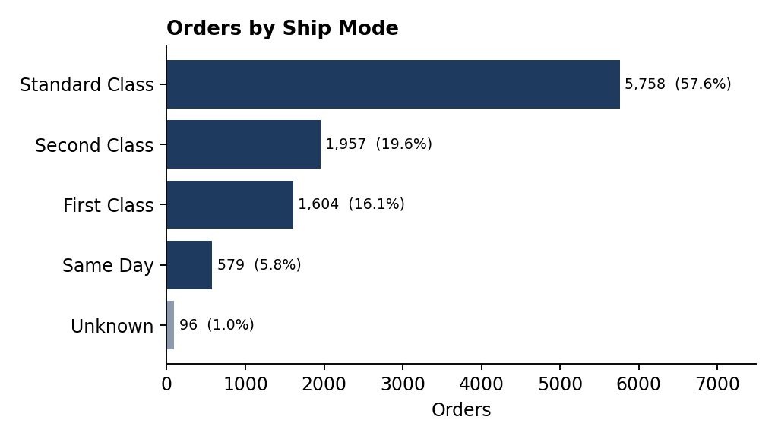
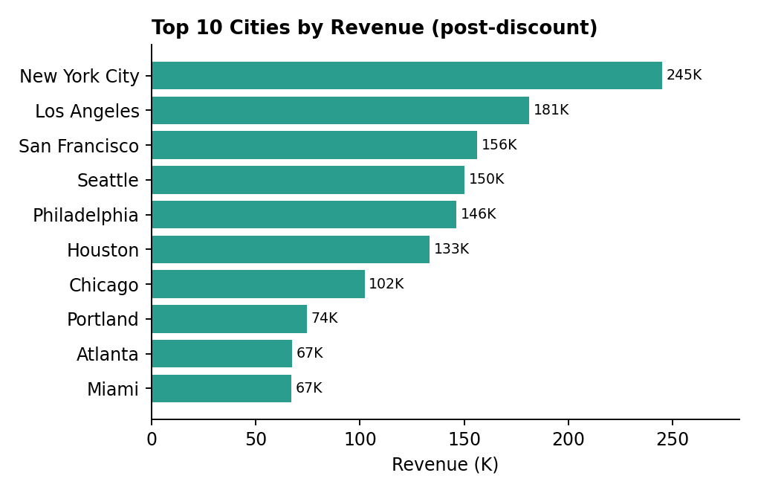

Page 3 - Discounts & Profitability
- Clustered column: Discount Rate % and Profit Margin % by category (required visual: category discount rates)
- Scatter: x = Discount Rate %, y = Profit Margin %, size = Revenue Post Discount, details = sub_category
- Bar chart: Top 10 products by Total Profit with data labels and Margin Colour conditional formatting (required visual: product profitability)
- Table: loss-making products (filter Total Profit < 0); line + column combo of margin and units per discount level (discount_percent)
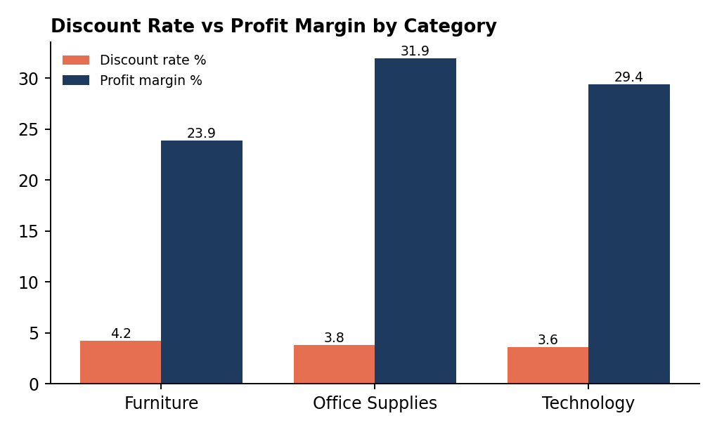
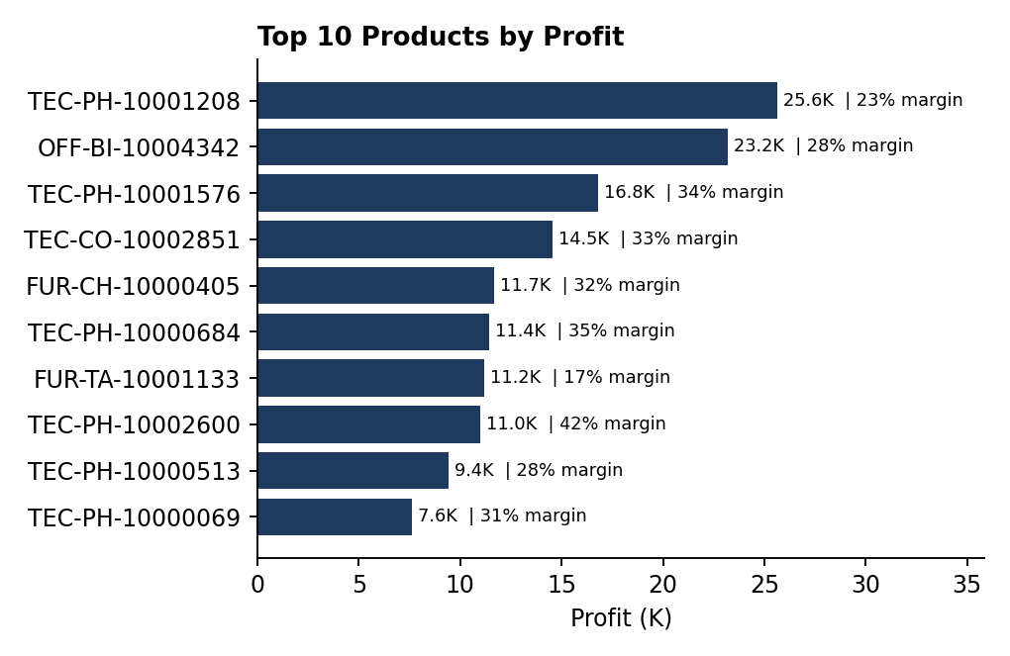
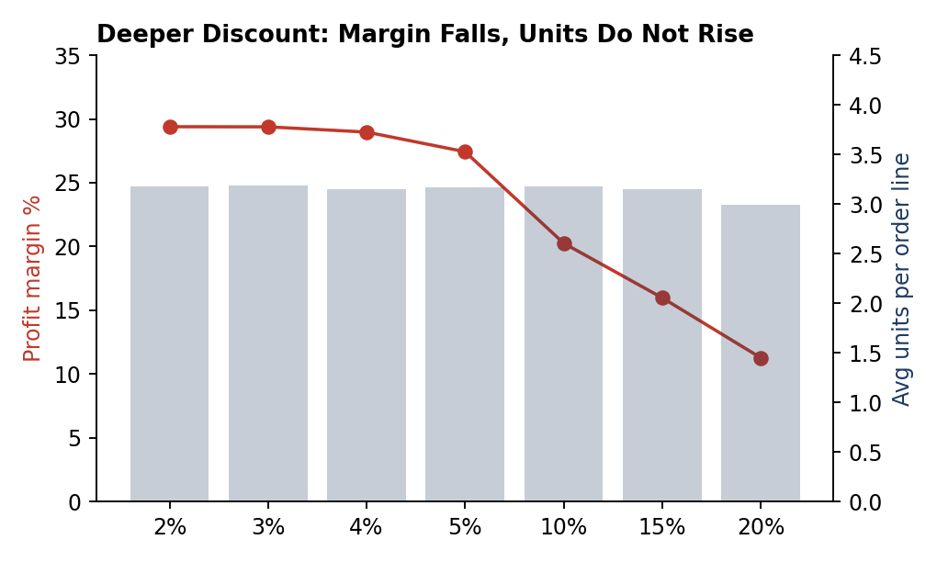
Images above are reference renderings of each visual's data, produced from the SQL results. Your Power BI visuals should show the same numbers.

4.4 Polish checklist
- Same page background and card style on all three pages; titles in sentence case that state the point, e.g. 'Furniture earns the lowest margin'
- Turn on data labels, sort bars descending, remove gridlines and redundant axis titles
- Use Edit interactions so cards do not filter each other unexpectedly
- Add tooltips pages showing orders, units and margin; add a Reset-filters bookmark button
- Test every slicer combination and compare the KPI cards with SQL Q02

5. Reconciliation Check
Before presenting, confirm the three tools agree. On the bundled data they must match exactly:
Measure | Python summary | SQL Q02 | Power BI card (expected)
Total orders | 9,994 | 9,994 | 9,994
Revenue pre-discount | 3,184,594 | 3,184,594.00 | $3,184,594
Revenue post-discount | 3,061,720 | 3,061,719.52 | $3,061,720
Total profit | 867,219 | 867,218.52 | $867,219
Discount rate / margin | - | 3.86% / 28.32% | 3.9% / 28.3%

6. Findings and Pricing Recommendations
Caveat
These findings were computed on the synthetic bundled dataset to demonstrate the method. Re-run the pipeline on the original Kaggle file and replace every number before you present them as real conclusions.

6.1 What the data shows
- Scale and growth: 9,994 order lines, 31,675 units; post-discount revenue 3.06M on 3.18M pre-discount (122.9K discount, 3.86% discount rate); gross margin 28.3%. 2023 revenue is 24.8% above 2022 (1.70M vs 1.36M) on 18.7% more orders.
- Seasonality: September, November and December together produce about 37.5% of revenue (December alone 14.6%); January and February are the weakest months (4.7% and 4.0%).
- Regions and cities: West is the largest region (29.1% of revenue), South the smallest (17.4%). New York City is the top city (245K, 8.0% of revenue) and the top five cities generate 28.7% of revenue. Central has the highest discount rate (4.18%) and 9.9% of its lines are discounted by more than 5%, versus 4.9-5.9% elsewhere.
- Ship modes: Standard Class takes 57.6% of orders, Second Class 19.6%, First Class 16.1%, Same Day 5.8%. Average order value is similar for all modes (about 298-312), so ship mode is not driving basket size. 96 orders (1.0%) have no valid ship mode.
- Category margins: Furniture has the lowest margin (23.9%) and the highest discount rate (4.19%); Office Supplies has the best margin (31.9%); Technology has the most revenue (1.16M). Within Furniture, Tables run at 13.7% margin and Bookcases 18.0%; Machines (Technology) run at 16.4%.
- Discount effectiveness: average units per order line stay flat at about 3.0-3.2 whatever the discount (2% to 20%), while margin falls from 29.4% at 2% to 11.3% at 20%. Lines discounted by more than 5% (678 lines) earn an 18.1% margin versus 28.3% overall. In this data, deeper discounts reduce margin without lifting volume.
- Loss-makers: only four products lose money overall; three are Tables sold at 10-20% discount.

6.2 Recommendations
# | Recommendation | Evidence | Expected effect
1 | Cap standard discounts at 5% for all sub-categories; require manager approval above 5% | Units per line do not rise with discount; 678 lines above 5% earn 18.1% margin | If volume holds, about +16.2K profit (+1.9% of total profit)
2 | Start with Tables, Bookcases, Machines and Binders: review list price and set a hard 5% ceiling | 10.7-13.6% of their lines are deeply discounted; margins 13.7%, 18.0%, 16.4%, 25.2% | Lifts the weakest sub-category margins first
3 | Reprice or delist the three loss-making Tables SKUs | Negative profit at 10-20% discount | Removes direct losses
4 | Tighten discount governance in the Central region | 9.9% of lines above 5% discount vs 4.9-5.9% elsewhere | Brings Central in line with other regions
5 | Move promotions to January-February and avoid blanket discounts in Sep, Nov, Dec when demand is already high | Jan-Feb are 8.7% of revenue; Sep + Nov + Dec are 37.5% | Smooths demand without giving margin away at peak
6 | Make ship mode mandatory at order entry | 1.0% of orders have no valid ship mode | Complete logistics reporting
Estimate for recommendation 1: sum over lines with discount above 5% of (discount% - 5) / 100 x list price x quantity. It assumes demand does not fall when the discount is capped, which you should test with a pilot before rolling out.

7. Resume Bullets and Interview Preparation

7.1 Resume wording
Retail Orders & Global Mart Sales Analytics | Python (Pandas, Kaggle API), SQL, Power BI
- Built an automated pipeline that pulls retail order data through the Kaggle API, cleans categorical and numeric fields, engineers revenue, discount and profit features and loads about 10K order lines into a relational SQL database
- Wrote window-function SQL to measure order volume, pre- and post-discount revenue, top products per region and regional sales, reconciling totals to the cent across Python, SQL and Power BI
- Designed a three-page Power BI dashboard (ship modes, city revenue ranking, category discount rates, product profitability) and recommended a 5% discount cap that is estimated to add about 1.9% to profit
Only use the quantified claims if you re-run on the real data and the numbers still hold.

7.2 Likely interview questions
Question | Strong answer outline
Walk me through the project. | Goal (pricing and discount effectiveness) -> ingest and clean -> engineer features -> SQL store -> SQL questions -> dashboard -> recommendation with a number.
How did you handle the 'Not Available' and 'unknown' ship modes? | Read them as nulls, then labelled 'Unknown' so the order and its revenue stay in the totals; reported it as about 1% of rows and suggested fixing it at source.
How do you define revenue and profit? | Gross revenue = list price x quantity; net revenue = sale price x quantity after discount; profit = (sale price - cost) x quantity. Same formulas in Python, SQL and DAX.
Why store the data in SQL and not just use the CSV? | Single governed source, typed columns, repeatable queries, and Power BI can refresh from it.
Why ROW_NUMBER instead of TOP? | Needed for top N per group (top 5 per region) and keeps the query portable across databases.
How do you know discounts do not work? | Average units per order line are flat across discount levels while margin drops; caveat: no control group, so recommend a pilot.
How would you validate the dashboard? | Reconcile KPI cards with SQL Q02, test slicers, check blank and unknown categories, review with a stakeholder.
What would you do next? | Add cost of shipping, customer ids and returns; run a price-elasticity pilot; schedule refresh.

8. Troubleshooting
Problem | Fix
kaggle command or import not found, or 'Could not find kaggle.json' | pip install kaggle; place kaggle.json in ~/.kaggle (chmod 600) or set KAGGLE_USERNAME and KAGGLE_KEY
403 or 'accept competition rules' from Kaggle | Open the dataset page once while logged in and make sure the token belongs to that account
Kaggle file name differs after download | Run kaggle datasets files ankitbansal06/retail-orders and update KAGGLE_FILE in the script
pyodbc error 'Data source name not found' | Install Microsoft ODBC Driver 17/18 for SQL Server and match the driver name in the connection URL
SQL Server error about too many parameters on load | Keep chunksize=500 in to_sql; SQL Server allows 2,100 parameters per statement
Power BI shows months in alphabetical order | Sort Month by Month No (and order_month_name by order_month)
Time-intelligence measures return blank | Mark dim_date as the date table and make sure the relationship uses df_orders[order_date] as a date type
Postal codes show 2110 instead of 02110 | Keep postal_code as text in Power Query; the cleaning script already pads to 5 digits

