REACT.JS

**D:\WebDevelopmentShashisir\ReactCourseHarry\react-request-response>** npm start

> react-request-responce@0.1.0 start

> react-scripts start

Yha se padhna h

<https://legacy.reactjs.org/docs/getting-started.html>

**1). Introduction to jsx**

It is called JSX, and it is a syntax extension to JavaScript

# Understanding Props and PropTypes in React | Complete React Course in Hindi #6

Module.mjs

import dza, {a, c, d} from './module2.mjs'

console.log(dza);

console.log(c);

console.log(d);

console.log(a);

Module2.mjs

const a = "Rayan";

const b = "Rohan";

const c = "Aakash";

const d = "Priyanka";

export default b;

export {a};

export {c};

export {d};

In dono ko ek sath run krna h and logic comment on off krke dekhna h Isme Navbar file ko link krna h react ke tarike se

**2).Components and Props**

Bootstrap ke css and js ke link ko copy krke pest krna h

App.js

// import logo from './logo.svg';

import './App.css';

import Navbar from './components/Navbar';

function App() {

  return (

    <>

    <Navbar title="TextUtil" about="Aboutani"/>

    {/* <Navbar/> */}

    </>

  );

}

export default App;

Component>Navbar.js

import React from 'react'

import PropTypes from 'prop-types'

export default function Navbar(props){

    return (

        <nav className="navbar navbar-expand-lg bg-body-tertiary">

        <div className="container-fluid">

          <a className="navbar-brand" href="/">{props.title}</a>

          <button className="navbar-toggler" type="button" data-bs-toggle="collapse" data-bs-target="#navbarSupportedContent" aria-controls="navbarSupportedContent" aria-expanded="false" aria-label="Toggle navigation">

            <span className="navbar-toggler-icon"></span>

          </button>

          <div className="collapse navbar-collapse" id="navbarSupportedContent">

            <ul className="navbar-nav me-auto mb-2 mb-lg-0">

              <li className="nav-item">

                <a className="nav-link active" aria-current="page" href="/">Home</a>

              </li>

              <li className="nav-item">

                <a className="nav-link" href="/">Link</a>

              </li>

              <li className="nav-item">

                <a className="nav-link" href="/">{props.about}</a>

              </li>

            </ul>

            <form className="d-flex" role="search">

              <input className="form-control me-2" type="search" placeholder="Search" aria-label="Search" />

              <button className="btn btn-outline-success" type="submit">Search</button>

            </form>

          </div>

        </div>

      </nav>

    )

}

Navbar.propTypes = {title: PropTypes.string.isRequired,

                    about: PropTypes.string}

                    // default is u not given in app.js css like title="" about=""

//  Navbar.defaultProps = { title: "Set title here",

//                         about: "About text here"}

# Understanding State & Handling Events in React | Complete React Course in Hindi #7

# App.js

// import logo from './logo.svg';

import './App.css';

import TextForm from './components/TextForm';

function App() {

  return (

    <>

    <div className="container">

    <TextForm heading="Enter hte thext to analyze" />

    </div>

    </>

  );

}

export default App;

# component>TextForm.js

import React, {useState} from 'react'

export default function TextForm(props){

    const handleUpClick = ()=>{

        console.log("Uppercse was clicked");

        setText("You have clicked on handleUpClick")

    }

    const handleOnChange = ()=>{

        console.log("On Change");

    }

    const [text, setText] = useState('Enter text here ');

    //for update test Enter text here use setTest("abcxyz");

    return (

    <>

    <h3>{props.heading}</h3>

    <div className="mb-3">

    {/* <label for="myBox" class="form-label">Example textarea</label> */}

    <textarea className="form-control" value={text}  onChange={handleOnChange} id="myBox" rows="8"></textarea>

    </div>

    <button className="btn btn-primary" onClick={handleUpClick}>Convert Uppercase</button>

    </>

    )

}

Output…..

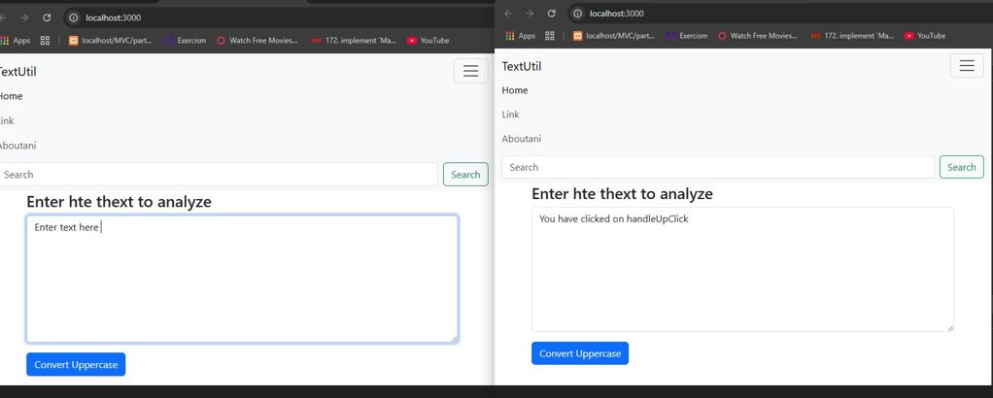

TextForm.js

You can write in textarea using this lines

  const handleOnChange = (event)=>{

        console.log("On Change");

        setText(event.target.value);

    }

//Convert into Upper and lower case

 const handleUpClick = ()=>{

        console.log("Uppercse was clicked " + text);

        // setText("You have clicked on handleUpClick")

        let newText = text.toUpperCase();

        setText(newText);

    }