***Heaven’s Light is Our Guide***

**Rajshahi University of Engineering & Technology**

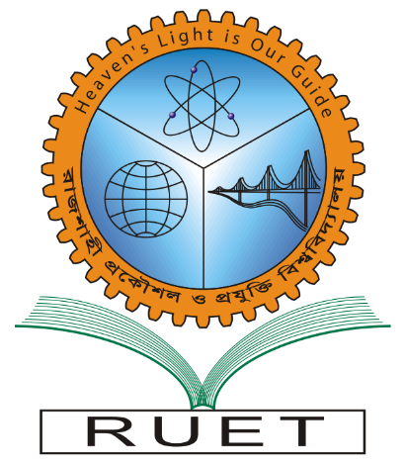

*Department of Electrical & Computer Engineering*

**Course Title:** Software Engineering & Information System Design Sessional

**Course No. :** ECE 3118

**Submitted by:        Submitted to:**

**Name:** Anika Nawer       Rakibul Hassan

**Roll:**    1810012       Lecturer

**Date:** 05-06-2022Dept. of ECE

      RUET