**MEDIA STREAMING WITH IBM CLOUD VIDEO STREAMING**

**Problem Statement:**

Create a virtual cinema platform using IBM Cloud Video Streaming. Upload and stream your favourite movies and videos on demand. Share the joy of movie nights with friends and family, no matter where they are located. Elevate the movie watching experience with seamless streaming and high-quality video playback for a truly immersive cinematic experience!

**Phase 2: Innovation**

Consider incorporating features like user generated playlists or real time chat for a more engaging movie watching experience.

**Solution:** Phase Two focuses on introducing innovative features to enhance user engagement and create a more immersive movie-watching experience.

Phase Two of the virtual cinema platform initiative is designed to usher in a new era of innovation and user engagement, transforming the movie-watching experience into an interactive and community-driven endeavor. The proposed enhancements are comprehensive, aiming to create a platform where users not only consume content but actively participate, share, and connect with others who share similar interests. Let's delve deeper into the innovative features:

1. **User Generated Playlists:**
   * **Collaborative Playlists:** Users can collaboratively create playlists, fostering social interaction by enabling groups to curate movie lists collectively. This feature is perfect for organizing movie nights with friends or family, bringing people together regardless of their physical location.
   * **Public and Private Playlists:** Public playlists encourage a sense of sharing and discovery within the platform's community, while private playlists offer personal curation options without public visibility. Users have full control over the visibility settings, ensuring their playlists are shared according to their preferences.
   * **Recommendation Engine:** Leveraging sophisticated machine learning algorithms, the recommendation engine analyzes users' playlist histories to suggest movies aligning with their preferences. By identifying patterns in users' tastes, this feature encourages exploration and helps users discover new content tailored to their liking.
2. **Real Time Chat:**
   * **Watch Party Chat:** Real-time chat functionality allows users watching the same movie in a watch party to communicate instantly. This immersive experience enables users to share reactions, discuss plot twists, and enjoy a communal viewing atmosphere, fostering a sense of togetherness even when physically apart.
   * **General Chat Rooms:** Diverse chat rooms cater to various topics such as movie recommendations, genre discussions, or general chatter. Users can join discussions that align with their interests, encouraging meaningful conversations and community bonding. To maintain a positive environment, moderation tools are in place to swiftly address any issues that may arise.
   * **Moderation Features:** The introduction of reporting mechanisms for inappropriate content or user behavior ensures that the platform remains a safe and enjoyable space for all users. Filters and automated moderation tools further enhance the chat experience, promoting positive interactions and discussions.
3. **Social Integration:**
   * **Shareable Playlists:** Users have the ability to share their favorite playlists on external social media platforms such as Twitter or Facebook. This social sharing serves as a promotional tool, attracting new users to the platform and expanding its reach.
   * **Social Sign In:** Simplifying the registration process, users can now sign in using their existing social media accounts. This integration not only streamlines the onboarding experience but also leverages social networks for authentication and connection, enhancing user engagement.
   * **Emoji Reactions:** Users can express their emotions during movie watching by utilizing emojis in the chat. This interactive feature adds a fun element to communication, making the virtual cinema experience not only engaging but also social.
4. **Continuous Improvement:**
   * **Feedback Mechanisms:** Implementation of in-app feedback forms and surveys enables the collection of valuable user insights. Regular analysis of user feedback helps identify areas for improvement, ensuring that the platform evolves based on user preferences and suggestions.
   * **Agile Development:** By adopting agile development methodologies, the platform can ensure quick releases and updates. Regularly introducing new features and improvements keeps the platform fresh, exciting, and aligned with user expectations.
5. **Promotion and Community Building:**
   * **Event Notifications:** Users will receive timely notifications about upcoming movie nights, special events, or new releases. These notifications serve as invitations, encouraging active participation and engagement in community events. By building anticipation and excitement, these notifications enhance the overall user experience.
   * **Community Challenges:** Introducing challenges such as movie trivia contests or themed watch parties fosters a sense of community engagement and friendly competition. Participants can be rewarded or recognized, further enhancing the community spirit and encouraging active involvement.

**BLOCK DIAGRAM**

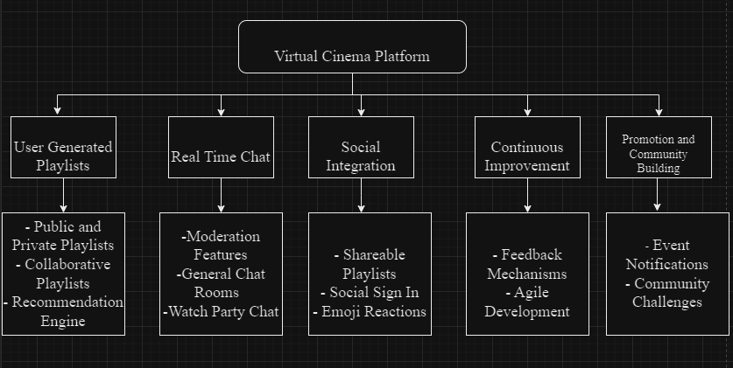

**CONCLUSION**

In summary, the incorporation of these innovative features not only enriches the user experience but also establishes the virtual cinema platform as a vibrant, dynamic, and socially connected space. Users are not merely viewers; they are active participants, contributing to a thriving community bound by their shared love for movies. Through continuous improvement and user-oriented design, the platform aims to create an immersive, enjoyable, and inclusive environment where every movie night becomes a memorable social experience.