Name: Anika Jain
ID: 37379577
Email: aj8g25@soton.ac.uk

Usecase Diagram of the system

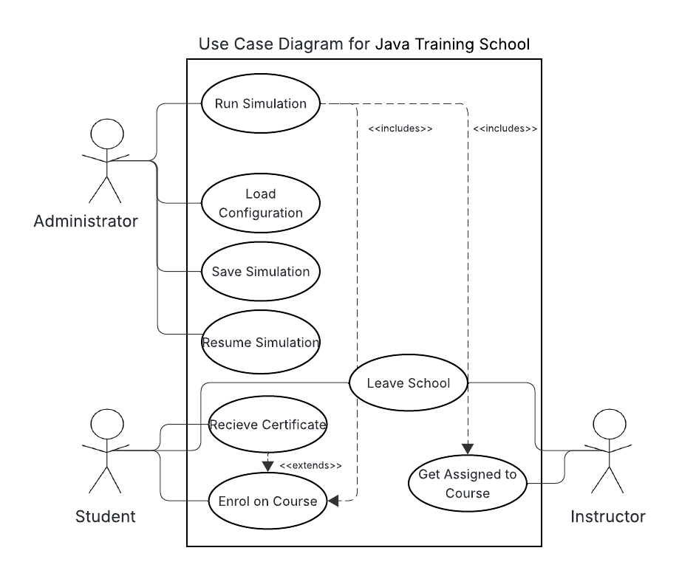

Class Diagram of the system
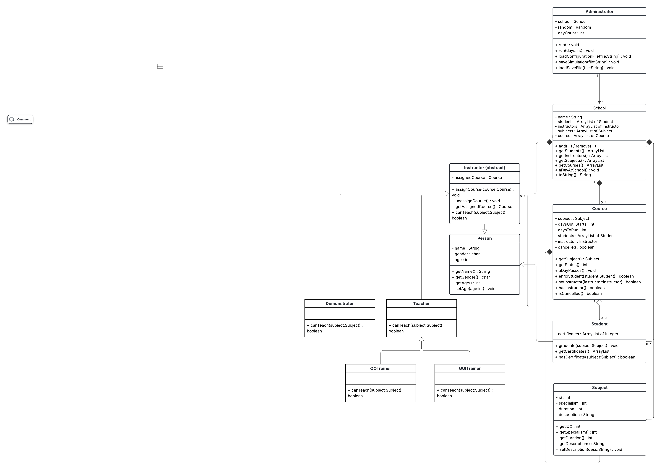

Sequence diagrams of the system
- aDayAtSchool() - course creation, student enrolment, and course completion

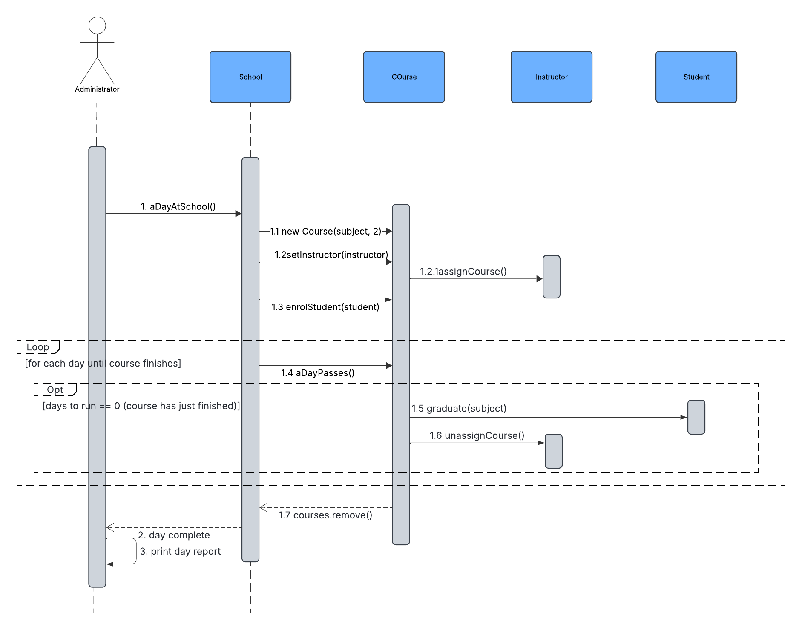

- Loading a configuration file and running the simulation
