Exp-6

Design and Implementation of an 4-bit Arithmetic Circuit

**Objectives.**

1. Design an Arithmetic circuit with the following function Table
2. Implement the Arithmetic Circuit in hardware and observe various outputs and inputs

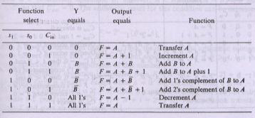**Equipments Function Table**

* DC-Power supply,
* Bread-board,
* LEDs,
* Switches
* AND gates IC
* OR gates IC
* Not gates IC
* Full adder IC (74LS83),

**Circuit Diagram**

