Purpose
This experiment is designed to show that digital signals can be changed into analog signals with Amplitude Shift Keying (ASK) and that several analog signals can merge using Frequency Division Multiplexing (FDM). Moreover, it shows that demodulation techniques can be used to recover and restore the original digital signal from these separate bits. It’s important for analyzing the systems we use in daily life.

Result
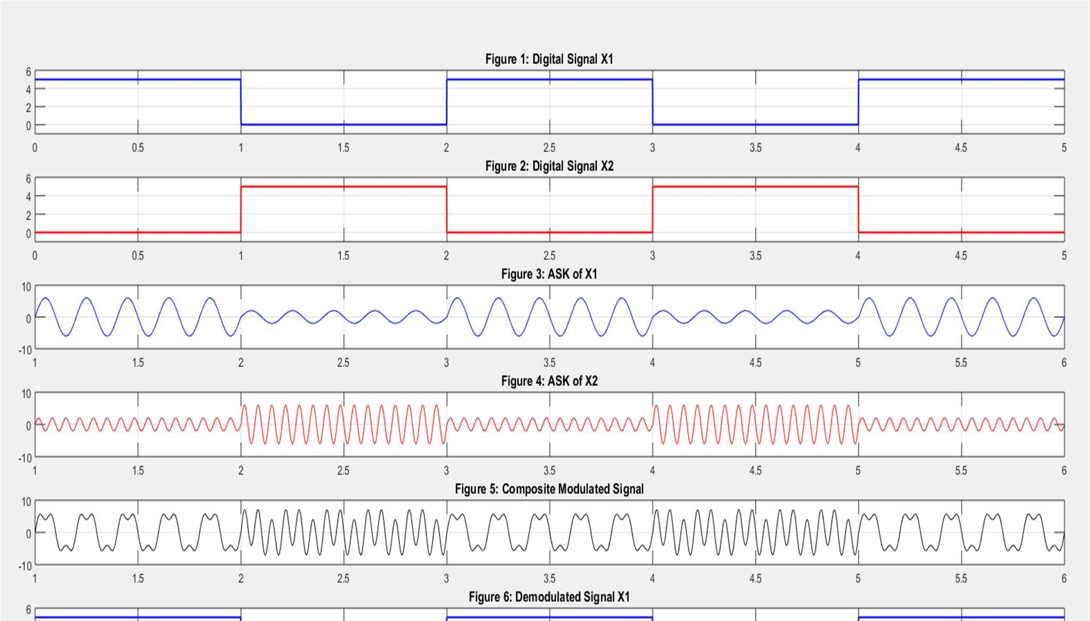
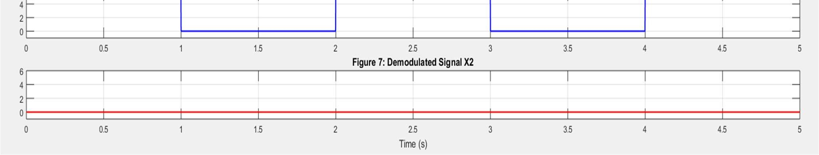
- Figure 1 & 2: Digital NRZ representations of x1 and x2.
- Figure 3 & 4: ASK modulated signals for x1 and x2.
- Figure 5: Composite signal using FDM (sum of ASK1 and ASK2).
- Figure 6 & 7: Demodulated and reconstructed signals for x1 and x2.
These plots verify that the original data can be effectively transmitted and recovered using ASK and FDM.

Impact on Society, Health and Safety
Mobile phones, TV, radio and the internet rely heavily on the use of Amplitude Shift Keying (ASK) and Frequency Division Multiplexing (FDM).

1. It help us make better use of the available bandwidth by sending multiple signals together at once.
2. Multiple users can successfully send and receive data together without affecting each other.
3. They help make healthcare quicker and stronger, especially because doctors can monitor patients remotely and hold online sessions.

4. They allow for a data transfer that is easier and safer because they need less complicated systems.
5. ASK and FDM enable individuals all over the global to talk, exchange messages and share their cultures online.

They help people connect better across many areas of society and they also benefit health and safety.

Discussion and Conclusions
The experiment gave us knowledge of how ASK and FDM are applied in data communication. We managed to convert digital data into an analog format, mix digest this and finally retrieve recorded digital data using demodulation. Everything went smoothly in the process.
Besides, there were just a few limitations to consider.Just two data signals were used in the experiment, while real systems depend on many more.In our model, we did not consider noise or interference which are common issues in real communications. Even so, the experiment still proved very useful. It offered us a clear understanding of how digital data is moved using analog signals which matters for real-life communication systems.

