Location:

D:\CustomData\Galderma_midas_feed\Input\Quarterly\PTR Mexico

Then we need to pivote the prm file for all the three database

Then database:

\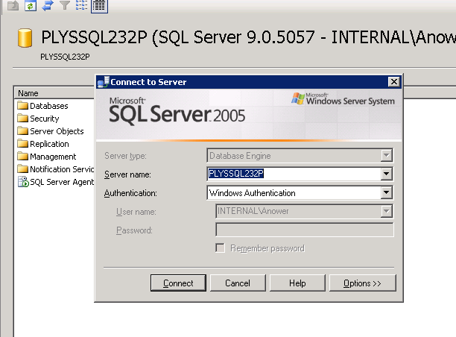

Database Name: Galderma_Mexico_PTR_RX_OTC

Then need to load pivoted file data in the table M01_pivoted-sales, M02_pivoted-pre,M03_pivoted-otc.

Mol-5000,intprd-500

Then run the sp : GALDERMA_OTC_RX_PTR_MEXICO

Then export the data in the same location but with “” and ;

QA: QTR PTR MEXICO.sql