Galderma AK BCC Market QTR Staging Area

User Documentation
Version 1.0


Contents
1 Document control 3
1.1 About this document 3
1.2 Changes made to this document 3
1.3 Purpose of this document 3
1.4 Audience for this document 3
2 Assumptions and constraints 4
3 Process 5
4 QC 8
5 Appendices 17
5.1 Appendix A1: Download FTP Information 17
5.2 Appendix A2: Download Server Information 17
5.3 Appendix A3:Processing Server Information 17

Document control

About this document
Author | Anika Nower
Published
File location
Status
Confidentiality | This document is confidential and must not be distributed outside of IMS Health.
Copyright | © 2026 IMS Health Incorporated or its affiliates. All rights reserved.

Changes made to this document

Version | Sections changed or created | Date of change | Author or contributor name | Role | Change summary
 |  | August, 12 | Anika Nower

Purpose of this document
The purpose of this document is to describe Galderma Monthly PTR Staging area.

Audience for this document
This document has been written for:
- Production team members

Assumptions and constraints

ID | Assumptions

ID | Constraints

Process
Step# | Step Description
Sample mail
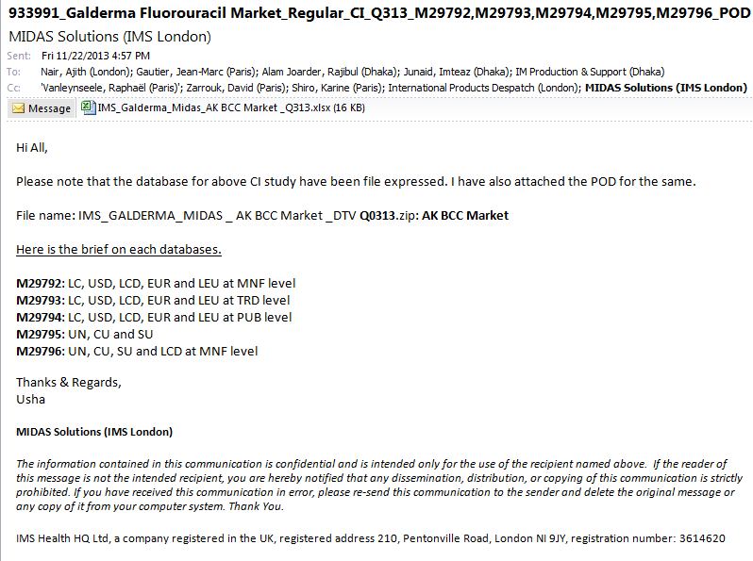
 | Log in to server using Appendix A4 to Appendix A2
 | Select Favorite Products →IMS File Express Administration → IMS File Express Menu →IMS File Express
Download and copy the file to \\162.44.22.161\d$ Address
CustomData \Galderma_midas_feed\Input\Quarterly\Quarterly FLUOROURACIL
 | Log on to the server using Appendix A3
Go to D:\CustomData \Galderma_midas_feed\Input\Quarterly\Quarterly FLUOROURACIL
Unzip the file using Extract Here.
Check all 5 files are there or not. Usually ignore the last file.(delete file)
Rename the file
- Check which file include UN, CU, SU only from mail. Rename with Q01.zip
- Check which file include LC, USD, LCD, EUR and LEU at MNF level from mail. Rename with Q02.zip
- Check which file include LC, USD, LCD, EUR and LEU at TRD level from mail. Rename with Q03.zip
- Check which file include LC, USD, LCD, EUR and LEU at PUB level from mail. Rename with Q04.zip

Unzip all the file using Extract to folder name
[for example: Q1.zip as Q1, Q2.zip as Q2, Q3.zip as Q3, Q4.zip as Q4]
For Q1:
Open the previous backup of fluorouracil run. Open .out file with textpad in Q1 folder.
Copy the 1st row in new textpad/notepad
Close .out file
Go to location
D:\PADDS Convert Tool\Convert50
Open convert.exe
1.Click analyze from menu bar.
2.Browse source file mask: D:\CustomData\Galderma_midas_feed\Input\Quarterly\Quarterly FLUOROURACIL\Q01
3.Select .PRM file and open
4.Select Quarterly
5.Click Scan Directory
6. Check Export headers, Norm. Periods
7.Click Edit Hierarchies
8. Delete all .DLL file
9. check step by step column of textpad file(which you copy the 1st row) with Hierarchies and delete the Additional Description.
1st CTY delete .dll file
MKT-TYPE no action
for CRP no action
for MNF delete Additional Description
ATC4 delete .dll file
INTPRD delete all Additional description
PRD -- with out LDATE ,delete rest of Additional description
PRD_LDATE
INTRX no action
NFC123 delete .dll file
STR no action
INSTR no action
INTPCK no action
PCK no action
PCK_LDATE no action
SALT no action
MOL delete all Additional description

 | Click ok
 | Click convert→ yes
- on | One notepad open and the last line should be ready.
 | Close notepad,close Hierarchies, close window.
 | For Q2, Q3, Q4 follow step 11 to 17.
Now go to Q1 folder and rename .out file to Q01.TXT
go to Q2 folder and rename .out file to Q02.TXT
go to Q3 folder and rename .out file to Q03.TXT
go to Q4 folder and rename .out file to Q04.TXT
Go to D:\CustomData\Galderma_midas_feed\SSIS\galderma_midas_feed_Quarterly_ FLUOROURACIL
Open galderma_midas_feed.sln
Run QUARTERLY_Fluorouracil.dtsx
Output file IMS_GALDERMA_Quarterly_YYYYMM_01_FLUOROURACIL_Test.txt will generate in location D:\CustomData\Galderma_midas_feed\Output\quarterly\Quarterly FLUOROURACIL
Zip the file
 | Backup the txt and zip file in one folder with name the latest period.
For delivery:
Log in to server using Appendix A4 to Appendix A2
 | Copy the output zip using \\162.44.22.161\d$
Select Favorite Products →IMS File Express Administration → Add new file→browse select the output zip file.
Template :Galderma
File description: AK BCC MARKET delivery for Mmm/YY MIDAS QTR data
Save all.
Go to D:\CustomData\Galderma_midas_feed\Input\Quarterly\Quarterly FLUOROURACIL\Q1 2012 Fluorouracil
Create a New folder named MmmYYYY
[For example, the folder name M042012]

Take backup of the files in D:\CustomData\Galderma_midas_feed\Input\Quarterly\Quarterly FLUOROURACIL
To the newly created MmmYYYY folder.

QC
1 | Copy:  FinaltestQ.xls  Book2.xls  IMS_GALDERMA_MIDAS_AK_BCC_Market_FF_VALIDATION_Q213.XLS  files from previous month folder to  D:\CustomData\Galderma_midas_feed\Input\Quarterly\Quarterly New Contract\Old
2 | Steps of QC:  Step 1: open IMS_GALDERMA_CTY_LEVEL_QTR_COMPARE_Qnyy.xls
3 | Open .prm file from Q01 folder. See screenshort below:
 | 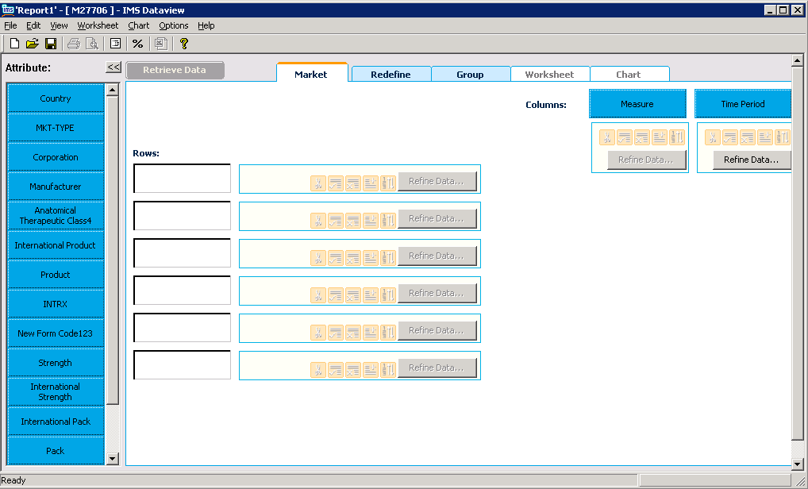
4. | Click “Country”,. Click “Add all” and then “OK”. See screenshot below:
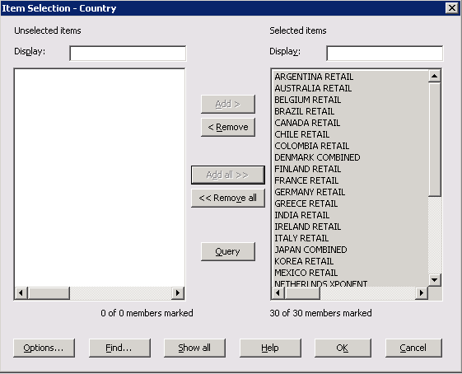
Click “Redefine Data” . Select “Ascending” and “Alphabetic” and click OK. See screenshot below:

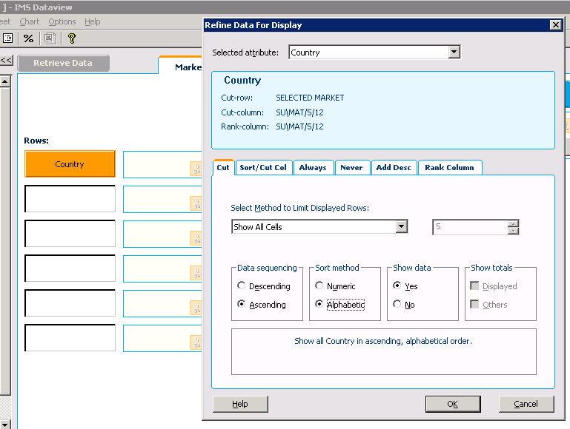
5. | Click “Measure”,. Click “Add all” and then “OK”. See screenshot below:
 | 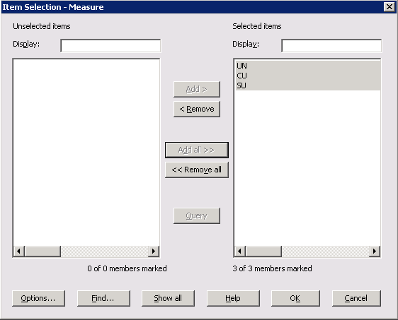
6. | Click “Period”, select latest month from the list. Click “Add” and then “OK”. See screenshot below:
 | 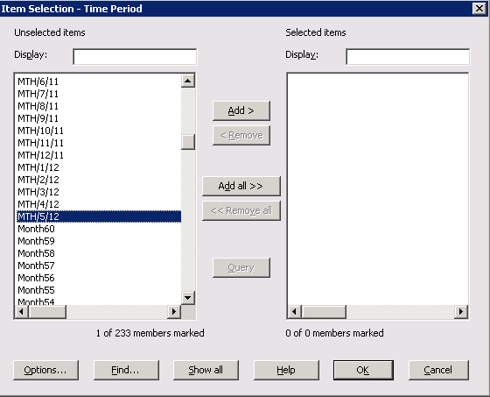
7. | Click “Retrieve data”,. Then copy the value from dataview
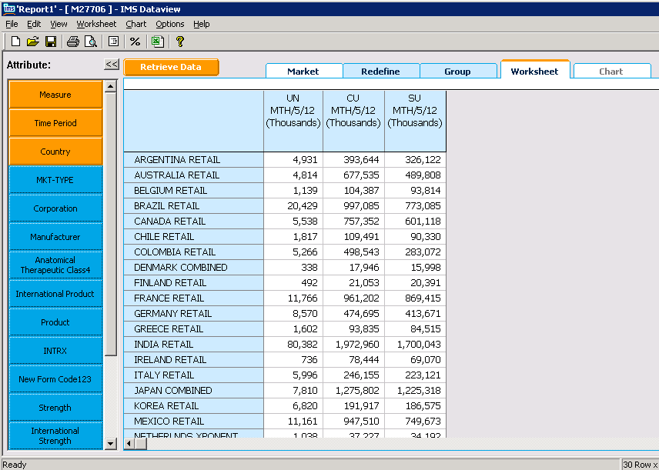
And paste in dataview sheet. See the screen short below:
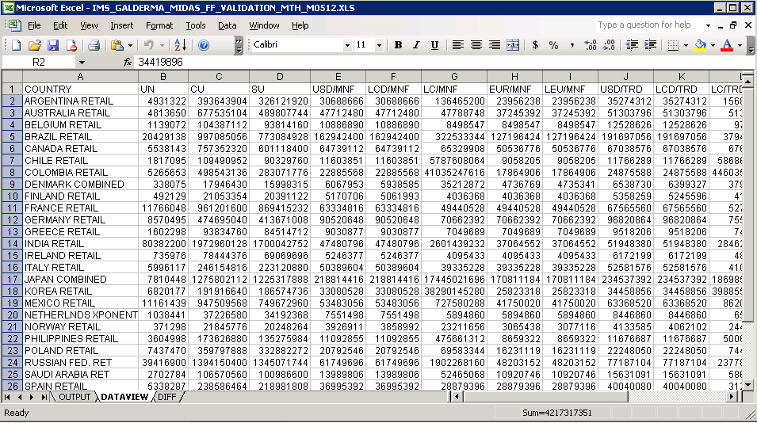
8 | Repeat this 3 to 7 for Q02 to Q04
9 | Now log on to SQL Server 2005
10 | Run QTR_QA_Fluorouracil.sqlfrom D:\CustomData\Galderma_midas_feed\Tools\SQL
11 | Paste result into output sheet
12 | Check DIFF page that Diff should be 0.0000%
13 | Step 2: open FinaltestQ.xls
14 | Now open .prm file from M01 folder  Click “Period”, select MAT1 from the list. Click “Add” and then “OK”. See screenshot below:  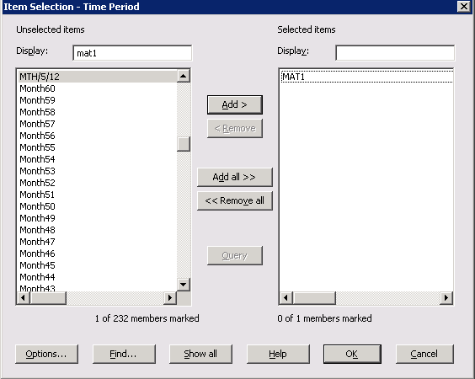  Click “Retrieve data”,. Then copy the value in MAT1 sheet  Repeat this for .PRM files in folder M02 to M07 to select the MAT1 value.  Repeat this for MAT2, MAT3, Mat4, Mat5 for these 7 .PRM files.
16 | Open Book2.xls  Copy MAT1 from FinaltestQ and paste Book2 MAT1. Check that the values should be rounded.
17 | Open IMS_GALDERMA_CTY_LEVEL_MAT_COMPARE_Qnyy.xls  Copy two part from Book1 and paste IMS_GALDERMA_CTY_LEVEL_MAT_COMPARE_Qnyy.xls  See the diff is 0.0000%
References
The table below lists other materials that are relevant to this document.
Title | Author | Version | Date | Location

Appendices

Appendix A1: Download FTP Information
Key | Value
FTP Server: | ftp-emea.rxcorp.com
Username: | D08044
Password: | CHProd
Location: | /Level1 PTRi/Client/Respective Month Name

Appendix A2: Download Server Information
Key | Value
Server Address: | 162.44.12.72
Username: | PINASVC-IMAdmin
Password: | !nf0_MgmT

Appendix A3:Processing Server Information
Key | Value
Server Address: | 162.44.22.161
Username: | DACASVC-GDCRDPAdmin
Password: | !nf0_MgmT

